Task 1: To Create Main Loop, Display Prompt, Read User Input, Handle Exit Conditions, Design Control Flow Diagram, Test Interactive Loop
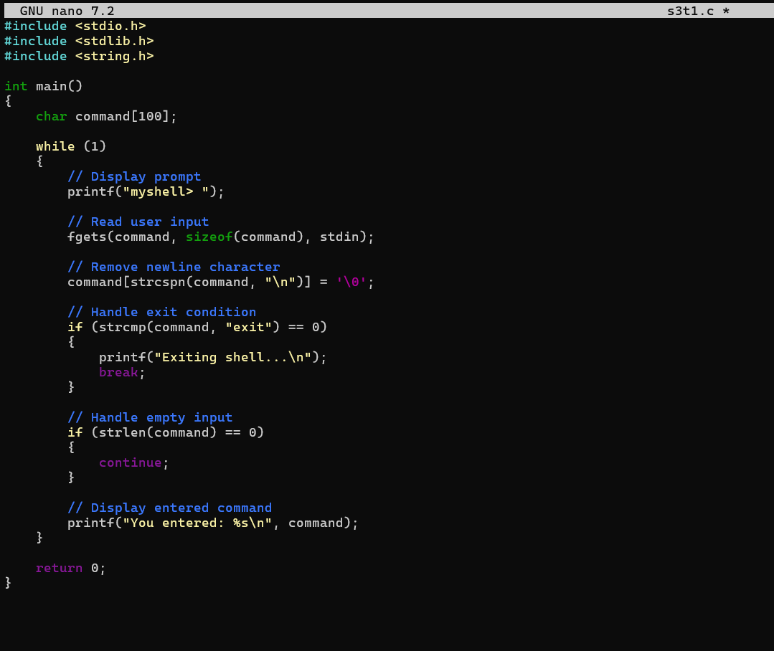
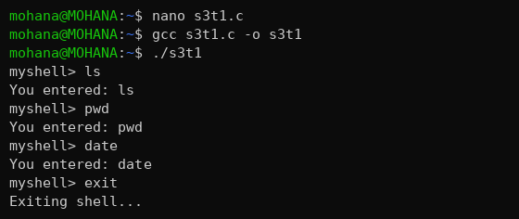
Task 2: Using the following system calls, copy the content from File1.txt to File2.txt.
1. Open()
2. Read()
3. Write()
4. Close()

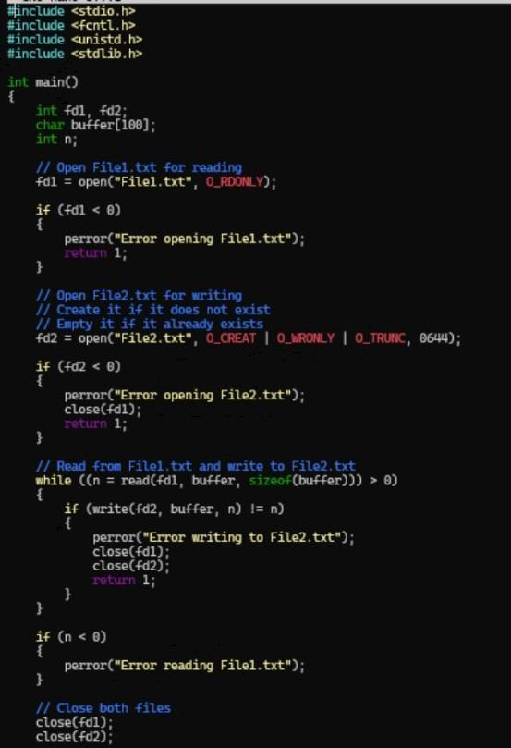
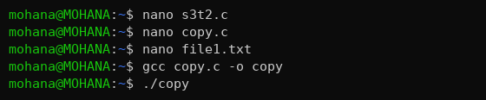
Task 3: To Capture Keyboard Input, Handle Backspace, Process Enter Key, Manage Input Buffer, Support Multi-Character Commands, Test User Interaction.

