**WEEK – 8(HandsOn)**

**GIT**

**1.Git-HOL**

Familiar with Git commands like git init, git status, git add, git commit, git push, and git pull.

In this hands-on lab, you will learn how to

* Setup your machine with Git Configuration

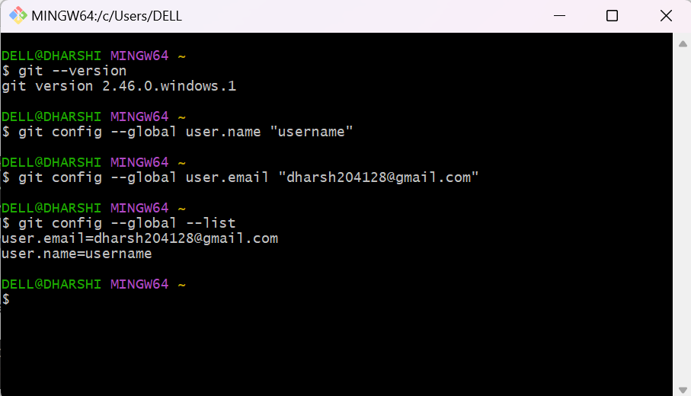

* Integrate notepad++.exe to Git and make it a default editor

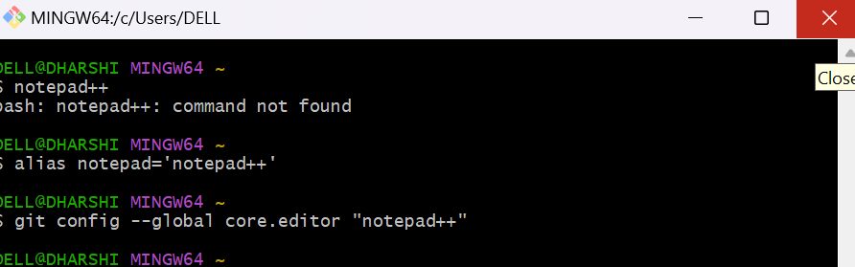

* Add a file to source code repository\

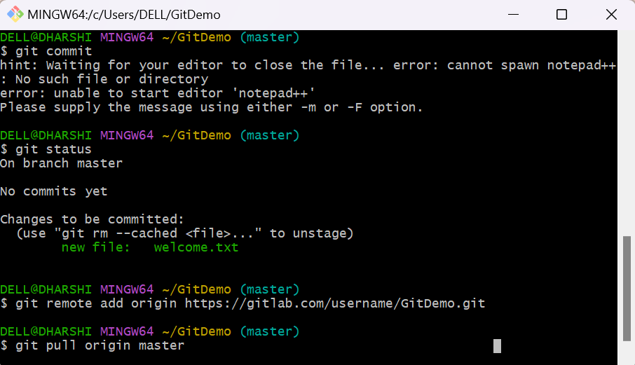

**2. Git-HOL**

**Objectives**

* Explain git ignore
* Explain how to ignore unwanted files using git ignore

In this hands-on lab, you will learn how to:

* Implement git ignore command to ignore unwanted files and folders

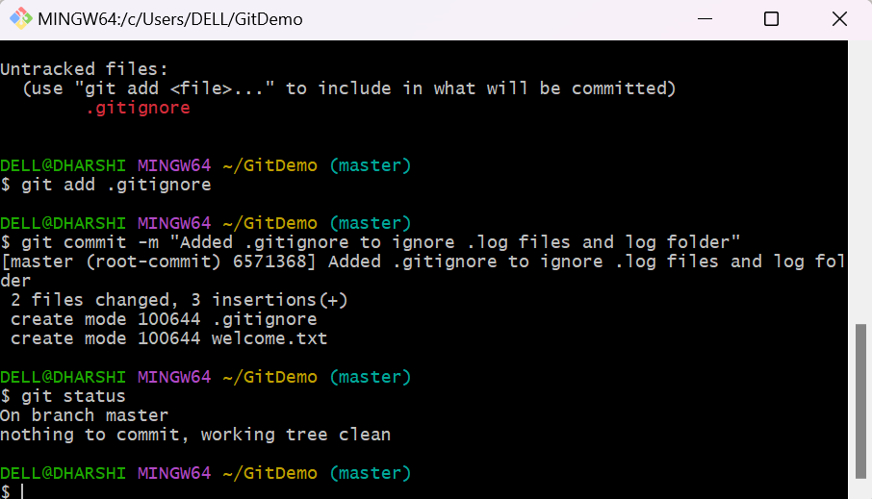

**3. Git-HOL**

**Objectives**

* Explain branching and merging
* Explain about creating a branch request in GitLab
* Explain about creating a merge request in GitLab

In this hands-on lab, you will learn how to:

* Construct a branch, do some changes in the branch, and merge it with master (or trunk)

**Prerequisites**

The following are the pre-requisites to complete this hands-on lab:

* Setting up Git environment with P4Merge tool for Windows

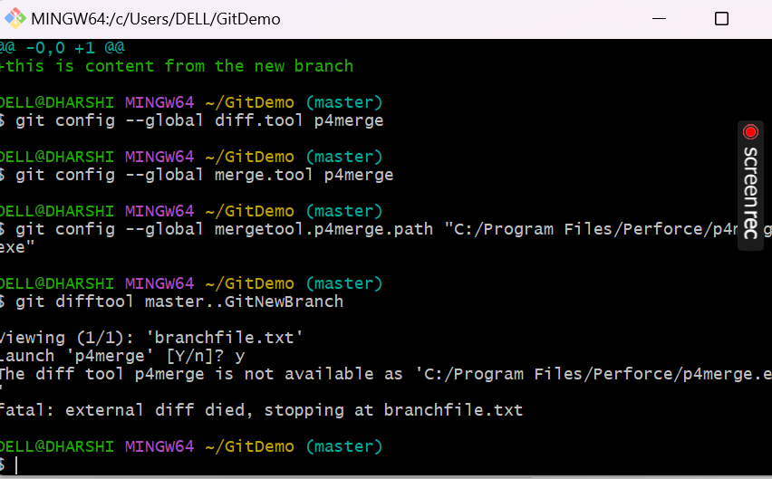

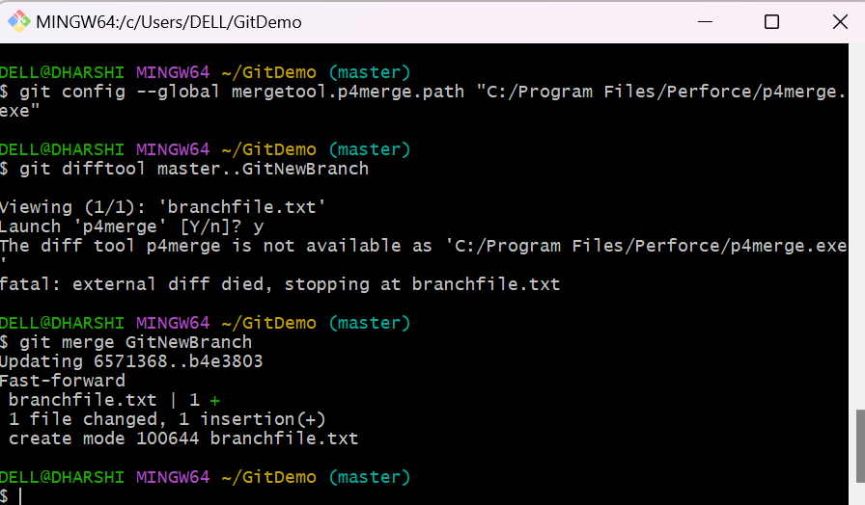

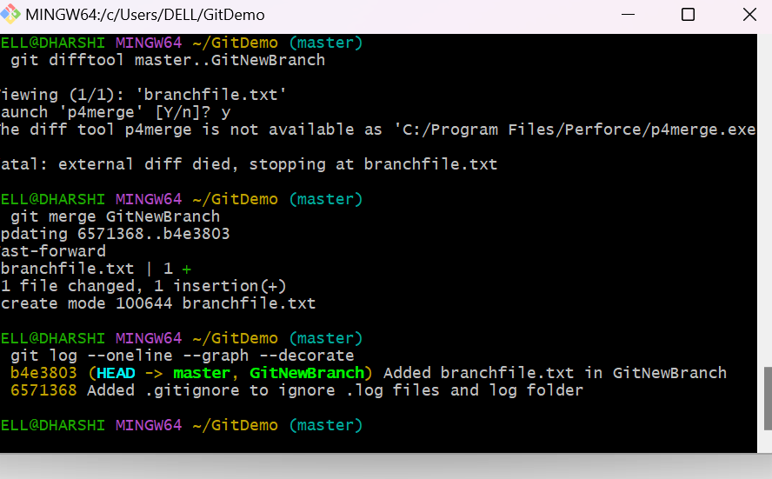

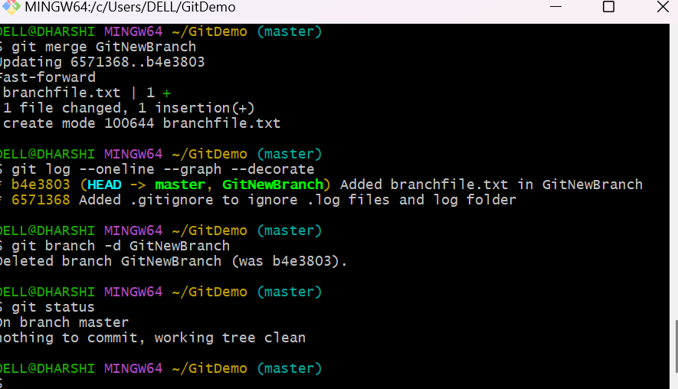

**4. Git-HOL**

**Objectives**

* Explain how to resolve the conflict during merge.

In this hands-on lab, you will learn how to:

* Implement conflict resolution when multiple users are updating the trunk (or master) in such a way that it results into a conflict with the branch’s modification.

**Prerequisites**

The following are the pre-requisites to complete this hands-on lab:

* Hands-on ID: **“Git-T03-HOL_001”**

Notes*:

|  |
| --- |
| Please follow the below steps for creating a free account in GitHub.  Do not use cognizant credentials to login to GitHub. |

Estimated time to complete this lab: **30 minutes.**

Please follow the instructions to complete the hands-on. Each instruction expect a command for the Git Bash.

1. Verify if master is in clean state.
2. Create a branch **“GitWork”.** Add a file “hello.xml”.
3. Update the content of “hello.xml” and observe the status
4. Commit the changes to reflect in the branch
5. Switch to master.
6. Add a file **“hello.xml”** to the master and add some different content than previous.
7. Commit the changes to the master
8. Observe the log by executing **“git log –oneline –graph –decorate –all”**
9. Check the differences with Git diff tool
10. For better visualization, use P4Merge tool to list out all the differences between master and branch
11. Merge the bran to the master
12. Observe the git mark up.
13. Use 3-way merge tool to resolve the conflict
14. Commit the changes to the master, once done with conflict
15. Observe the git status and add backup file to the .gitignore file.
16. Commit the changes to the .gitignore
17. List out all the available branches
18. Delete the branch, which merge to master.
19. Observe the log by executing **“git log –oneline –graph –decorate”**

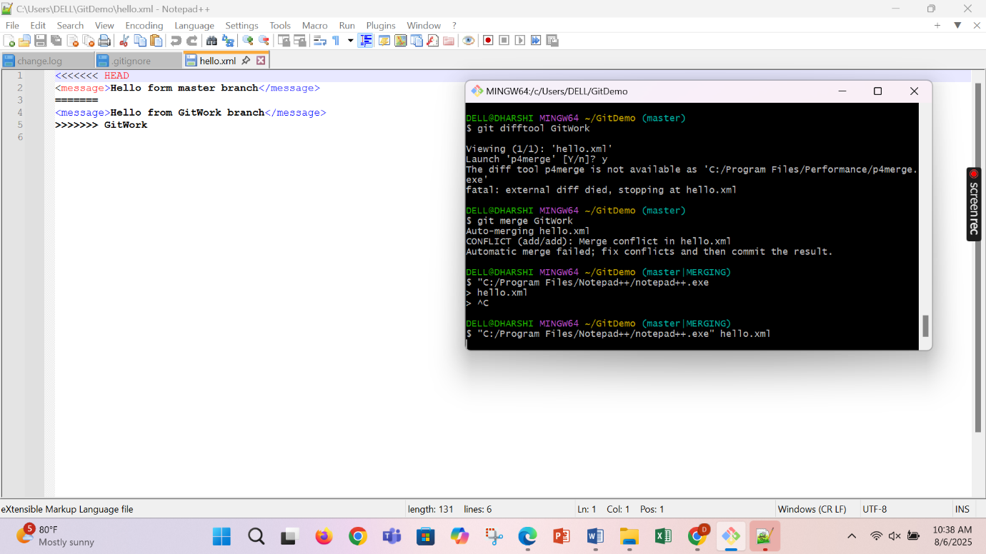

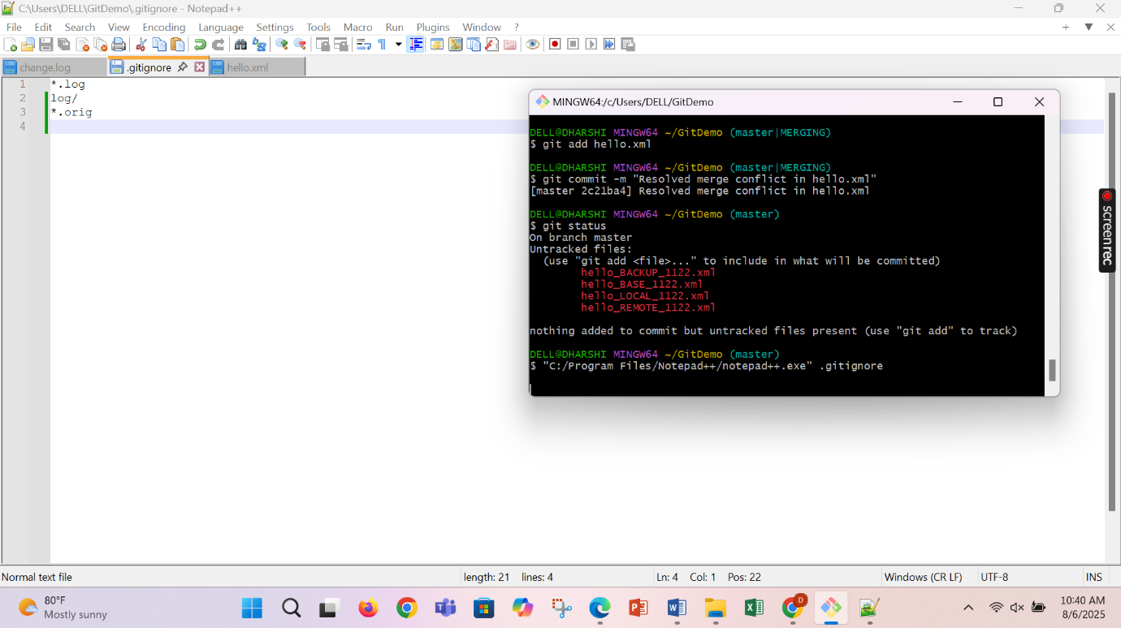

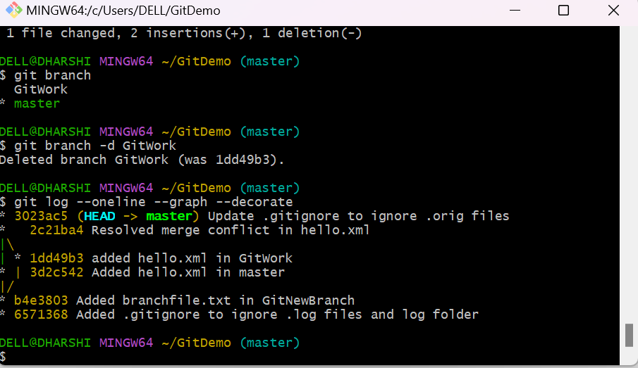

**5. Git-HOL**

**Objectives**

* Explain how to clean up and push back to remote Git

In this hands-on lab, you will learn how to:

* Execute steps involving clean up and push back to remote Git.

**Prerequisites**

The following are the pre-requisites to complete this hands-on lab:

* Hands-on ID: **“Git-T03-HOL_002”**

Notes*:

|  |
| --- |
| Please follow the below steps for creating a free account in GitHub.  Do not use cognizant credentials to login to GitHub. |

Estimated time to complete this lab: **10 minutes.**

Please follow the instructions to complete the hands-on. Each instruction expects a command for the Git Bash.

1. Verify if master is in clean state.
2. List out all the available branches.
3. Pull the remote git repository to the master
4. Push the changes, which are pending from **“Git-T03-HOL_002”** to the remote repository.
5. Observe if the changes are reflected in the remote repository.

