HANDSPEAK AI: REAL-TIME SIGN LANGUAGE INTERPRETER FOR SEAMLESS COMMUNICATION

SL.NO | TITLE | PAGE.NO
01 | ABSTRACT
02 | EXISTING SYSTEM  2.1 DRAWBACKS
03 | INTRODUCTION  3.1 DATA SCIENCE  3.2 ARTIFICIAL INTELLIGENCE
04 | MACHINE LEARNING
05 | PREPARING DATASET
06 | PROPOSED SYSTEM  6.1 ADVANTAGES
07 | LITERATURE SURVEY
08 | SYSTEM STUDY  8.1 OBJECTIVES  8.2 PROJECT GOAL  8.3 SCOPE OF THE PROJECT
09 | FEASIBILITY STUDY
10 | LIST OF MODULES
11 | PROJECT REQUIREMENTS  11.1 FUNCTIONAL REQUIREMENTS  11.2 NON-FUNCTIONAL REQUIREMENTS
12 | ENVIRONMENT REQUIREMENT
13 | SOFTWARE DESCRIPTION  13.1 ANACONDA NAVIGATOR  13.2 JUPYTER NOTEBOOK
14 | PYTHON
15 | SYSTEM ARCHITECTURE
16 | WORKFLOW DIAGRAM
17 | USECASE DIAGRAM
18 | CLASS DIAGRAM
19 | ACTIVITY DIAGRAM
20 | SEQUENCE DIAGRAM
21 | ER – DIAGRAM
22 | MODULE DESCRIPTION  22.1 MODULE DIAGRAM  22.2 MODULE GIVEN INPUT EXPECTED OUTPUT
23 | DEPLOYMENT
24 | HTML
25 | CSS
26 | CODING
27 | CONCLUSION
28 | FUTURE WORK

LIST OF FIGURES
SL.NO | TITLE | PAGE.NO
01 | SYSTEM ARCHITECTURE
02 | WORKFLOW DIAGRAM
03 | USECASE DIAGRAM
04 | CLASS DIAGRAM
05 | ACTIVITY DIAGRAM
06 | SEQUENCE DIAGRAM
07 | ER – DIAGRAM
08 | MODULE DIAGRAM

LIST OF SYMBOLS
S.NO | NOTATION  NAME | NOTATION | DESCRIPTION
1. | Class | Class Name  -attribute  -attribute  +operation  +operation  +operation  + public  -private  # protected | Represents a collection of similar entities grouped together.
2. | Association | nAME  Class B  Class A  Class B  Class A | Associations represents static relationships between classes. Roles representsthe way the two classes see each other.
3. | Actor | Class A  Class A  Class B  Class B | It aggregates several classes into a single classes.
4. | Aggregation |  | Interaction between the system and external environment

5. | Relation  (uses) | uses | Used for additional process communication.
6. | Relation  (extends) | EXTENDS | Extends relationship is used when one use case is similar to another use case but does a bit more.
7. | Communication |  | Communication between various use cases.
8. | State | State | State of the processs.
9. | Initial State |  | Initial state of the object
10. | Final state |  | Final state of the object
11. | Control flow |  | Represents various control flow between the states.
12. | Decision box |  | Represents decision making process from a constraint
13. | Usecase | Usescase | Interact ion between the system and external environment.
14. | Component |  | Represents physical modules which is a collection of components.
15. | Node |  | Represents physical modules which are a collection of components.
16. | Data Process/State |  | A circle in DFD represents a state or process which has been triggered due to some event or acion.
17. | External entity |  | Represents external entities such as keyboard,sensors,etc.
18. | Transition |  | Represents communication that occurs between processes.
19. | Object Lifeline |  | Represents the vertical dimensions that the object communications.
20. | Message | Message | Represents the message exchanged.

ABSTRACT:
The proposed system, HandSpeak AI: Real-Time Sign Language Interpreter for Seamless Communication, aims to bridge the communication gap between the hearing-impaired community and the general public by providing an intelligent, real-time sign language recognition framework. Leveraging advanced Convolutional Neural Networks (CNNs) and computer vision techniques, the system captures hand Signs through accurately interprets signs representing alphabets A to Z of sign language. The recognized signs are instantly converted into readable text or accessible interactions in diverse social and professional settings. Designed to operate efficiently on both desktop and Web platforms, this AI-powered interpreter promotes inclusivity, enhances accessibility, and empowers users with improved communication capabilities in real-time.
Keywords:
Sign Language Recognition, Real-Time Interpreter, HandSpeak AI, CNN, Computer Vision, A-Z Hand Signs, Accessibility, Inclusivity, Human-Computer Interaction, Deaf Communication

EXISTING SYSTEM:

Continuous sign language recognition (CSLR) plays a crucial role in facilitating communication between deaf and hearing individuals. A key aspect of achieving precise CSLR is the alignment of the video segment of each sign with its gloss, namely its corresponding text representation in natural language. However, the coarticulation phenomenon, where contextual dependencies between adjacent signs blur the boundaries of individual signs, poses a significant challenge to this task. In this paper, we propose a novel boundary-aware sentence-gloss alignment network for CSLR to address this challenge. Our network first designs a task-relevant boundary-aware similarity measurement, evaluating sign frames by both appearance and their recognition contribution, mitigating coarticulation-induced transition noise to restore precise boundaries. For enhanced alignment, we propose a hierarchical sentence-gloss alignment: coarse sentence-level alignment reduces cross-modal disparity, while fine-grained gloss-level alignment refines video-to-token mapping. Finally, an adaptive class-divergence loss sharpens gloss decoding by maximizing inter-class discrimination. Our proposed framework provides a simple and effective solution to mitigate the boundary ambiguity caused by coarticulation, optimizing continuous sign language recognition algorithms from a new perspective. Extensive experiments conducted on four public sign language recognition (SLR) datasets demonstrate that our proposed boundary-aware sentence-gloss alignment network learns precise alignments and achieves state-of-the-art performance.

DISADVANTAGES:
- High computational cost due to complex boundary-aware similarity and hierarchical alignment processes.
- Requires large annotated datasets with precise sentence-gloss alignment for effective training.
- Sensitive to video quality and hand Sign occlusions, affecting recognition accuracy.
- Struggles with performance on low-resource or mobile devices due to heavy model complexity.
- Coarticulation effects may still persist in highly dynamic or rapid signing sequences.

INTRODUCTION:
Hand Signs are an important part of nonverbal communication and form an integral part of our interactions with the environment. Notably, sign language is a set of hand Signs that is valuable to millions of disabled people. However, deaf/dumb users experience difficulty in communicating with the outside world as most neither understand nor can use sign language. Sign recognition and classification platforms can aid in translating the Signs to those who do not understand sign language. There are two major approaches in the classification of hand Signs. The first approach is the vision-based approach. This involves the use of cameras to acquire the pose and movement of the hand and algorithms to process the recorded images. Although this approach is popular, it is very computationally intensive, as images or videos have to undergo significant preprocessing to segment features such as the image’s color, pixel values, and shape of hand.

Domain overview:
4.1 Data Science:
Data science is an interdisciplinary field that uses scientific methods, processes, algorithms and systems to extract knowledge and insights from structured and unstructured data, and apply knowledge and actionable insights from data across a broad range of application domains.
The term "data science" has been traced back to 1974, when Peter Naur proposed it as an alternative name for computer science. In 1996, the International Federation of Classification Societies became the first conference to specifically feature data science as a topic. However, the definition was still in flux.
The term “data science” was first coined in 2008 by D.J. Patil, and Jeff Hammerbacher, the pioneer leads of data and analytics efforts at LinkedIn and Facebook. In less than a decade, it has become one of the hottest and most trending professions in the market.
Data science is the field of study that combines domain expertise, programming skills, and knowledge of mathematics and statistics to extract meaningful insights from data.
Data science can be defined as a blend of mathematics, business acumen, tools, algorithms and machine learning techniques, all of which help us in finding out the hidden insights or patterns from raw data which can be of major use in the formation of big business decisions.

Data Scientist:
Data scientists examine which questions need answering and where to find the related data. They have business acumen and analytical skills as well as the ability to mine, clean, and present data. Businesses use data scientists to source, manage, and analyze large amounts of unstructured data.
Required Skills for a Data Scientist:
- Programming: Python, SQL, Scala, Java, R, MATLAB.
- Machine Learning: Natural Language Processing, Classification, Clustering.
- Data Visualization: Tableau, SAS, D3.js, Python, Java, R libraries.
- Big data platforms: MongoDB, Oracle, Microsoft Azure, Cloudera.

  - ARTIFICIAL INTELLIGENCE:
Artificial intelligence (AI) refers to the simulation of human intelligence in machines that are programmed to think like humans and mimic their actions. The term may also be applied to any machine that exhibits traits associated with a human mind such as learning and problem-solving.
Artificial intelligence (AI) is intelligence demonstrated by machines, as opposed to the natural intelligence displayed by humans or animals. Leading AI textbooks define the field as the study of “intelligent agents” any system that perceives its environment and takes actions that maximize its chance of achieving its goals.
Some popular accounts use the term “artificial intelligence” to describe machines that mimic “cognitive” functions that humans associate with the human mind, such as “learning” and “problem solving”, however this definition is rejected by major AI researchers.
Artificial intelligence is the simulation of human intelligence processes by machines, especially computer systems. Specific applications of AI include expert systems, natural language processing, speech recognition and machine vision.
AI applications include advanced web search engines, recommendation systems (used by Youtube, Amazon and Netflix), Understanding human speech (such as Siri or Alexa), self-driving cars (e.g. Tesla), and competing at the highest level in strategic game systems (such as chess and Go), As machines become increasingly capable, tasks considered to require “intelligence” are often removed from the definition of AI, a phenomenon known as the AI effect. For instance, optical character recognition is frequently excluded from things considered to be AI, having become a routine technology.
Artificial intelligence was founded as an academic discipline in 1956, and in the years since has experienced several waves of optimism, followed by disappointment and the loss of funding (known as an “AI winter”), followed by new approaches, success and renewed funding.
AI research has tried and discarded many different approaches during its lifetime, including simulating the Paddy Leaves, modeling human problem solving, formal logic, large databases of knowledge and imitating animal behavior. In the first decades of the 21st century, highly mathematical statistical machine learning has dominated the field, and this technique has proved highly successful, helping to solve many challenging problems throughout industry and academia.
The various sub-fields of AI research are centered around particular goals and the use of particular tools. The traditional goals of AI research include reasoning, knowledge representation, planning, learning, natural language processing, perception and the ability to move and manipulate objects. General intelligence (the ability to solve an arbitrary problem) is among the field’s long-term goals.
To solve these problems, AI researchers use versions of search and mathematical optimization, formal logic, artificial neural networks, and methods based on statistics, probability and economics. AI also draws upon computer science, psychology, linguistics, philosophy, and many other fields.
The field was founded on the assumption that human intelligence “can be so precisely described that a machine can be made to simulate it”. This raises philosophical arguments about the mind and the ethics of creating artificial beings endowed with human-like intelligence.
These issues have been explored by myth, fiction and philosophy since antiquity. Science fiction and futurology have also suggested that, with its enormous potential and power, AI may become an existential risk to humanity.
As the hype around AI has accelerated, vendors have been scrambling to promote how their products and services use AI. Often what they refer to as AI is simply one component of AI, such as machine learning.
AI requires a foundation of specialized hardware and software for writing and training machine learning algorithms. No one programming language is synonymous with AI, but a few, including Python, R and Java, are popular.
In general, AI systems work by ingesting large amounts of labeled training data, analyzing the data for correlations and patterns, and using these patterns to make predictions about future states.
In this way, a chatbot that is fed examples of text chats can learn to produce life like exchanges with people, or an image recognition tool can learn to identify and describe objects in images by reviewing millions of examples.
AI programming focuses on three cognitive skills: learning, reasoning and self-correction.

Learning processes. This aspect of AI programming focuses on acquiring data and creating rules for how to turn the data into actionable information. The rules, which are called algorithms, provide computing devices with step-by-step instructions for how to complete a specific task.
Reasoning processes. This aspect of AI programming focuses on choosing the right algorithm to reach a desired outcome.
Self-correction processes. This aspect of AI programming is designed to continually fine-tune algorithms and ensure they provide the most accurate results possible.
AI is important because it can give enterprises insights into their operations that they may not have been aware of previously and because, in some cases, AI can perform tasks better than humans. Particularly when it comes to repetitive, detail-oriented tasks like analyzing large numbers of legal documents to ensure relevant fields are filled in properly, AI tools often complete jobs quickly and with relatively few errors.
Artificial neural networks and deep learning artificial intelligence technologies are quickly evolving, primarily because AI processes large amounts of data much faster and makes predictions more accurately than humanly possible.

  - DEEP LEARNING
Deep learning is a branch of machine learning which is completely based on artificial neural networks, as neural network is going to mimic the human disease so deep learning is also a kind of mimic of human disease. It’s on hype nowadays because earlier we did not have that much processing power and a lot of data. A formal definition of deep learning is- neurons Deep learning is a particular kind of machine learning that achieves great power and flexibility by learning to represent the world as a nested hierarchy of concepts, with each concept defined in relation to simpler concepts, and more abstract representations computed in terms of less abstract ones. In disease approximately 100 billion neurons all together this is a picture of an individual neuron and each neuron is connected through thousands of their neighbors. The question here is how it recreates these neurons in a computer. So, it creates an artificial structure called an artificial neural net where we have nodes or neurons. It has some neurons for input value and some for output value and in between, there may be lots of neurons interconnected in the hidden layer.
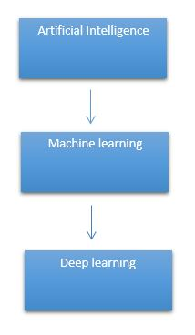

It need to identify the actual problem in order to get the right solution and it should be understood, the feasibility of the Deep Learning should also be checked (whether it should fit Deep Learning or not). It needs to identify the relevant data which should correspond to the actual problem and should be prepared accordingly. Choose the Deep Learning Algorithm appropriately. Algorithm should be used while training the dataset. Final testing should be done on the dataset
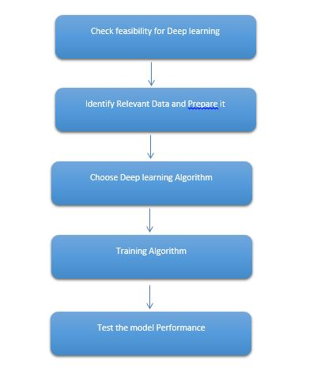
Deep learning (also known as deep structured learning) is part of a broader family of machine learning methods based on artificial neural networks with representation learning. Learning can be supervised, semi-supervised or unsupervised.
Deep-learning architectures such as deep neural networks, deep belief networks, deep reinforcement learning, recurrent neural networks and convolutional neural networks have been applied to fields including computer vision, speech recognition, natural language processing, machine translation, bioinformatics, drug design, medical image analysis, material inspection and board game programs, where they have produced results comparable to and in some cases surpassing human expert performance.
Artificial neural networks (ANNs) were inspired by information processing and distributed communication nodes in biological systems. ANNs have various differences from biological disease. Specifically, neural networks tend to be static and symbolic, while the biological disease of most living organisms is dynamic (plastic) and analogue.
The adjective "deep" in deep learning refers to the use of multiple layers in the network. Early work showed that a linear perceptron cannot be a universal classifier, but that a network with a non-polynomial activation function with one hidden layer of unbounded width can. Deep learning is a modern variation which is concerned with an unbounded number of layers of bounded size, which permits practical application and optimized implementation, while retaining theoretical universality under mild conditions. In deep learning the layers are also permitted to be heterogeneous and to deviate widely from biologically informed connectionist models, for the sake of efficiency, trainability and understandability, whence the "structured" part.
Deep learning is a class of machine learning algorithms that uses multiple layers to progressively extract higher-level features from the raw input. For example, in image processing, lower layers may identify edges, while higher layers may identify the concepts relevant to a human such as digits or letters or faces.
Interpretations:
Deep neural networks are generally interpreted in terms of the universal approximation theorem or probabilistic inference.
The classic universal approximation theorem concerns the capacity of feed-forward neural networks with a single hidden layer of finite size to approximate continuous functions. In 1989, the first proof was published by George Cybenko for sigmoid activation functions and was generalised to feed-forward multi-layer architectures in 1991 by Kurt Hornik. Recent work also showed that universal approximation also holds for non-bounded activation functions such as the rectified linear unit.
The universal approximation theorem for deep neural networks concerns the capacity of networks with bounded width but the depth is allowed to grow proved that if the width of a deep neural network with ReLU activation is strictly larger than the input dimension, then the network can approximate any Lebesgue integrable function; If the width is smaller or equal to the input dimension, then deep neural network is not a universal approximator.
The probabilistic interpretation derives from the field of machine learning. It features inference, as well as the optimization concepts of training and testing, related to fitting and generalization, respectively. More specifically, the probabilistic interpretation considers the activation nonlinearity as a cumulative distribution function. The probabilistic interpretation led to the introduction of dropout as regularizer in neural networks. The probabilistic interpretation was introduced by researchers including Hopfield, Widrow and Narendra and popularized in surveys such as the one by Bishop.

Deep learning revolution:

In 2012, a team led by George E. Dahl won the "Merck Molecular Activity Challenge" using multi-task deep neural networks to predict the biomolecular target of one drug. In 2014, Hochreiter's group used deep learning to detect off-target and toxic effects of environmental chemicals in nutrients, household products and drugs and won the "Tox21 Data Challenge" of NIH, FDA and NCATS.
Significant additional impacts in image or object recognition were felt from 2011 to 2012. Although CNNs trained by back-propagation had been around for decades, and GPU implementations of NNs for years, including CNNs, fast implementations of CNNs on GPUs were needed to progress on computer vision. In 2011, this approach achieved for the first time superhuman performance in a visual pattern recognition contest. Also in 2011, it won the ICDAR Chinese handwriting contest, and in May 2012, it won the ISBI image segmentation contest. Until 2011, CNNs did not play a major role at computer vision conferences, but in June 2012, a paper by Ciresan et al. at the leading conference CVPR showed how max-pooling CNNs on GPU can dramatically improve many vision benchmark records.
In October 2012, a similar system by Krizhevsky et al. won the large-scale ImageNet competition by a significant margin over shallow machine learning methods. In November 2012, Ciresan et al.'s system also won the ICPR contest on analysis of large medical images for cancer detection, and in the following year also the MICCAI Grand Challenge on the same topic. In 2013 and 2014, the error rate on the ImageNet task using deep learning was further reduced, following a similar trend in large-scale speech recognition.
Image classification was then extended to the more challenging task of generating descriptions (captions) for images, often as a combination of CNNs and LSTMs.
Some researchers state that the October 2012 ImageNet victory anchored the start of a "deep learning revolution" that has transformed the AI industry.
In March 2019, Yoshua Bengio, Geoffrey Hinton and Yann LeCun were awarded the Turing Award for conceptual and engineering breakthroughs that have made deep neural networks a critical component of computing.

5. PROPOSED SYSTEM:
The proposed system, HandSpeak AI: Real-Time Sign Language Interpreter for Seamless Communication, aims to develop an intelligent, real-time hand Sign recognition framework capable of accurately interpreting the Sign Language (SL) alphabet from A to Z. By leveraging advanced Convolutional Neural Network (CNN) architectures and computer vision techniques, the system will process live video streams to detect and classify hand Signs corresponding to each alphabet letter. This AI-powered solution is designed to bridge communication gaps between hearing-impaired individuals and non-signers by instantly translating recognized hand signs into readable text outputs. The system will be optimized for deployment on web platforms, and assistive communication tools, ensuring accessibility, efficiency, and inclusivity in various social, educational, and professional environments.

PROPOSED SYSTEM ADVANTAGES:
- Enables real-time translation of sign language alphabets into text.
- Leverages advanced computer vision for high-accuracy recognition.
- Supports deployment on web platforms for broad accessibility.
- Improves inclusivity in social, educational, and professional spaces.
- Reduces dependency on human interpreters for basic sign communication.
- Scalable and adaptable for future multi-language and Sign extensions.
- User-friendly and non-invasive for everyday communication scenarios.

6. PREPARING DATASET:
This dataset contains approximately train and test image records of features extracted, which were then classified into number of classes:
- ThumbsUp
- ThumbsDown
- Piace
- Ok

LITERATURE SURVEY
General
A literature review is a body of text that aims to review the critical points of current knowledge on and/or methodological approaches to a particular topic. It is secondary sources and discuss published information in a particular subject area and sometimes information in a particular subject area within a certain time period.
Its ultimate goal is to bring the reader up to date with current literature on a topic and forms the basis for another goal, such as future research that may be needed in the area and precedes a research proposal and may be just a simple summary of sources. Usually, it has an organizational pattern and combines both summary and synthesis.
A summary is a recap of important information about the source, but a synthesis is a re-organization, reshuffling of information. It might give a new interpretation of old material or combine new with old interpretations or it might trace the intellectual progression of the field, including major debates. Depending on the situation, the literature review may evaluate the sources and advise the reader on the most pertinent or relevant of them. Loan default trends have been long studied from a socio-economic stand point.
Most economics surveys believe in empirical modeling of these complex systems in order to be able to predict the loan default rate for a particular individual. The use of machine learning for such tasks is a trend which it is observing now. Some of the survey’s to understand the past and present perspective of loan approval or not.

Review of Literature Survey
Title : Hand Sign Recognition Based on Computer Vision: A Review of Techniques
Author : Munir Oudah 1 , Ali Al-Naji 1,2,* and Javaan Chahl 2
Year : 2020
Hand Signs are a form of nonverbal communication that can be used in several fields such as communication between deaf-mute people, robot control, human–computer interaction (HCI), home automation and medical applications. Research papers based on hand Signs have adopted many different techniques, including those based on instrumented sensor technology and computer vision. In other words, the hand sign can be classified under many headings, such as posture and Sign, as well as dynamic and static, or a hybrid of the two. This paper focuses on a review of the literature on hand Sign techniques and introduces their merits and limitations under different circumstances. In addition, it tabulates the performance of these methods, focusing on computer vision techniques that deal with the similarity and difference points, technique of hand segmentation used, classification algorithms and drawbacks, number and types of Signs, dataset used, detection range (distance) and type of camera used. This paper is a thorough general overview of hand Sign methods with a brief discussion of some possible applications.

Title : Hand Sign Recognition with Skin Detection and Deep Learning Method
Author : Hanwen Huang1 , Yanwen Chong2*
Year : 2019
Sign recognition, although has been exploring for many years, is still a challenging problem. Complex background, camera angles and illumination conditions make the problem more difficult. Thus, this paper presents a fast and robust method for hand Sign recognition based on RGB video. First we detect the skin based on their color. Then we extract the contour and segment the hand region. Finally we recognize the Sign. The results of experiment demonstrate that the proposed method are efficient to recognize Sign with a higher accuracy than the state of the art.

Title : Hand Sign Recognition System Using Camera
Author : Viraj Shinde, Tushar Bacchav, Jitendra Pawar
Year : 2014
In this paper, we focus on using pointing behavior for a natural interface, Hand Sign recognition based human-machine interface is being developed vigorously in recent years. Due to the effect of lighting and complex background, most visual hand Sign recognition systems work only under restricted environment. To classify the dynamic hand Signs, we developed a simple and fast motion history image based method. In recent years, the Sign control technique has become a new developmental trend for many human-based electronics products. This technique let people can control these products more naturally, intuitively and conveniently. In this paper, a fast Sign recognition scheme is proposed to be an interface for the human-machine interaction (HMI) of systems. This paper presents some low-complexity algorithms and Signs to reduce the Sign recognition complexity and be more suitable for controlling real-time computer systems.

Title : Static Hand Sign Recognition using Convolutional Neural Network with Data Augmentation
Author : Md. Zahirul Islam, Mohammad Shahadat Hossain
Computer is a part and parcel in our day to day life and used in various fields. The interaction of human and computer is accomplished by traditional input devices like mouse, keyboard etc. Hand Signs can be a useful medium of human-computer interaction and can make the interaction easier. Signs vary in orientation and shape from person to person. So, non-linearity exists in this problem. Recent research has proved the supremacy of Convolutional Neural Network (CNN) for image representation and classification. Since, CNN can learn complex and non-linear relationships among images, in this paper, a static hand Sign recognition method using CNN was proposed. Data augmentation like re-scaling, zooming, shearing, rotation, width and height shifting was applied to the dataset. The model was trained on 8000 images and tested on 1600 images which were divided into 10 classes. The model with augmented data achieved accuracy 97.12% which is nearly 4% higher than the model without augmentation (92.87%).

Title : Real-Time Hand Sign Recognition Using Finger Segmentation
Author : Zhi-hua Chen,1 Jung-Tae Kim,1 Jianning Liang
Year : 2014
Hand Sign recognition is very significant for human-computer interaction. In this work, we present a novel real-time method for hand Sign recognition. In our framework, the hand region is extracted from the background with the background subtraction method. Then, the palm and fingers are segmented so as to detect and recognize the fingers. Finally, a rule classifier is applied to predict the labels of hand Signs. The experiments on the data set of 1300 images show that our method performs well and is highly efficient. Moreover, our method shows better performance than a state-of-art method on another data set of hand Signs.

SYSTEM STUDY
Aim:
Hand Sign is one of the major factors in our communicationsociety. There are lot of Sign languages that are actively present in the world. So we can’t able to classify the action easily. So this project can easily classify the hand Sign.

Objectives:
The goal is to develop a deep learning model for Hand Sign classification by convolutional neural network algorithm for potentially classifying the results in the form of best accuracy by comparing the CNN architectures.

Scope:
Hand Signimages are collected. We have to train the machine to classify the types of Sign. This project contains different typesof Sign like ThumbsUp, Thumbsdown, Callme, Looser, etc. We train to teach the machine to ac`hieve the accuracy and get the possible outcome.

OUTLINE OF THE PROJECT

Overview of the system:
- Define a problem
- Gathering image data set
- Evaluating algorithms
- Detecting results
The steps involved in Building the data model is depicted below.

Data collection (Splitting Training set & Test) set)

Pre Processing (Sequential)

Building classification Model

Prediction (Hand Sign Detection)

Fig: data flow diagram for CNN model

PROJECT REQUIREMENTS
General:
Requirements are the basic constrains that are required to develop a system. Requirements are collected while designing the system. The following are the requirements that are to be discussed.
1. Functional requirements
2. Non-Functional requirements
3. Environment requirements
A. Hardware requirements
B. software requirements

Functional requirements:
The software requirements specification is a technical specification of requirements for the software product. It is the first step in the requirements analysis process. It lists requirements of a particular software system. The following details to follow the special libraries like tensorflow, keras, matplotlib.

Non-Functional Requirements:
Process of functional steps,
- Problem define
- Preparing data
- Evaluating algorithm
- Improving results
- Prediction the result

ENVIRONMENTAL REQUIREMENTS:
Software Requirements:
- Operating System : Windows 10 or later
- Simulation Tool : Anaconda with Jupyter Notebook
- Language : Python
Hardware requirements:
- Processor : intel i3 or later
- Hard disk : minimum 10 GB
- RAM : minimum 4 GB

FEASIBILITY STUDY
Splitting the dataset:
The data use is usually split into training data and test data. The training set contains a known output and the model learns on this data in order to be generalized to other data later on. It has the test dataset (or subset) in order to test our models and it will do this using Tensorflow library in Python using the Keras method.

Construction of a Detecting Model:

Deep learning needs data gathering have lot of past image data’s. Training and testing this model working and predicting correctly.
Data Gathering
CNN Algorithm
Train model

Test model
Prediction

Steps of dataflow diagram

DESIGN ARCHITECTURE

General

Design is meaningful engineering representation of something that is to be built. Software design is a process design is the perfect way to accurately translate requirements in to a finished software product. Design creates a representation or model, provides detail about software data structure, architecture, interfaces and components that are necessary to implement a system.

Data Flow Diagram:
Image Details
Test dataset
Pre-processing
Sign Sign Detection
CNN Algorithm
Training dataset

Process of dataflow diagram

A data flow diagram (DFD) is a graphical representation of the "flow" of data through an information system, modeling its process aspects. A DFD is often used as a preliminary step to create an overview of the system without going into great detail, which can later be elaborated. DFDs can also be used for the visualization of data processing (structured design). A DFD shows what kind of information will be input to and output from the system, how the data will advance through the system, and where the data will be stored. It does not show information about process timing or whether processes will operate in sequence or in parallel, unlike a traditional structured flowchart which focuses on control flow, or a UML activity workflow diagram, which presents both control and data flows as a unified model. Data flow diagrams are also known as bubble charts. DFD is a designing tool used in the top down approach to Systems Design. Symbols and Notations Used in DFDs Using any convention’s DFD rules or guidelines, the symbols depict the four components of data flow diagrams.
External entity: an outside system that sends or receives data, communicating with the system being diagrammed. They are the sources and destinations of information entering or leaving the system. They might be an outside organization or person, a computer system or a business system. They are also known as terminators, sources and sinks or actors. They are typically drawn on the edges of the diagram.
Process: any process that changes the data, producing an output. It might perform computations, or sort data based on logic, or direct the data flow based on business rules.
Data store: files or repositories that hold information for later use, such as a database table or a membership form.
Data flow: the route that data takes between the external entities, processes and data stores. It portrays the interface between the other components and is shown with arrows, typically labeled with a short data name, like “Billing details.”

DFD levels and layers A data flow diagram can dive into progressively more detail by using levels and layers, zeroing in on a particular piece. DFD levels are numbered 0, 1 or 2, and occasionally go to even Level 3 or beyond. The necessary level of detail depends on the scope of what you are trying to accomplish. DFD Level 0 is also called a Context Diagram. It’s a basic overview of the whole system or process being analyzed or modeled. It’s designed to be an at-a-glance view, showing the system as a single high-level process, with its relationship to external entities. It should be easily understood by a wide audience, including stakeholders, business analysts, data analysts and developers.

System Architecture:

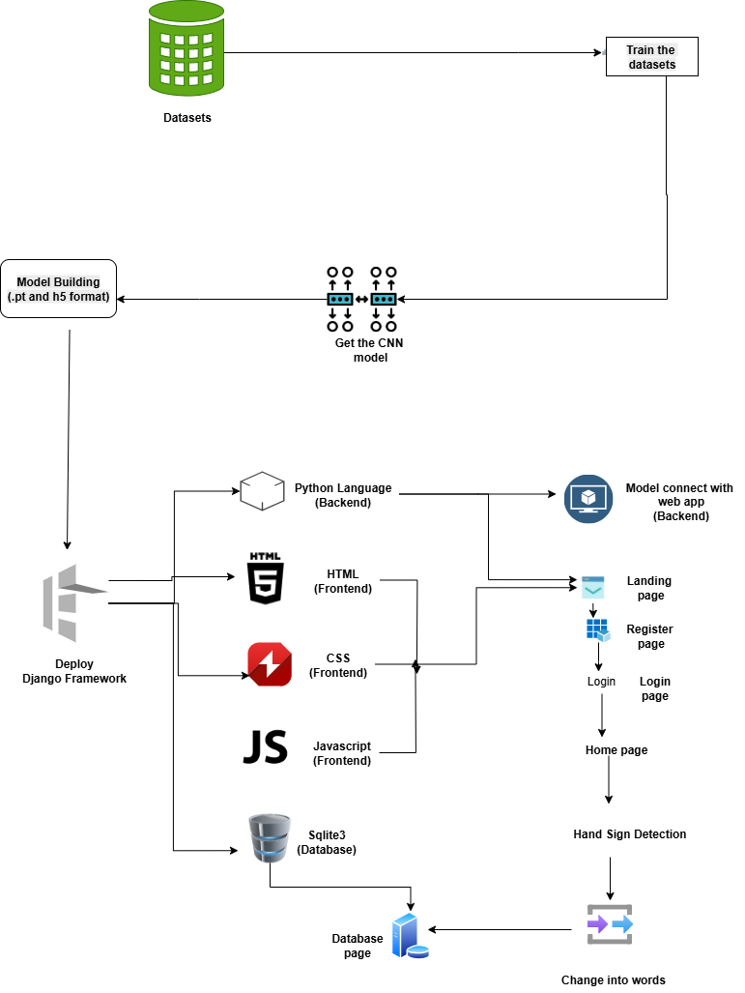

Work flow diagram:
Data Collection

Pre-processing

Training Dataset
Testing Dataset

CNN algorithm
Model

Sign Detection

Workflow Diagram

Use Case Diagram:
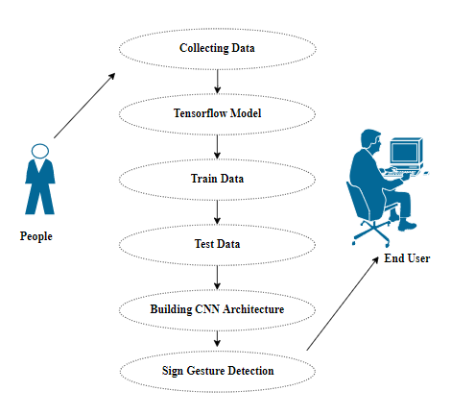

Use case diagrams are considered for high level requirement analysis of a system. So when the requirements of a system are analyzed the functionalities are captured in use cases. So, it can say that uses cases are nothing but the system functionalities written in an organized manner.

CLASS DIAGRAM:
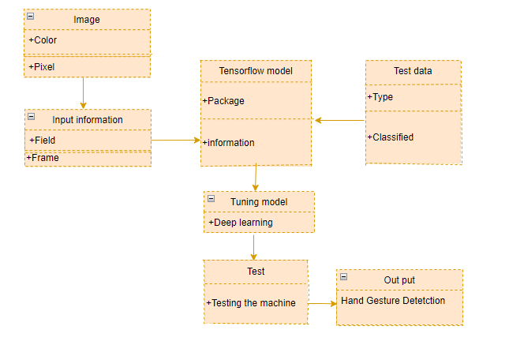

Class diagram is basically a graphical representation of the static view of the system and represents different aspects of the application. So a collection of class diagrams represent the whole system. The name of the class diagram should be meaningful to describe the aspect of the system. Each element and their relationships should be identified in advance Responsibility (attributes and methods) of each class should be clearly identified for each class minimum number of properties should be specified and because, unnecessary properties will make the diagram complicated. Use notes whenever required to describe some aspect of the diagram and at the end of the drawing it should be understandable to the developer/coder. Finally, before making the final version, the diagram should be drawn on plain paper and rework as many times as possible to make it correct.
ACTIVITY DIAGRAM:
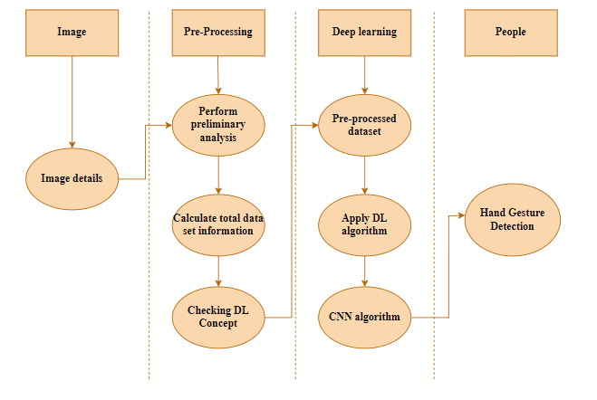

Activity is a particular operation of the system. Activity diagrams are not only used for visualizing dynamic nature of a system but they are also used to construct the executable system by using forward and reverse engineering techniques. The only missing thing in activity diagram is the message part. It does not show any message flow from one activity to another. Activity diagram is some time considered as the flow chart. Although the diagrams looks like a flow chart but it is not. It shows different flow like parallel, branched, concurrent and single.

SEQUENCE DIAGRAM:
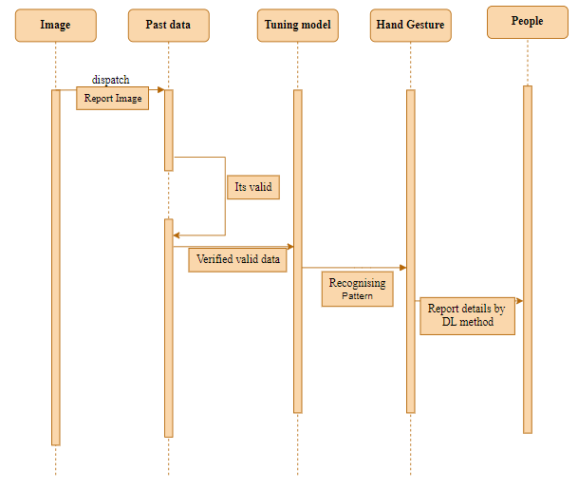

Sequence diagrams model the flow of logic within your system in a visual manner, enabling you both to document and validate your logic, and are commonly used for both analysis and design purposes. Sequence diagrams are the most popular UML artifact for dynamic modelling, which focuses on identifying the behaviour within your system. Other dynamic modelling techniques include activity diagramming, communication diagramming, timing diagramming, and interaction overview diagramming. Sequence diagrams, along with class diagrams and physical data models are in my opinion the most important design-level models for modern business application development.
ER DIAGRAM:
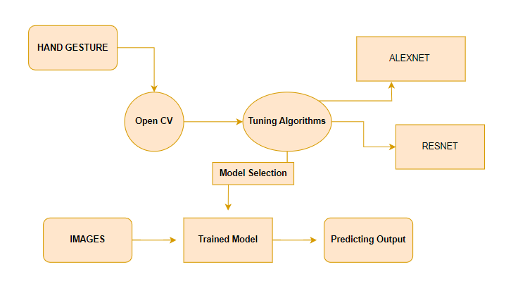

An entity relationship diagram (ERD), also known as an entity relationship model, is a graphical representation of an information system that depicts the relationships among people, objects, places, concepts or events within that system. An ERD is a data modeling technique that can help define business processes and be used as the foundation for a relational database. Entity relationship diagrams provide a visual starting point for database design that can also be used to help determine information system requirements throughout an organization. After a relational database is rolled out, an ERD can still serve as a referral point, should any debugging or business process re-engineering be needed later.

SOFTWARE DESCRIPTION
Anaconda is a free and open-source distribution of the Python and R programming languages for scientific computing (data science, machine learning applications, large-scale data processing, predictive analytics, etc.), that aims to simplify package management and deployment. Package versions are managed by the package management system “Conda”. The Anaconda distribution is used by over 12 million users and includes more than 1400 popular data-science packages suitable for Windows, Linux, and MacOS. So, Anaconda distribution comes with more than 1,400 packages as well as the Conda package and virtual environment manager called Anaconda Navigator and it eliminates the need to learn to install each library independently. The open source packages can be individually installed from the Anaconda repository with the conda install command or using the pip install command that is installed with Anaconda. Pip packages provide many of the features of conda packages and in most cases they can work together. Custom packages can be made using the conda build command, and can be shared with others by uploading them to Anaconda Cloud, PyPI or other repositories. The default installation of Anaconda2 includes Python 2.7 and Anaconda3 includes Python 3.7. However, you can create new environments that include any version of Python packaged with conda.

ANACONDA NAVIGATOR:
Anaconda Navigator is a desktop graphical user interface (GUI) included in Anaconda® distribution that allows you to launch applications and easily manage conda packages, environments, and channels without using command-line commands. Navigator can search for packages on Anaconda.org or in a local Anaconda Repository.
Anaconda. Now, if you are primarily doing data science work, Anaconda is also a great option. Anaconda is created by Continuum Analytics, and it is a Python distribution that comes preinstalled with lots of useful python libraries for data science.
Anaconda is a distribution of the Python and R programming languages for scientific computing (data science, machine learning applications, large-scale data processing, predictive analytics, etc.), that aims to simplify package management and deployment.
In order to run, many scientific packages depend on specific versions of other packages. Data scientists often use multiple versions of many packages and use multiple environments to separate these different versions.
The command-line program conda is both a package manager and an environment manager. This helps data scientists ensure that each version of each package has all the dependencies it requires and works correctly.
Navigator is an easy, point-and-click way to work with packages and environments without needing to type conda commands in a terminal window. You can use it to find the packages you want, install them in an environment, run the packages, and update them – all inside Navigator.

The following applications are available by default in Navigator:
- JupyterLab
- Jupyter Notebook
- Spyder
- PyCharm
- VSCode
- Glueviz
- Orange 3 App
- RStudio
- Anaconda Prompt (Windows only)
- Anaconda PowerShell (Windows only)

Anaconda Navigator is a desktop graphical user interface (GUI) included in Anaconda distribution.
Navigator allows you to launch common Python programs and easily manage conda packages, environments, and channels without using command-line commands. Navigator can search for packages on Anaconda Cloud or in a local Anaconda Repository.
Anaconda comes with many built-in packages that you can easily find with conda list on your anaconda prompt. As it has lots of packages (many of which are rarely used), it requires lots of space and time as well. If you have enough space, time and do not want to burden yourself to install small utilities like JSON, YAML, you better go for Anaconda.

JUPYTER NOTEBOOK:
This website acts as “meta” documentation for the Jupyter ecosystem. It has a collection of resources to navigate the tools and communities in this ecosystem, and to help you get started.
Project Jupyter is a project and community whose goal is to "develop open-source software, open-standards, and services for interactive computing across dozens of programming languages". It was spun off from IPython in 2014 by Fernando Perez.
Notebook documents are documents produced by the Jupyter Notebook App, which contain both computer code (e.g. python) and rich text elements (paragraph, equations, figures, links, etc…). Notebook documents are both human-readable documents containing the analysis description and the results (figures, tables, etc.) as well as executable documents which can be run to perform data analysis.

Installation: The easiest way to install the Jupyter Notebook App is installing a scientific python distribution which also includes scientific python packages. The most common distribution is called Anaconda

Running the Jupyter Notebook

Launching Jupyter Notebook App: The Jupyter Notebook App can be launched by clicking on the Jupyter Notebook icon installed by Anaconda in the start menu (Windows) or by typing in a terminal (cmd on Windows): “jupyter notebook”

This will launch a new browser window (or a new tab) showing the Notebook Dashboard, a sort of control panel that allows (among other things) to select which notebook to open.

When started, the Jupyter Notebook App can access only files within its start-up folder (including any sub-folder). No configuration is necessary if you place your notebooks in your home folder or subfolders. Otherwise, you need to choose a Jupyter Notebook App start-up folder which will contain all the notebooks.

Save notebooks: Modifications to the notebooks are automatically saved every few minutes. To avoid modifying the original notebook, make a copy of the notebook document (menu file -> make a copy…) and save the modifications on the copy.

Executing a notebook: Download the notebook you want to execute and put it in your notebook folder (or a sub-folder of it).
- Launch the jupyter notebook app
- In the Notebook Dashboard navigate to find the notebook: clicking on its name will open it in a new browser tab.
- Click on the menu Help -> User Interface Tour for an overview of the Jupyter Notebook App user interface.
- You can run the notebook document step-by-step (one cell a time) by pressing shift + enter.
- You can run the whole notebook in a single step by clicking on the menu Cell -> Run All.
- To restart the kernel (i.e. the computational engine), click on the menu Kernel -> Restart. This can be useful to start over a computation from scratch (e.g. variables are deleted, open files are closed, etc…).

Purpose: To support interactive data science and scientific computing across all programming languages.

File Extension: An IPYNB file is a notebook document created by Jupyter Notebook, an interactive computational environment that helps scientists manipulate and analyze data using Python.

JUPYTER Notebook App: The Jupyter Notebook App is a server-client application that allows editing and running notebook documents via a web browser. The Jupyter Notebook App can be executed on a local desktop requiring no internet access (as described in this document) or can be installed on a remote server and accessed through the internet.
In addition to displaying/editing/running notebook documents, the Jupyter Notebook App has a “Dashboard” (Notebook Dashboard), a “control panel” showing local files and allowing to open notebook documents or shutting down their kernels.

kernel: A notebook kernel is a “computational engine” that executes the code contained in a Notebook document. The ipython kernel, referenced in this guide, executes python code. Kernels for many other languages exist (official kernels).
When you open a Notebook document, the associated kernel is automatically launched. When the notebook is executed (either cell-by-cell or with menu Cell -> Run All), the kernel performs the computation and produces the results. Depending on the type of computations, the kernel may consume significant CPU and RAM. Note that the RAM is not released until the kernel is shut-down

Notebook Dashboard: The Notebook Dashboard is the component which is shown first when you launch Jupyter Notebook App. The Notebook Dashboard is mainly used to open notebook documents, and to manage the running kernels (visualize and shutdown).
The Notebook Dashboard has other features similar to a file manager, namely navigating folders and renaming/deleting files

Working Process:
- Download and install anaconda and get the most useful package for machine learning in Python.
- Load a dataset and understand its structure using statistical summaries and data visualization.
- Machine learning models, pick the best and build confidence that the accuracy is reliable.

Python is a popular and powerful interpreted language. Unlike R, Python is a complete language and platform that you can use for both research and development and developing production systems. There are also a lot of modules and libraries to choose from, providing multiple ways to do each task. It can feel overwhelming.

The best way to get started using Python for machine learning is to complete a project.
- It will force you to install and start the Python interpreter (at the very least).
- It will give you a bird’s eye view of how to step through a small project.
- It will give you confidence, maybe to go on to your own small projects.

When you are applying machine learning to your own datasets, you are working on a project. A machine learning project may not be linear, but it has a number of well-known steps:
- Define Problem.
- Prepare Data.
- Evaluate Algorithms.
- Improve Results.
- Present Results.

The best way to really come to terms with a new platform or tool is to work through a machine learning project end-to-end and cover the key steps. Namely, from loading data, summarizing data, evaluating algorithms and making some predictions.
Here is an overview of what we are going to cover:
- Installing the Python anaconda platform.
- Loading the dataset.
- Summarizing the dataset.
- Visualizing the dataset.
- Evaluating some algorithms.
- Making some predictions.

PYTHON
Introduction:
Python is an interpreted high-level general-purpose programming language. Its design philosophy emphasizes code readability with its use of significant indentation. Its language constructs as well as its object-oriented approach aim to help programmers write clear, logical code for small and large-scale projects.
Python is dynamically-typed and garbage-collected. It supports multiple programming paradigms, including structured (particularly, procedural), object-oriented and functional programming. It is often described as a "batteries included" language due to its comprehensive standard library.
Guido van Rossum began working on Python in the late 1980s, as a successor to the ABC programming language, and first released it in 1991 as Python 0.9.0. Python 2.0 was released in 2000 and introduced new features, such as list comprehensions and a garbage collection system using reference counting. Python 3.0 was released in 2008 and was a major revision of the language that is not completely backward-compatible. Python 2 was discontinued with version 2.7.18 in 2020.
Python consistently ranks as one of the most popular programming languages

History:
Python was conceived in the late 1980s by Guido van Rossum at Centrum Wiskunde & Informatica (CWI) in the Netherlands as a successor to ABC programming language, which was inspired by SETL, capable of exception handling and interfacing with the Amoeba operating system. Its implementation began in December 1989. Van Rossum shouldered sole responsibility for the project, as the lead developer, until 12 July 2018, when he announced his "permanent vacation" from his responsibilities as Python's Benevolent Dictator For Life, a title the Python community bestowed upon him to reflect his long-term commitment as the project's chief decision-maker. In January 2019, active Python core developers elected a 5-member "Steering Council" to lead the project. As of 2021, the current members of this council are Barry Warsaw, Brett Cannon, Carol Willing, Thomas Wouters, and Pablo Galindo Salgado.
Python 2.0 was released on 16 October 2000, with many major new features, including a cycle-detecting garbage collector and support for Unicode.
Python 3.0 was released on 3 December 2008. It was a major revision of the language that is not completely backward-compatible. Many of its major features were backported to Python 2.6.x and 2.7.x version series. Releases of Python 3 include the 2 to 3 utility, which automates (at least partially) the translation of Python 2 code to Python 3.
Python 2.7's end-of-life date was initially set at 2015 then postponed to 2020 out of concern that a large body of existing code could not easily be forward-ported to Python 3. No more security patches or other improvements will be released for it. With Python 2's end-of-life, only Python 3.6.x and later are supported.
Python 3.9.2 and 3.8.8 were expeditedas all versions of Python (including 2.7) had security issues, leading to possible remote code execution and web cache poisoning.
Design Philosophy & Feature
Python is a multi-paradigm programming language. Object-oriented programming and structured programming are fully supported, and many of its features support functional programming and aspect-oriented programming (including by meta-programming and meta-objects (magic methods)). Many other paradigms are supported via extensions, including design by contract and logic programming.
Python uses dynamic typing and a combination of reference counting and a cycle-detecting garbage collector for memory management. It also features dynamic name resolution (late binding), which binds method and variable names during program execution.
Python's design offers some support for functional programming in the Lisp tradition. It has filter, map and reduce functions; list comprehensions, dictionaries, sets, and generator expressions. The standard library has two modules (itertools and functools) that implement functional tools borrowed from Haskell and Standard ML.
The language's core philosophy is summarized in the document The Zen of Python (PEP 20), which includes aphorisms such as:
- Beautiful is better than ugly.
- Explicit is better than implicit.
- Simple is better than complex.
- Complex is better than complicated.
- Readability counts.

Rather than having all of its functionality built into its core, Python was designed to be highly extensible (with modules). This compact modularity has made it particularly popular as a means of adding programmable interfaces to existing applications. Van Rossum's vision of a small core language with a large standard library and easily extensible interpreter stemmed from his frustrations with ABC, which espoused the opposite approach.
Python strives for a simpler, less-cluttered syntax and grammar while giving developers a choice in their coding methodology. In contrast to Perl's "there is more than one way to do it" motto, Python embraces a "there should be one— and preferably only one —obvious way to do it" design philosophy. Alex Martelli, a Fellow at the Python Software Foundation and Python book author, writes that "To describe something as 'clever' is not considered a compliment in the Python culture."
Python's developers strive to avoid premature optimization, and reject patches to non-critical parts of the C-Python reference implementation that would offer marginal increases in speed at the cost of clarity. When speed is important, a Python programmer can move time-critical functions to extension modules written in languages such as C, or use PyPy, a just-in-time compiler. Cython is also available, which translates a Python script into C and makes direct C-level API calls into the Python interpreter.
Python's developers aim to keep the language fun to use. This is reflected in its name a tribute to the British comedy group Monty Python and in occasionally playful approaches to tutorials and reference materials, such as examples that refer to spam and eggs (a reference to a Monty Python sketch) instead of the standard foo and bar.
A common neologism in the Python community is pythonic, which can have a wide range of meanings related to program style. To say that code is pythonic is to say that it uses Python idioms well, that it is natural or shows fluency in the language, that it conforms with Python's minimalist philosophy and emphasis on readability. In contrast, code that is difficult to understand or reads like a rough transcription from another programming language is called unpythonic.
Users and admirers of Python, especially those considered knowledgeable or experienced, are often referred to as Pythonistas

Syntax and Semantics :
Python is meant to be an easily readable language. Its formatting is visually uncluttered, and it often uses English keywords where other languages use punctuation. Unlike many other languages, it does not use curly brackets to delimit blocks, and semicolons after statements are allowed but are rarely, if ever, used. It has fewer syntactic exceptions and special cases than C or Pascal.

Indentation :

Main article: Python syntax and semantics & Indentation
Python uses whitespace indentation, rather than curly brackets or keywords, to delimit blocks. An increase in indentation comes after certain statements; a decrease in indentation signifies the end of the current block. Thus, the program's visual structure accurately represents the program's semantic structure. This feature is sometimes termed the off-side rule, which some other languages share, but in most languages indentation does not have any semantic meaning. The recommended indent size is four spaces.

Statements and control flow :
Python's statements include:
- The assignment statement, using a single equals sign =.
- The if statement, which conditionally executes a block of code, along with else and elif (a contraction of else-if).
- The for statement, which iterates over an iterable object, capturing each element to a local variable for use by the attached block.
- The while statement, which executes a block of code as long as its condition is true.
- The Try statement, which allows exceptions raised in its attached code block to be caught and handled by except clauses; it also ensures that clean-up code in a finally block will always be run regardless of how the block exits.
- The raise statement, used to raise a specified exception or re-raise a caught exception.
- The class statement, which executes a block of code and attaches its local namespace to a class, for use in object-oriented programming.
- The def statement, which defines a function or method.
- The with statement, which encloses a code block within a context manager (for example, acquiring a lock before the block of code is run and releasing the lock afterwards, or opening a file and then closing it), allowing resource-acquisition-is-initialization (RAII) - like behavior and replaces a common try/finally idiom.
- The break statement, exits from a loop.
- The continue statement, skips this iteration and continues with the next item.
- The del statement, removes a variable, which means the reference from the name to the value is deleted and trying to use that variable will cause an error. A deleted variable can be reassigned.
- The pass statement, which serves as a NOP. It is syntactically needed to create an empty code block.
- The assert statement, used during debugging to check for conditions that should apply.
- The yield statement, which returns a value from a generator function and yield is also an operator. This form is used to implement co-routines.
- The return statement, used to return a value from a function.
- The import statement, which is used to import modules whose functions or variables can be used in the current program.

The assignment statement (=) operates by binding a name as a reference to a separate, dynamically-allocated object. Variables may be subsequently rebound at any time to any object. In Python, a variable name is a generic reference holder and does not have a fixed data type associated with it. However, at a given time, a variable will refer to some object, which will have a type. This is referred to as dynamic typing and is contrasted with statically-typed programming languages, where each variable may only contain values of a certain type.
Python does not support tail call optimization or first-class continuations, and, according to Guido van Rossum, it never will.^{[80][81]} However, better support for co-routine-like functionality is provided, by extending Python's generators. Before 2.5, generators were lazy iterators; information was passed uni-directionally out of the generator. From Python 2.5, it is possible to pass information back into a generator function, and from Python 3.3, the information can be passed through multiple stack levels.

Expressions :
Some Python expressions are similar to those found in languages such as C and Java, while some are not:
- Addition, subtraction, and multiplication are the same, but the behavior of division differs. There are two types of divisions in Python. They are floor division (or integer division) // and floating-point/division. Python also uses the ** operator for exponentiation.
- From Python 3.5, the new @ infix operator was introduced. It is intended to be used by libraries such as NumPy for matrix multiplication.
- From Python 3.8, the syntax :=, called the 'walrus operator' was introduced. It assigns values to variables as part of a larger expression.
- In Python, == compares by value, versus Java, which compares numerics by value and objects by reference. (Value comparisons in Java on objects can be performed with the equals() method.) Python's is operator may be used to compare object identities (comparison by reference). In Python, comparisons may be chained, for example A<=B<=C.
- Python uses the words and, or, not for or its boolean operators rather than the symbolic &&, ||, ! used in Java and C.
- Python has a type of expression termed a list comprehension as well as a more general expression termed a generator expression.
- Anonymous functions are implemented using lambda expressions; however, these are limited in that the body can only be one expression.
- Conditional expressions in Python are written as x if c else y (different in order of operands from the c ? x : y operator common to many other languages).
- Python makes a distinction between lists and tuples. Lists are written as [1, 2, 3], are mutable, and cannot be used as the keys of dictionaries (dictionary keys must be immutable in Python). Tuples are written as (1, 2, 3), are immutable and thus can be used as the keys of dictionaries, provided all elements of the tuple are immutable. The + operator can be used to concatenate two tuples, which does not directly modify their contents, but rather produces a new tuple containing the elements of both provided tuples. Thus, given the variable t initially equal to (1, 2, 3), executing t = t + (4, 5) first evaluates t + (4, 5), which yields (1, 2, 3, 4, 5), which is then assigned back to t, thereby effectively "modifying the contents" of t, while conforming to the immutable nature of tuple objects. Parentheses are optional for tuples in unambiguous contexts.
- Python features sequence unpacking wherein multiple expressions, each evaluating to anything that can be assigned to (a variable, a writable property, etc.), are associated in an identical manner to that forming tuple literals and, as a whole, are put on the left-hand side of the equal sign in an assignment statement. The statement expects an iterable object on the right-hand side of the equal sign that produces the same number of values as the provided writable expressions when iterated through and will iterate through it, assigning each of the produced values to the corresponding expression on the left.
- Python has a "string format" operator %. This functions analogously ton printf format strings in C, e.g. “spam=%s eggs=%d” % (“blah”,2) evaluates to “spam=blah eggs=2”. In Python 3 and 2.6+, this was supplemented by the format() method of the str class, e.g. “spam={0} eggs={1}”.format(“blah”,2). Python 3.6 added "f-strings": blah = “blah”; eggs = 2; f‘spam={blah} eggs={eggs}’
- Strings in Python can be concatenated, by "adding" them (same operator as for adding integers and floats). E.g. “spam” + “eggs”returns “spameggs”. Even if your strings contain numbers, they are still added as strings rather than integers. E.g. “2” + “2” returns “2”.

- Python has various kinds of string literals:
  - Strings delimited by single or double quote marks. Unlike in Unix shells, Perl and Perl-influenced languages, single quote marks and double quote marks function identically. Both kinds of string use the backslash (\) as an escape character. String interpolation became available in Python 3.6 as "formatted string literals".
  - Triple-quoted strings, which begin and end with a series of three single or double quote marks. They may span multiple lines and function like here documents in shells, Perl and Ruby.
  - Raw string varieties, denoted by prefixing the string literal with an r. Escape sequences are not interpreted; hence raw strings are useful where literal backslashes are common, such as regular expressions and Windows-style paths. Compare "@-quoting" in C#.

- Python has array index and array slicing expressions on lists, denoted as a[Key], a[start:stop] or a[start:stop:step]. Indexes are zero-based, and negative indexes are relative to the end. Slices take elements from the start index up to, but not including, the stop index. The third slice parameter, called step or stride, allows elements to be skipped and reversed. Slice indexes may be omitted, for example a[:] returns a copy of the entire list. Each element of a slice is a shallow copy.

In Python, a distinction between expressions and statements is rigidly enforced, in contrast to languages such as Common Lisp, Scheme, or Ruby. This leads to duplicating some functionality. For example:
- List comprehensions vs. for-loops
- Conditional expressions vs. if blocks
- The eval() vs. exec() built-in functions (in Python 2, exec is a statement); the former is for expressions, the latter is for statements.

Statements cannot be a part of an expression, so list and other comprehensions or lambda expressions, all being expressions, cannot contain statements. A particular case of this is that an assignment statement such as a=1 cannot form part of the conditional expression of a conditional statement. This has the advantage of avoiding a classic C error of mistaking an assignment operator = for an equality operator == in conditions: if (c==1) {…} is syntactically valid (but probably unintended) C code but if c=1: … causes a syntax error in Python.

Methods :
Methods on objects are functions attached to the object's class; the syntax instance.method(argument) is, for normal methods and functions, syntactic sugar for Class.method(instance, argument). Python methods have an explicit self parameter access instance data, in contrast to the implicit self (or this) in some other object-oriented programming languages (e.g., C++, Java, Objective-C, or Ruby). Apart from this Python also provides methods, sometimes called d-under methods due to their names beginning and ending with double-underscores, to extend the functionality of custom class to support native functions such as print, length, comparison, support for arithmetic operations, type conversion, and many more.

Typing :
Python uses duck typing and has typed objects but untyped variable names. Type constraints are not checked at compile time; rather, operations on an object may fail, signifying that the given object is not of a suitable type. Despite being dynamically-typed, Python is strongly-typed, forbidding operations that are not well-defined (for example, adding a number to a string) rather than silently attempting to make sense of them.
Python allows programmers to define their own types using classes, which are most often used for object-oriented programming. New instances of classes are constructed by calling the class (for example, SpamClass() or EggsClass()), and the classes are instances of the metaclass type (itself an instance of itself), allowing meta-programming and reflection.
Before version 3.0, Python had two kinds of classes: old-style and new-style.The syntax of both styles is the same, the difference being whether the class object is inherited from, directly or indirectly (all new-style classes inherit from object and are instances of type). In versions of Python 2 from Python 2.2 onwards, both kinds of classes can be used. Old-style classes were eliminated in Python 3.0.
The long-term plan is to support gradual typing and from Python 3.5, the syntax of the language allows specifying static types but they are not checked in the default implementation, CPython. An experimental optional static type checker named mypy supports compile-time type checking.

LIST OF MODULES
1. Manual Net
2. Google Net
3. Mobile Net.
4. Deployment

MODULE DESCRIPTION
1. Data Preparation:
The dataset collection is the very important part of our project. The collection of the dataset is based on the hand posture. Using open CV we can access the live videos. With the help of open CV we record the videos frame by frame. First we record the videos one by one. And save the hand position data as a image in a folder. We repeat this process for the Signs which are needed for us.

Module Diagram:
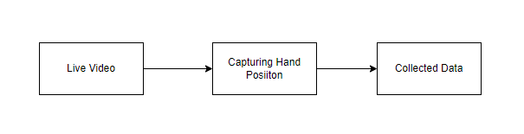
Input : Video capture
Output : Data Collection

2. GOOGLE NET:
"GoogleNet," also known as "Inception-v1," is a deep learning architecture for image classification. It was developed by a team of researchers at Google, led by Christian Szegedy, and was the winner of the ImageNet Large Scale Visual Recognition Challenge (ILSVRC) in 2014.
The main innovation in the GoogleNet architecture is the use of the "Inception module," which incorporates multiple parallel convolutional operations of different filter sizes to capture features at various scales. This allows the network to learn both fine-grained and high-level abstract features efficiently.
Key features of the GoogleNet architecture:
Inception Module: The Inception module consists of a combination of 1x1, 3x3, and 5x5 convolutional filters, along with max-pooling operations. The idea behind this module is to allow the network to learn features at different spatial scales and capture both local and global patterns effectively. Additionally, 1x1 convolutions are used to reduce the dimensionality of the input channels, which helps in reducing computational complexity.
Multiple Stacked Inception Modules: GoogleNet consists of multiple stacked Inception modules to create a deep network. These modules are designed to capture increasingly complex patterns as the network goes deeper. The inclusion of multiple Inception modules also allows the network to be computationally efficient, as it can utilize different filter sizes simultaneously.
Auxiliary Classifiers: GoogleNet includes auxiliary classifiers at intermediate layers of the network. These auxiliary classifiers serve as "side branches" and are used to combat the vanishing gradient problem during training. They add extra supervision to the network and help in better gradient flow during backpropagation.
Global Average Pooling: Instead of using fully connected layers at the end of the network, GoogleNet employs global average pooling. This operation computes the average value for each feature map in the last convolutional layer, resulting in a single vector that is used as input to the final softmax layer for classification. Global average pooling reduces the number of parameters and helps prevent overfitting.
GoogleNet was one of the early deep learning architectures to demonstrate the effectiveness of deep networks in image classification tasks. It achieved top accuracy in the ILSVRC 2014 competition while being more computationally efficient compared to other models available at the time. Since its introduction, several improved versions of the Inception architecture, such as Inception-v2, Inception-v3, and Inception-v4, have been developed by the research community.

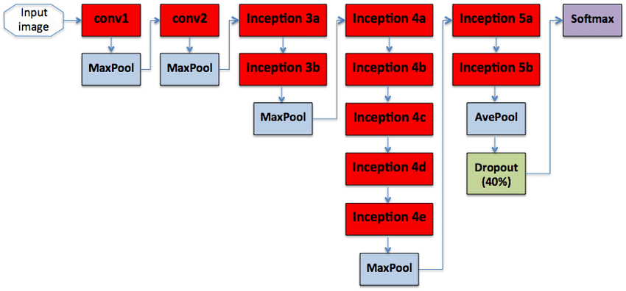
MOBILENET:

MobileNet is a family of deep learning architectures designed for efficient on-device image classification and computer vision tasks. It was developed by Andrew G. Howard, Menglong Zhu, Bo Chen, Dmitry Kalenichenko, Weijun Wang, Tobias Weyand, Marco Andreetto, and Hartwig Adam from Google in 2017.
The key motivation behind MobileNet is to create neural network architectures that are computationally lightweight, allowing them to run efficiently on mobile devices with limited resources (e.g., smartphones) and embedded systems. The focus is on achieving a good trade-off between model accuracy and model size or computational complexity.
MobileNet achieves this efficiency through the use of two main techniques:
Depthwise Separable Convolutions: Similar to the Xception architecture, MobileNet utilizes depthwise separable convolutions. This factorizes a standard convolution into two separate operations: depthwise convolution and pointwise convolution.
Depthwise Convolution: In this step, each channel of the input feature map is convolved with its own set of filters independently, just like in Xception. This reduces the computational cost significantly as it requires fewer operations compared to a standard convolution.
Pointwise Convolution: Following the depthwise convolution, a 1x1 pointwise convolution is applied to combine the output channels from the depthwise convolution. This helps capture cross-channel interactions and create the final output feature map.
Width Multiplier: MobileNet introduces a hyperparameter called the "width multiplier" (usually denoted by the Greek letter "α"). The width multiplier scales the number of channels in each layer of the network. By reducing the number of channels in each layer, the model becomes more compact and computationally efficient. The width multiplier allows for easy control over the model's size and computational cost, trading off accuracy for efficiency.
MobileNet comes in different versions, denoted as MobileNetV1, MobileNetV2, and MobileNetV3, each introducing improvements over the previous version. MobileNetV2, for example, introduced inverted residual blocks and linear bottlenecks to improve performance. MobileNetV3 further optimized the architecture with the use of h-swish activation and other refinements.
MobileNet has been widely adopted in various applications, such as real-time image classification on mobile devices, object detection, and semantic segmentation. Its efficiency and effectiveness have made it a popular choice for deploying deep learning models on resource-constrained devices and platforms.

Convolutional layers:
Convolutional layers are the layers where filters are applied to the original image, or to other feature maps in a deep CNN. This is where most of the user-specified parameters are in the network. The most important parameters are the number of kernels and the size of the kernels.
Pooling layers:
Pooling layers are similar to convolutional layers, but they perform a specific function such as max pooling, which takes the maximum value in a certain filter region, or average pooling, which takes the average value in a filter region. These are typically used to reduce the dimensionality of the network.
Dense or Fully connected layers:
Fully connected layers are placed before the classification output of a CNN and are used to flatten the results before classification. This is similar to the output layer of an MLP.

Softmax / Logistic Layer:
Softmax or Logistic layer is the last layer of CNN. It resides at the end of FC layer. Logistic is used for binary classification and softmax is for multi-classification.

Output Layer:
Output layer contains the label which is in the form of one-hot encoded. Now you have a good understanding of CNN.

Module Diagram:
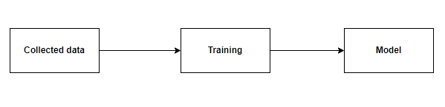
Input : Data
Output : Trained Model

Deployment:
Deploying the model in Django Framework and predicting output
In this module the trained deep learning model is converted into hierarchical data format file (.h5 file) which is then deployed in our django framework for providing better user interface and predicting the output.

Django:
Django is a high-level Python web framework that enables rapid development of secure and maintainable websites. Built by experienced developers, Django takes care of much of the hassle of web development, so you can focus on writing your app without needing to reinvent the wheel. It is free and open source, has a thriving and active community, great documentation, and many options for free and paid-for support.
Django helps you write software that is:

Scalable:
Django uses a component-based “shared-nothing” architecture (each part of the architecture is independent of the others, and can hence be replaced or changed if needed). Having a clear separation between the different parts means that it can scale for increased traffic by adding hardware at any level: caching servers, database servers, or application servers. Some of the busiest sites have successfully scaled Django to meet their demands (e.g. Instagram and Disqus, to name just two).

Maintainable:
Django code is written using design principles and patterns that encourage the creation of maintainable and reusable code. In particular, it makes use of the Don't Repeat Yourself (DRY) principle so there is no unnecessary duplication, reducing the amount of code. Django also promotes the grouping of related functionality into reusable "applications" and, at a lower level, groups related code into modules (along the lines of the Model View Controller (MVC) pattern).

Portable:
Django is written in Python, which runs on many platforms. That means that you are not tied to any particular server platform, and can run your applications on many flavours of Linux, Windows, and Mac OS X. Furthermore, Django is well-supported by many web hosting providers, who often provide specific infrastructure and documentation for hosting Django sites.
Code:
Bgng
from django.shortcuts import render, redirect
from django.urls import reverse_lazy
from django.contrib.auth.views import LoginView, PasswordResetView, PasswordChangeView
from django.contrib import messages
from django.contrib.messages.views import SuccessMessageMixin
from django.views import View
from django.contrib.auth.decorators import login_required
from django.contrib.auth import logout as auth_logout
import numpy as np
import joblib
from .forms import RegisterForm, LoginForm, UpdateUserForm, UpdateProfileForm

def home(request):
return render(request, 'users/home.html')

@login_required(login_url='users-register')

def index(request):
return render(request, 'app/index.html')

class RegisterView(View):
form_class = RegisterForm
initial = {'key': 'value'}
template_name = 'users/register.html'

def dispatch(self, request, *args, **kwargs):
# will redirect to the home page if a user tries to access the register page while logged in
if request.user.is_authenticated:
return redirect(to='/')

# else process dispatch as it otherwise normally would
return super(RegisterView, self).dispatch(request, *args, **kwargs)

def get(self, request, *args, **kwargs):
form = self.form_class(initial=self.initial)
return render(request, self.template_name, {'form': form})

def post(self, request, *args, **kwargs):
form = self.form_class(request.POST)

if form.is_valid():
form.save()

username = form.cleaned_data.get('username')
messages.success(request, f'Account created for {username}')

return redirect(to='login')

return render(request, self.template_name, {'form': form})

# Class based view that extends from the built in login view to add a remember me functionality

class CustomLoginView(LoginView):
form_class = LoginForm

def form_valid(self, form):
remember_me = form.cleaned_data.get('remember_me')

if not remember_me:
# set session expiry to 0 seconds. So it will automatically close the session after the browser is closed.
self.request.session.set_expiry(0)

# Set session as modified to force data updates/cookie to be saved.
self.request.session.modified = True

# else browser session will be as long as the session cookie time "SESSION_COOKIE_AGE" defined in settings.py
return super(CustomLoginView, self).form_valid(form)

class ResetPasswordView(SuccessMessageMixin, PasswordResetView):
template_name = 'users/password_reset.html'
email_template_name = 'users/password_reset_email.html'
subject_template_name = 'users/password_reset_subject'
success_message = "We've emailed you instructions for setting your password, " \
"if an account exists with the email you entered. You should receive them shortly." \
" If you don't receive an email, " \
"please make sure you've entered the address you registered with, and check your spam folder."
success_url = reverse_lazy('users-home')

class ChangePasswordView(SuccessMessageMixin, PasswordChangeView):
template_name = 'users/change_password.html'
success_message = "Successfully Changed Your Password"
success_url = reverse_lazy('users-home')

@login_required
def profile(request):
if request.method == 'POST':
user_form = UpdateUserForm(request.POST, instance=request.user)
profile_form = UpdateProfileForm(request.POST, request.FILES, instance=request.user.profile)

if user_form.is_valid() and profile_form.is_valid():
user_form.save()
profile_form.save()
messages.success(request, 'Your profile is updated successfully')
return redirect(to='users-profile')
else:
user_form = UpdateUserForm(instance=request.user)
profile_form = UpdateProfileForm(instance=request.user.profile)

return render(request, 'users/profile.html', {'user_form': user_form, 'profile_form': profile_form})

from django.shortcuts import render, redirect
from django.contrib import messages
import os
import cv2
import pickle
import mediapipe as mp
import numpy as np
from sklearn.ensemble import RandomForestClassifier
from sklearn.model_selection import train_test_split
from sklearn.metrics import accuracy_score, confusion_matrix, classification_report

# -------------------------------------------------------
# 1) COLLECT IMAGES USING MEDIAPIPE (WEBCAM)
# -------------------------------------------------------
def collectimages(request):
if request.method == 'POST':

DATA_DIR = 'users/data'
os.makedirs(DATA_DIR, exist_ok=True)

characters = ['A', 'B', 'C', 'D', 'E']
dataset_size = 200

mp_hands = mp.solutions.hands
hands = mp_hands.Hands(
static_image_mode=False,
max_num_hands=1,
model_complexity=1,
min_detection_confidence=0.6,
min_tracking_confidence=0.6
)

mp_draw = mp.solutions.drawing_utils
cap = cv2.VideoCapture(0)

for j, current_character in enumerate(characters):
class_dir = os.path.join(DATA_DIR, str(j))
os.makedirs(class_dir, exist_ok=True)

print(f"\nShow character {current_character} — Press S to start")

# WAIT FOR S KEY
while True:
ret, frame = cap.read()
if not ret:
break

cv2.putText(frame, f"Show {current_character} — Press S",
(50, 50), cv2.FONT_HERSHEY_SIMPLEX,
1, (0, 255, 0), 2)

cv2.imshow("frame", frame)

if cv2.waitKey(20) & 0xFF == ord('s'):
break

counter = 0

# START COLLECTION
while counter < dataset_size:
ret, frame = cap.read()
if not ret:
break

frame_rgb = cv2.cvtColor(frame, cv2.COLOR_BGR2RGB)
results = hands.process(frame_rgb)

if results.multi_hand_landmarks:

# Draw only for visualization
for hand_lm in results.multi_hand_landmarks:
mp_draw.draw_landmarks(frame, hand_lm, mp_hands.HAND_CONNECTIONS)

# SAVE CLEAN IMAGE (pure BGR without drawings)
clean_frame = cv2.cvtColor(frame_rgb, cv2.COLOR_RGB2BGR)
file_path = os.path.join(class_dir, f"{counter}.jpg")
cv2.imwrite(file_path, clean_frame)

counter += 1

cv2.putText(frame, f"Saved {counter}/{dataset_size}",
(30, 70), cv2.FONT_HERSHEY_SIMPLEX,
1, (0, 255, 0), 2)

else:
cv2.putText(frame, "HAND NOT DETECTED",
(30, 70), cv2.FONT_HERSHEY_SIMPLEX,
1, (0, 0, 255), 2)

cv2.imshow("frame", frame)

if cv2.waitKey(1) & 0xFF == ord('q'):
break

cap.release()
cv2.destroyAllWindows()

messages.success(request, "Images collected successfully!")
return redirect('collectimages')

return render(request, 'app/collectimages.html')

# -------------------------------------------------------
# 2) CREATE DATASET USING MEDIAPIPE HAND LANDMARKS
# -------------------------------------------------------
def createdatasetmodel(request):
if request.method == 'POST':

mp_hands = mp.solutions.hands
hands = mp_hands.Hands(
static_image_mode=True,
max_num_hands=1,
min_detection_confidence=0.4
)

DATA_DIR = 'users/data'
data, labels = [], []

for class_id in os.listdir(DATA_DIR):
class_dir = os.path.join(DATA_DIR, class_id)
if not os.path.isdir(class_dir):
continue

for img_name in os.listdir(class_dir):
img_path = os.path.join(class_dir, img_name)
img = cv2.imread(img_path)
if img is None:
continue

img_rgb = cv2.cvtColor(img, cv2.COLOR_BGR2RGB)
results = hands.process(img_rgb)

if not results.multi_hand_landmarks:
print("Skipping bad image:", img_name)
continue

hand = results.multi_hand_landmarks[0]
x_vals = [lm.x for lm in hand.landmark]
y_vals = [lm.y for lm in hand.landmark]

sample = []
for lm in hand.landmark:
sample.append(lm.x - min(x_vals))
sample.append(lm.y - min(y_vals))

data.append(sample)
labels.append(class_id)

if len(data) == 0:
messages.error(request, "ERROR: No valid hand images! Please recollect images.")
return redirect('collectimages')

with open('users/data.pickle', 'wb') as f:
pickle.dump({'data': data, 'labels': labels}, f)

messages.success(request, "Dataset created successfully!")
return redirect('createdatasetmodel')

return render(request, 'app/collectimages.html')

# -------------------------------------------------------
# 3) TRAIN RANDOM FOREST MODEL
# -------------------------------------------------------
def trainmodel(request):
if request.method == 'POST':
try:
with open('users/data.pickle', 'rb') as f:
data_dict = pickle.load(f)
except:
messages.error(request, "Dataset not found! Create dataset first.")
return redirect('createdatasetmodel')

data = data_dict['data']
labels = data_dict['labels']

# FIX VECTOR LENGTH
max_len = max(len(x) for x in data)
data_fixed = [x + [0] * (max_len - len(x)) for x in data]

data = np.array(data_fixed)
labels = np.array(labels)

# SPLIT DATA
x_train, x_test, y_train, y_test = train_test_split(
data, labels, test_size=0.2, shuffle=True)

# TRAIN MODEL
model = RandomForestClassifier(n_estimators=100)
model.fit(x_train, y_train)

y_pred = model.predict(x_test)

print("Accuracy:", accuracy_score(y_test, y_pred))
print("Confusion Matrix:", confusion_matrix(y_test, y_pred))
print("Report:", classification_report(y_test, y_pred))

# SAVE MODEL
with open('users/model.p', 'wb') as f:
pickle.dump({'model': model}, f)

messages.success(request, "Model trained successfully!")
return redirect('trainmodel')

return render(request, 'app/collectimages.html')

import pickle
import cv2
import mediapipe as mp
import numpy as np
import tkinter as tk
from collections import Counter
import time
from googletrans import Translator
from spellchecker import SpellChecker
import threading
import pyttsx3
recognized_word = ""
last_symbol_time = time.time()
letter_buffer = []
running = False # Camera running flag
def detect(request):
if request.method == 'POST':

# Load model
model_dict = pickle.load(open(r'users/model.p', 'rb'))
model = model_dict['model']

# Mediapipe hands module
mp_hands = mp.solutions.hands
mp_drawing = mp.solutions.drawing_utils
mp_drawing_styles = mp.solutions.drawing_styles
hands = mp_hands.Hands(static_image_mode=True, min_detection_confidence=0.3)

# Labels
labels_dict = {i: chr(65 + i) for i in range(26)}
labels_dict[26] = 'Thank You'
labels_dict[27] = ''

# Extended language list
languages = {
'English': 'en', 'French': 'fr', 'Spanish': 'es', 'German': 'de', 'Hindi': 'hi', 'Telugu': 'te',
'Tamil': 'ta', 'Kannada': 'kn', 'Malayalam': 'ml', 'Italian': 'it', 'Russian': 'ru',
'Chinese (Simplified)': 'zh-cn', 'Japanese': 'ja', 'Korean': 'ko', 'Arabic': 'ar',
'Portuguese': 'pt', 'Dutch': 'nl', 'Greek': 'el', 'Turkish': 'tr', 'Bengali': 'bn',
'Gujarati': 'gu', 'Punjabi': 'pa', 'Marathi': 'mr', 'Urdu': 'ur', 'Swedish': 'sv',
'Filipino': 'tl', 'Polish': 'pl'
}

# Tkinter window setup
root = tk.Tk()
root.title("Sign Language to Text & Translation")
root.configure(bg="#e6f2ff")

frame_layout = tk.Frame(root, padx=20, pady=20, bg="#e6f2ff")
frame_layout.pack()

# English Conversion Frame - Redesigned
frame_english = tk.LabelFrame(
frame_layout,
text="Recognized Word",
font=("Verdana", 18, 'bold'),
padx=20,
pady=20,
bg="#e8f0fe", # Soft light blue background
bd=3,
relief="ridge", # Adds a nice 3D border effect
fg="#1a237e" # Dark blue text color for title
)
frame_english.pack(side=tk.LEFT, padx=15, pady=10)

# Label for displaying recognized word
recognized_word_label = tk.Label(
frame_english,
text="",
font=("Verdana", 28, "bold"),
fg="#0d47a1", # Deep blue text color
bg="#e8f0fe",
pady=10
)
recognized_word_label.pack()

# Optionally, you could add a border or shadow effect using a Frame or Canvas behind this Label for extra pop.
# Redesigned LabelFrame

frame_languages = tk.LabelFrame(
root,
text="🌐 Select Language",
font=("Verdana", 16, 'bold'),
padx=20,
pady=20,
bg="#ffffff",
fg="#333333",
bd=3,
relief="groove",
labelanchor="n"
)
frame_languages.pack(pady=40, padx=20, fill="both")

# StringVar for language selection
selected_language = tk.StringVar(root)
selected_language.set('English')

# OptionMenu with new styling
language_options = tk.OptionMenu(
frame_languages,
selected_language,
*languages.keys()
)
language_options.config(
font=("Verdana", 14),
bg="#d9edf7",
fg="#333333",
width=12,
relief="raised",
borderwidth=2,
activebackground="#FFFFFF",
activeforeground="#000000"
)
language_options["menu"].config(
font=("Verdana", 12),
bg="#f0f0f0",
fg="#333333",
activebackground="#b10000"
)
language_options.pack(pady=20)
# Translation Display Frame with Updated Design
frame_translation = tk.LabelFrame(frame_layout,
text="Translation",
font=("Helvetica", 18, 'bold'),
padx=20, pady=20,
bg="#eafaf1", # soft greenish background
fg="#333333", # dark text color for label frame
bd=3,
relief="groove")
frame_translation.pack(side=tk.LEFT, padx=15, pady=10)

# Translation Label with New Styling
translation_label = tk.Label(frame_translation,
text="",
font=("Verdana", 26, "bold"),
fg="#2e7d32", # deep green text color
bg="#eafaf1", # match frame background
wraplength=300,
justify="center",
pady=10)
translation_label.pack()

# Spell checker, translator and text-to-speech engine
spell = SpellChecker()
translator = Translator()
tts_engine = pyttsx3.init()

def correct_spelling(sentence):
corrected = ""
words = sentence.split()
for word in words:
corrected_word = spell.correction(word)
corrected += corrected_word + " "
return corrected.strip()

def translate_now():
global recognized_word
if recognized_word.strip() == "":
translation_label.config(text="No word to translate")
return
corrected_sentence = correct_spelling(recognized_word)
selected_lang = selected_language.get()
dest_lang_code = languages[selected_lang]
try:
result = translator.translate(corrected_sentence, src='en', dest=dest_lang_code)
translation_label.config(text=result.text)
except:
translation_label.config(text="Translation Error")

# Speak translated text aloud
def speak_translation():
text = translation_label.cget("text")
if text and text not in ["", "No word to translate", "Translation Error"]:
threading.Thread(target=lambda: tts_engine.say(text) or tts_engine.runAndWait(), daemon=True).start()
else:
translation_label.config(text="Nothing to speak")

# Speak recognized English text aloud
def speak_recognized_word():
text = recognized_word_label.cget("text")
if text and text.strip() != "":
threading.Thread(target=lambda: tts_engine.say(text) or tts_engine.runAndWait(), daemon=True).start()
else:
translation_label.config(text="Nothing to speak")

def update_recognized_word():
global recognized_word, letter_buffer, last_symbol_time
if letter_buffer:
most_common_letter = Counter(letter_buffer).most_common(1)[0][0]
recognized_word += most_common_letter
recognized_word_label.config(text=recognized_word)
letter_buffer.clear()
if time.time() - last_symbol_time > 5:
recognized_word += " "
recognized_word_label.config(text=recognized_word)
root.after(5000, update_recognized_word)

def run_camera():
global recognized_word, last_symbol_time, letter_buffer, running
cap = cv2.VideoCapture(0)
if not cap.isOpened():
print("Error: Unable to open the camera.")
return
while running:
try:
data_aux, x_, y_ = [], [], []
ret, frame = cap.read()
if not ret:
continue
H, W, _ = frame.shape
frame_rgb = cv2.cvtColor(frame, cv2.COLOR_BGR2RGB)
results = hands.process(frame_rgb)
if results.multi_hand_landmarks:
last_symbol_time = time.time()
for hand_landmarks in results.multi_hand_landmarks:
mp_drawing.draw_landmarks(frame, hand_landmarks, mp_hands.HAND_CONNECTIONS,
mp_drawing_styles.get_default_hand_landmarks_style(),
mp_drawing_styles.get_default_hand_connections_style())
for i in range(len(hand_landmarks.landmark)):
x, y = hand_landmarks.landmark[i].x, hand_landmarks.landmark[i].y
x_.append(x)
y_.append(y)
for i in range(len(hand_landmarks.landmark)):
x, y = hand_landmarks.landmark[i].x, hand_landmarks.landmark[i].y
data_aux.append(x - min(x_))
data_aux.append(y - min(y_))
x1, y1 = int(min(x_) * W) - 10, int(min(y_) * H) - 10
x2, y2 = int(max(x_) * W) + 10, int(max(y_) * H) + 10
prediction = model.predict([np.asarray(data_aux)])
predicted_character = labels_dict[int(prediction[0])]
cv2.rectangle(frame, (x1, y1), (x2, y2), (0, 0, 0), 4)
cv2.putText(frame, predicted_character, (x1, y1 - 10), cv2.FONT_HERSHEY_SIMPLEX, 1.3, (255, 0, 0), 3)
letter_buffer.append(predicted_character)
cv2.imshow('Hand Sign Detection', frame)
if cv2.waitKey(1) & 0xFF == ord('q'):
break
except:
continue
print("Recognized Word:", recognized_word)
cap.release()
cv2.destroyAllWindows()

frame_controls = tk.Frame(root, pady=10, bg="#e6f2ff")
frame_controls.pack()

def start_camera():
global running
if not running:
running = True
threading.Thread(target=run_camera, daemon=True).start()

def pause_camera():
global running
running = False

def quit_application():
global running
running = False
root.destroy()

def clear_words():
global recognized_word
recognized_word = ""
recognized_word_label.config(text="")
translation_label.config(text="")

# Buttons
tk.Button(frame_controls, text="▶️ Play", command=start_camera, font=("Helvetica", 14, 'bold'),
bg="#33cc33", fg="white", padx=10, pady=5).pack(side=tk.LEFT, padx=10)
tk.Button(frame_controls, text="⏸️ Pause", command=pause_camera, font=("Helvetica", 14, 'bold'),
bg="#ff9933", fg="white", padx=10, pady=5).pack(side=tk.LEFT, padx=10)
tk.Button(frame_controls, text="❌ Quit", command=quit_application, font=("Helvetica", 14, 'bold'),
bg="#cc0000", fg="white", padx=10, pady=5).pack(side=tk.LEFT, padx=10)
tk.Button(frame_controls, text="🗑️ Clear", command=clear_words, font=("Helvetica", 14, 'bold'),
bg="#666699", fg="white", padx=10, pady=5).pack(side=tk.LEFT, padx=10)
tk.Button(frame_controls, text="🔊 Speak Recognized Word", command=speak_recognized_word, font=("Helvetica", 14, 'bold'),
bg="#3399ff", fg="white", padx=10, pady=5).pack(side=tk.LEFT, padx=10)

tk.Button(frame_languages, text="Translate Now", command=translate_now, font=("Helvetica", 14, 'bold'),
bg="#3399ff", fg="white", padx=10, pady=5).pack(pady=15)
tk.Button(frame_languages, text="🔊 Speak Translation", command=speak_translation, font=("Helvetica", 14, 'bold'),
bg="#0066cc", fg="white", padx=10, pady=5).pack(pady=5)

root.after(100, update_recognized_word)
root.mainloop()

return render(request, 'app/detect.html')

else:
return render(request, 'app/detect.html')

def logout_view(request):
auth_logout(request)
return redirect('/')

OUTPUT SCREENSHOT:

Landing page:
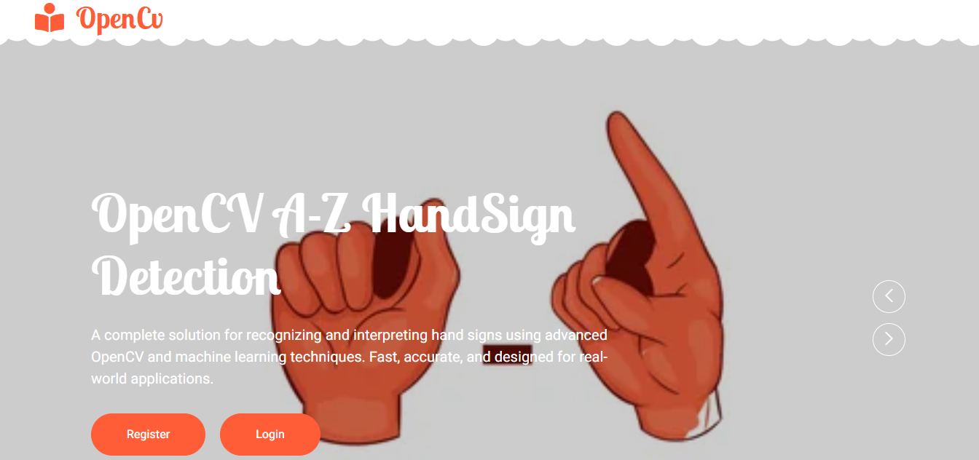

Register page:
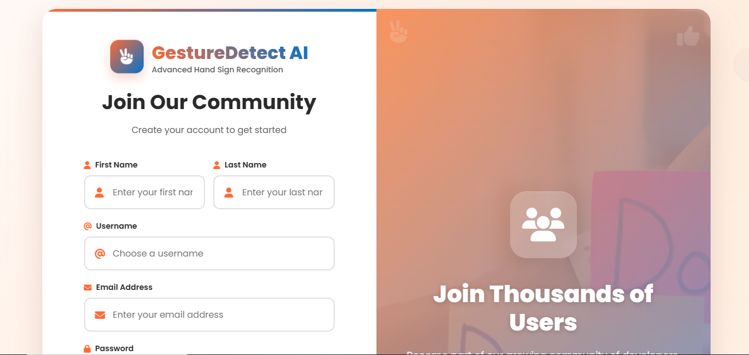

Login page:
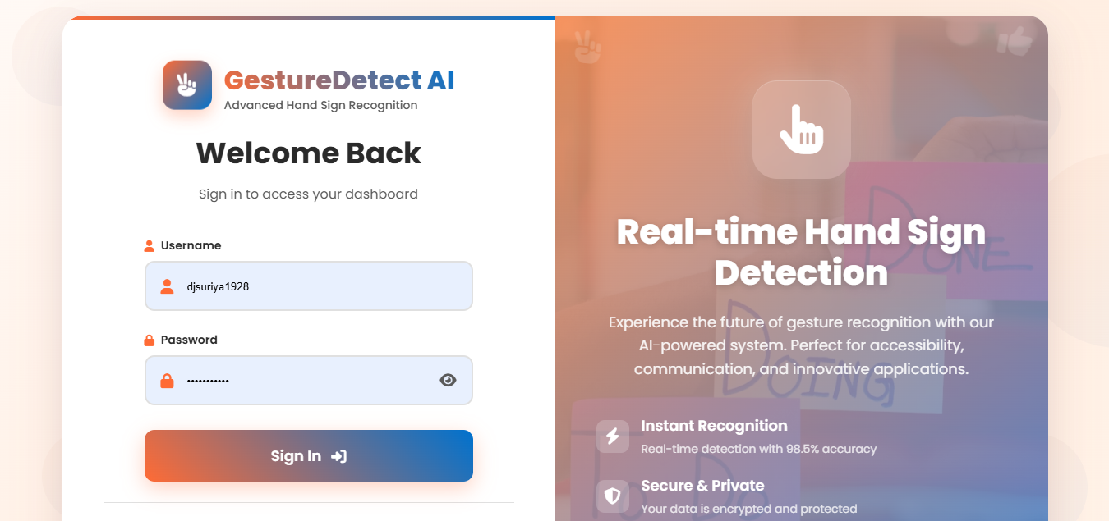

Home page:


Model page:
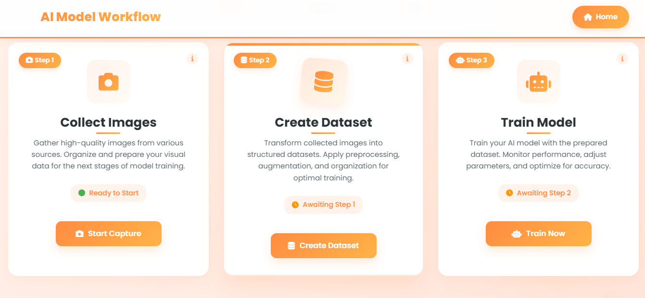
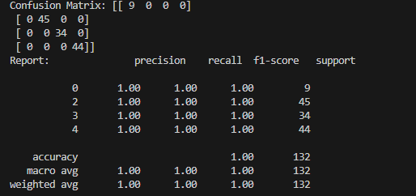

Detection page:
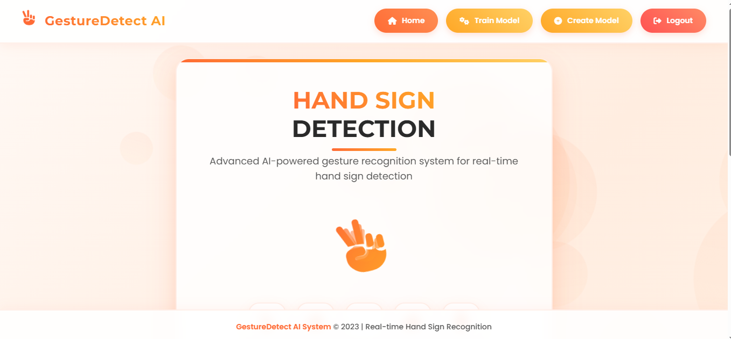
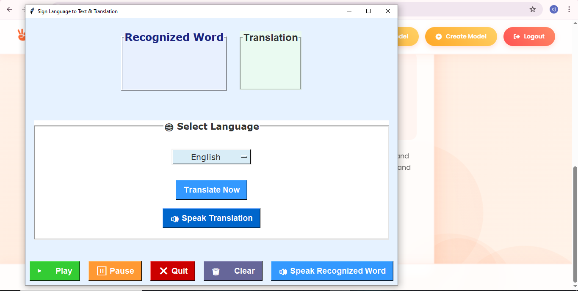

Conclusion:
It focused how image from given dataset (trained dataset) in field and past data set used predict the pattern of different Sign using NN model. This brings some of the following different live sign prediction. We applied NN where the accuracy and loss of the neural network makes better classification and the .h5 file is taken from there and that is deployed in real time.

Future work:
An OpenCV-based hand Sign recognition system leverages advanced computer vision techniques to accurately detect and interpret hand Signs in real-time. The core of the system involves hand segmentation to isolate the hand from its background, followed by hand tracking to monitor its movements using algorithms such as Kalman Filters. Key features include contour detection to outline hand shapes and landmark detection to pinpoint critical hand features like fingertips and knuckles. The system employs machine learning models or deep learning approaches, such as Convolutional Neural Networks, to classify and recognize specific Signs. To ensure real-time performance, the system is optimized for low latency and efficient resource usage. Robustness is achieved through techniques that handle varying lighting conditions and occlusions. Additionally, the user interface incorporates feedback mechanisms and customization options, while the system is designed for integration with various applications and cross-platform support. Data collection and annotation of diverse Sign datasets are crucial for training accurate models, with data augmentation techniques enhancing the system's overall performance.

