DEEP LEARNING–BASED HAND GESTURE RECOGNITION FOR SIGN LANGUAGE TRANSLATING VISUAL GESTURES INTO REAL-TIME TEXTUAL COMMUNICATION.
ABSTRACT:
The proposed system, HandSpeak AI: Real-Time Sign Language Interpreter for Seamless Communication, aims to bridge the communication gap between the hearing-impaired community and the general public by providing an intelligent, real-time sign language recognition framework. Leveraging advanced Convolutional Neural Networks (CNNs) and computer vision techniques, the system captures hand gestures through accurately interprets signs representing alphabets A to Z of sign language. The recognized signs are instantly converted into readable text or accessible interactions in diverse social and professional settings. Designed to operate efficiently on both desktop and Web platforms, this AI-powered interpreter promotes inclusivity, enhances accessibility, and empowers users with improved communication capabilities in real-time.
Keywords:
Sign Language Recognition, Real-Time Interpreter, HandSpeak AI, CNN, Computer Vision, A-Z Hand Signs, Accessibility, Inclusivity, Human-Computer Interaction, Deaf Communication

EXISTING SYSTEM:
Continuous sign language recognition (CSLR) plays a crucial role in facilitating communication between deaf and hearing individuals. A key aspect of achieving precise CSLR is the alignment of the video segment of each sign with its gloss, namely its corresponding text representation in natural language. However, the coarticulation phenomenon, where contextual dependencies between adjacent signs blur the boundaries of individual signs, poses a significant challenge to this task. In this paper, we propose a novel boundary-aware sentence-gloss alignment network for CSLR to address this challenge. Our network first designs a task-relevant boundary-aware similarity measurement, evaluating sign frames by both appearance and their recognition contribution, mitigating coarticulation-induced transition noise to restore precise boundaries. For enhanced alignment, we propose a hierarchical sentence-gloss alignment: coarse sentence-level alignment reduces cross-modal disparity, while fine-grained gloss-level alignment refines video-to-token mapping. Finally, an adaptive class-divergence loss sharpens gloss decoding by maximizing inter-class discrimination. Our proposed framework provides a simple and effective solution to mitigate the boundary ambiguity caused by coarticulation, optimizing continuous sign language recognition algorithms from a new perspective. Extensive experiments conducted on four public sign language recognition (SLR) datasets demonstrate that our proposed boundary-aware sentence-gloss alignment network learns precise alignments and achieves state-of-the-art performance.

DISADVANTAGES:
- High computational cost due to complex boundary-aware similarity and hierarchical alignment processes.
- Requires large annotated datasets with precise sentence-gloss alignment for effective training.
- Sensitive to video quality and hand gesture occlusions, affecting recognition accuracy.
- Struggles with performance on low-resource or mobile devices due to heavy model complexity.
- Coarticulation effects may still persist in highly dynamic or rapid signing sequences.
PROPOSED SYSTEM:
The proposed system, HandSpeak AI: Real-Time Sign Language Interpreter for Seamless Communication, aims to develop an intelligent, real-time hand gesture recognition framework capable of accurately interpreting the Sign Language (SL) alphabet from A to Z. By leveraging advanced Convolutional Neural Network (CNN) architectures and computer vision techniques, the system will process live video streams to detect and classify hand gestures corresponding to each alphabet letter. This AI-powered solution is designed to bridge communication gaps between hearing-impaired individuals and non-signers by instantly translating recognized hand signs into readable text outputs. The system will be optimized for deployment on web platforms, and assistive communication tools, ensuring accessibility, efficiency, and inclusivity in various social, educational, and professional environments.

PROPOSED SYSTEM ADVANTAGES:
- Enables real-time translation of sign language alphabets into text.
- Leverages advanced computer vision for high-accuracy recognition.
- Supports deployment on web platforms for broad accessibility.
- Improves inclusivity in social, educational, and professional spaces.
- Reduces dependency on human interpreters for basic sign communication.
- Scalable and adaptable for future multi-language and gesture extensions.
- User-friendly and non-invasive for everyday communication scenarios.

ENVIRONMENT REQUIREMENTS:

1. Software Requirements:
Operating System : Windows
Tool : Anaconda with Jupyter Notebook
2. Hardware requirements:
Processor : Intel® Core™ i7 processor 14650HX (30M Cache, up to 5.20 GHz)
Hard disk : minimum 80 GB
RAM : minimum 4 GB

LITERATURE SURVEY
General
A literature review is a body of text that aims to review the critical points of current knowledge on and/or methodological approaches to a particular topic. It is secondary sources and discuss published information in a particular subject area and sometimes information in a particular subject area within a certain time period.
Its ultimate goal is to bring the reader up to date with current literature on a topic and forms the basis for another goal, such as future research that may be needed in the area and precedes a research proposal and may be just a simple summary of sources. Usually, it has an organizational pattern and combines both summary and synthesis.
A summary is a recap of important information about the source, but a synthesis is a re-organization, reshuffling of information. It might give a new interpretation of old material or combine new with old interpretations or it might trace the intellectual progression of the field, including major debates. Depending on the situation, the literature review may evaluate the sources and advise the reader on the most pertinent or relevant of them. Loan default trends have been long studied from a socio-economic stand point.
Most economics surveys believe in empirical modeling of these complex systems in order to be able to predict the loan default rate for a particular individual. The use of machine learning for such tasks is a trend which it is observing now. Some of the survey’s to understand the past and present perspective of loan approval or not.

Review of Literature Survey
Title : Hand Sign Recognition Based on Computer Vision: A Review of Techniques
Author : Munir Oudah 1 , Ali Al-Naji 1,2,* and Javaan Chahl 2
Year : 2020
Hand Signs are a form of nonverbal communication that can be used in several fields such as communication between deaf-mute people, robot control, human–computer interaction (HCI), home automation and medical applications. Research papers based on hand Signs have adopted many different techniques, including those based on instrumented sensor technology and computer vision. In other words, the hand sign can be classified under many headings, such as posture and Sign, as well as dynamic and static, or a hybrid of the two. This paper focuses on a review of the literature on hand Sign techniques and introduces their merits and limitations under different circumstances. In addition, it tabulates the performance of these methods, focusing on computer vision techniques that deal with the similarity and difference points, technique of hand segmentation used, classification algorithms and drawbacks, number and types of Signs, dataset used, detection range (distance) and type of camera used. This paper is a thorough general overview of hand Sign methods with a brief discussion of some possible applications.

Title : Hand Sign Recognition with Skin Detection and Deep Learning Method
Author : Hanwen Huang1 , Yanwen Chong2*
Year : 2019
Sign recognition, although has been exploring for many years, is still a challenging problem. Complex background, camera angles and illumination conditions make the problem more difficult. Thus, this paper presents a fast and robust method for hand Sign recognition based on RGB video. First we detect the skin based on their color. Then we extract the contour and segment the hand region. Finally we recognize the Sign. The results of experiment demonstrate that the proposed method are efficient to recognize Sign with a higher accuracy than the state of the art.

Title : Hand Sign Recognition System Using Camera
Author : Viraj Shinde, Tushar Bacchav, Jitendra Pawar
Year : 2014
In this paper, we focus on using pointing behavior for a natural interface, Hand Sign recognition based human-machine interface is being developed vigorously in recent years. Due to the effect of lighting and complex background, most visual hand Sign recognition systems work only under restricted environment. To classify the dynamic hand Signs, we developed a simple and fast motion history image based method. In recent years, the Sign control technique has become a new developmental trend for many human-based electronics products. This technique let people can control these products more naturally, intuitively and conveniently. In this paper, a fast Sign recognition scheme is proposed to be an interface for the human-machine interaction (HMI) of systems. This paper presents some low-complexity algorithms and Signs to reduce the Sign recognition complexity and be more suitable for controlling real-time computer systems.

Title : Static Hand Sign Recognition using Convolutional Neural Network with Data Augmentation
Author : Md. Zahirul Islam, Mohammad Shahadat Hossain
Computer is a part and parcel in our day to day life and used in various fields. The interaction of human and computer is accomplished by traditional input devices like mouse, keyboard etc. Hand Signs can be a useful medium of human-computer interaction and can make the interaction easier. Signs vary in orientation and shape from person to person. So, non-linearity exists in this problem. Recent research has proved the supremacy of Convolutional Neural Network (CNN) for image representation and classification. Since, CNN can learn complex and non-linear relationships among images, in this paper, a static hand Sign recognition method using CNN was proposed. Data augmentation like re-scaling, zooming, shearing, rotation, width and height shifting was applied to the dataset. The model was trained on 8000 images and tested on 1600 images which were divided into 10 classes. The model with augmented data achieved accuracy 97.12% which is nearly 4% higher than the model without augmentation (92.87%).

Title : Real-Time Hand Sign Recognition Using Finger Segmentation
Author : Zhi-hua Chen,1 Jung-Tae Kim,1 Jianning Liang
Year : 2014
Hand Sign recognition is very significant for human-computer interaction. In this work, we present a novel real-time method for hand Sign recognition. In our framework, the hand region is extracted from the background with the background subtraction method. Then, the palm and fingers are segmented so as to detect and recognize the fingers. Finally, a rule classifier is applied to predict the labels of hand Signs. The experiments on the data set of 1300 images show that our method performs well and is highly efficient. Moreover, our method shows better performance than a state-of-art method on another data set of hand Signs.
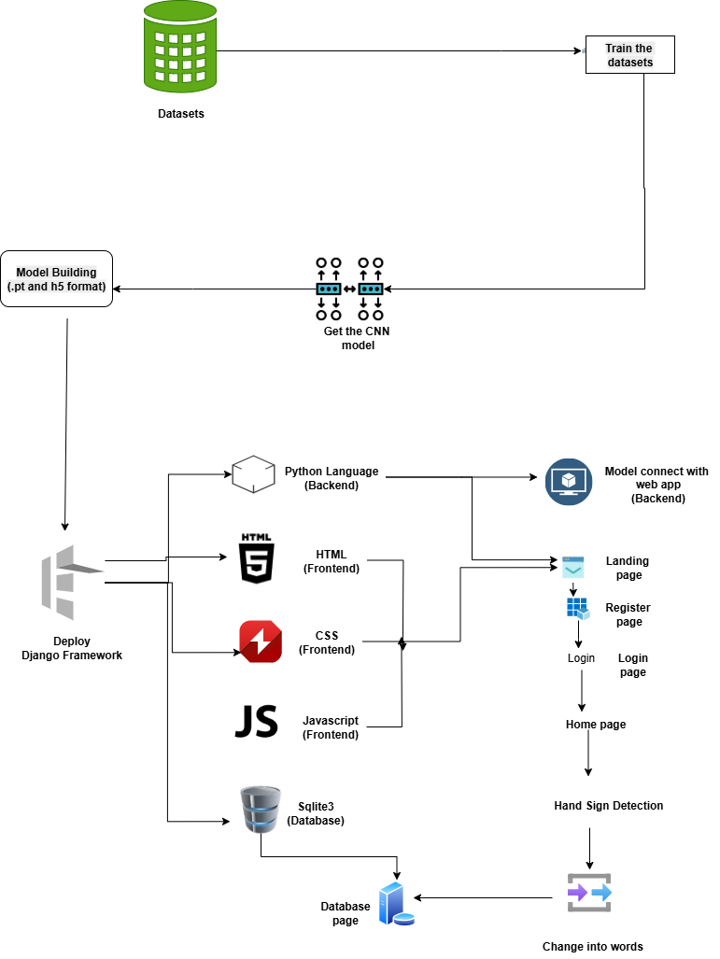

Work flow diagram:
Data Collection

Pre-processing

Training Dataset
Testing Dataset

CNN algorithm
Model

Sign Detection

Workflow Diagram

METHODOLOGY
The HandSpeak AI system follows a structured and modular methodology to ensure accurate, real-time sign language recognition and seamless text translation. The overall workflow consists of data acquisition, preprocessing, feature extraction, gesture classification using deep learning, and output generation.

1. Data Acquisition
Hand gesture data corresponding to sign language alphabets (A–Z) is collected using a webcam or camera device. The system captures real-time video frames of hand movements under varying lighting conditions and backgrounds to ensure robustness and generalization.

2. Image Preprocessing
To improve recognition accuracy and reduce noise, each captured frame undergoes preprocessing steps:
- Conversion of RGB images to grayscale
- Background subtraction to isolate hand regions
- Image resizing and normalization
- Noise removal using Gaussian blur
- Thresholding for better hand contour extraction
These steps ensure consistent input quality for the CNN model.

3. Hand Detection and Segmentation
Computer vision techniques using OpenCV are applied to detect and segment the hand region from each frame. Techniques such as:
- Skin color detection
- Contour extraction
- Region of Interest (ROI) selection
are used to precisely isolate the hand gesture from the background.

4. Feature Extraction Using CNN
A Convolutional Neural Network (CNN) automatically extracts discriminative spatial features from the segmented hand images. The CNN architecture consists of:
- Convolutional layers for feature learning
- Max-pooling layers for dimensionality reduction
- Fully connected layers for classification
The network learns hand shape, finger orientation, and gesture patterns essential for distinguishing alphabets.

5. Gesture Classification
The trained CNN model classifies the extracted features into one of the 26 sign language alphabet classes (A–Z). Softmax activation is used in the output layer to provide class probabilities, ensuring accurate and confident predictions.

6. Real-Time Prediction and Text Conversion
The classified gesture is instantly mapped to its corresponding alphabet and converted into readable text. The system displays the recognized character on the user interface in real time, enabling smooth and interactive communication.

7. Web/Desktop Deployment
The system is implemented using:
- Python for model training and backend processing
- OpenCV for image processing
- TensorFlow/Keras for CNN modeling
- Django/Flask for web-based deployment
This enables real-time operation on both desktop and web platforms.

8. Performance Evaluation
The model’s performance is evaluated using:
- Accuracy
- Precision
- Recall
- Confusion Matrix
Real-time testing is conducted under different environmental conditions to validate system reliability.

