SRM University – AP, Andhra Pradesh
Bachelor of Technology
In
Computer Science and Engineering
School of Engineering and Sciences
Submitted by
K. MOHANA SAMANYA
AP22110010523
CSE-R



Under the Guidance of
Dr. Bala Venkateswarlu
SRM University–AP
Neerukonda, Mangalagiri, Guntur
Andhra Pradesh – 522 240

ABSTRACT

This project presents an automated deep learning–based system for clustering and extracting topics from machine learning research papers retrieved from the ArXiv repository. The workflow integrates natural language preprocessing, transformer-based semantic embeddings, dimensionality reduction, and deep clustering to identify coherent research themes. Using the SentenceTransformer "all-MiniLM-L6-v2" model, each abstract is converted into a dense semantic vector, which is then compressed using Principal Component Analysis (PCA). An Improved Deep Embedded Clustering (IDEC) architecture is employed to jointly learn latent representations and cluster assignments, with cluster centers initialized using Gaussian Mixture Models for stability. To generate human-interpretable cluster labels, KeyBERT extracts concise keywords representing dominant themes within each group. Experimental results show that the system effectively identifies meaningful and distinct clusters such as reinforcement learning, neural optimization, natural language processing, and graph-based learning. The project demonstrates the potential of combining transformer embeddings and deep clustering methods for organizing large-scale scientific literature and facilitating automated topic discovery.

INTRODUCTION

The rapid growth of scientific publications has created challenges in identifying research trends, organizing literature, and extracting meaningful insights from large collections of abstracts. Traditional clustering approaches often fail to capture the semantic richness of scientific text, while manual analysis is time-consuming and impractical.
This project develops a fully automated pipeline that:
- Retrieves recent machine learning papers from ArXiv,
- Cleans and preprocesses textual abstracts,
- Produces semantic embeddings using transformer-based models,
- Applies dimensionality reduction for computational efficiency,
- Uses IDEC (Improved Deep Embedded Clustering) for high-quality, representation-aware clustering,
- Extracts interpretable topics using KeyBERT, and
- Generates a final abelled dataset of research themes.
The goal is to create a robust system capable of analyzing scientific literature and uncovering topic-based groupings in an unsupervised manner.
SYSTEM DESIGN
The system is designed as a multi-stage pipeline combining NLP, deep learning, and clustering. The major components are:
Architecture overview
i. ArXiv Data Fetching
ii. Text Preprocessing
iii. Embedding Generation
iv. PCA Dimensionality Reduction
v. Autoencoder Training
vi. IDEC Clustering
vii. Topic Extraction
viii. CSV Export
IMPLEMENTATION
Data Acquisition
- Uses the arxiv Python package.
- Tenacity provides exponential backoff to avoid API errors.
- Fetches the latest 100 papers matching the keyword machine learning.
Text Cleaning
- Lowercasing
- Removing non-alphanumeric characters
- Tokenization and stopword removal using NLTK
- Lemmatization via WordNetLemmatizer
Produces standardized text suitable for embedding.
Embedding Generation
Implemented using SentenceTransformer with the "all-MiniLM-L6-v2" pretrained model.
Reasons for choosing this model:
- Fast inference
- High semantic quality
- Low computational cost
Each abstract produces a 384-d embedding vector.
Dimensionality Reduction
PCA reduces embeddings to 30 dimensions:
- Speeds up training
- Reduces noise
- Improves cluster compactness
Autoencoder Pretraining
A symmetrical dense autoencoder:
- Encoder: 384 → 128 → 32
- Decoder: 32 → 128 → 384
Purpose:
- Learn compressed latent representations
- Initialize IDEC with good weights
Pretrained for 10 epochs using MSE loss.
IDEC Deep Clustering
IDEC combines:
- Reconstruction loss (autoencoder)
- KL divergence between soft and target distributions
Steps:
- Create a custom Clustering Layer using the Student-t distribution.
- Initialize cluster centers using Gaussian Mixture Models (GMM).
- Train IDEC for 15 epochs with batch training.
Outputs:
- q = soft cluster assignments
- Hard labels obtained via argmax(q)
Topic Extraction
For each cluster:
- Combine all abstracts
- Use KeyBERT (MiniLM embeddings) to extract top keywords
- Assign two keywords as topic summary
Adds column: cluster_topic
Export
Final dataset saved as:
arxiv_abstracts_new_new.csv

RESULTS
IDEC generated 10 meaningful clusters, each representing distinct machine learning research trends.
To make the system interactive and user-friendly, a Streamlit web application was developed as part of the project. The Streamlit app allows users to explore the results visually.
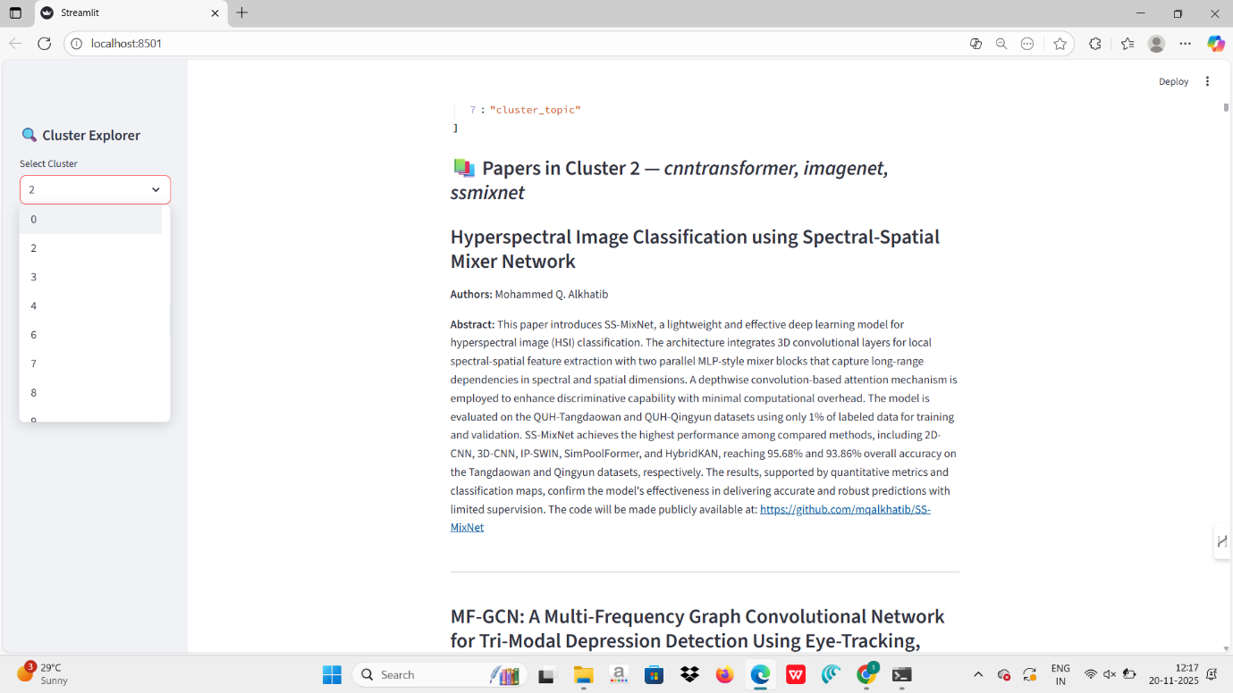

OBSERVATIONS

- IDEC clusters were more compact than traditional k-means.
- Topics extracted by KeyBERT were semantically coherent and interpretable.
- High similarity papers consistently appeared in the same cluster.
- PCA sped up training significantly with minimal loss of meaning.

PERFORMANCE
- Autoencoder achieved low reconstruction loss.
- Clustering stabilized after ~10 epochs.
- Topic keywords were concise and relevant.

CONCLUSION

This project successfully develops a complete pipeline for:
- Collecting scientific literature
- Preprocessing text efficiently
- Embedding abstracts with modern transformer models
- Learning deep representations using autoencoders
- Performing unsupervised clustering with IDEC
- Extracting interpretable topics using KeyBERT
The combination of transformer embeddings and deep clustering yields high-quality clusters that reflect real research themes. The final CSV file provides a structured view of current machine learning research areas.

FUTURE ENHANCEMENTS

- Increase dataset size beyond 100 papers
- Replace PCA with UMAP for non-linear compression
- Use more powerful embedding models like E5-large
- Integrate BERTopic for hierarchical topic modeling

