**TASK3:**

**Exercise 4: Creating and Configuring a Maven Project:**

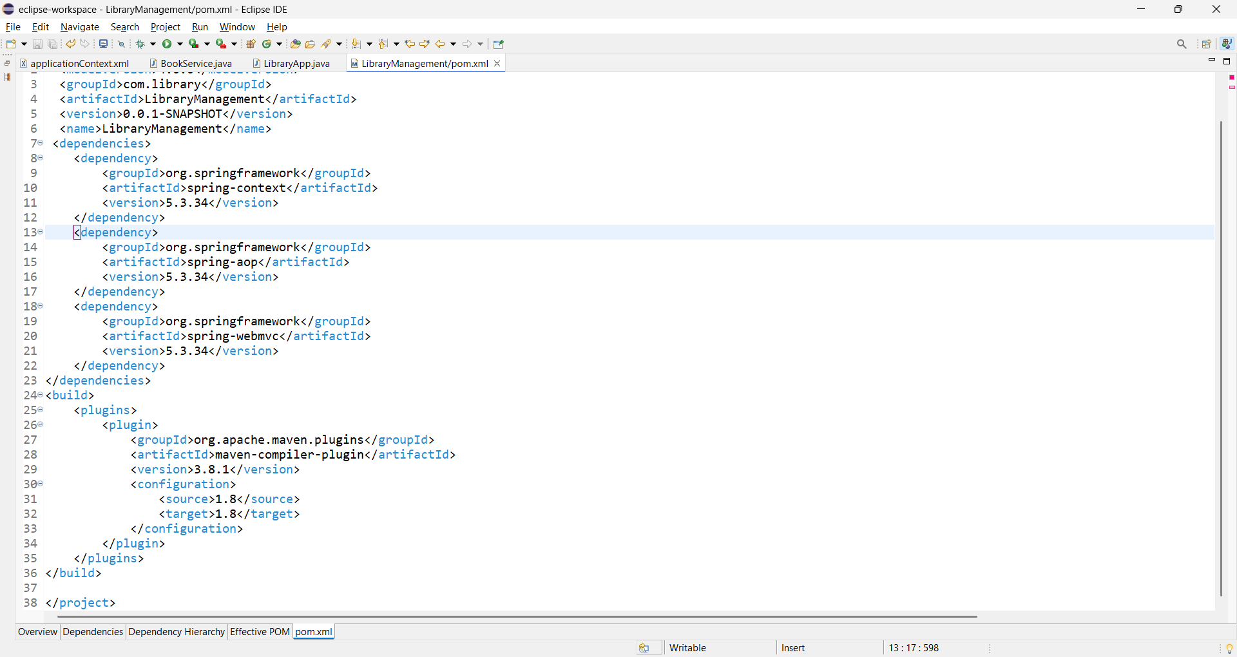

**Exercise 9: Creating a Spring Boot Application:**

**POM.XML:**

**<?xml version="1.0" encoding="UTF-8"?>**

**<project xmlns="http://maven.apache.org/POM/4.0.0" xmlns:xsi="http://www.w3.org/2001/XMLSchema-instance"**

**xsi:schemaLocation="http://maven.apache.org/POM/4.0.0 https://maven.apache.org/xsd/maven-4.0.0.xsd">**

**<modelVersion>4.0.0</modelVersion>**

**<parent>**

**<groupId>org.springframework.boot</groupId>**

**<artifactId>spring-boot-starter-parent</artifactId>**

**<version>4.0.0-SNAPSHOT</version>**

**<relativePath/> <!-- lookup parent from repository -->**

**</parent>**

**<groupId>com.library</groupId>**

**<artifactId>LibraryManagement</artifactId>**

**<version>0.0.1-SNAPSHOT</version>**

**<name>LibraryManagement</name>**

**<description>Demo project for Spring Boot</description>**

**<url/>**

**<licenses>**

**<license/>**

**</licenses>**

**<developers>**

**<developer/>**

**</developers>**

**<scm>**

**<connection/>**

**<developerConnection/>**

**<tag/>**

**<url/>**

**</scm>**

**<properties>**

**<java.version>17</java.version>**

**</properties>**

**<dependencies>**

**<dependencies>**

**<!-- Spring Web -->**

**<dependency>**

**<groupId>org.springframework.boot</groupId>**

**<artifactId>spring-boot-starter-web</artifactId>**

**</dependency>**

**<!-- Spring Data JPA -->**

**<dependency>**

**<groupId>org.springframework.boot</groupId>**

**<artifactId>spring-boot-starter-data-jpa</artifactId>**

**</dependency>**

**<!-- H2 Database -->**

**<dependency>**

**<groupId>com.h2database</groupId>**

**<artifactId>h2</artifactId>**

**<scope>runtime</scope>**

**</dependency>**

**</dependencies>**

**<dependency>**

**<groupId>org.springframework.boot</groupId>**

**<artifactId>spring-boot-starter-data-jpa</artifactId>**

**</dependency>**

**<dependency>**

**<groupId>org.springframework.boot</groupId>**

**<artifactId>spring-boot-starter-web</artifactId>**

**</dependency>**

**<dependency>**

**<groupId>com.h2database</groupId>**

**<artifactId>h2</artifactId>**

**<scope>runtime</scope>**

**</dependency>**

**<dependency>**

**<groupId>org.springframework.boot</groupId>**

**<artifactId>spring-boot-starter-test</artifactId>**

**<scope>test</scope>**

**</dependency>**

**</dependencies>**

**<build>**

**<plugins>**

**<plugin>**

**<groupId>org.springframework.boot</groupId>**

**<artifactId>spring-boot-maven-plugin</artifactId>**

**</plugin>**

**</plugins>**

**</build>**

**<repositories>**

**<repository>**

**<id>spring-milestones</id>**

**<name>Spring Milestones</name>**

**<url>https://repo.spring.io/milestone</url>**

**<snapshots>**

**<enabled>false</enabled>**

**</snapshots>**

**</repository>**

**<repository>**

**<id>spring-snapshots</id>**

**<name>Spring Snapshots</name>**

**<url>https://repo.spring.io/snapshot</url>**

**<releases>**

**<enabled>false</enabled>**

**</releases>**

**</repository>**

**</repositories>**

**<pluginRepositories>**

**<pluginRepository>**

**<id>spring-milestones</id>**

**<name>Spring Milestones</name>**

**<url>https://repo.spring.io/milestone</url>**

**<snapshots>**

**<enabled>false</enabled>**

**</snapshots>**

**</pluginRepository>**

**<pluginRepository>**

**<id>spring-snapshots</id>**

**<name>Spring Snapshots</name>**

**<url>https://repo.spring.io/snapshot</url>**

**<releases>**

**<enabled>false</enabled>**

**</releases>**

**</pluginRepository>**

**</pluginRepositories>**

**</project>**

