

End-User Guide 5-Step Journey Format
Professional. Visual. Simple. Journey-Led.


Platform Overview
What is MetaBrain?

MetaBrain is an AI-driven strategic intelligence platform that integrates curated industry datasets with enterprise systems. Operating within SAP BTP, it leverages conversational interfaces to enhance decision-making through predictive and prescriptive analytics.
Key Features:

- AI-Powered Insights: Utilizes AI to deliver strategic insights by combining enterprise data with external industry information.
- Conversational Interface: Engage with the platform using natural language queries.
- Integration with SAP: Seamlessly integrates with SAP systems for enhanced data analysis.

Step 1: Access & Onboard
Go to: https://demo.metafrost.ai/dashboard
Signup: Signup at the portal by providing
  - Name, Email ID, Password, Company Name, Industry, Phone number, & Address
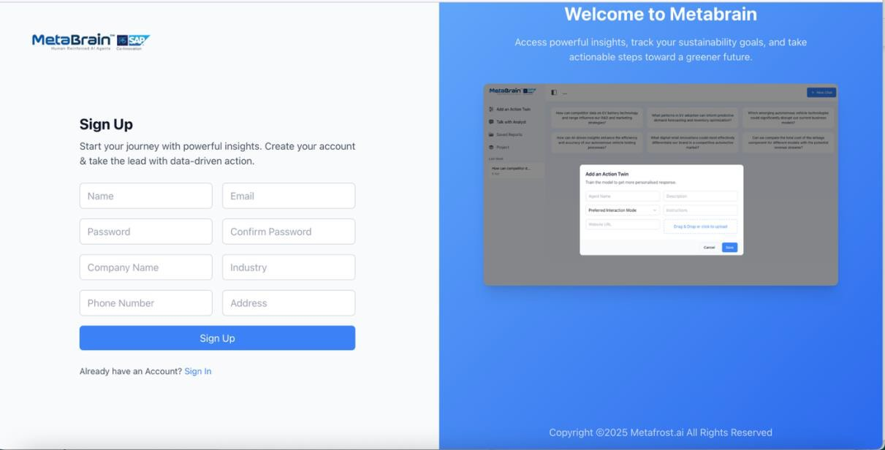
Click the Sign Up Button:
Verify your Email: Enter the code sent to your provided email ID to complete the Sign Up process.




Welcome to the MetaBrain Dashboard
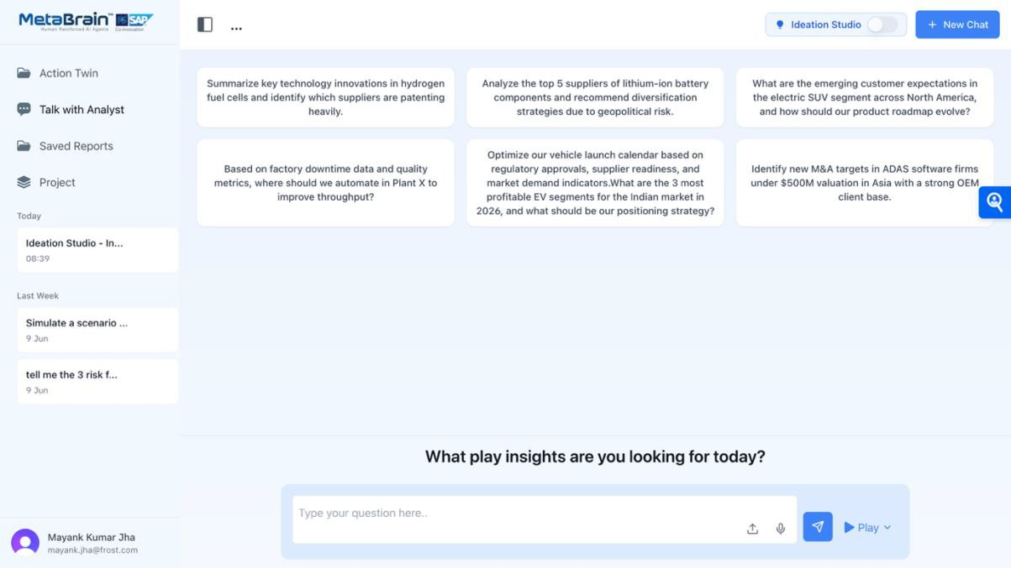

Step 2: Ask & Analyze
Use the Prompt Bar to ask business questions like:
- “What are the top 5 risks in lithium-ion battery sourcing?”
- “Which EV segments will be profitable in India by 2026?”


You can:
- Upload a document (PDF, Excel, PPT) to enrich your prompt
- Use voice input to ask naturally
- Select a preloaded use case for your industry
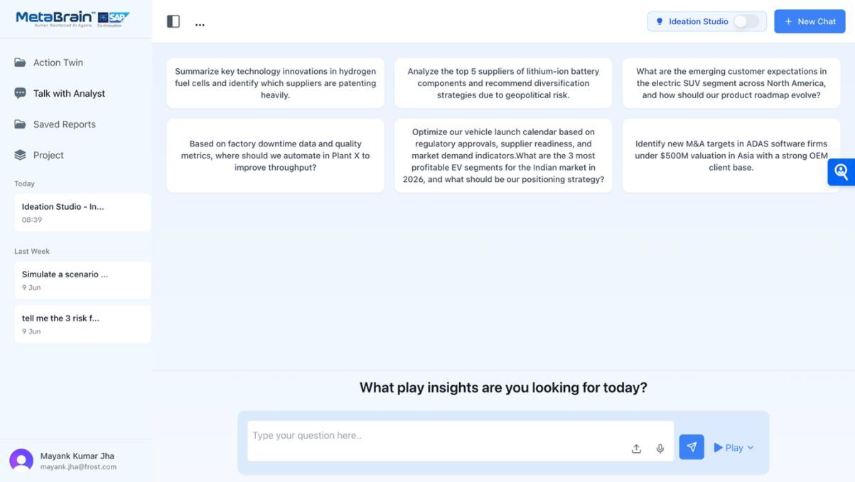
Visual:
Prompt Bar
Voice Input
Prompt bar
Talk with Analyst
Saved Projects
New Chat
Open /Create Project
Ideation Studio

Developer Workflow:
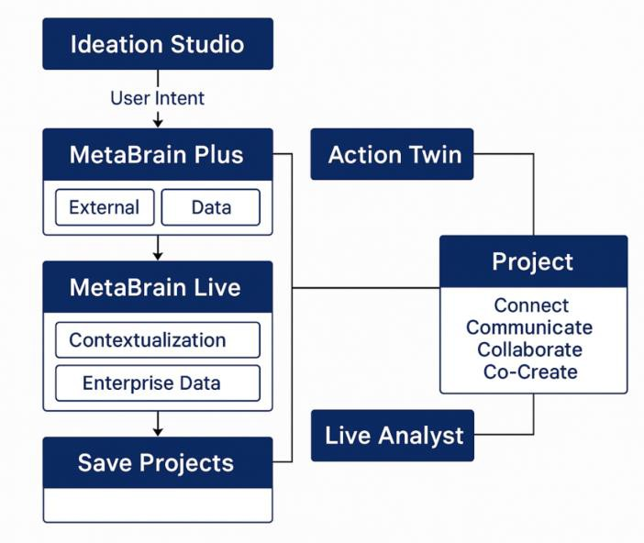


For Prompting Choose Your desired mode:

Mode | Use When You Want To... | Best For
Play | Combine your SAP ERP data with external market  data for contextual insights | Strategy, Innovation
Plus | Use expert-curated Frost & Sullivan insights for  fast, accurate strategy answers | Planning, Ops
Ideation  Studio | Collaborate on custom ideas, brainstorm, or  simulate strategy shifts | CXOs, Consultants
Visual:
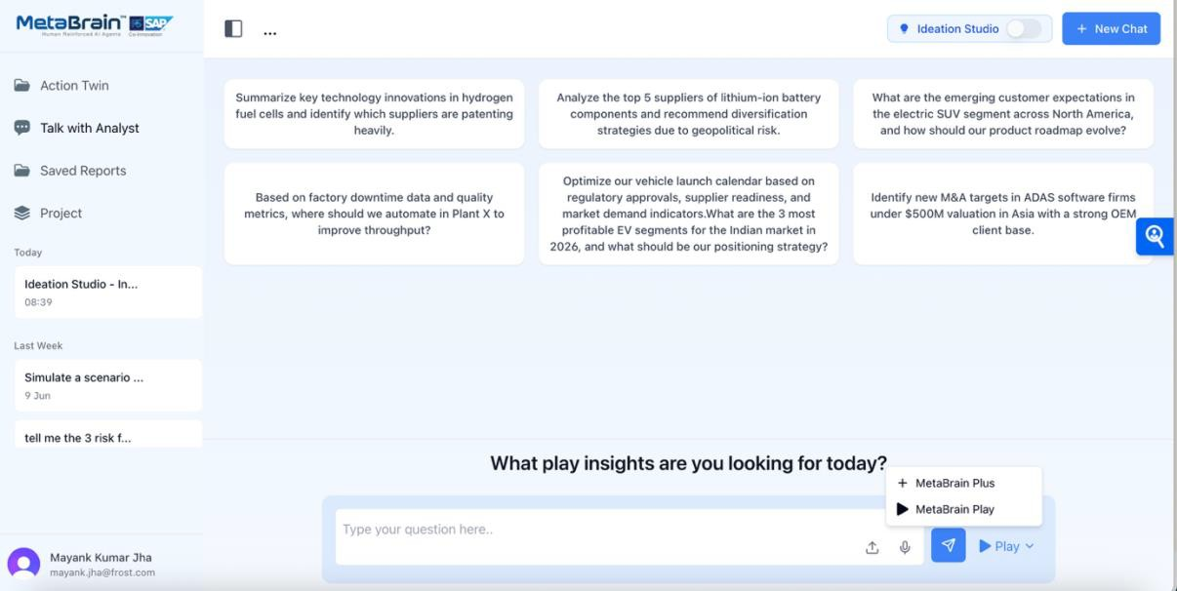
Modes of Operation
Ideation Studio Mode:
Click the ‘Ideation Studio’ mode to switch ON
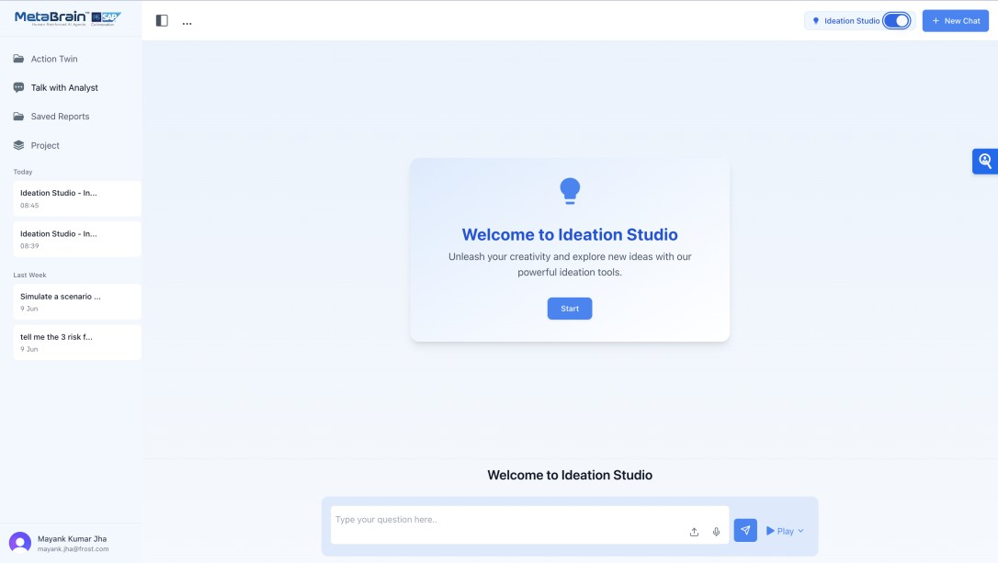
Ideation Studio Mode

Steps:

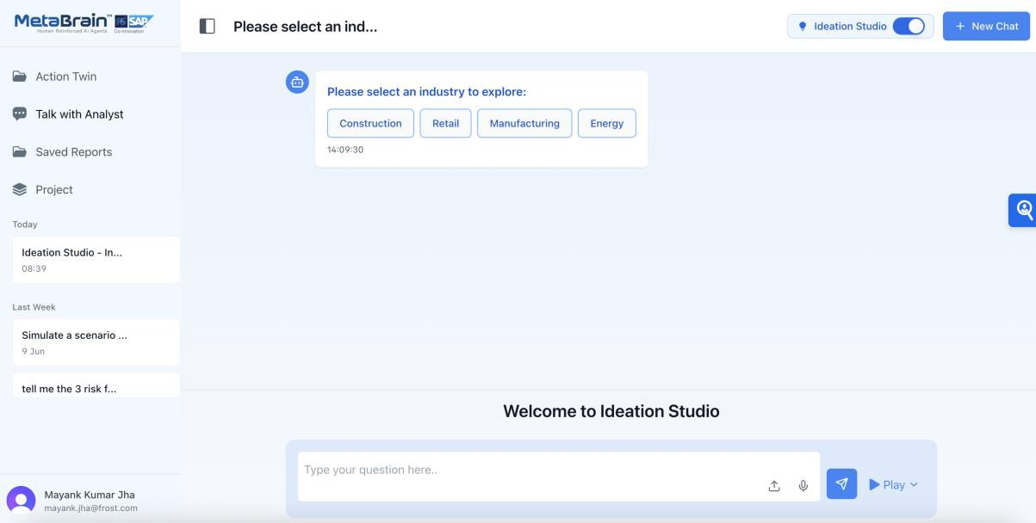
- Choose Industry to explore:

- Choose a Sub- Industry:


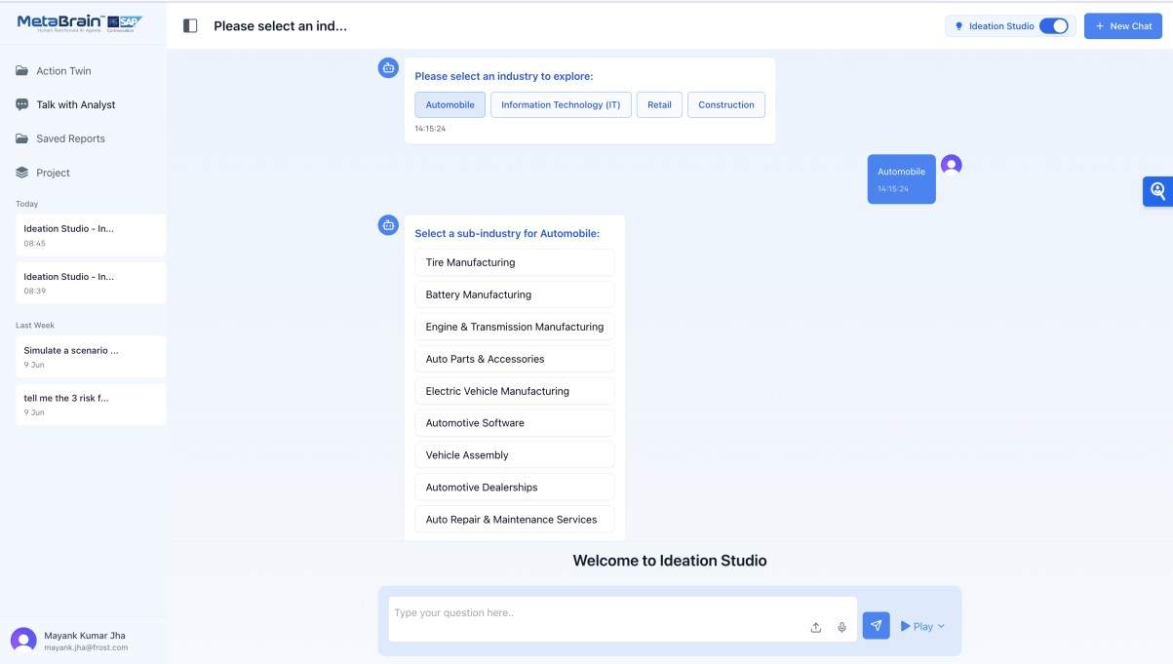


Step 3: Interpret & Use the Insights
Once the system processes your question:
  - You'll see a response window with detailed AI-driven answers
  - It will show sources used (SAP, Frost, etc.)
  - You can export the insight in:
    - PDF
    - PowerPoint
    - MP3 audio
    - Video summary
You can also create Assignments to follow up on insights and track actions.
Visual:
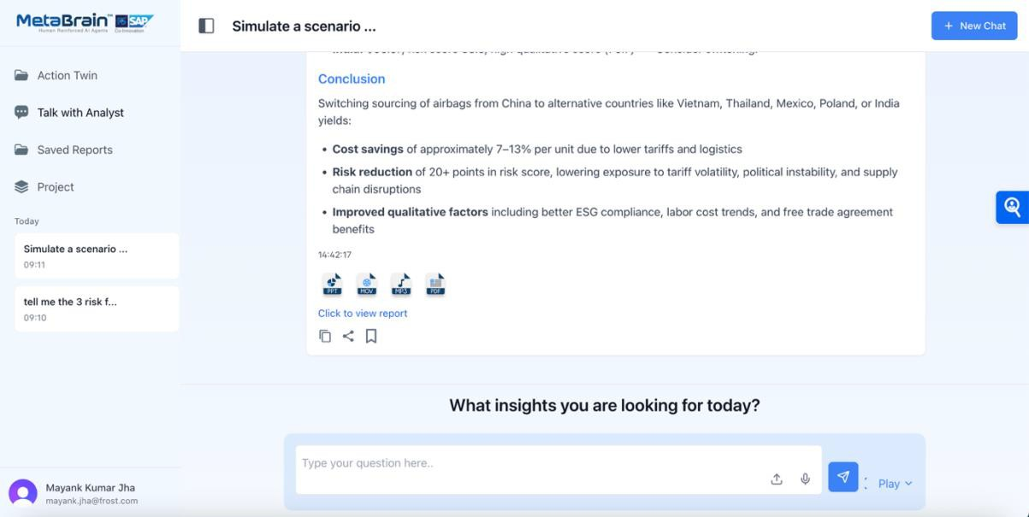
Export options

Step 4: Organize & Collaborate
Use the Projects tab to group your conversations and insights.
Track and view chat history by date (Today, This Week, Last Month).
Use Talk with Analyst to validate findings or co-build a strategy.

Tip: Create a new chat thread for each unique use case to stay organized.


Visual:
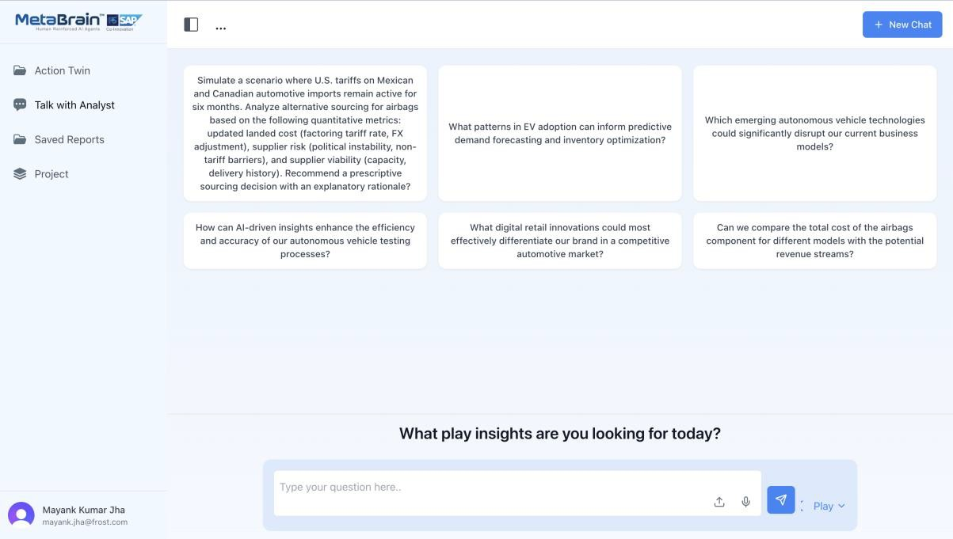
Navigating Platform

Action Twin: Train the model to get more personalised response
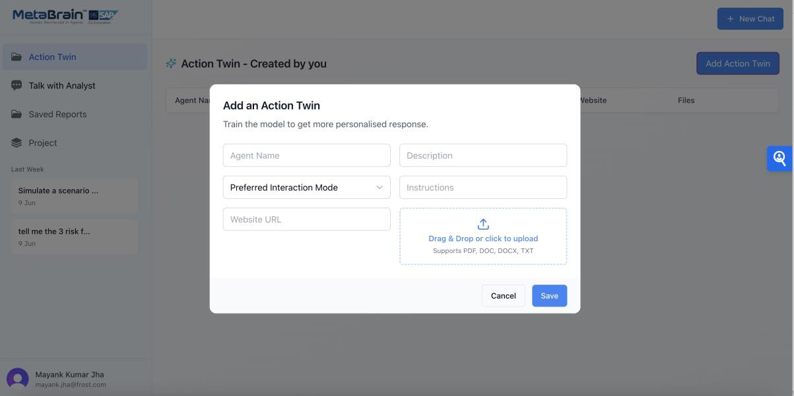


Project:
For Trial version:
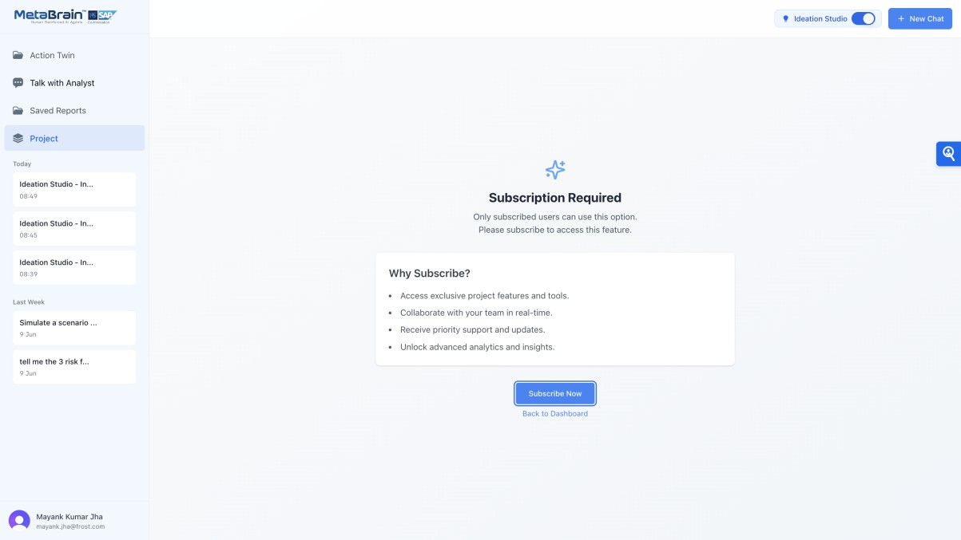

Talk with Analyst:
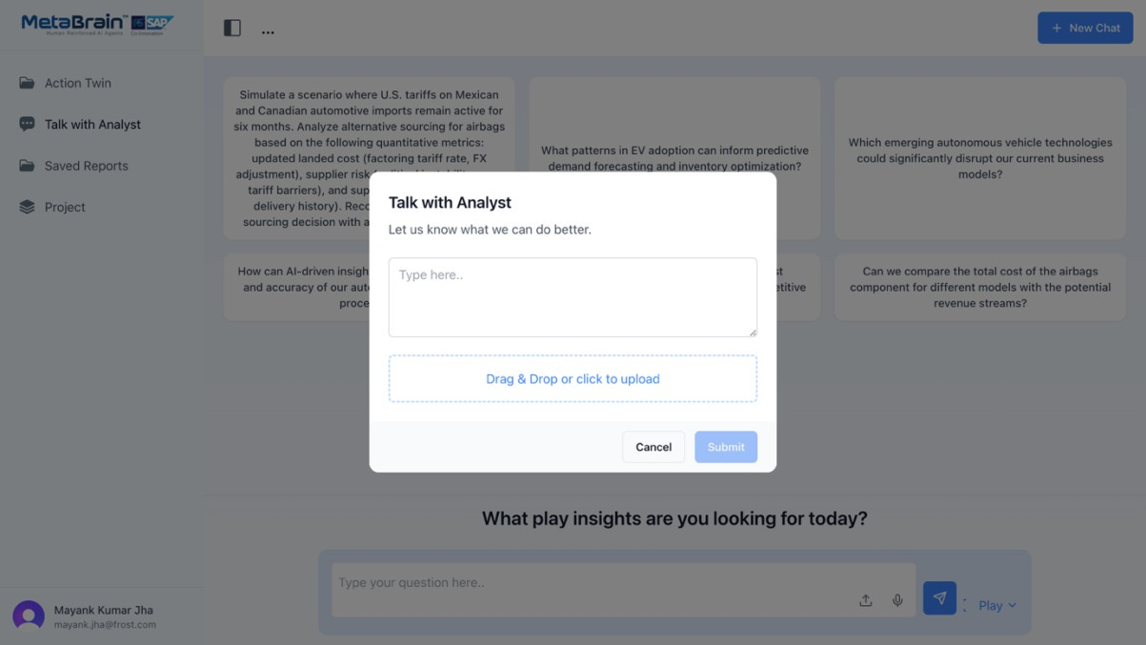


Saved Reports:
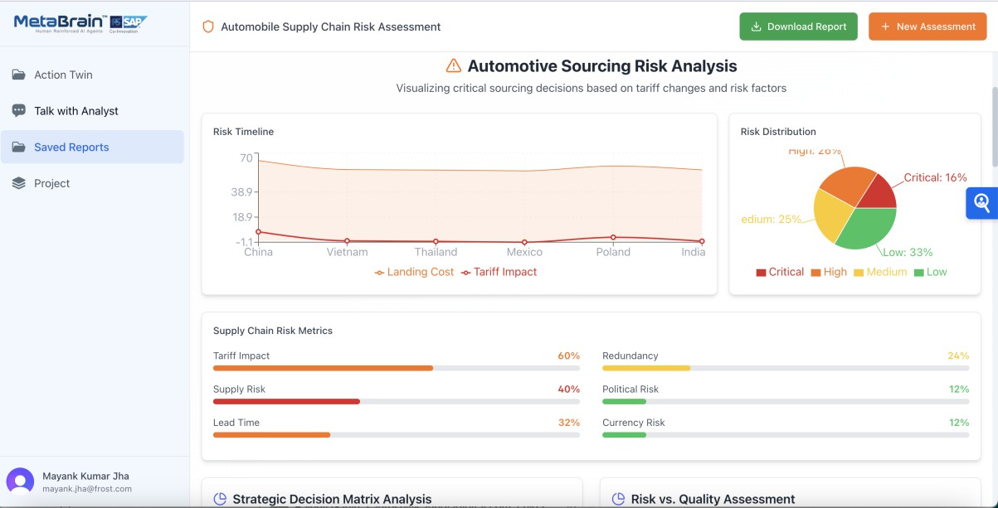
Generate Dynamic Reports:
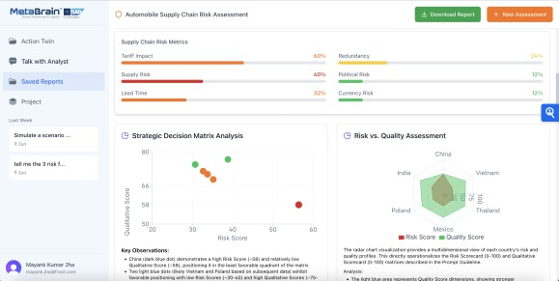
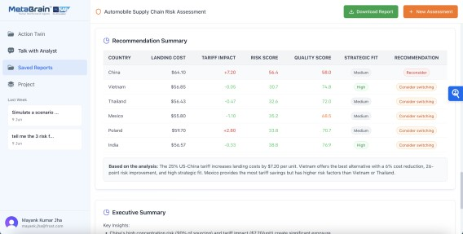
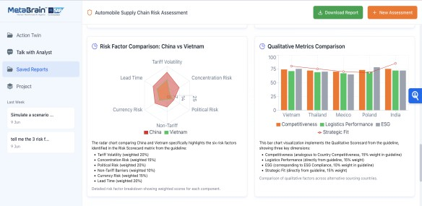
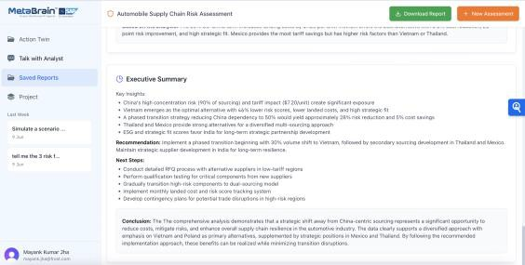


Step 5: Edition Comparison:
Feature Availability Summary
Feature | Trial | Standard | Premium
Project creation
Save chats & documents
Collaborative access
Version tracking
Analyst co-pilot |  | Optional
Export full archive

Detailed comparison:
Feature | 7-Day Free Trial | Standard Edition | Premium Edition
Duration | 7 days | 12 months  (minimum) | Custom contract
User Access | Up to 50 enterprise users | Up to 50 enterprise users | Unlimited enterprise users
Industry Scope | 1 Industry  2 Sub-industries  2 Strategic Imperatives | Same as trial | Fully customizable (industries, sub- industries, imperatives)
Prompt Library | 200 curated prompts | 200 curated prompts | Unlimited prompts + custom ontologies
Data Integration | Sandbox access with SAP BTP datasets | Sandbox + pre- connected APIs | Full SAP S/4HANA, IBP,  Joule, and BTP integration
Customization | Fixed datasets, no custom API training | Optional: live analyst sessions ($200/hr) | Fully custom-trained API calls, logic layers, dashboards
Support | Email-based FAQ, onboarding video | Email support + onboarding walkthrough | 24×7 support + 40 hours analyst time/month
Decision Cockpit Access | No | Limited view | Full cockpit with role- based dashboards, alerting
Report Export | Yes (PDF, PPT,  MP3, Video) | Yes | Yes, with collaborative annotations
Compliance Readiness | SAP BTP compliant | SAP IBP, Joule- ready | ISO, SOC 2, GDPR,  DLM-compliant
Pricing | Free | Starting at USD  9,999/month + setup fee | Price upon request


Do’s & Don’ts for a Smooth Experience:

Do | Don’t
Ask domain-specific questions like  “Battery supplier geo-risk” | Avoid vague prompts like “tell me something about the market”
Upload relevant documents for better grounding | Don’t skip project folders—it helps track insights easily
Use Play mode for SAP-integrated scenarios | Don’t run multiple tabs simultaneously
Bookmark insights and share via report links | Don’t forget to tag your projects for easy  retrieval

Support and Resources
Ambassador Support:

During the trial period, leverage the support of a MetaBrain ambassador who can assist with:

- Defining use cases.
- Coordinating with analysts and SAP experts.
- Guiding onboarding for cross-functional users.
- Monitoring insight quality and engagement.

Need Help?
Your MetaBrain Ambassador will:
- Help you set up high-impact use cases
- Arrange onboarding or demo calls
- Guide you in collaborating with our analysts
□ Contact: support@metafrost.ai
● Learn More: https://metafrost.ai
Upgrade the Plan (SAP Store): https://store.sap.com/dcp/en/product/display-2002002392_live_v1

