Bring up java code

1. Take the code bike.zip

2. Uzip the code

3. Import the code as a maven project

4. Run as springboot app in STS 1.3

Setup SQLite DB

1. Browse to <https://www.sqlite.org/download.html>
2. Download the following zip from the page.

sqlite-tools-win32-x86-3300100.zip

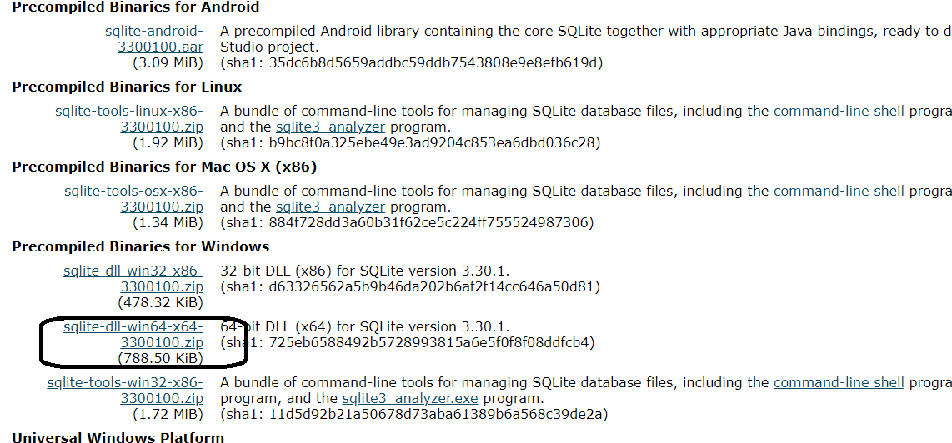

1. Unzip the file and it has 3 files

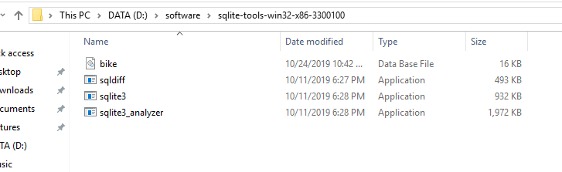

1. For sqlite3 set tin the environment variables or in the same folder create the bike.db as shown below

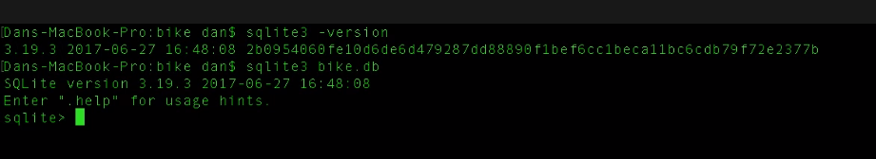

1. Go to [https://github.com/dlbunker/ps-spring-boot-and-angular/tree/master/sql and execute the bike.sql](https://github.com/dlbunker/ps-spring-boot-and-angular/tree/master/sql%20and%20execute%20the%20bike.sql)

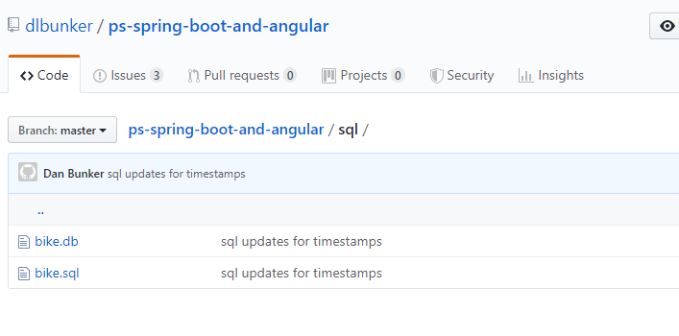

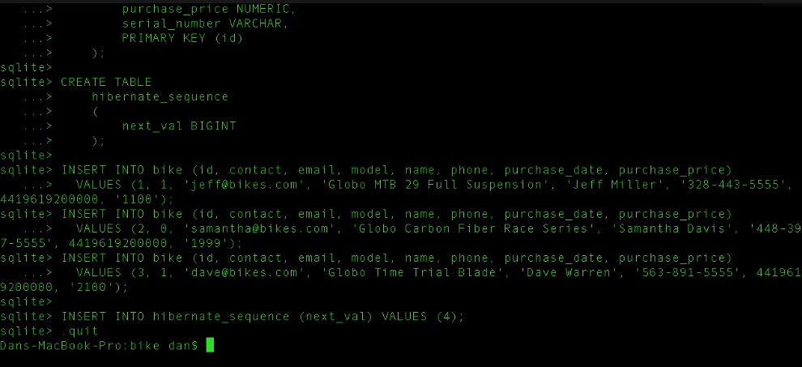

1. Copy bike.sql to the maven bike project

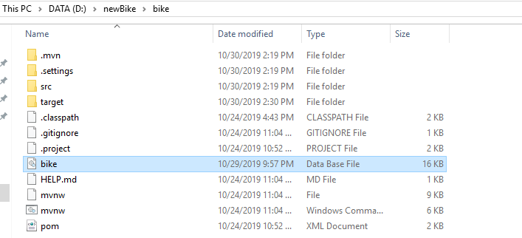

Angular Set up

1. Unzip bikeui.zip

2. Install nodejs and set the path of node in environment variables or command propmpt

set PATH=%PATH%;C:\Program Files\nodejs\

3. Run the command npm install -g @angular/cli

4. npm start

