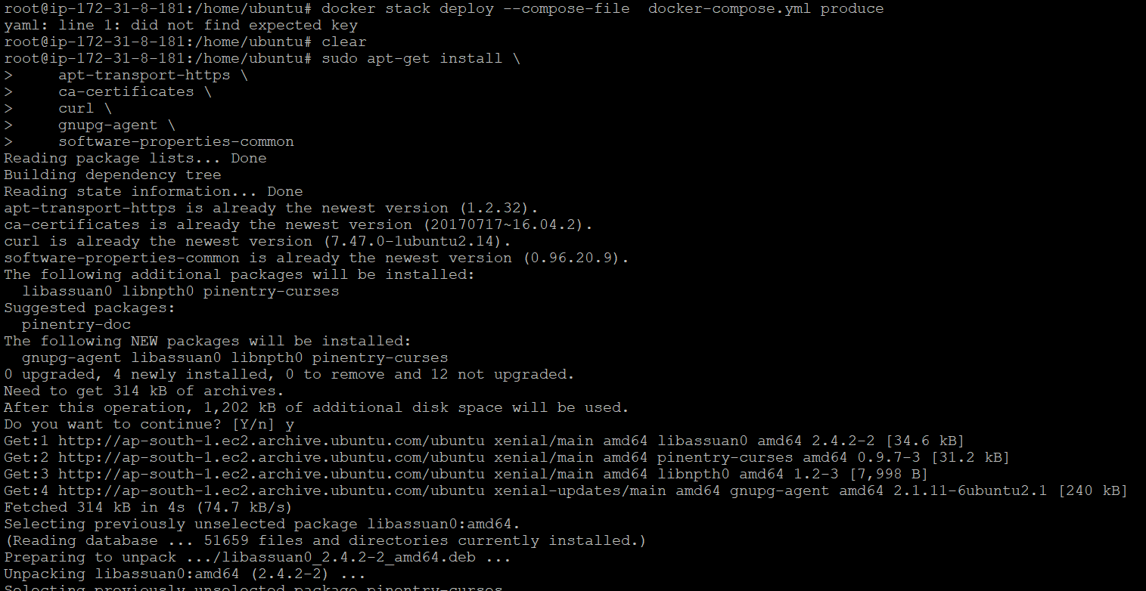

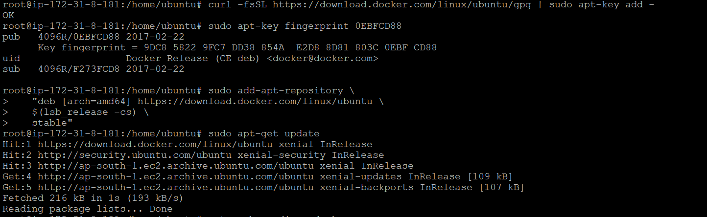

Check version installed :;

$ apt-cache madison docker-ce

$ sudo apt-get install docker-ce=5:18.09.5~3-0~ubuntu-bionic docker-ce-cli=5:18.09.5~3-0~ubuntu-bionic containerd.io

Add user ::





