1. Docker swarm init
2. Deploy stack using below .yml file

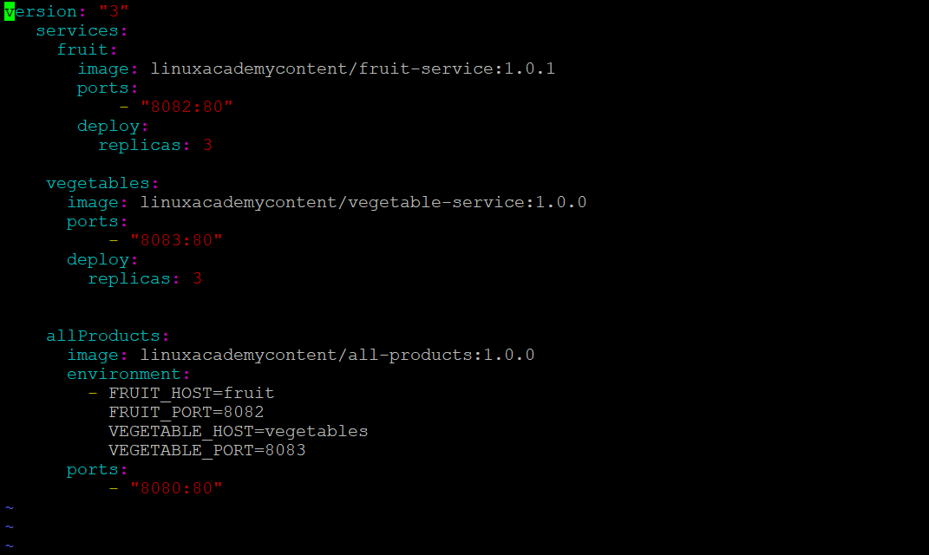

curl localhost:8080