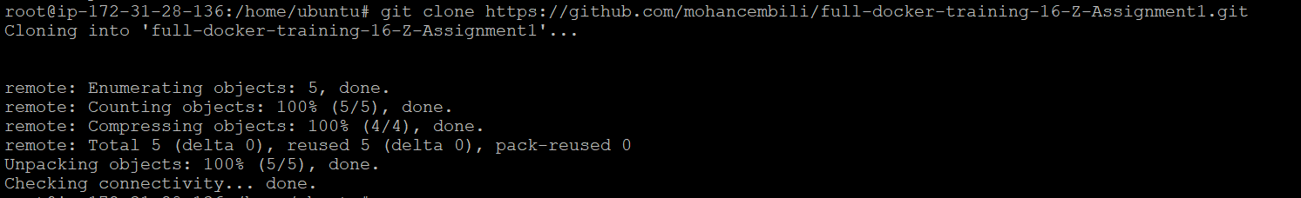

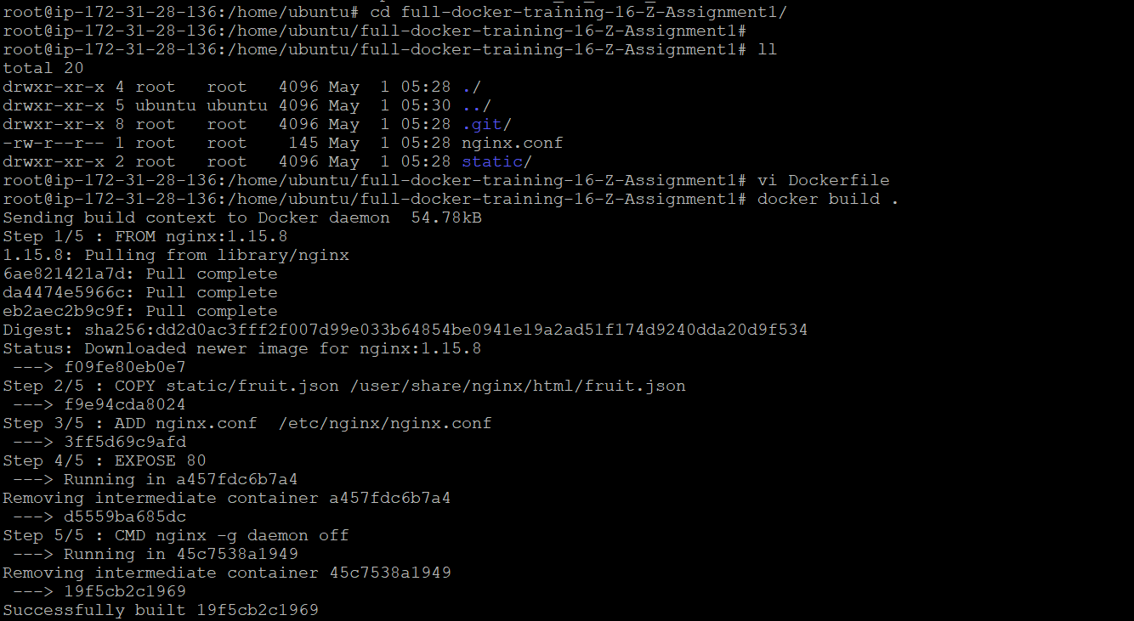

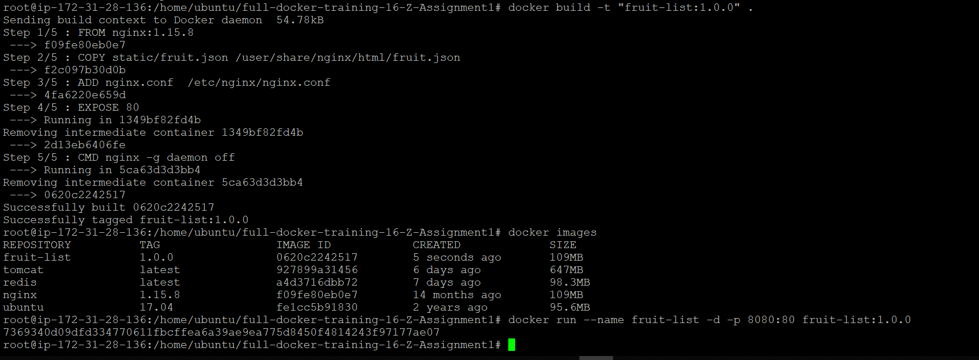

Automatically container getting Exited



Docker file is as below

FROM nginx:1.15.8

COPY static/fruit.json /user/share/nginx/html/fruit.json

ADD nginx.conf /etc/nginx/nginx.conf

EXPOSE 80

CMD nginx -g daemon off