Agriculture Helper Chatbot

In this project we are designing Chatbot for farmers where Chatbot ask farmer to upload crop image and then application will apply Deep Learning CNN algorithm to predict disease from that crop leaf and display possible remedies. After getting remedies user can ask question related to crop such as crop name and then Chatbot will display soil, rainfall and other details.

User can ask question Chatbot in their voice and application will use speech recognition algorithm to understand farmer question and then display answer.

To run project install below packages

pip install keras==2.3.1

pip install tensorflow==1.14.0

pip install tqdm==4.49.0

pip install numpy==1.19.2

pip install opencv-python==4.1.1.26

pip install pandas==0.25.3

pip install matplotlib==3.1.1

pip install h5py==2.10.0

pip install SpeechRecognition==3.8.1

pip install Django==2.1.7

to upload crop images you can upload images from ‘testImages’ folder which is showing in below screen’

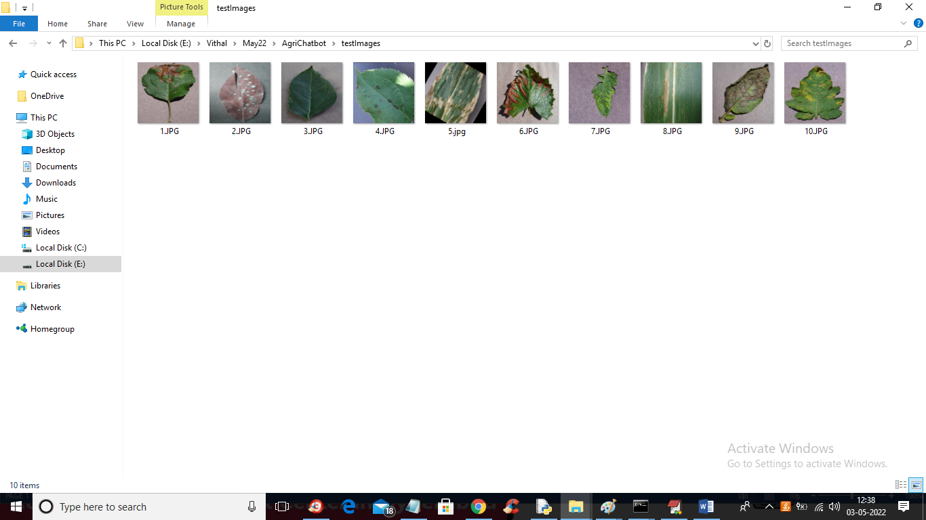

To run project double click on ‘runServer.bat’ file to start python DJANGO web server similar to below screen

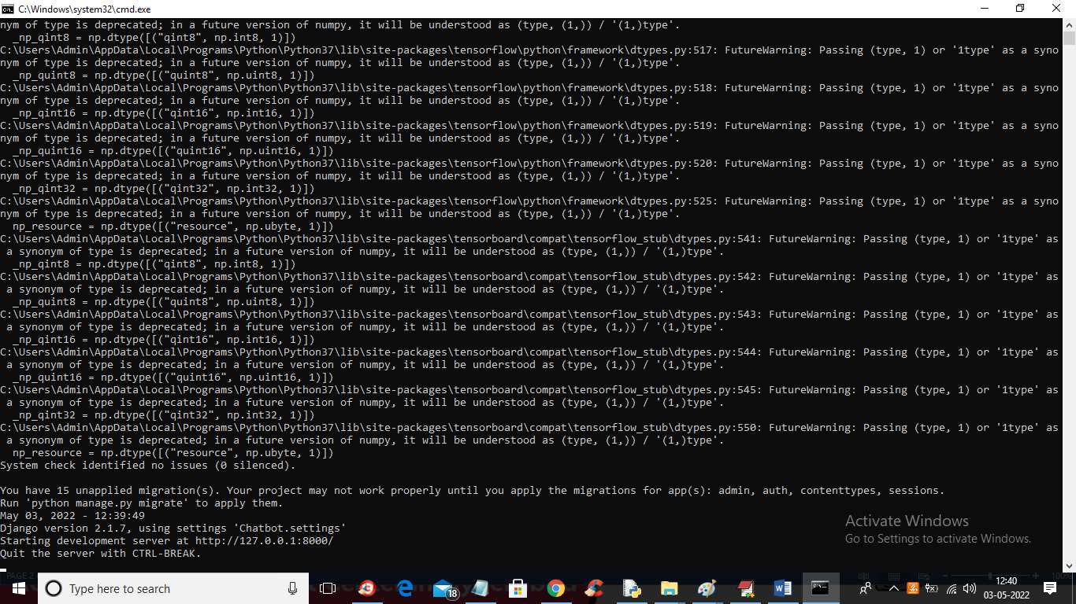

In above screen DJANGO server started and now open browser and enter URL as ‘http://127.0.0.1:8000/index.html’ and press enter key to get below screen

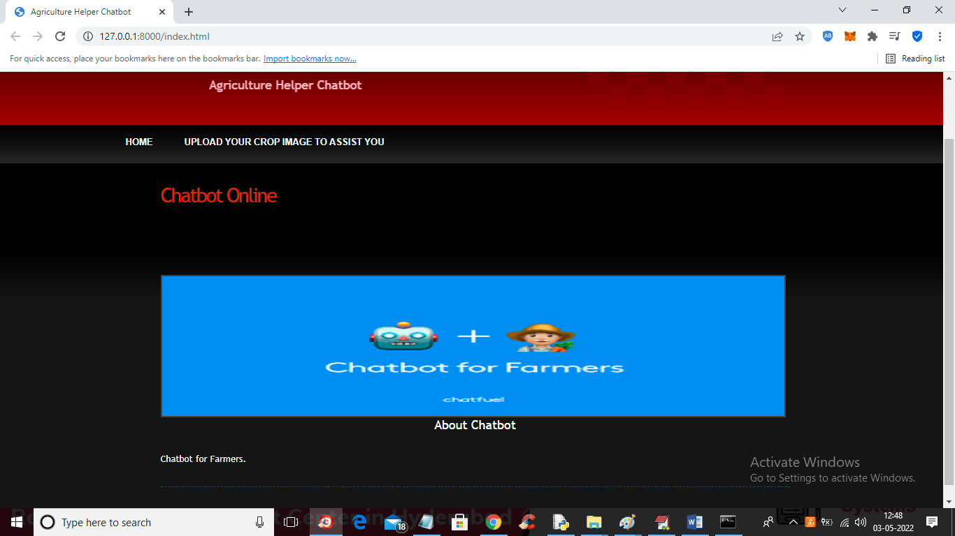

In above screen click on ‘Upload Your Crop Image to Assist You’ button to upload crop disease image like below screen

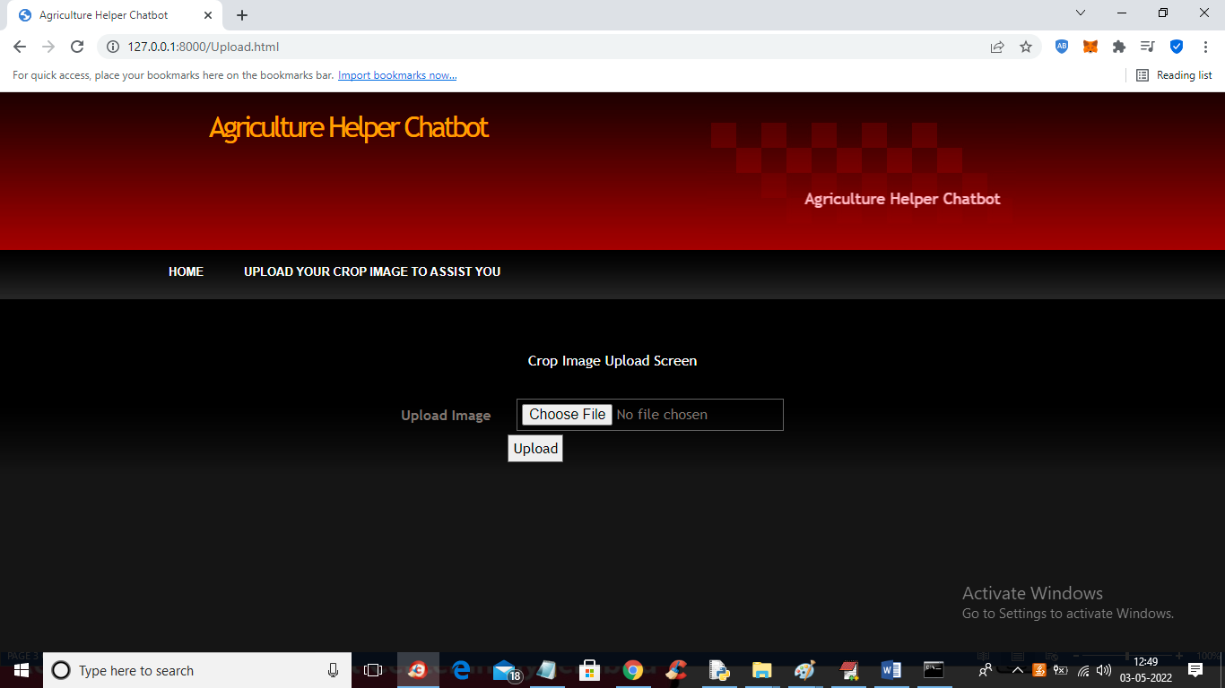

In above screen click on ‘Choose File’ button to upload crop image like below screen

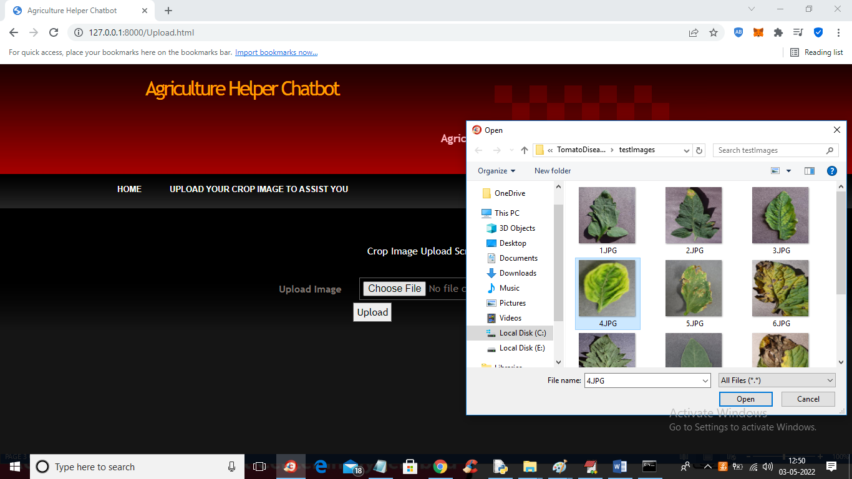

In above screen selecting and uploading ‘4.JPG’ file and then click on ‘Open’ button to load image and then click on ‘Upload’ button to get below output

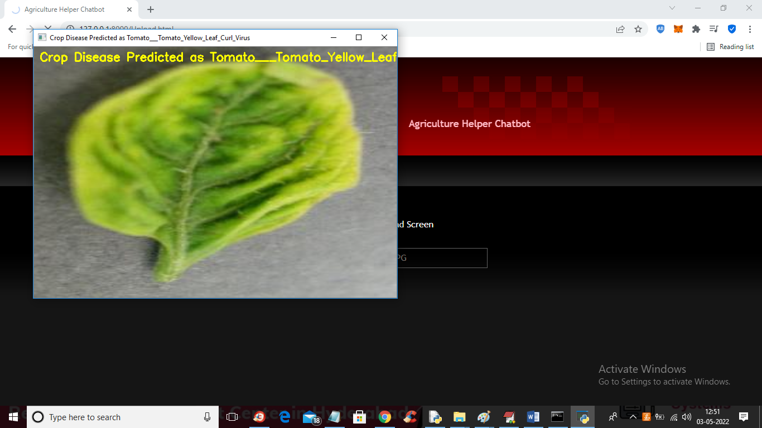

In above screen in yellow colour text we can see crop disease predicted as ‘Tomato Yellow Leaf curl’ disease and now close above image to get possible remedies from chat bot

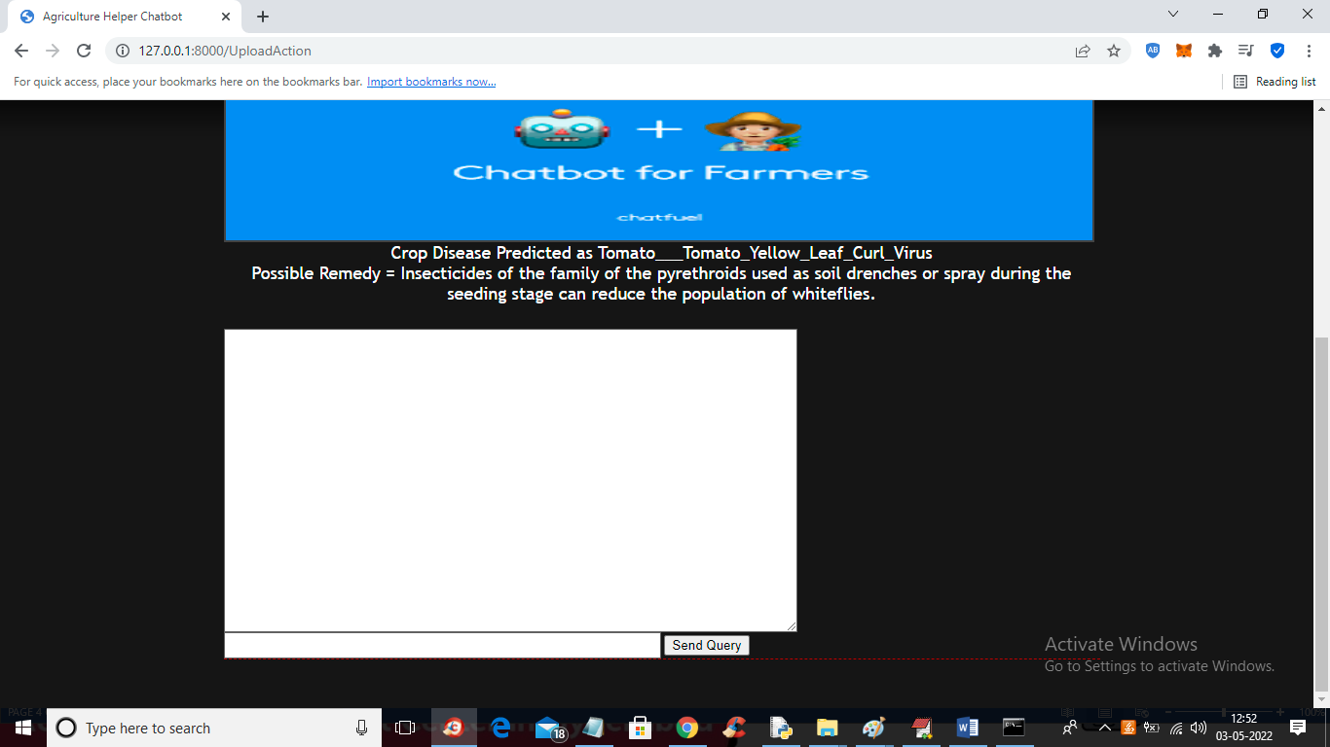

In above screen in white colour text we can see crop disease name and then displaying possible REMEDIES and now user can post queries to Chatbot by entering query in text field

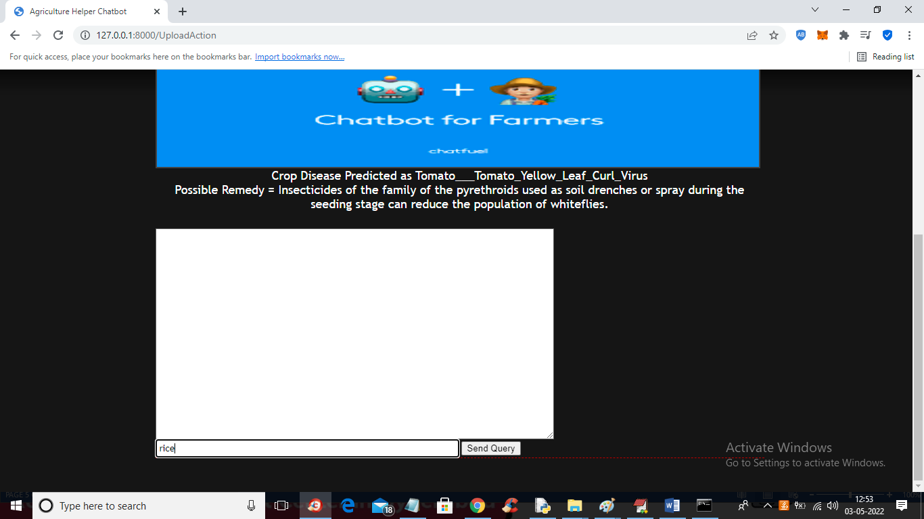

In above screen I entered query as ‘rice’ to know information on rice details and then click on ‘Send Query’ button to get below output

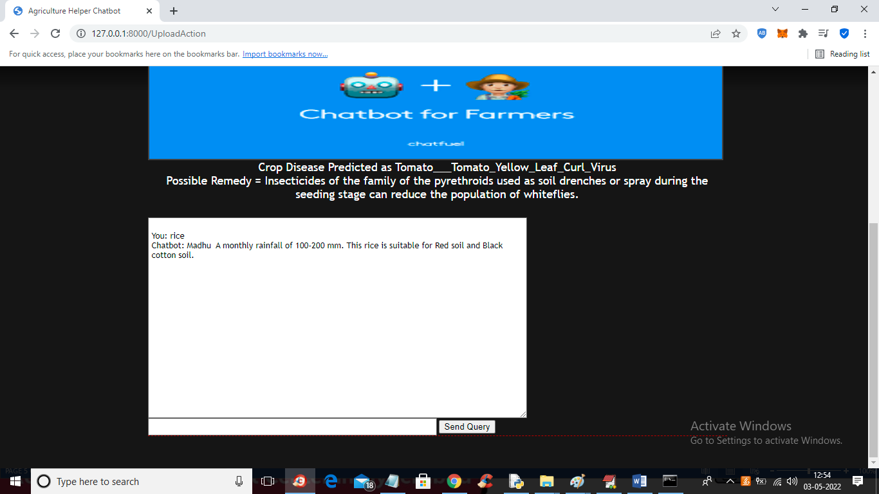

In above screen in text area we can see response from Chatbot and similarly you can enter any other query like below screen

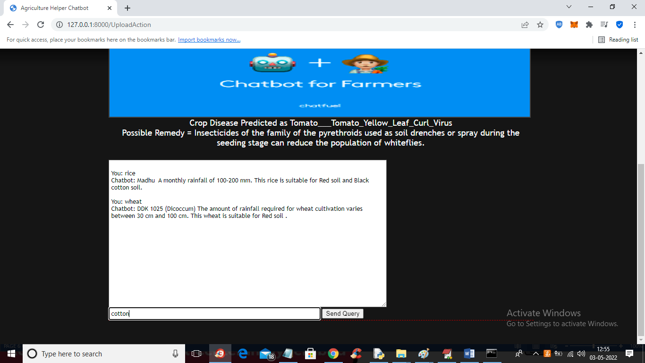

In above screen I entered query as ‘cotton’ press button to get below output

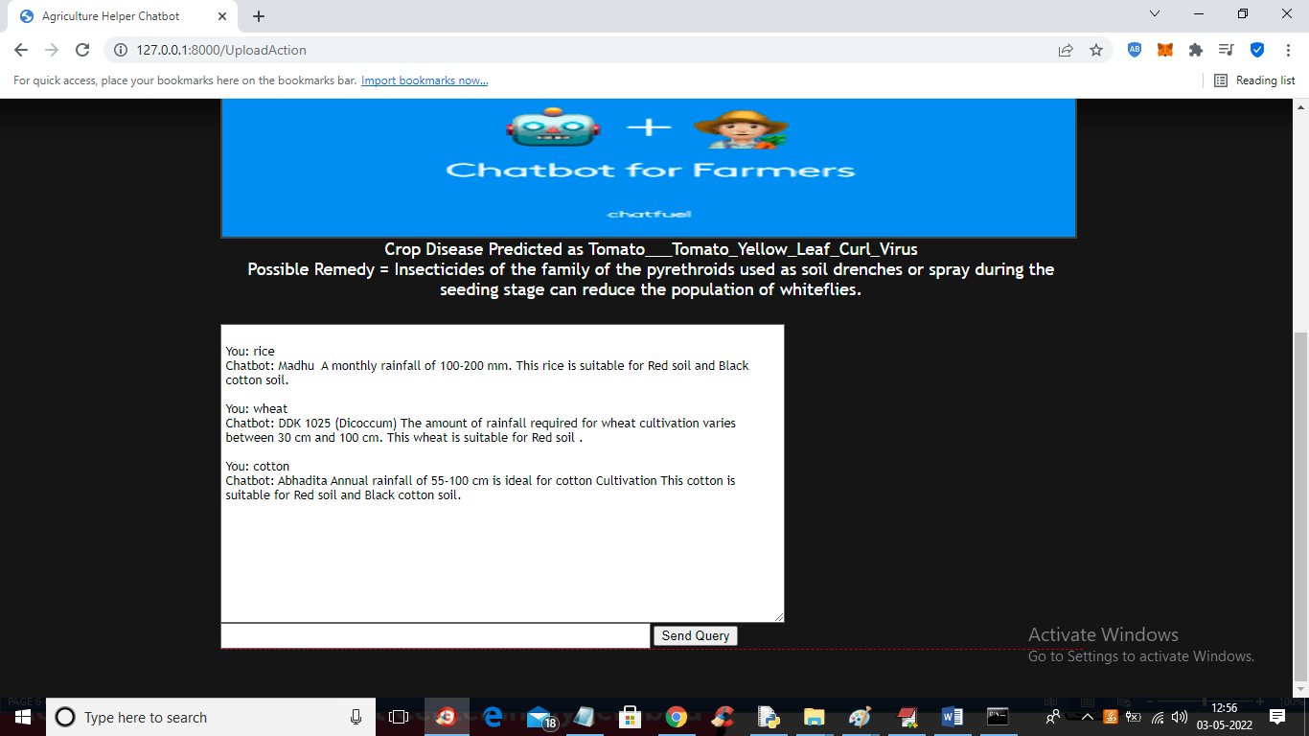

In above screen we got details for cotton crop from Chatbot and similarly you can ask any related question and if you ask unrelated question then will get below output

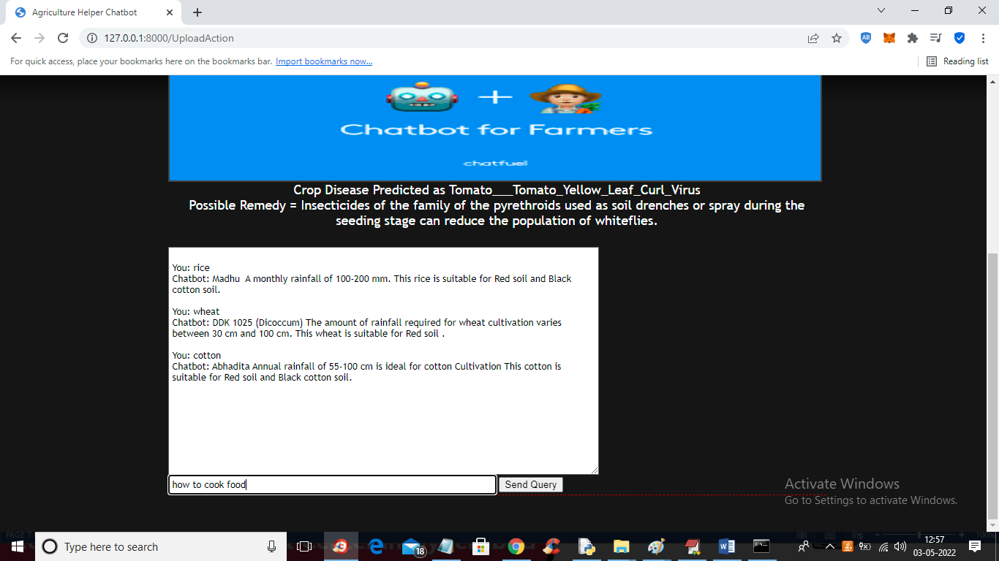

In above screen I am asking unrelated question as ‘how to cook food’ and below is the response

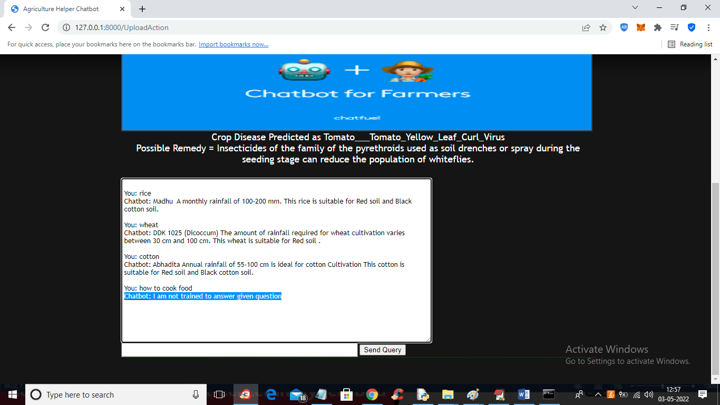

In above screen in blue colour text we can see Chatbot not trained to answer that question and if 3 times its exceed then will get below output

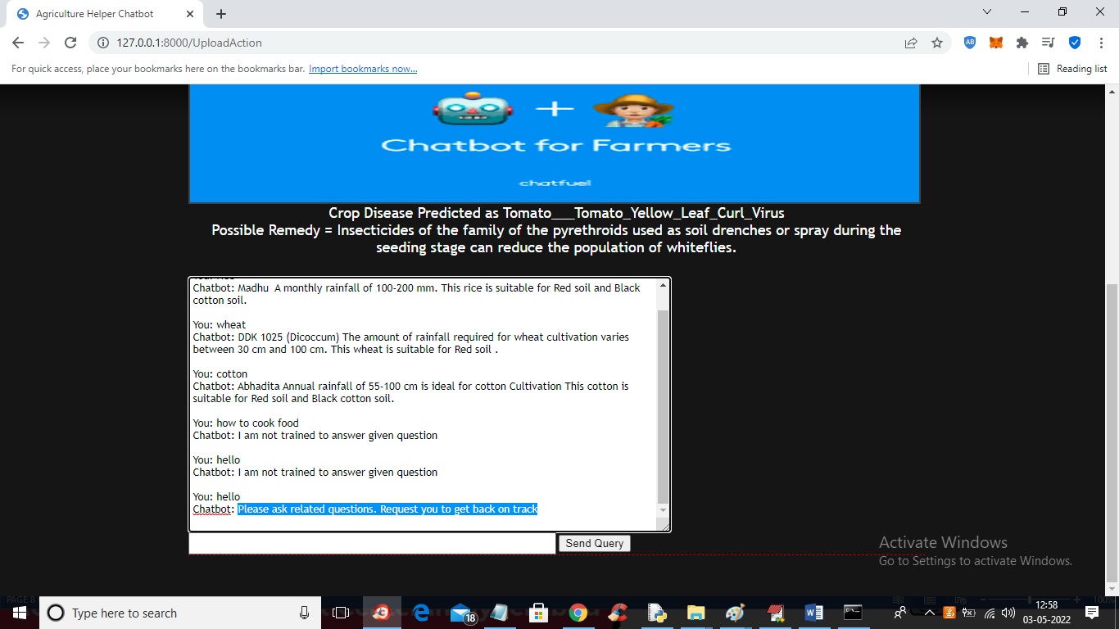

In above screen we can see ‘Chatbot suggesting user to ask related questions’ and now click on ‘Voice Based Chat’ link to allow user to Chat with Chatbot using voice questions which use speech recognition to understand user question

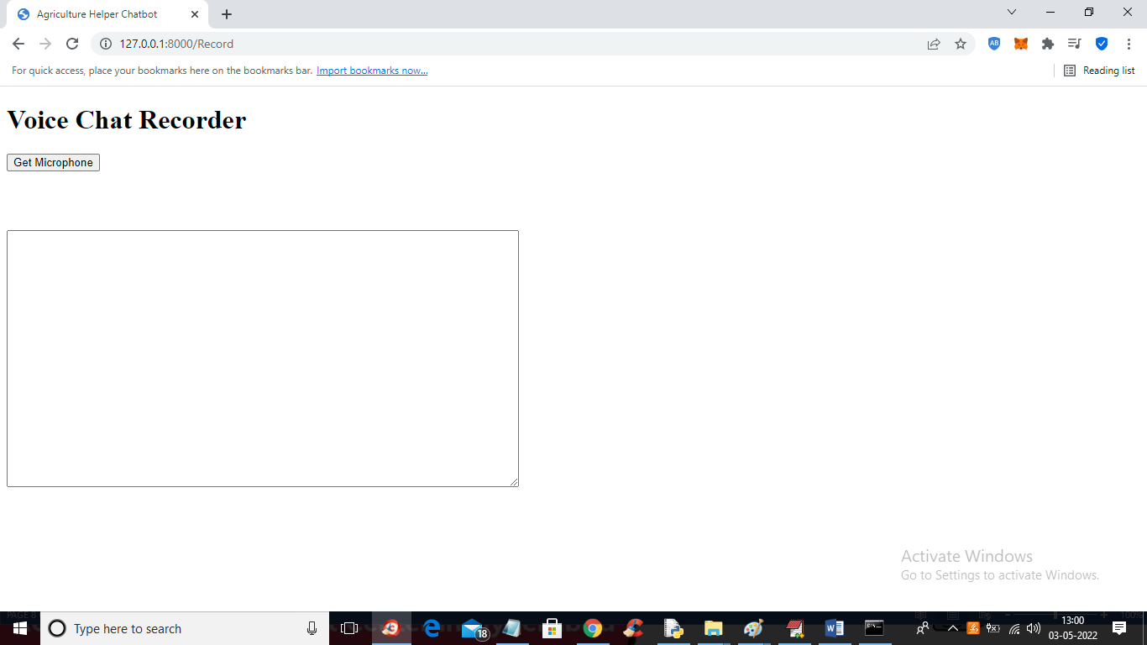

In above screen click on ‘Get Microphone’ button to connect to microphone and get below output

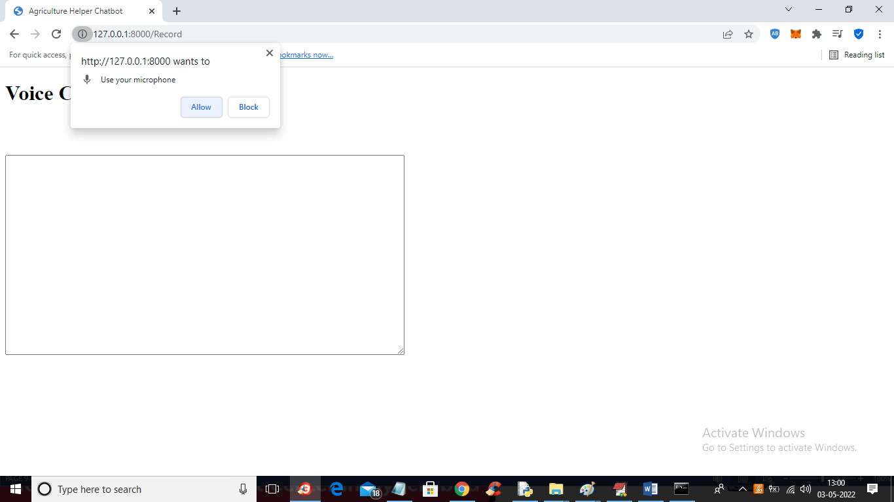

In above screen click ‘allow’ to get below output

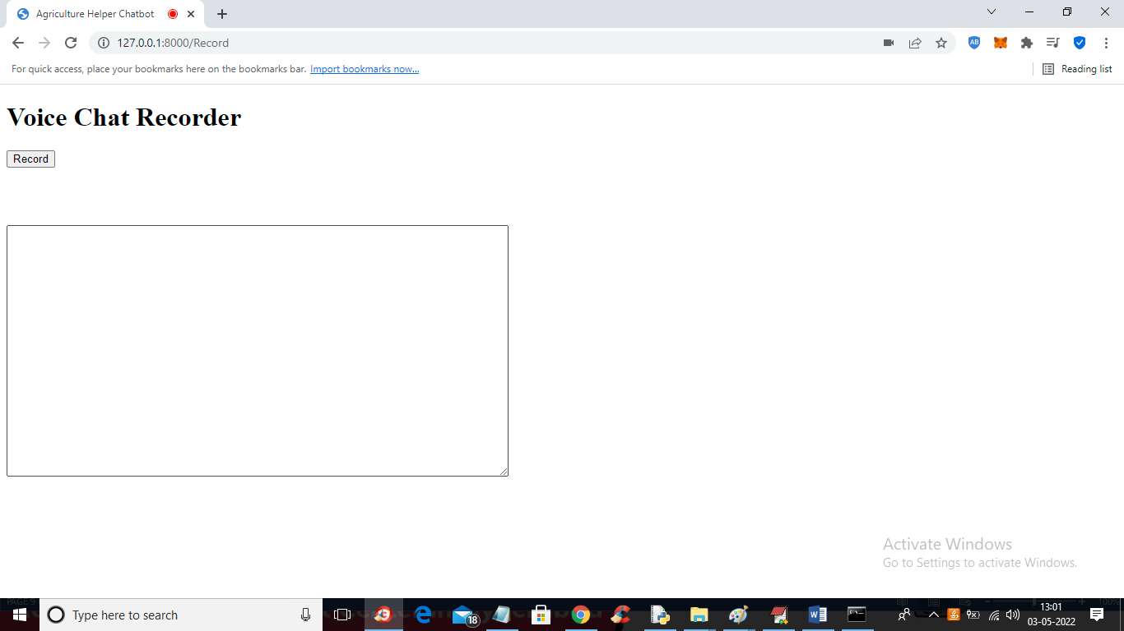

In above screen now you can ‘Record’ voice and send to Chatbot

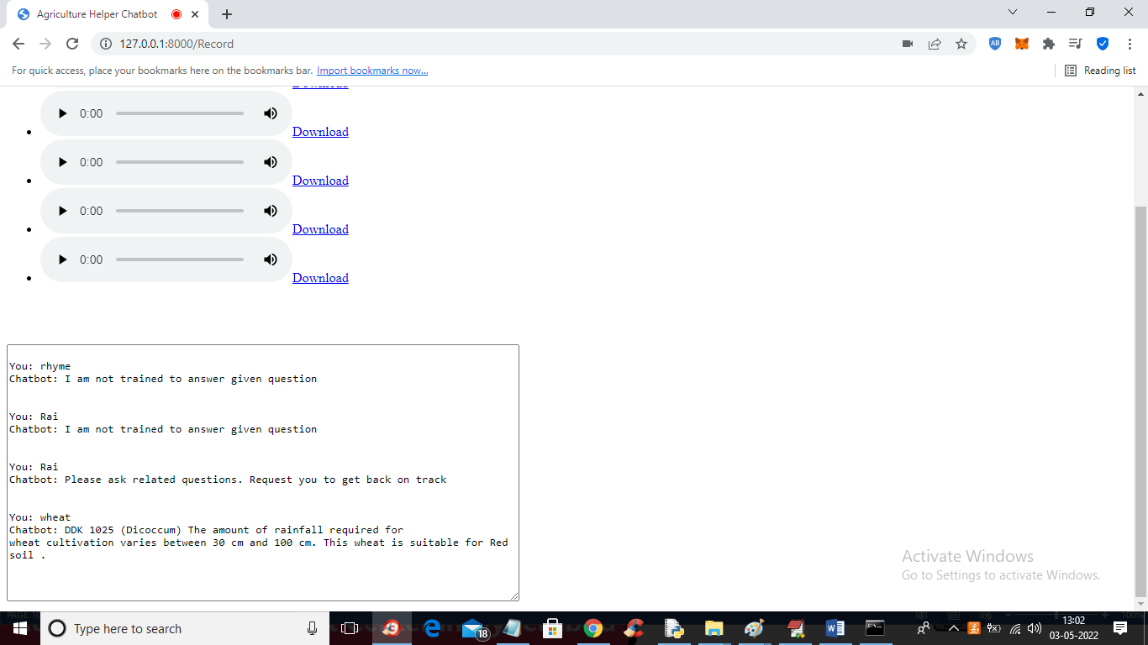

In above screen I tried for voice command as ‘rice’ but it was not cleared voice so Chatbot replied ‘Not Trained’ and then I said voice command as ‘wheat’ to get suitable condition for sowing wheat. Similarly you can ask any question

We are using below dataset for Chatbot to answers

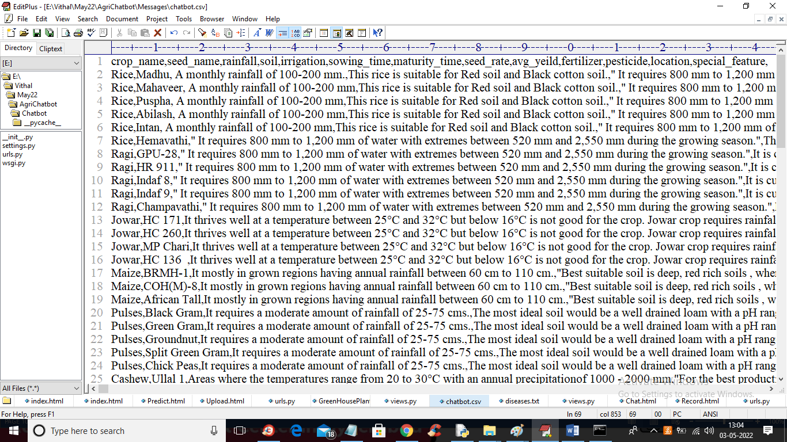

In above screen whatever crop name you entered then Chatbot will fectch details for that crop and display to user