<https://code.visualstudio.com/docs/python/python-tutorial>

* Learn openGL with python

<https://noobtuts.com/python/opengl-introduction>

* Make sure to download freeglut.dll (freeglut 3.0.0 MSVC Package)from

<https://www.transmissionzero.co.uk/software/freeglut-devel/>

go to /bin folder and use x64 version in 64 bit operating system and 64 based processor

* Make sure of this sentence , pass bytes instead of string

window = glutCreateWindow(b"I like this")

d

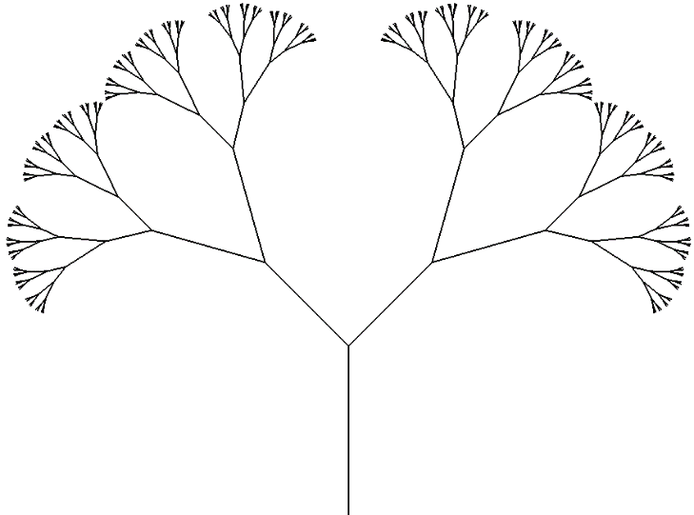

Angle starts with 45 with reduction ratio 0.56, fractal lines starts with 150 pixels and reduction ratio is 0.40, depth = 4

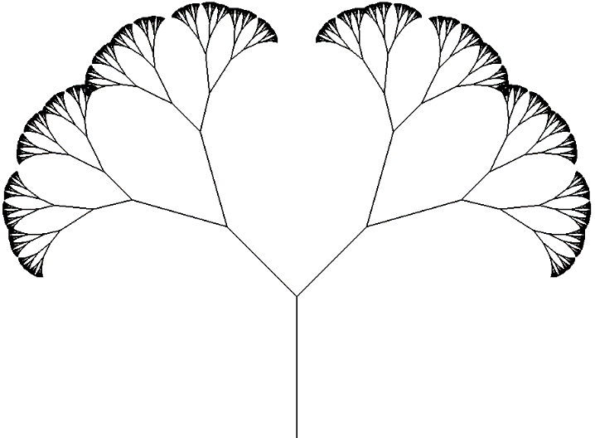

Angle starts with 45 with reduction ratio 0.56, fractal lines starts with 150 pixels and reduction ration is 0.40, depth = 8

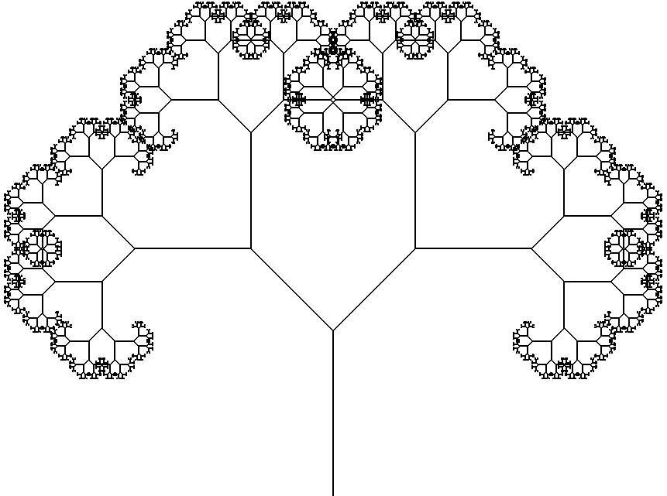

Angle is fixed to 45, fractal lines starts with 150 pixels and reduction ration is 0.40, depth = 6

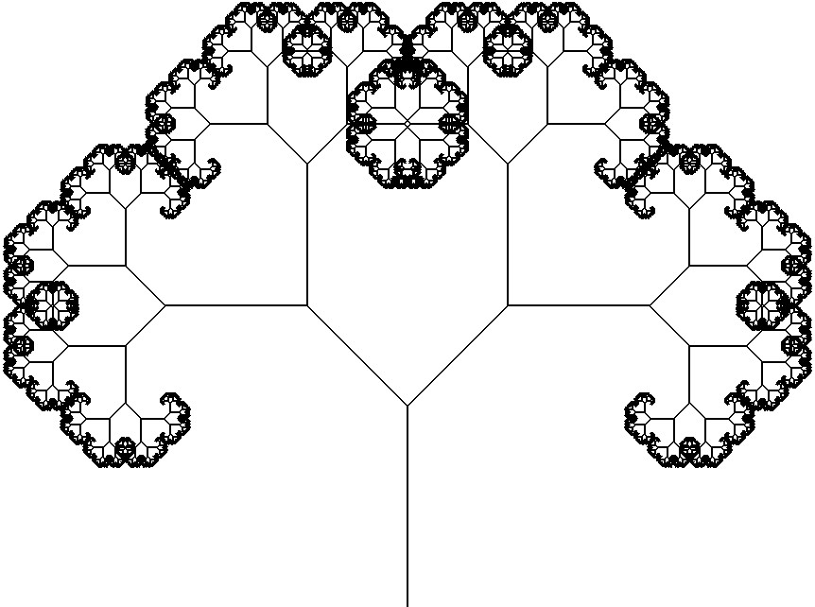

Angle is fixed to 45, fractal lines starts with 150 pixels and reduction ration is 0.40, depth = 9

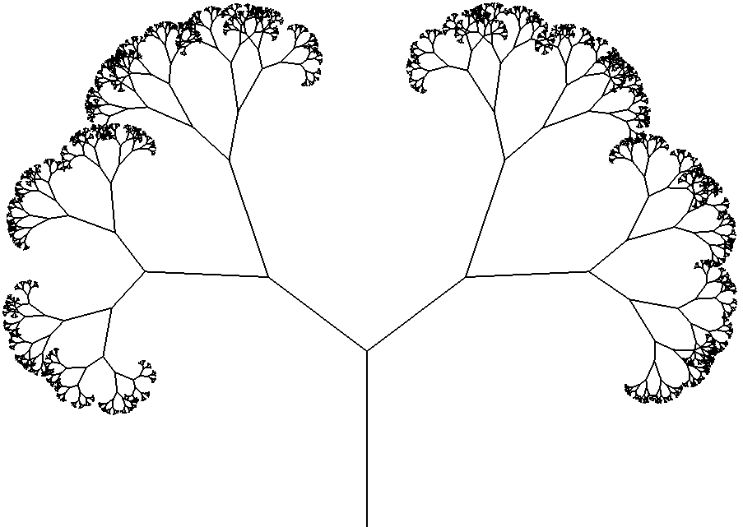

Random angle in each level, starts with random value between 55, 75 and ends with random value between 25, 45. reduction ration is 0.40, depth = 6