1.Download VirtualBox-5.0.24-108355-Win

2.http://filehippo.com/download_virtualbox/tech/68824/

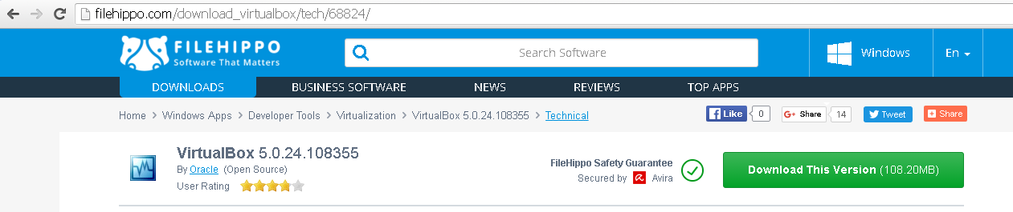

3.Download vagrant file for windows .MSI file

4.https://releases.hashicorp.com/vagrant/1.7.4/

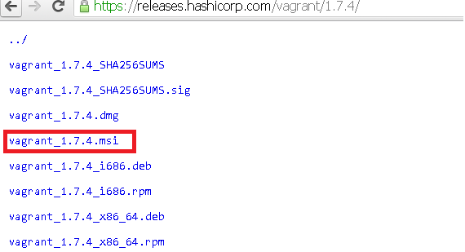

Svn Client installation :

Go to google and search subversion download

once page will open go down select windows

https://sourceforge.net/projects/win32svn

5. Goto **desktop and create one empty folder name it as vagrant and click on the path and open cmd.**

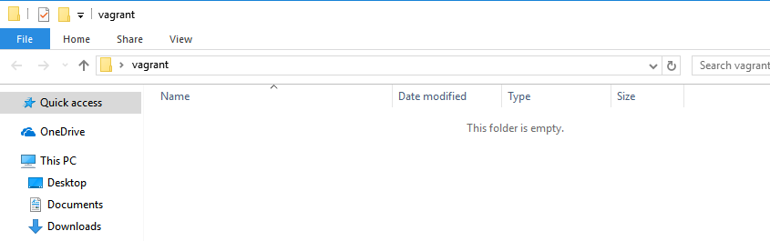

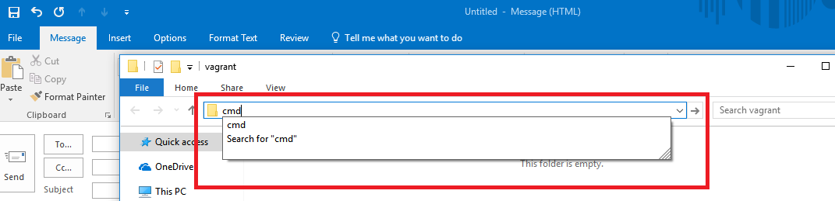

6 **run the command in vagrant folder in command prompt**

**vagrant init geerlingguy/centos6**

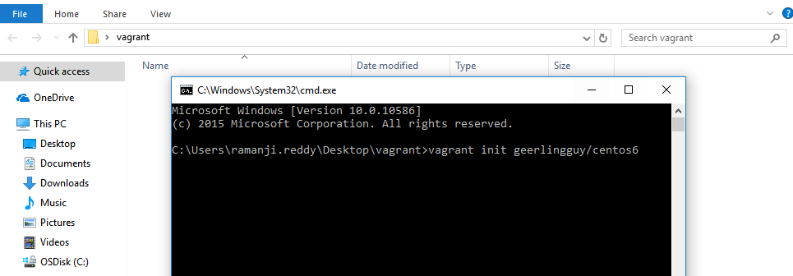

7. After that you will get the below file then open that file in **notepad go to 29th line and remove the # and save the file.**

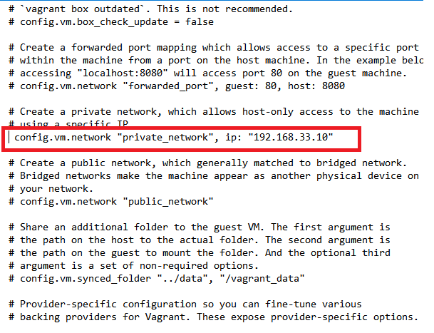

8. Now goto same command prompt and run the command **vagrant up**

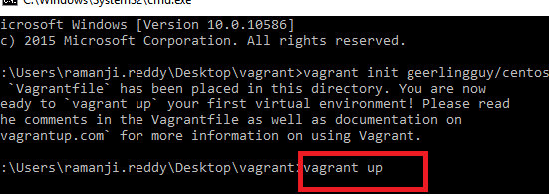

9.It will take 15min may be in that process you will get the error like connection time out error that is not issue that is default error please wait to complete the process.

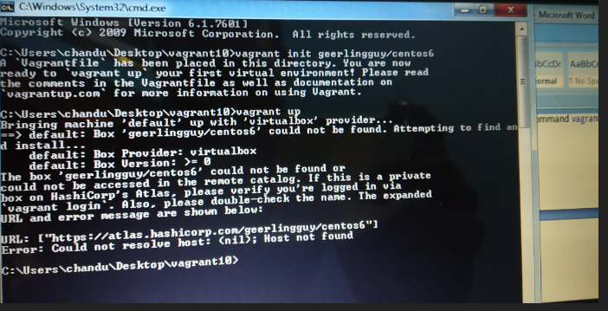

# In That VAGRANT URL Missing ..SO { Go to Vagrant Folder open Vagrantfile add the vagrant URL And Save ……Below Screen shot ….

config.vm.box_url = "<https://app.vagrantup.com/geerlingguy/boxes/centos6>"

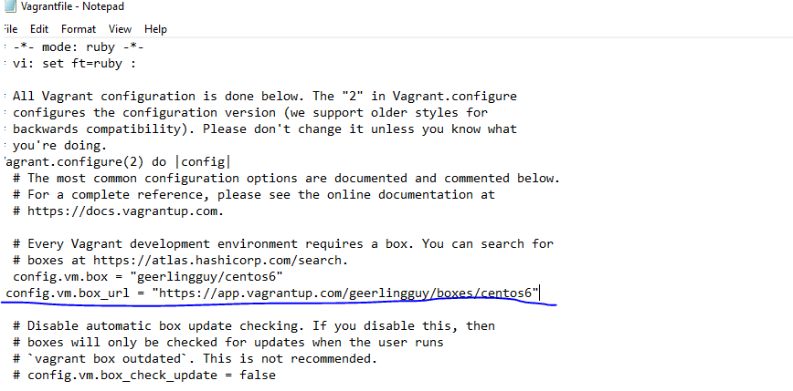

config.vm.box_url = "<https://app.vagrantup.com/geerlingguy/boxes/centos6>"

10.Once it is done go to google and download putty click 1st option

**Once you putty not connect see the below screen shot ……………..**

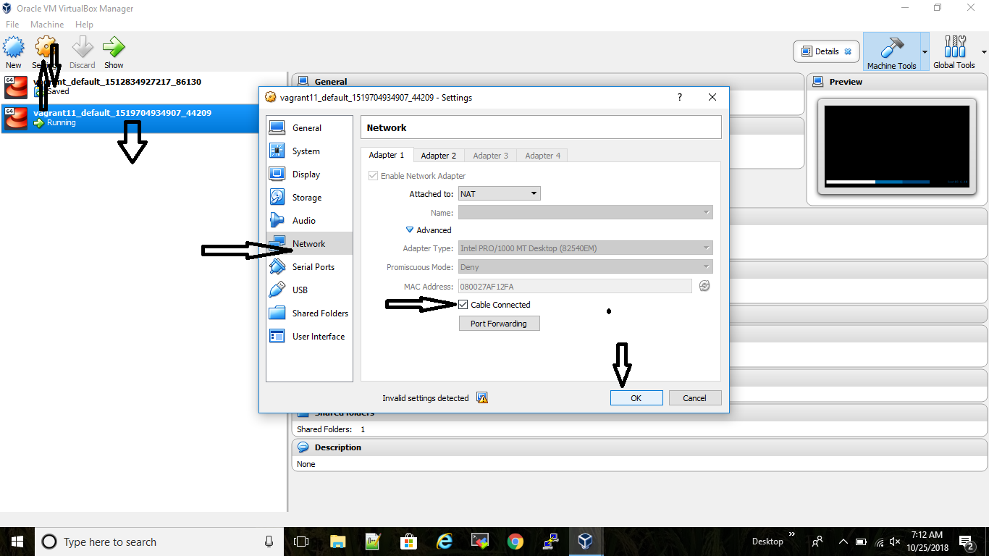

11. Again Run the command ------🡪**vagrant reload**



11. click on Putty here.

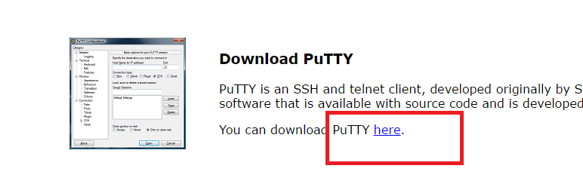

11**. Go to putty login : 192.168.33.10 user name : vagrant password : vagrant**

**Devops first Topic**

1. **SVN installation** :

go to google and search bitnami subversion and go to link

https://bitnami.com/stack/subversion/installer#linux

Now right click on svn and click on copy address link.

# Now go to putty run the command :

1). wget https://bitnami.com/redirect/to/127862/bitnami-subversion-1.9.4-1-linux-x64-installer.run

Run the commands

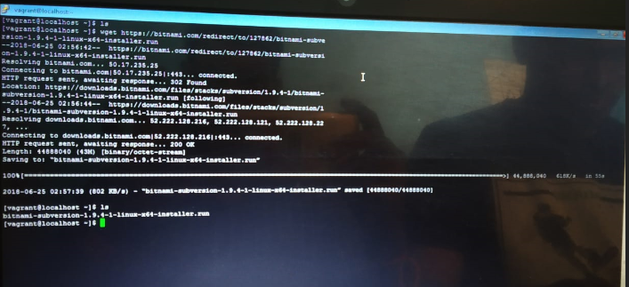

ls -l

copy the file : bitnami-subversion-1.9.4-1-linux-x64-installer.run

run the command

./bitnami-subversion-1.9.4-1-linux-x64-installer.run

Then it showing perssion error so you need to run the below command

**Given Full Permission ----------chmod 777 bitnami-subversion-1.9.4-1-linux-x64-installer.run**

2) chmod 777 bitnami-subversion-1.9.4-1-linux-x64-installer.run

Run the command : ls –l

3) ./bitnami-subversion-1.9.4-1-linux-x64-installer.run

Click on enter two times

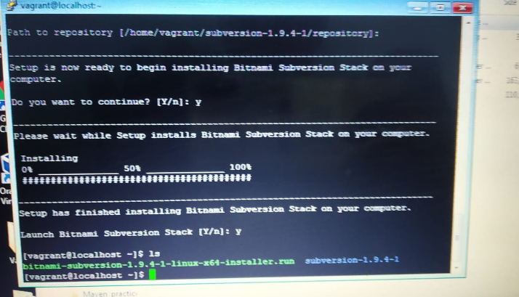

run the command ls -l

cd subversion-1.9.4-1

ls -l

sh ctlscript.sh

sh ctlscript.sh status

Go to browser http://192.168.33.10:8080/subversion/

Svn Client installation :

Go to google and search subversion download

https://subversion.apache.org/download.cgi go to binary packages

https://subversion.apache.org/packages.html

once page will open go down select windows

https://sourceforge.net/projects/win32svn/