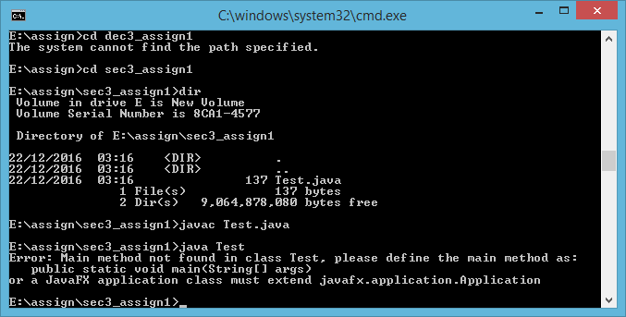

Output is

b. Will throw a NoSuchMethod error at runtime.