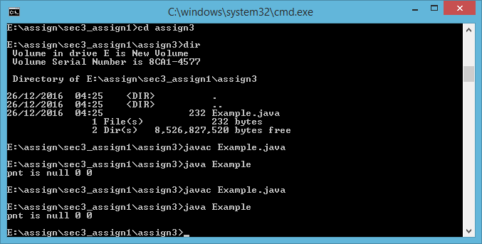

Answer is

d. The program prints pnt is null 0 0