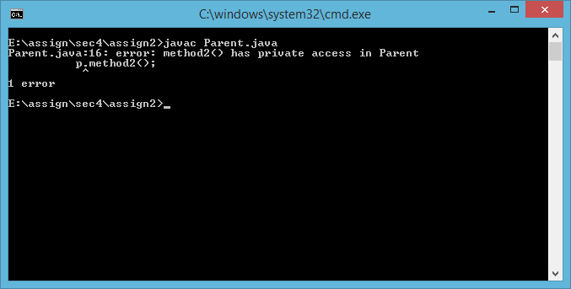

**Answer**

1. Compile-time error