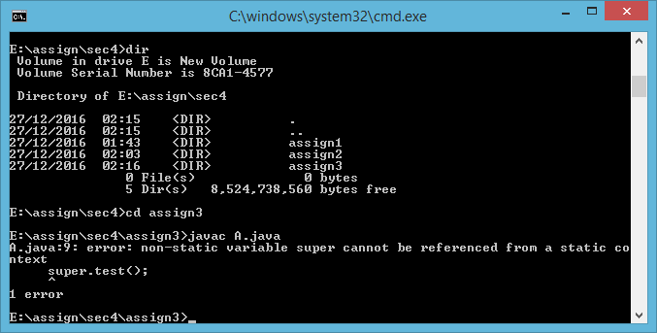

**Answer.**

**(D)** It is not possible to invoke test() method defined in C from a method in A.