UML Diagram version 1.0:

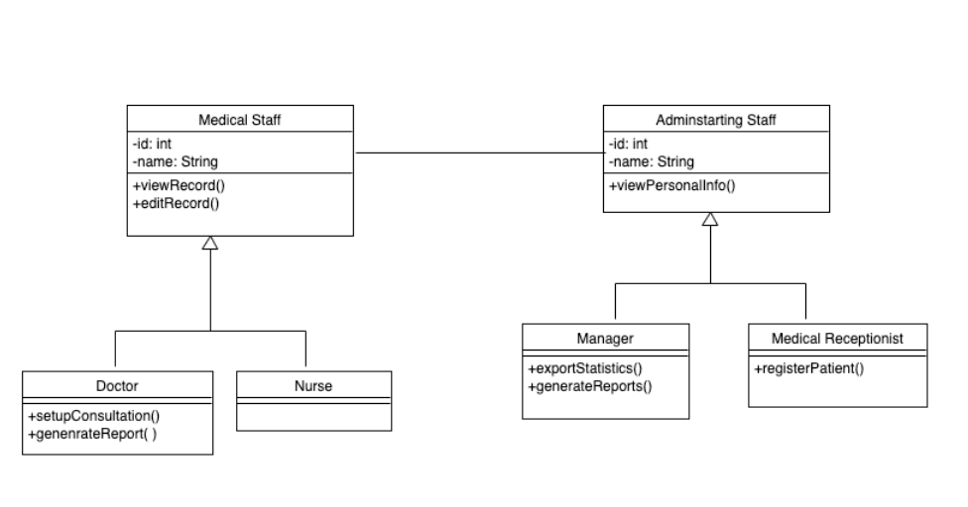

Code:

class MedicalStaff {

//veriables declation

public void viewRecords() {

// the code goes here

}

public void editRecords() {

// the code gose here

}

}

class Nurse extends MedicalStaff {

// Veriables Decleration

}

class Doctor extends MedicalStaff{

public void setupConsultation() {

// The code gose here

}

public void generateReport() {

// The code gose here

}

}

class AdminstrationStaff {

//Veriables Decleration

public void viewPersonalInfo() {

// the code goes here

}

}

class Manager extends AdminstrationStaff {

//Veriables Decleration

public void exportStatistics() {

// the code goes here

}

public void generateReport() {

//The code gose here

}

}

class MedicalReceptionist extends AdminstrationStaff {

//Veriables Decleration

public void registerPersonlInfo() {

// the code goes here

}

}

UML version 2.0:

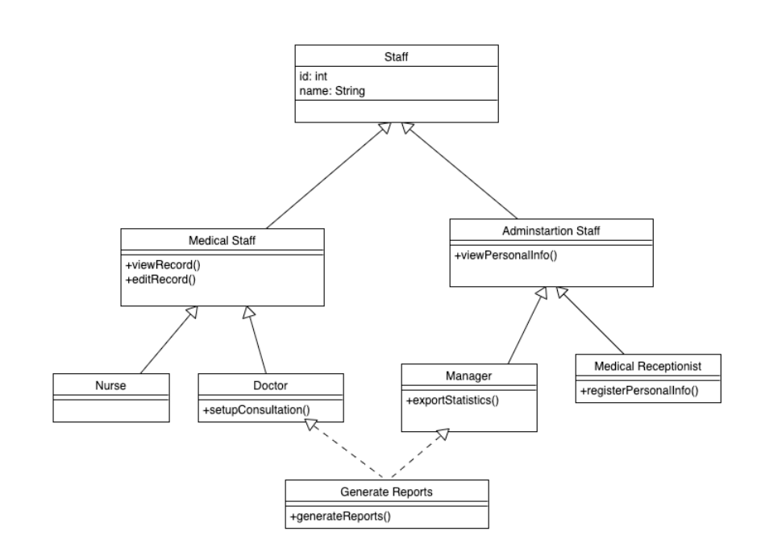

Code:

public class Staff {

//satff veriables

//staff methods

}

class MedicalStaff extends Staff {

//Medical Staff veriables

public void viewRecords() {

// the code goes here

}

public void editRecords() {

// the code gose here

}

}

class Nurse extends MedicalStaff {

// Veriables Decleration

}

class Doctor extends MedicalStaff implements GenerateReport{

public void setupConsultation() {

// The code gose here

}

@Override

public void generateReport() {

// TODO Auto-generated method stub

}

}

class AdminstrationStaff extends Staff {

//Veriables declrations

public void viewPersonalInfo() {

// the code goes here

}

}

class Manager extends AdminstrationStaff implements GenerateReport {

// Veriables decleration

public void exportStatistics() {

// the code goes here

}

@Override

public void generateReport() {

// TODO Auto-generated method stub

}

}

class MedicalReceptionist extends AdminstrationStaff {

// Veriables Decelrations

public void registerPersonlInfo() {

// the code goes here

}

}

interface GenerateReport{

void generateReport();

}