Aircraft Performance Model:
A Conceptual-Level Mission Analysis Tool
Technical Report
Mohaned
Aerospace Engineering, University of Manchester
Personal Engineering Portfolio Project — Summer 2026

Abstract
This report documents the development of a Python-based aircraft performance model built from first principles across five structured phases: steady level flight, takeoff, climb and descent, cruise and range, and longitudinal static stability. Each phase was independently validated before being integrated into a single continuous mission simulation that tracks aircraft weight as fuel is consumed throughout a representative flight.
The model is applied to two contrasting aircraft configurations — a long-haul design and a short-haul design — to demonstrate how fundamental performance characteristics (takeoff distance, climb rate, range, and fuel-use distribution) scale with aircraft size, thrust-to-weight ratio, and mission profile. A key analytical finding, identified through the modelling process itself rather than assumed in advance, is the distinction between maximum endurance speed and maximum range speed — two genuinely different optimum flight conditions that are frequently conflated.
The project demonstrates the application of fundamental aerodynamic and performance theory to a working computational tool, following a conceptual-design-level methodology consistent with established aerospace engineering practice.

Table of Contents
Abstract 1
Table of Contents 1
1. Introduction 1
1.1 Objectives 1
1.2 Scope 1
1.3 Methodology Approach 1
2. Methodology 1
2.1 Steady Level Flight 1
2.2 Takeoff Performance 1
2.3 Climb and Descent 1
2.4 Cruise and Range 1
2.5 Longitudinal Static Stability 1
3. Mission Integration 1
3.1 Fuel Fraction Method 1
3.2 Mission Sequence 1
3.3 Fuel Conservation Verification 1
4. Results: Long-Haul vs Short-Haul Comparison 1
4.1 Aircraft Configurations 1
4.2 Mission Results 1
4.3 Discussion of Results 1
5. Limitations and Assumptions 1
6. Conclusion 1
6.1 Possible Future Extensions 1
Appendix A: Code Structure 1

1. Introduction

1.1 Objectives
The objective of this project was to build a working aircraft performance model covering the full range of flight phases an aircraft experiences during a mission, using only fundamental aerodynamic and flight mechanics theory. The model was developed entirely in Python, structured to mirror real engineering software practice: physics functions, aircraft data, execution logic, and visualisation kept in clearly separated files.

1.2 Scope
The model covers the following phases, developed sequentially over five structured weeks:
- Steady level flight — the fundamental force balance (lift = weight, thrust = drag)
- Takeoff — stall speed, liftoff speed, ground roll distance (analytical and numerical methods)
- Climb and descent — rate of climb, glide performance, best glide speed and CL
- Cruise and range — fuel burn, the Breguet range equation, and the distinction between maximum range and maximum endurance flight conditions
- Longitudinal static stability — centre of gravity, neutral point, and static margin
These five phases were subsequently integrated into a single mission profile function, applied comparatively to two different aircraft configurations representing long-haul and short-haul design philosophies.

1.3 Methodology Approach
This model operates at conceptual design level — the level of fidelity used early in aircraft design to compare configurations and establish baseline performance, before detailed engineering analysis. Several standard conceptual-design simplifications were used throughout and are stated explicitly wherever applied, consistent with established methodology (e.g. Raymer's fuel-fraction method for mission fuel allocation).

2. Methodology

2.1 Steady Level Flight
Steady level flight requires two simultaneous force balances: lift equals weight, and thrust equals drag. Lift and drag were calculated using standard aerodynamic relations:
L = 0.5 x rho x V^2 x S x CL
CD = cd0 + k x CL^2 (the drag polar)
D = 0.5 x rho x V^2 x S x CD
Where cd0 represents zero-lift (parasitic) drag and k x CL^2 represents induced drag — drag generated as a direct consequence of producing lift. A steady_flight() check function verifies both force balances within a defined tolerance, accounting for the fact that exact equality is rarely achieved in floating-point computation.
A further function, CL_required(), calculates the lift coefficient an aircraft must generate at a given speed to remain level — used extensively throughout later phases to determine realistic flight conditions at any chosen velocity.
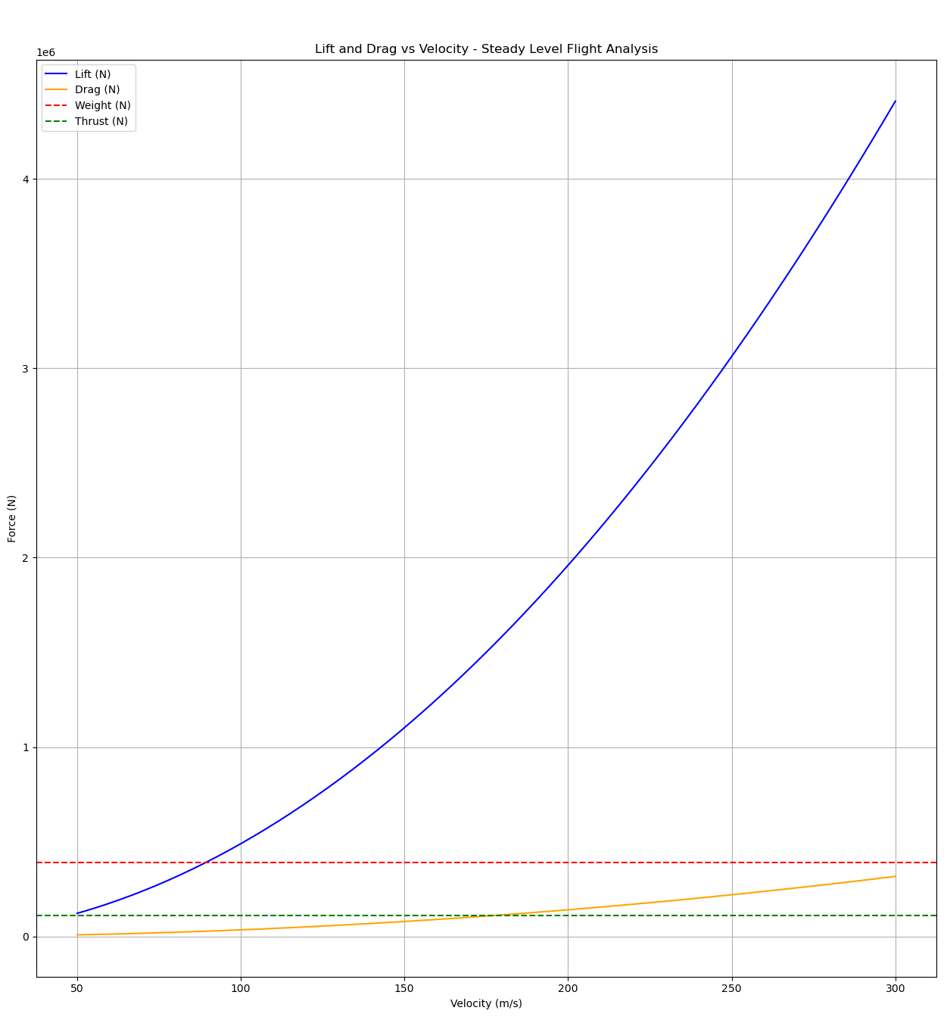

2.2 Takeoff Performance
Stall speed was derived by rearranging the lift equation under the condition L = W and CL = CL_max:
V_stall = sqrt(2W / (rho x S x CL_max))
Liftoff speed was taken as 1.2 x V_stall, a standard safety margin applied in real aircraft operations, since aircraft do not lift off at exactly stall speed.
Takeoff ground roll distance was calculated two ways, allowing direct comparison between analytical and numerical methods:
- Analytical method — assumes a single average acceleration calculated at 70% of liftoff speed, then applies the kinematic equation s = V^2 / 2a
- Numerical method — integrates acceleration in small time steps (dt = 0.1s) across the full ground roll, recalculating lift, drag, and friction at every step as speed increases
The numerical method is more accurate because it captures the continuously changing forces during ground roll — friction decreases as lift builds (reducing the normal force on the wheels), while drag increases with speed. The analytical method's single average-condition assumption is a simplification that trades some accuracy for computational simplicity.
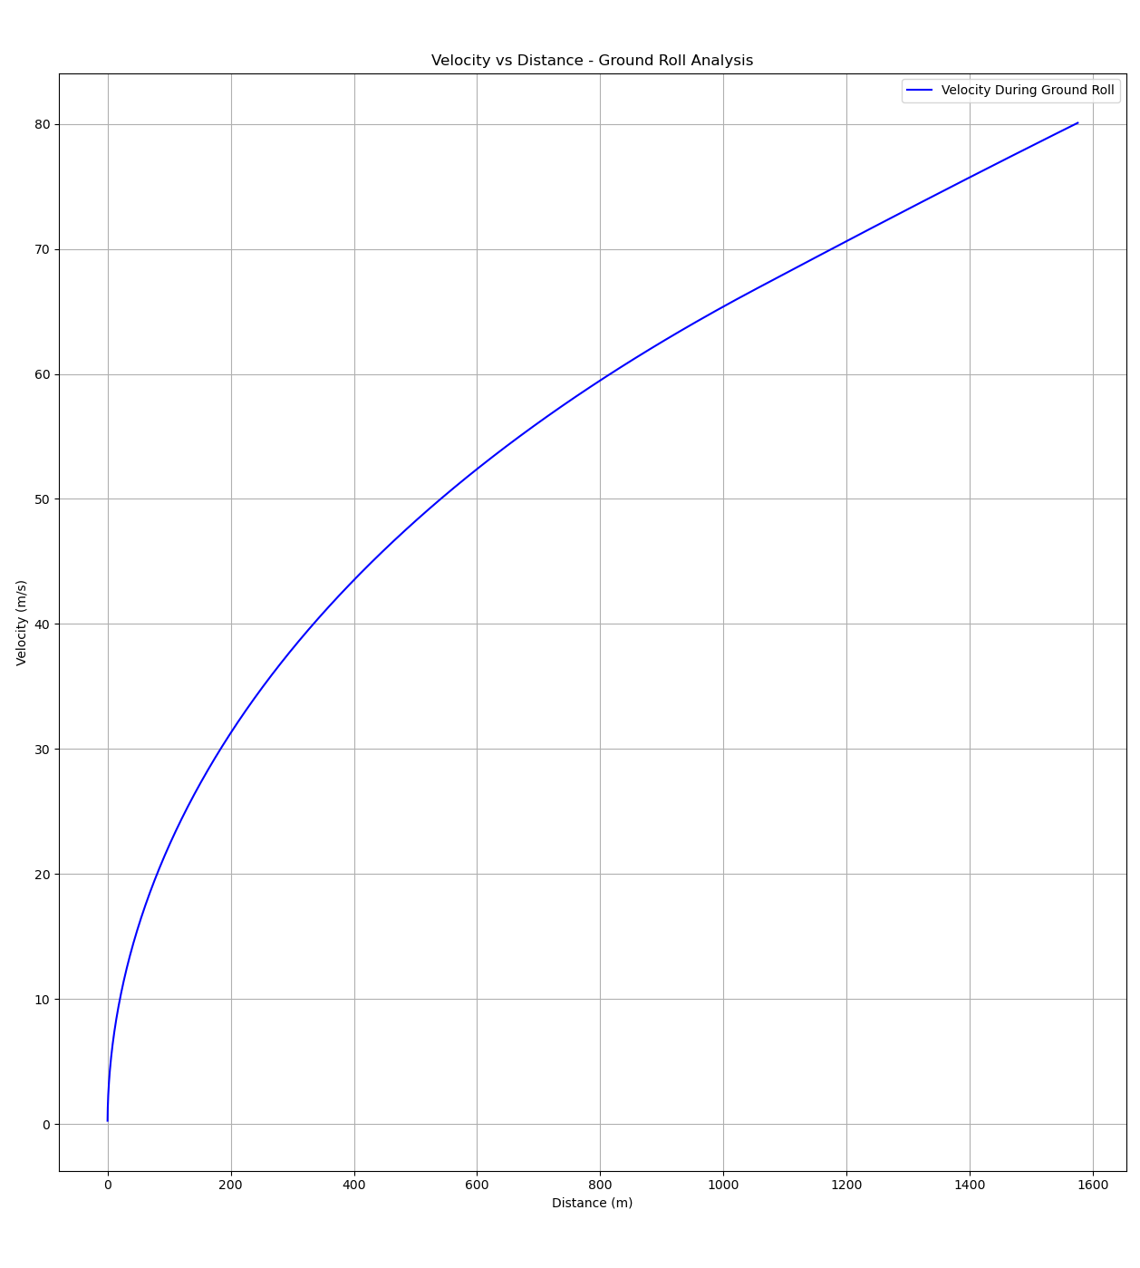

2.3 Climb and Descent
Rate of climb is derived from the excess thrust available beyond what is needed to overcome drag, converted into a vertical speed:
RC = (T - D) x V / W
At the cruise condition where T = D, RC = 0 — confirming that steady level flight is simply the special case of climb/descent analysis where no excess thrust exists. As velocity increases, drag grows while thrust remains roughly constant, meaning excess thrust — and therefore RC — peaks at an intermediate speed known as best climb speed (Vy), rather than increasing indefinitely.
Rate of descent mirrors this relationship, with the pure glide case (engines fully idle, T = 0) of particular interest:
RD = (D - T) x V / W -> RD_glide = D x V / W (when T = 0)
Two distinct optimum points were identified for the glide case:
- Minimum sink rate — the speed that keeps the aircraft airborne longest per unit of altitude lost
- Best glide speed (maximum L/D) — the speed that covers the greatest horizontal distance per unit of altitude lost, found analytically via CL_opt = sqrt(cd0/k)
These are different speeds answering different questions, and both are operationally meaningful (e.g. an engine-out emergency over land favours maximum distance; over water, maximum time aloft may be preferable).
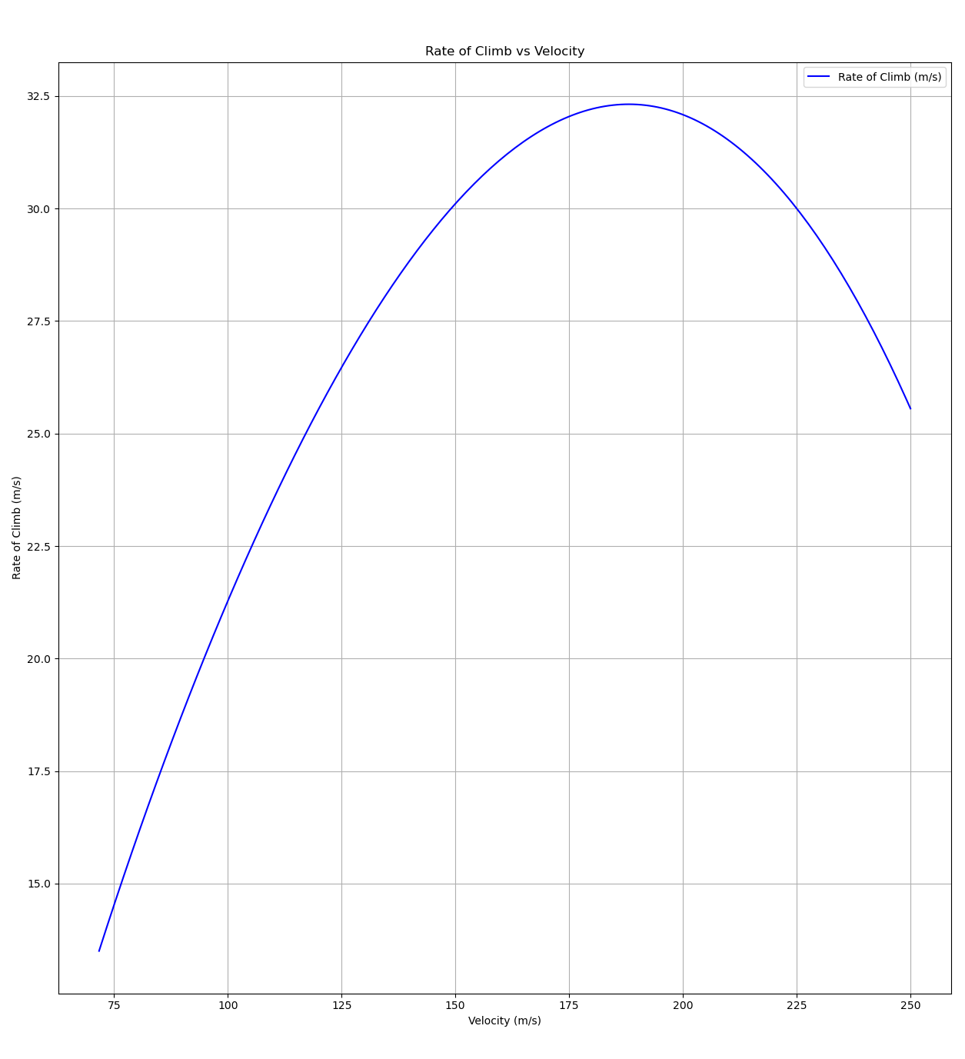
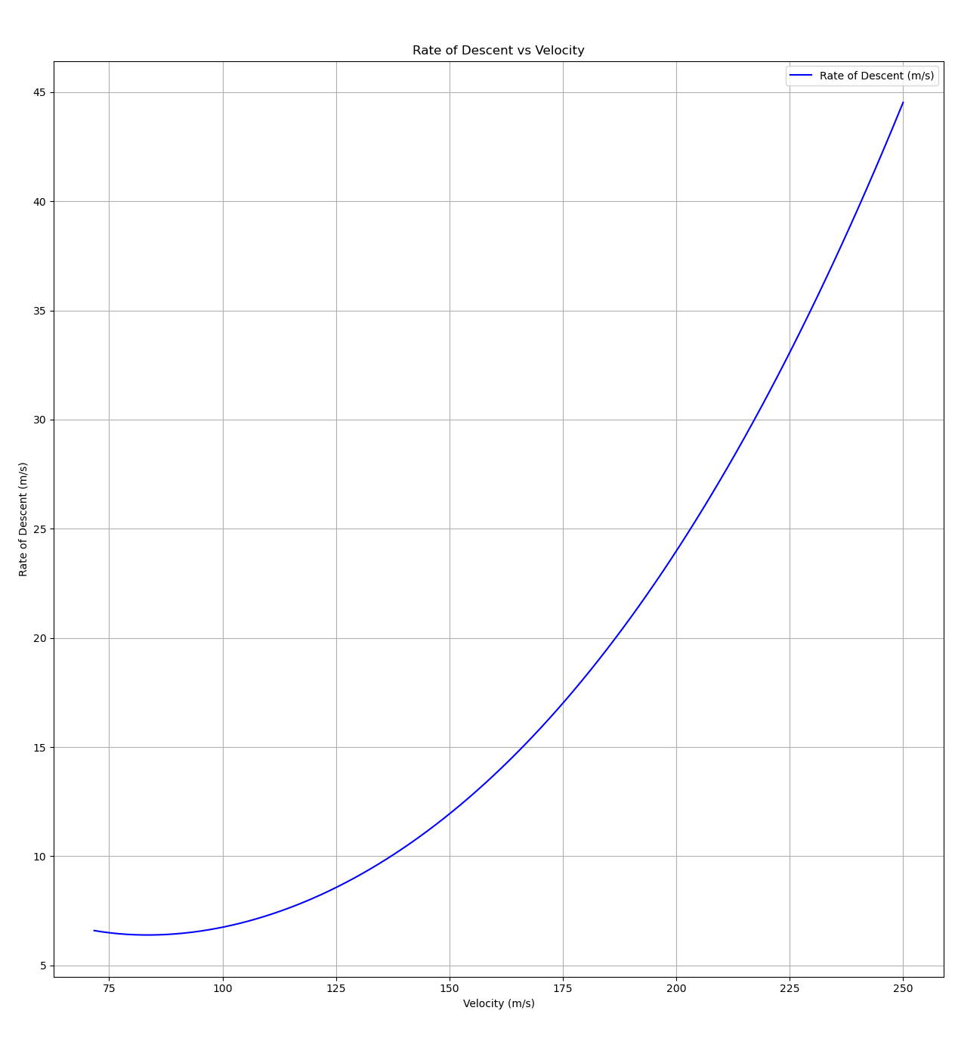

2.4 Cruise and Range
Cruise range was modelled using the Breguet Range Equation, the standard analytical model for jet aircraft cruise performance:
Range = (V / c) x (L/D) x ln(W_initial / W_final)
where c is specific fuel consumption (fuel burned per unit thrust per unit time), and W_final is the aircraft's weight after the fuel allocated to cruise has been consumed.
Key simplifying assumption: the Breguet equation assumes a cruise-climb flight profile, where the pilot maintains constant CL (and therefore constant L/D and true airspeed) by gradually climbing to higher altitude as weight decreases, with reduced air density compensating for reduced weight. Under this assumption only weight changes during cruise, captured entirely by the logarithmic term. Real airliners fly discrete altitude “step climbs” rather than continuous cruise-climb, due to air traffic control altitude assignments — meaning this model gives the theoretical maximum achievable range under idealised conditions, not an exact real-world figure. This is a standard and accepted simplification at conceptual design level.
A notable finding emerged directly from the modelling process: minimum-drag speed (the speed that minimises D, used for cruise efficiency) is mathematically identical to best glide speed (the speed that maximises L/D), since in steady flight L always equals W, making D = W/(L/D) — minimising one is equivalent to maximising the other. The same best_glide_CL() and best_glide_speed() functions built in Section 2.3 were therefore reused directly for cruise analysis without modification.
Maximum endurance vs maximum range — a genuine distinction: plotting cruise range across a range of velocities revealed the optimum cruise speed (~144 m/s) is noticeably higher than best glide speed (~109.6 m/s). This is correct, well-established aerospace behaviour rather than an error: maximum ENDURANCE speed (longest time airborne per unit fuel) occurs at maximum L/D, while maximum RANGE speed (greatest distance per unit fuel) is faster, because range depends on V x (L/D) jointly — covering more ground compensates for operating slightly above the point of absolute minimum drag. For jet aircraft, a known closed-form relationship connects the two:
V_max_range = 3^(1/4) x V_max_endurance ≈ 1.316 x V_max_endurance
This relationship was confirmed independently by the model: the calculated value (144.24 m/s) matched the empirically plotted peak almost exactly, validating the internal consistency of the cruise model.
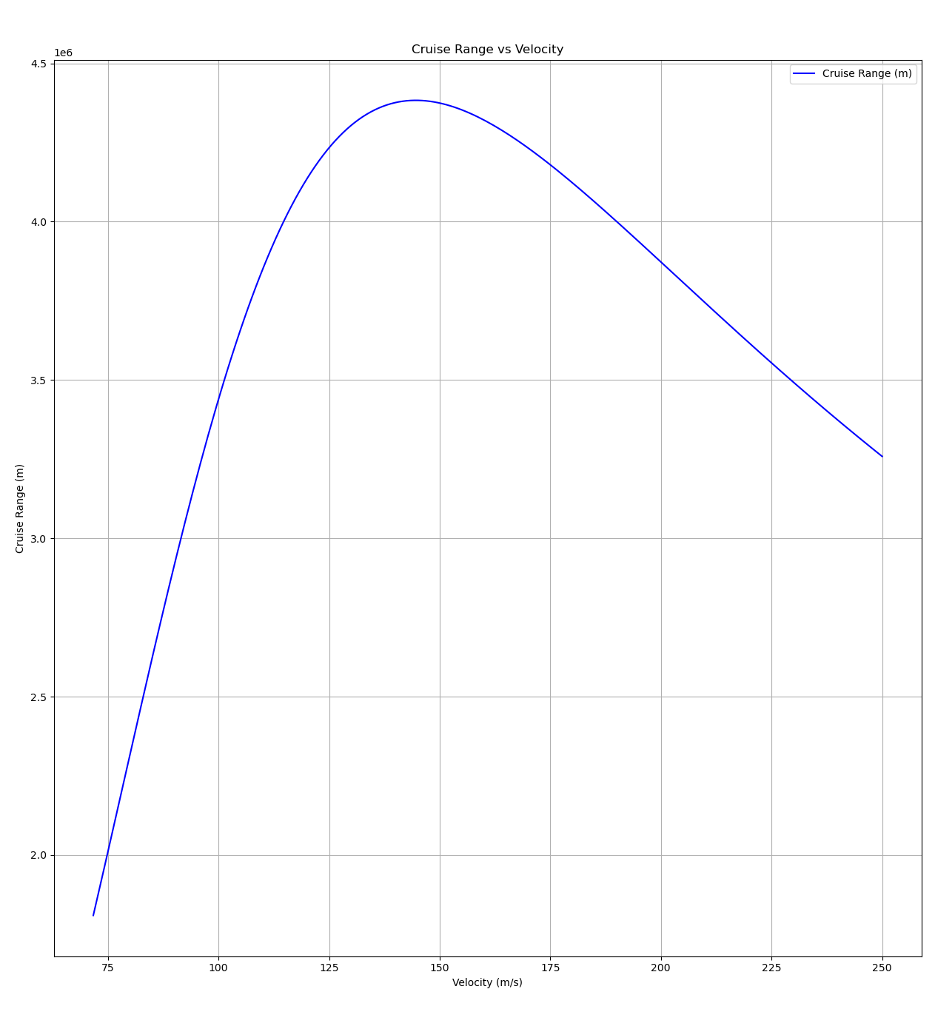

2.5 Longitudinal Static Stability
Static stability addresses a fundamentally different question to performance: not how fast, far, or high the aircraft can fly, but whether it naturally returns to its original attitude after being disturbed by a gust.
The physical mechanism: when a disturbance pitches the nose up, angle of attack increases and lift increases — particularly on the tail. Where that additional lift acts relative to the aircraft's Centre of Gravity (CG) determines the resulting moment:
- CG ahead of the Neutral Point (NP) — additional lift acts behind CG — produces a nose-down restoring moment — STABLE
- CG behind NP — additional lift acts ahead of CG — produces a nose-up moment that amplifies the disturbance — UNSTABLE
Static margin quantifies this relationship, normalised by wing chord so results are comparable across aircraft of different sizes:
SM = (NP - CG) / chord
Typical commercial aircraft target SM between 0.05 and 0.15 — below this range the aircraft is only marginally stable; above it, the aircraft becomes excessively stable and sluggish to manoeuvre. A sensitivity analysis varying CG while holding NP and chord fixed confirmed the expected linear relationship, with the static margin crossing zero exactly at CG = NP, and a gradient of exactly -1/chord — meaning aircraft with a longer chord are inherently less sensitive to CG shifts caused by fuel burn, passenger movement, or cargo loading.
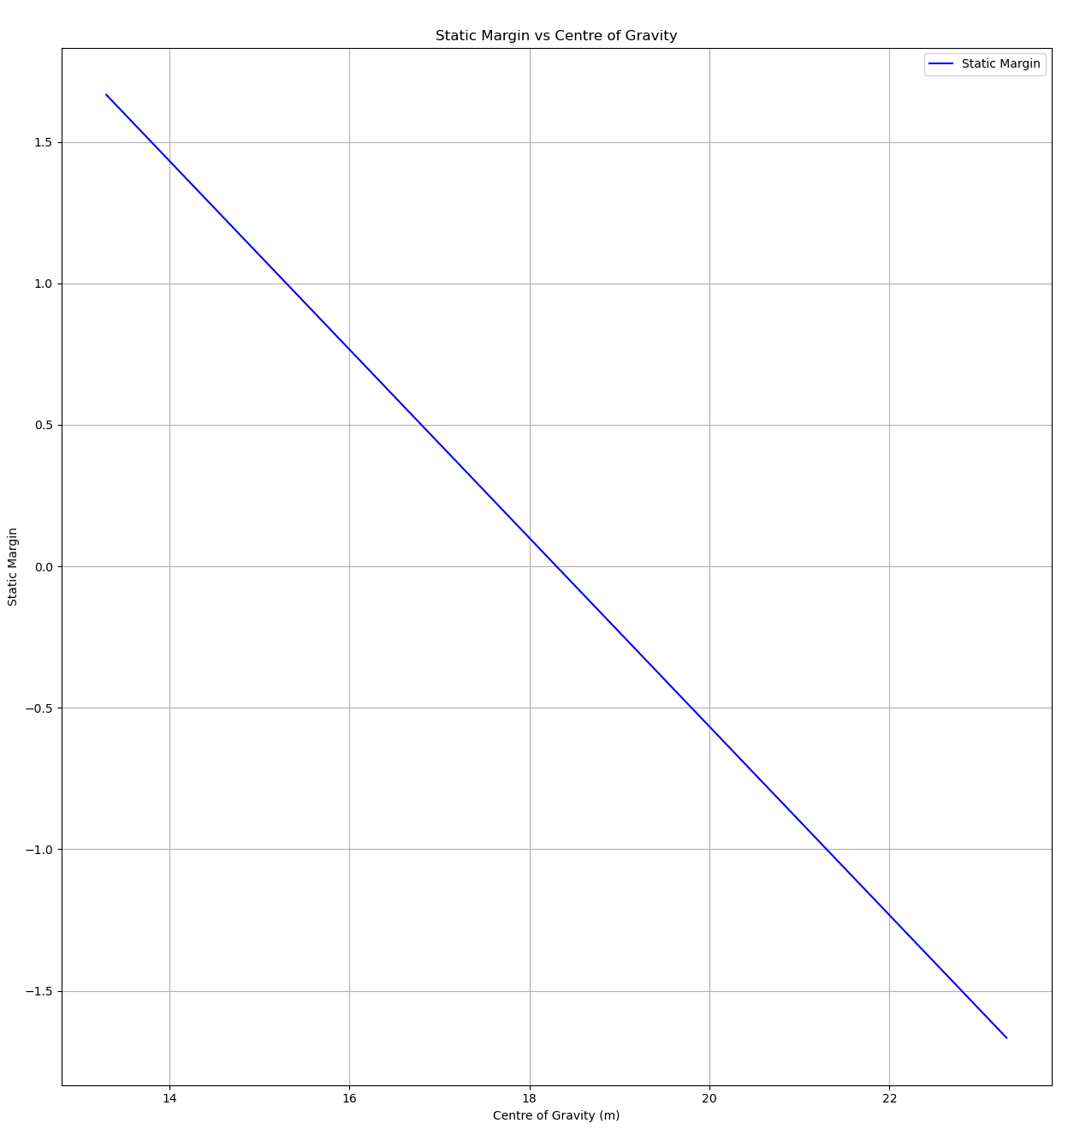

3. Mission Integration
Sections 2.1 to 2.5 each validate one flight phase independently, using the aircraft's full takeoff weight throughout. In reality, aircraft weight decreases continuously as fuel is consumed, and later flight phases should reflect this lighter condition. A single mission_profile() function was built to chain all five phases sequentially, updating a running weight value after each phase based on fuel consumed.

3.1 Fuel Fraction Method
Detailed fuel-burn modelling for takeoff and climb would require numerically integrating thrust and fuel flow over a continuously changing speed and altitude profile — a substantial undertaking disproportionate to its impact, since takeoff and climb together typically account for only 10-15% of total mission fuel on a representative flight, with cruise dominating at 70-80%.
Consistent with standard conceptual aircraft design practice (the fuel fraction method, e.g. as used in Raymer's aircraft design methodology), fixed empirical fuel fractions were applied to takeoff, climb, and descent, with cruise allocated the remainder:
Phase | Fuel Fraction | Rationale
Takeoff | 3% | Short duration, high thrust
Climb | 5% | Sustained high power, moderate duration
Cruise | 91% (remainder) | Dominant phase — majority of mission duration
Descent | 1% | Predominantly idle thrust (glide-like)

3.2 Mission Sequence
The integrated mission proceeds as follows, with weight updated after each phase using its allocated fuel fraction:
- Takeoff — calculated using full initial weight (no fuel yet consumed); weight reduced by takeoff fuel fraction afterward
- Climb — calculated at V_climb = 1.3 x V_stall (a standard ratio-based approximation, consistent with the fidelity used for V_liftoff, since true best climb speed Vy has no closed-form solution and was only previously identified by plotting); weight reduced by climb fuel fraction afterward
- Cruise — calculated using the genuine best_glide_speed() and max_range_speed() functions (true optimum conditions, not approximations); requires both pre-cruise and post-cruise weight simultaneously, since the Breguet equation is built from their ratio; weight then updated to the post-cruise value
- Descent — modelled as a pure glide (T = 0) using best_glide_speed(), the same validated optimum-glide condition from Section 2.3, recalculated at the current (lighter) weight; weight reduced by descent fuel fraction afterward
Note on modelling consistency: climb speed uses an approximated ratio while descent uses an exact calculated optimum. This is a deliberate choice rather than an inconsistency: a genuine closed-form solution exists for best glide speed (validated in Section 2.3) and was reused directly, while no equivalent closed-form solution exists for best climb speed within the scope of this project, making the standard ratio-based approximation the appropriate choice for that phase specifically.

3.3 Fuel Conservation Verification
As a validation check, total fuel consumed across all four phases was compared against the total fuel carried (fuel_mass x gravity). An initial implementation omitted the final weight reduction for the descent phase, causing a discrepancy of exactly 1% of total fuel — traced directly to the missing descent fuel fraction subtraction. Once corrected, the model conserves fuel exactly: total weight lost across the full mission equals total fuel weight to within floating-point precision, confirming the integration logic is internally consistent.

4. Results: Long-Haul vs Short-Haul Comparison
The integrated mission model was applied to two contrasting aircraft configurations to test whether the model produces physically sensible, differentiated results consistent with real-world aircraft design philosophy — directly addressing the original project objective of comparing short-haul and long-haul aircraft.

4.1 Aircraft Configurations
Parameter | Aircraft 1 (Long-Haul) | Aircraft 2 (Short-Haul)
Mass | 60,000 kg | 40,000 kg
Wing area | 120 m² | 80 m²
Thrust | 120,000 N | 110,000 N
Fuel mass | 15,000 kg | 6,000 kg
Thrust-to-weight ratio | ~0.20 | ~0.28
Takeoff fuel fraction | 3% | 4%
Climb fuel fraction | 5% | 8%
The short-haul aircraft was deliberately configured with a higher thrust-to-weight ratio and higher takeoff/climb fuel fractions, reflecting genuine design differences: short-haul aircraft are typically optimised for rapid climb and operation from shorter runways, and a smaller proportion of their total fuel load is consumed during cruise simply because there is less cruise distance to cover.

4.2 Mission Results
Metric | Aircraft 1 (Long-Haul) | Aircraft 2 (Short-Haul)
Takeoff distance | 4,242.7 m | 2,265.2 m
Rate of climb | 11.15 m/s | 18.06 m/s
Max cruise range | 10,477.5 km | 4,346.3 km
Glide rate of descent | 5.70 m/s | 6.73 m/s
Final weight (post-mission) | 441,450 N | 333,540 N

4.3 Discussion of Results
The results reveal genuine engineering trade-offs rather than simple scaling of a single aircraft to a smaller size:
- Takeoff distance is nearly halved for the short-haul aircraft despite only a modest reduction in absolute thrust, driven by its substantially better thrust-to-weight ratio (0.28 vs 0.20)
- Rate of climb is approximately 62% higher for the short-haul aircraft, for the same reason — more excess thrust is available at any given speed
- Range scales down roughly in proportion to fuel carried rather than aircraft size alone, consistent with the Breguet equation's direct dependence on the fuel weight ratio
- Descent rate is marginally higher for the short-haul aircraft, attributable to its slightly higher parasitic and induced drag coefficients (cd0 = 0.022 vs 0.02, k = 0.05 vs 0.045) — a less aerodynamically refined design, consistent with a smaller regional-class aircraft
These results demonstrate that the model captures genuine physical relationships between aircraft configuration and performance, rather than producing arbitrary output — the comparative trends are explainable and consistent with established aerospace design principles.

5. Limitations and Assumptions
The following simplifications were made deliberately, at a level of fidelity appropriate for conceptual-level analysis. Each is stated explicitly here for transparency:
- Cruise-climb assumption — the Breguet range equation assumes continuous climb during cruise to maintain constant CL; real flights use discrete step climbs due to air traffic control constraints, so calculated range represents a theoretical maximum rather than an exact operational figure.
- Fixed fuel fractions — takeoff, climb, and descent fuel consumption are modelled using standard empirical fractions rather than full numerical integration of fuel flow over each phase's changing flight conditions. This is consistent with established conceptual design methodology and appropriate given these phases represent a minority of total mission fuel.
- Climb speed approximation — best climb speed (Vy) has no closed-form analytical solution within the scope of this model and is approximated as 1.3 x stall speed, a standard ratio-based estimate. The true optimum (found by direct search/plotting in Section 2.3) was approximately 170-175 m/s, somewhat higher than this approximation would suggest — a known limitation of the ratio method.
- Constant air density — air density (rho) is held at its sea-level value throughout all phases. A full model would calculate rho as a function of altitude using the International Standard Atmosphere (ISA) model, which would be a natural extension of this work.
- No wind, atmospheric, or structural load factors — the model considers only steady, calm-air aerodynamic and propulsive forces. Manoeuvring load factors, gust loading, and structural limits are outside the current scope.
- CL capping near stall — the model caps CL at CL_max when calculating climb, descent, and cruise conditions across a velocity range, to prevent unrealistic (and computationally unstable) results below stall speed. This correctly reflects that level flight is physically impossible below stall speed, but means plotted results below V_stall + a small margin are intentionally excluded rather than computed.

6. Conclusion
This project successfully developed a working aircraft performance model spanning five major flight phases, each validated against expected physical behaviour before being integrated into a single continuous mission simulation with correct fuel-weight tracking throughout.
Beyond simply implementing known equations, the development process surfaced and resolved several genuine engineering questions — most notably the distinction between maximum endurance speed and maximum range speed, which emerged directly from inspecting an unexpected plot result rather than being assumed from the outset. This kind of finding — trusting a model's output over an initial intuition, then verifying it against established theory — reflects the kind of investigative process used in real aerospace performance analysis.
The comparative case study between long-haul and short-haul aircraft configurations demonstrates that the model produces physically consistent, explainable differences in performance driven by genuine design parameters (thrust-to-weight ratio, fuel fraction allocation, aerodynamic efficiency) — confirming the model's validity as a conceptual-level analysis tool rather than a simple equation calculator.

6.1 Possible Future Extensions
- Altitude-dependent air density (ISA model) for more accurate climb and cruise performance at realistic cruise altitudes
- Numerical (rather than ratio-based) determination of true best climb speed, using a search algorithm similar to simulate_ground_roll()
- Full numerical fuel-burn integration during climb and descent, replacing fixed fuel fractions
- Lateral-directional stability analysis, extending beyond the longitudinal static margin covered in this report
- Validation against published performance data for a real aircraft type of comparable size and configuration

Appendix A: Code Structure
The model is organised across four Python files, following a clear separation of concerns:
File | Purpose
aircraft.py | Stores fixed aircraft parameters as a dictionary (mass, geometry, aerodynamic coefficients, fuel data, stability parameters, fuel fractions)
performance.py | Contains every physics function used throughout the model — lift, drag, takeoff, climb/descent, cruise/range, stability, and the integrated mission_profile() function
main.py | Unpacks aircraft parameters, calls functions from performance.py, and prints results
plots.py | Generates all visualisations using matplotlib, following the same structural pattern as main.py
This structure means a physics correction only ever needs to be made in one place (performance.py), and switching between aircraft configurations or running comparative scenarios requires minimal duplicated code.

