[AI-PACKAGE]

Milestone 2

**Milestone 2**

You have to implement the DBSCAN clustering algorithm with the following pseudocode

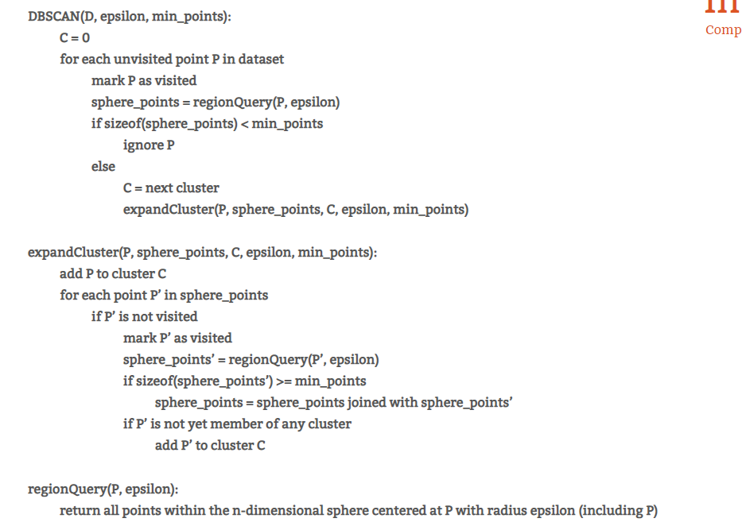

* Template:

1. Generate the Dataset (750 points around the three centers (1,1),(1,-1)(-1,-1)).

1. Build in DBSCAN using scikit learn

1. Compare your code with the build in one..

