Report

This is the first thing that will show on the screen it is asking the user to enter the vector size

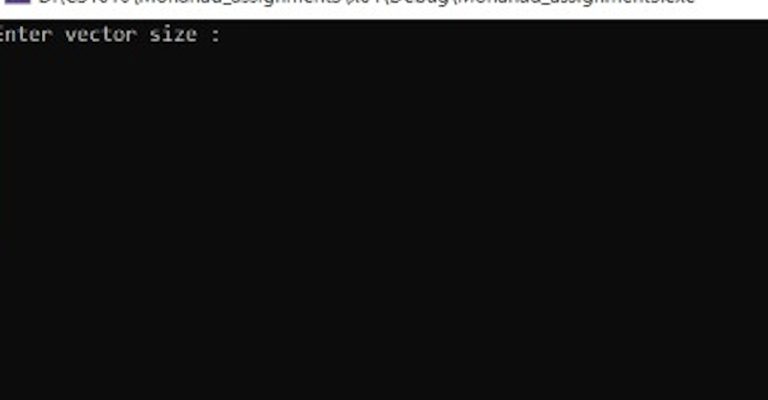

Here it is asking the user to enter the number of the vector

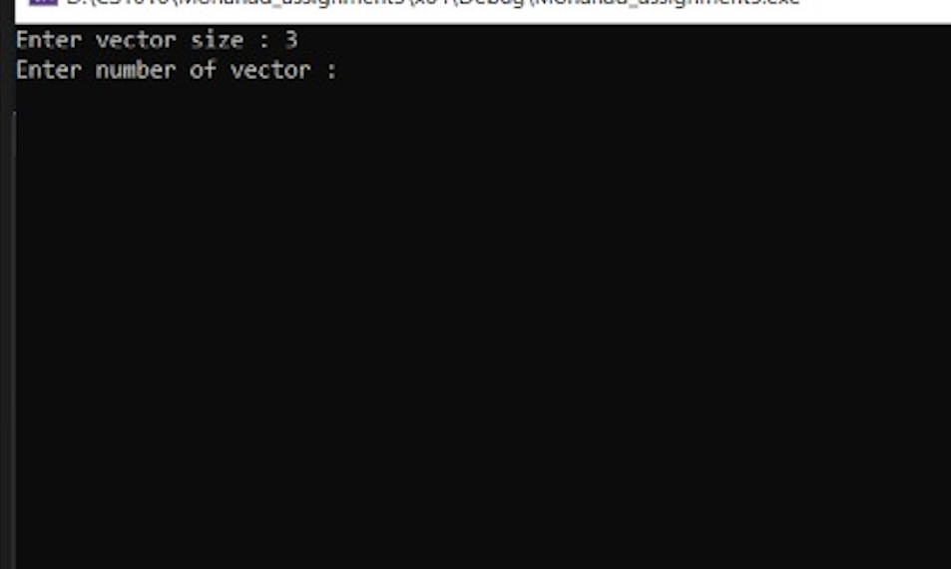

Here it is asking to enter the value inside the vector

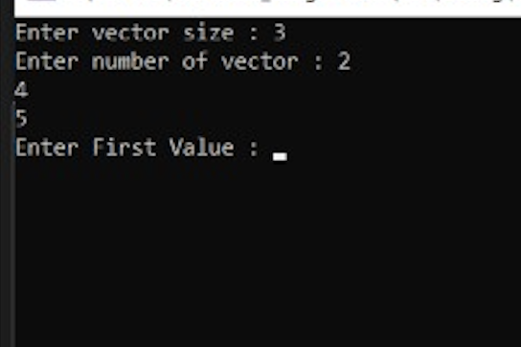

Here asking for the second value

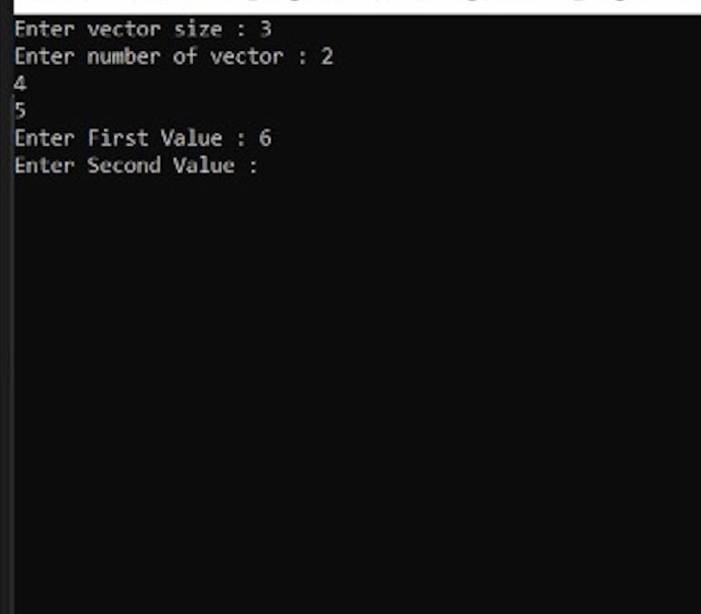

Here is the final outcome

