Civic Open-Data Dashboard for Public Accountability

Abstract— Government agencies maintain extensive open datasets covering healthcare, education, crime, public expenditure, environmental sustainability, and other public services. Despite their public availability, these datasets remain fragmented across multiple platforms, stored in heterogeneous formats, and updated independently, limiting their effective use for comprehensive analysis and evidence-based decision-making. Existing solutions primarily emphasize historical data visualization while providing limited support for integrated data processing, role-based access, and transparent analytical workflows. This paper proposes a Civic Open-Data Dashboard for Public Accountability, a unified platform that integrates heterogeneous public datasets into a single analytical environment. The framework is designed to improve data accessibility by combining data acquisition, preprocessing, validation, integration, and exploratory analysis to deliver stakeholder-specific insights for citizens, researchers, policymakers, government officials, and administrators. It also supports regional comparisons, transparent reporting, and informed decision-making through role-based analytical interfaces. The system is developed using React.js, FastAPI, Microsoft Fabric, PySpark, and Power BI/Tableau to support scalable data processing and interactive visualization. The framework was evaluated through a real-world case study using government datasets, with performance assessed based on data integration accuracy, processing efficiency, visualization responsiveness, and usability analysis. The suggested framework aims to deliver a transparent decision-support system that enhances public accountability, supports evidence-based policymaking, promotes informed citizen participation, and improves the effective use of public-sector data.
Index Terms—Open government data, public accountability, civic dashboard, data lineage, data quality, role-based access, gradient boosting, crop yield
I. Introduction
Governments collect and publish a lot of data about public services. This data covers health, education, crime, public spending, farming, water, transport and the environment. It can help citizens, researchers, officials and policy makers see how conditions are changing and how public money is used. But open data is not always easy to use. It is spread across many departments, portals and files. Each source has its own format, names and update times. So a person who wants to study one issue may have to visit many websites, download many files, clean each one and then still wonder if the numbers can be compared.
This gap between having data and using it matters a lot for accountability. A dataset may be public but still hard to understand. It may have missing values, different spellings for the same place, repeated rows, or different time periods. Even good datasets can cause trouble when we combine them. Two files may name the same district differently, use different levels of detail or write dates in different ways. Then even a simple comparison can go wrong. So a public dashboard needs more than charts. The data must first be collected, understood, cleaned, checked, joined and tracked.
Dashboards are one common way to make public data easier to use. Matheus, Janssen and Maheshwari explain that dashboards bring data together for a purpose and can help governments make decisions and talk to the public [1]. Their study of smart cities shows that dashboards can support openness and accountability. It also shows the problems: poor data quality, low understanding of the data, weak analysis and wrong reading of results [1]. This tells us that a dashboard is not just a nice screen on top of data. Data quality, the analysis and the way users are guided to read the results all matter.
Chokki et al. studied how citizens actually use government data [2]. They compared well-designed dashboards with single charts and made a list of design rules. These rules cover data quality, useful measures, user needs, chart choice, context, interaction, links to the source and ease of use [2]. Their test with the Namur budget dashboard showed that the way information is arranged changes how well citizens understand it. So an open-data platform should not just show charts or raw files. It should help users go from a question to a clear answer without needing deep technical skills.
Being open is not the same as being accountable. Park and Gil-Garcia studied this through health data charts made by a state government [3]. They showed how charts can support policy goals, and how people who explain data help connect government goals with what users expect [3]. This matters for our dashboard. Publishing data alone does not show whether a policy is working. Users need clear measures, fair comparisons and enough context to judge what the data really says, along with a link back to the source.
Peer and DiSalvo looked at civic dashboards from the builders’ side [4]. They studied a dashboard that combined data on education, transport, safety, health, water and the environment for a local community. They describe a civic dashboard as a set of screens built from many datasets, and they show how data, tools, institutions, developers and communities depend on each other [4]. Building such a dashboard also means dealing with upkeep, limited resources, communication and interpretation. In one case, a public-safety correlation chart was removed because people could read it as cause and effect [4]. This shows that honest analysis matters as much as how the data is shown.
Together, these studies show that the real problem is not a lack of data. The data often exists, but it is hard to use because it is scattered, shown without context or separated from the steps that make it reliable. The studies also show that dashboards help only when they have good data, useful measures, good charts, a focus on users and support from the organisation [1]–[4]. So we need a platform that links data collection, cleaning, analysis and charts, instead of treating them as separate jobs.
This is why data integration is at the centre of our system. We do not assume that government data is ready to use. The system first collects the datasets and then cleans and checks them before joining them. It checks the columns, finds missing and repeated rows, makes names and formats the same, and matches places and time periods. If two datasets use different definitions or levels of detail, these differences are found before any comparison is made. This lowers the chance that cleaning mistakes stay hidden in the dashboard, and it makes the work easy to repeat and check.
Our system also cares about traceability. Every result should link back to the data and the steps that produced it. Source details, versions, changes, quality checks and settings together form a trail from the original file to the final chart. This matters because a user may ask where a number came from, why two areas were compared, what cleaning was done, or whether a missing value changed the result. With this trail, the dashboard becomes more than a report screen. Users can check both the result and what it is based on.
Public data is used by people with different skills and goals. Citizens may want to compare areas on a public service. Researchers may need details about the datasets, the cleaning and the methods. Policy makers and officials may look at trends, gaps and how inputs relate to results. Administrators need to manage data sources, users, settings and the running system. A role-based interface can serve all of them while keeping the same evidence underneath. This matches earlier work that stresses user needs, ease of use, context and interaction [2], and the need to fit data tools to the goals of the organisation and its users [3].
Our dashboard also goes beyond showing past data. Trends and regional gaps give a picture of current conditions, and relationship analysis shows how different measures move together. But this needs care, because two things moving together does not mean one causes the other. Peer and DiSalvo give a clear example of why this matters [4]. So our system treats a relationship as evidence to be read in context, not as a ready-made explanation.
The Civic Open-Data Dashboard for Public Accountability meets these needs by bringing data collection, cleaning, checking, joining, analysis and charts into one place. It uses several public government datasets and gives each type of user a clear path from the source data to the result. The web interface is built with React, and the data and analysis services are built with Python and FastAPI. The design is ready to move processing to Microsoft Fabric and PySpark for larger data, and to share the clean tables with Power BI or Tableau. The system supports simple analysis, such as trends and regional comparisons, and also deeper checks of how public measures are related. Our focus is on a complete workflow, not a single dashboard or notebook.
We also want to keep the analysis clear without making the system hard to use. A citizen should be able to see a comparison without knowing how the data flows inside. A researcher or reviewer should still be able to open the method and the evidence trail when needed. This balance matters because public dashboards serve many kinds of users. Earlier studies show that ease of use, context and understanding depend on how information is arranged and shown [1], [2]. Work on openness and accountability also shows that charts must be linked to the wider goals of the organisation and its policies [3].
So, this paper presents the Civic Open-Data Dashboard for Public Accountability, a platform that turns scattered public data into information that is easy to use, trace and act on. We follow the full journey: collecting and checking data, joining it, analysing it, showing it and reading the results. We test the system with government data from public-service areas. We look at how correctly data is joined, how fast it is processed, how quickly charts respond, how easy the system is to use and how clear the analysis steps are. Our goal is not just to put government data on a screen. We want a place where citizens, researchers, policy makers, officials and administrators can explore public data, compare places, spot patterns and study relationships while still seeing the evidence behind each result.
The main contributions of this paper are: (i) a layered, role-based architecture that connects data collection, checking, joining, analysis, services and charts, and that can be scaled to Microsoft Fabric; (ii) a data preparation workflow that traces every result back to its source dataset; (iii) separate analysis pages for each type of user; and (iv) a case study that compares gradient-boosting and other models on district-level crop production data. The rest of the paper is organised as follows. Section II describes the system architecture, Section III the data preparation and integration method, Section IV the crop production case study, Section V the evaluation framework, and Section VI concludes the paper.
II. System Architecture
A. Design Requirements from Related Research
The studies in Section I show one clear point. A dashboard is useful only when the data behind it is correct and easy to understand. Janssen, Charalabidis and Zuiderwijk say the same about open data in general. Just publishing data does not create value. Poor data quality, hard tasks and low user skills get in the way [5]. Wang and Strong explain data quality from the user’s side. For them, data must be correct, fit the task, be easy to read and be easy to reach [6].
Table I lists the ten studies closest to our project. For each study it shows what the study did, how it relates to our work and what we add. From these studies we took three rules for our design. First, every cleaning step must be visible and traceable. Second, different users should see the same facts at different levels of detail. Third, results and predictions must come with their limits and must be compared with simple methods.
TABLE I
Related Research Papers and Their Connection to the Project
No. | Research paper | What the paper did | Link to our project | What we add
1 | Data-driven dashboards for transparent and accountable decision-making in smart cities [1] | Shows that dashboards can help make open decisions. Also lists problems: poor data, low understanding and wrong reading of results. | Very high: same goal of a public dashboard. | We show the cleaning steps and add predictions that are checked against simple methods.
2 | Engaging citizens with open government data: dashboards vs. individual visualizations [2] | Compares dashboards with single charts for citizens and gives design rules on context, users, measures and sources. | High: guides our public pages. | We follow these rules for five datasets and three roles. Every chart has a table view, a CSV download and a short note.
3 | Transparency and accountability in open government ecosystems: health data visualizations [3] | Shows that open data alone does not make anyone accountable. Users need measures, context and someone to explain the data. | High: supports our role-based design. | Our platform does this job. It checks the data before showing it and links every view to the source rows.
4 | The work of infrastructural bricoleurs in building civic data dashboards [4] | Studies people who build dashboards. One correlation chart was removed because users read it as cause and effect. | Very high for our rainfall–yield analysis. | We keep the correlation but show its range, state-wise detail and a clear warning.
5 | Benefits, adoption barriers and myths of open data and open government [5] | Lists the benefits and barriers of open data, such as poor quality, hard tasks and low skills. Also lists myths, for example that publishing data is enough. | Very high: this is the problem we start from. | Cleaning rules, quarantine and lineage fix quality issues. Role-based pages help users with different skills.
6 | Beyond accuracy: What data quality means to data consumers [6] | Asks data users what quality means and groups the answers into four types. | High: gives words for our quality rules and EDA page. | We turn these ideas into real rules for Indian government files and report how many rows each rule affects.
7 | Crop yield prediction using machine learning: A systematic literature review [7] | Finds that temperature, rainfall and soil are the most used inputs and neural networks the most used method. | Very high: our crop case study. | We use simpler public data, predict yield classes and compare five models on later years.
8 | The Indian monsoon, GDP and agriculture [8] | Shows that the monsoon drives farm output. Droughts hurt more than good years help. | High: the reason we join rainfall with crops. | We measure the link state by state. It is weak for India as a whole (ρ = 0.19) but strong in rainfed states.
9 | Statistical and machine learning forecasting methods: Concerns and ways forward [9] | Finds that simple methods are often as accurate as machine learning and cost less. | High: shapes how we test models. | We test every model on later years and say clearly when a simple input already decides the result.
10 | Why do tree-based models still outperform deep learning on typical tabular data? [10] | On 45 table datasets, tree models beat deep networks on medium-sized tables. | High: supports our choice of models. | Our results agree: LightGBM, random forest and XGBoost win all five tasks without neural networks.

B. Layered Architecture
The system has a front end and a back end, built in seven layers (Fig. 1). The layers are data sources, input checks, cleaning, storage, analysis and machine learning, the API service, and the user interface. Some parts work across all layers: lineage records, role checks on the server, a safe fallback mode and request logs. The user interface is built with React, TypeScript and Vite. The API is built in Python with FastAPI. It gives the data for dashboards, quality summaries, EDA, model reports and predictions.
In the version tested in this paper, all processing runs in Python on one machine. Clean tables are kept in a DuckDB database. Trained models and reports are saved as Joblib and JSON files. Each layer works on its own. So later, the processing and storage layers can be moved to Microsoft Fabric with PySpark for bigger data, and the clean tables can be opened in Power BI or Tableau. The API and the interface would not need to change. All numbers in Section V come from the single-machine version.
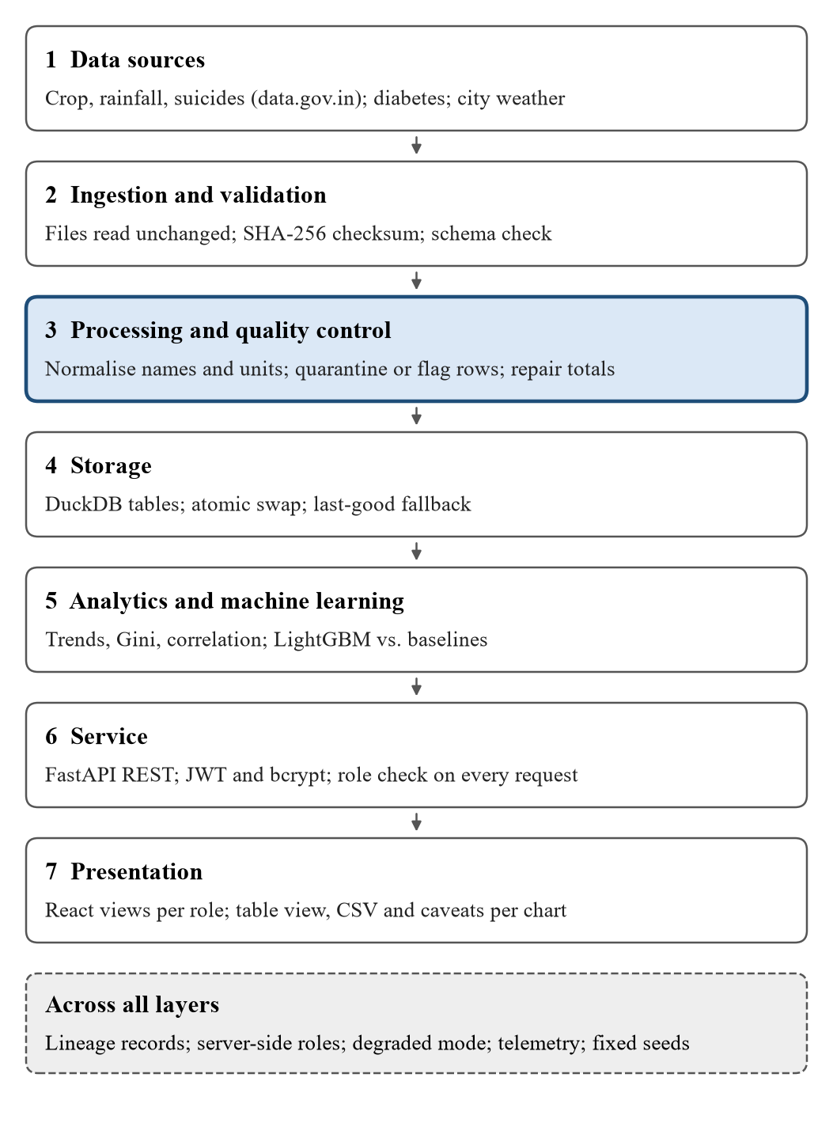
Fig. 1. Layers of the platform. Data moves in one direction, from raw files to the pages each role sees. The highlighted layer is where bad rows are put aside before anything is shown.
C. Data Flow
Fig. 2 shows the flow step by step. We never edit the original CSV files. First, each file is checked against the expected columns. Then cleaning rules are applied, and three tables are written: clean rows, quarantined rows and lineage. Bad rows go out through a side path. They are saved with the reason they failed and are still counted in the lineage. Next, the models are trained and tested, and the best one is saved. Finally, the API reads these results and sends them to the interface.
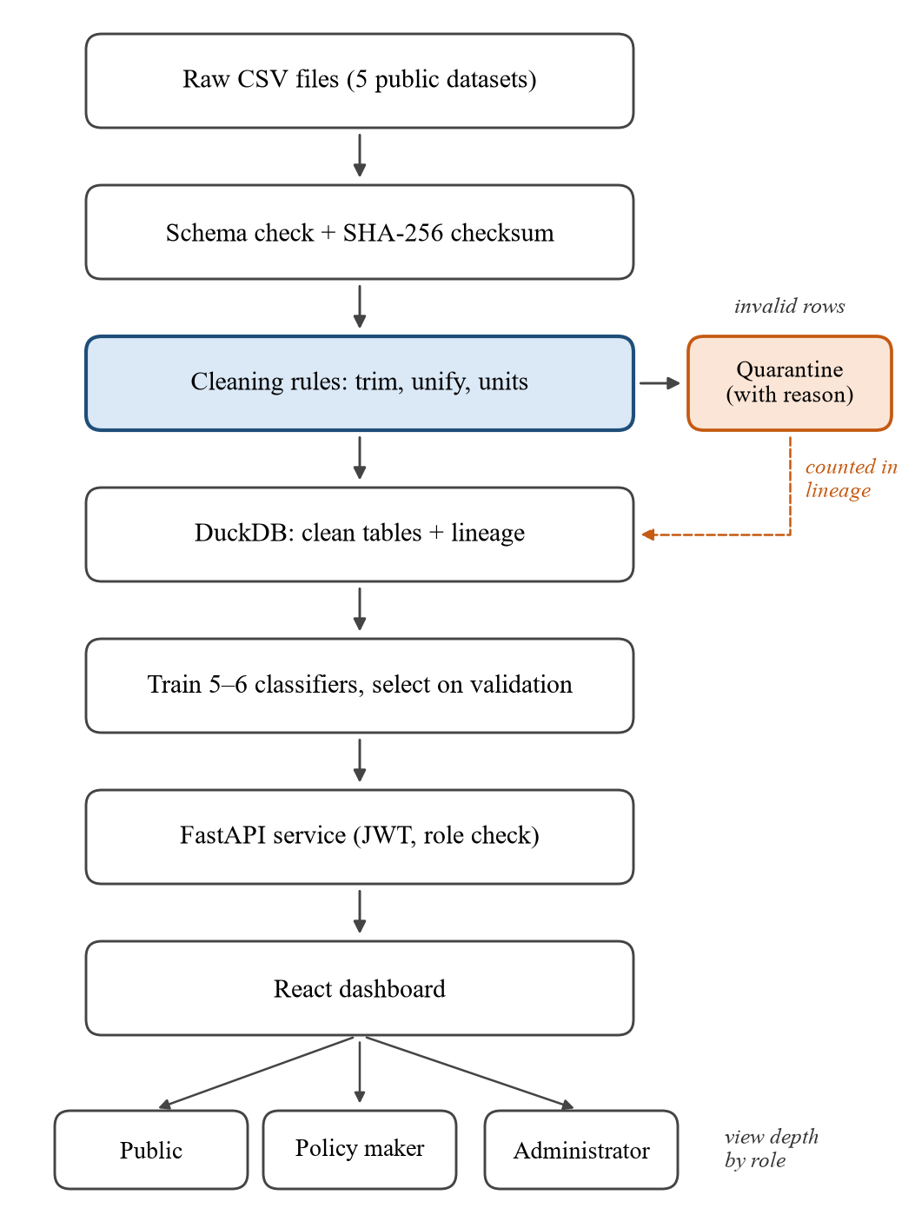
Fig. 2. Data flow of the platform. Each raw file is checked and cleaned. Bad rows go to quarantine with a reason instead of being deleted, and they are counted in the lineage record. The trained models are served through FastAPI to three roles.
D. Stakeholder Roles and Access Control
We serve five user groups through three roles. Citizens and researchers use the public role. Policy makers and government officials use the policy-maker role. Both roles see the same five pages: problem statement, datasets, EDA charts, model details with class predictions, and system architecture. Administrators see these five pages too, plus extra tools: dataset lineage, project details, read-only source code and system logs.
Roles are checked on the server for every request, not only hidden in the menu. Login uses JWT tokens, and passwords are stored as bcrypt hashes. A request without login gets error 401, and a request from the wrong role gets error 403. The code viewer only opens files from an allowed list, so a request like ../users.json is refused. We also take care with sensitive data. Suicide data is shown only as totals, with a national helpline number. Diabetes predictions are marked as learning examples, not medical advice. Every relationship chart says that a link between two things does not mean one causes the other.
III. Data Preparation and Integration Methodology
A. Datasets
We use five public datasets, with 676,030 raw rows in total. They are crop production by district for 1997–2015 (246,091 rows), IMD rainfall by sub-division for 1901–2015 (4,116 rows), NCRB suicide records for 2001–2012 (234,503 rows), a diabetes dataset (100,000 rows), and daily weather for ten Indian cities for 2000–2024 from ERA5 (91,320 rows). Each dataset is studied on its own. The only join is between crop and rainfall, because the monsoon strongly affects farm output in India [8]. We do not predict rainfall itself.
B. Validation and Cleaning Rules
Each raw file is read as it is. We check its columns and record its SHA-256 checksum. Extra spaces are removed and spellings are fixed. For example, MATATHWADA becomes MARATHWADA. Some crops use different units: coconut is counted in nuts, and cotton, jute and mesta in bales. We add a unit column for these and keep them out of tonne totals. Then named rules check for missing values, wrong ranges, duplicates and values that make no sense. Each rule does one of two things. It either moves the row to quarantine with a reason, or keeps the row with a flag so that charts and models can skip it. Table II lists the main findings.
TABLE II
Main Data-Quality Findings and Actions
Dataset | Issue | Rows | Action
Crop | Missing production value | 3,730 | Quarantined
Crop | Pre-computed totals (double counting) | 880 | Quarantined
Crop | Production reported as 0 | 3,510 | Flagged
Crop | Yield outlier (robust z > 5) | 1,597 | Flagged
Rainfall | Annual ≠ sum of months | 26 | Repaired
Suicides | Repeated key, different counts | 3,063 | Summed
Diabetes | Exact duplicate records | 3,854 | Quarantined
Rows are counted on the original files before cleaning.

Two choices need a short note. First, 3,063 suicide rows looked like duplicates, but their counts were different. The source puts several “Others” groups under one name. If we deleted these rows, we would lose real deaths, so we added them together. Second, the NCRB file reports the same deaths in several ways, for example by age and by cause. Adding these together would count each death about five times. So every main figure uses only one of them.
C. Lineage and Reconciliation
To check that no row is lost, we compute the lineage coverage of each dataset:
C = (N_{c} + N_{q} + N_{m}) / N_{in} × 100% (1)
Here c is the number of clean rows, q the quarantined rows, m the merged rows and in the rows read. If rows read and rows accounted for do not match, we count it as a reconciliation error. The database is first built in a temporary file and then swapped in at once. So running the pipeline again on the same files gives the same tables. If a rebuild fails, the system keeps showing the last good version.
D. Integrating Crop and Rainfall Data
Crop data is given by state and district, but rainfall is given by IMD sub-division. We made a table that links each sub-division to its state. A state’s seasonal rainfall is the simple average of its sub-divisions. Names are cleaned before the join. After the join, we check that every clean crop row has a rainfall value. Rows that do not match are reported, not dropped silently.
E. Feature Governance
Each model uses only the information that is known at the time of prediction. The crop model uses state, district, crop, season, the log of cultivated area, year and state seasonal rainfall. The weather models use the city and the values seen up to the forecast day, such as values from the last two days and totals of the last seven days. The suicide model uses state, gender, age group, year and the counts of the two previous years. It never uses the count of the current year. The diabetes model uses age, gender, BMI, HbA1c, blood glucose, blood pressure, heart disease and smoking history. Seasonal rainfall is known fully only after the season. So for crop forecasts, rainfall is treated as a “what if” input, not as a known value.
IV. Crop-Production Case Study
We chose crop as the main case study. It has the largest dataset, the only join between datasets and the most text-type inputs. Later, in Section IV-F, we apply the same steps to the other four tasks.
A. Problem Setup and Yield Classes
Most crop-yield studies use detailed farm or soil data. Their most common inputs are temperature, rainfall and soil type [7]. Indian public crop data is much simpler. It gives only place, season, area and production. So we predict a yield class instead of an exact number, and users see Low, Medium or High. For yield, temperature and suicide counts, the class limits are the 33rd and 67th percentiles of the training data, called q1 and q2:
y = L if v < q₁, M if v < q₂, H otherwise (2)
Here v is the actual number, and L, M and H mean Low, Medium and High. For yield, the limits are set for each crop separately, so “High” means high for that crop. For temperature, they are set for each city and month, so the classes follow the season. Rain uses the IMD classes for one day: no rain (below 2.5 mm), light (2.5 to 15.5 mm), and moderate to heavy (15.6 mm or more). Diabetes keeps its original two classes, called Low risk and High risk. Table III shows how many records fall in each class. Three tasks are almost evenly split. Diabetes and rain are not: most records are Low risk or No rain. For these two tasks, accuracy alone can be misleading.
TABLE III
Class Distribution of Each Prediction Task
Task | Class | Records | Share
Crop-yield class | Low | 69,688 | 30.8%
 | Medium | 73,872 | 32.6%
 | High | 82,933 | 36.6%
Diabetes risk | Low risk | 87,664 | 91.2%
 | High risk | 8,482 | 8.8%
Temperature, next day | Low | 29,154 | 31.9%
 | Medium | 29,882 | 32.7%
 | High | 32,214 | 35.3%
Rain, next day | No rain | 70,797 | 77.6%
 | Light | 15,487 | 17.0%
 | Moderate to heavy | 4,966 | 5.4%
Suicide count | Low | 1,104 | 31.5%
 | Medium | 1,191 | 34.0%
 | High | 1,205 | 34.4%
Counts cover the training, validation and test data together. Shares may not add up to exactly 100% because of rounding.

B. Candidate Models
We mainly tried tree-based models. A test on 45 table datasets found that these models still beat deep neural networks on medium-sized tables [10]. A random forest builds many decision trees, each on a random part of the data, and takes their vote [11]. Gradient boosting builds trees one by one, and each new tree fixes the mistakes of the earlier ones. XGBoost [12] and LightGBM [13] are the two most popular tools for this. LightGBM can work directly with text-type columns. This helps a lot with the crop data, which has about 640 districts. We also tried logistic regression, naive Bayes and a single decision tree as simpler models for comparison (Table IV).
TABLE IV
Classifier Settings
Model | Key settings
Logistic regression | Balanced weights, up to 3,000 iterations
Naive Bayes | Gaussian, dense one-hot inputs
Decision tree | Maximum depth 12, 20 rows per leaf
Random forest | 100–200 trees, depth 16–20, balanced subsamples
XGBoost | 400 trees, depth 7, learning rate 0.05
LightGBM | 400 trees, 63 leaves, learning rate 0.05

All models were trained on the same rows and inputs. Each model got the data in the form that suits it. Linear models got one-hot columns and scaled numbers. The other tree models got number codes. LightGBM used its own way of handling text columns. Wherever possible, the classes were given equal weight, and the random seed was fixed at 42. We did not use naive Bayes for crop, because one-hot columns for about 640 districts did not fit in memory.
C. Time-Ordered Splits, Selection and Metrics
Simple methods are often as good as machine learning [9]. So a model must be tested on years that come after its training years, and we must report more than one score. For crop, we train on 1997–2009, choose the model on 2010 and test on 2011–2015. These parts have 164,372, 13,183 and 48,938 records. The model with the best macro-F1 on 2010 is chosen, and it is tested only once. We report accuracy, balanced accuracy, macro precision and recall, ROC-AUC, recall for each class and the confusion matrix. For K classes, macro-F1 gives each class the same weight:
macro-F1 = (1/K) Σ_{k} 2P_{k}R_{k} / (P_{k} + R_{k}) (3)
Here Pk and Rk are the precision and recall of class k. Since every class counts the same, a model cannot get a good score by ignoring a small class.
D. Results
Table V shows all crop models, sorted by their 2010 score. LightGBM was chosen. Its test macro-F1 is 0.645, while the next best, XGBoost, gets 0.600. LightGBM is ahead on every measure. Logistic regression and the single decision tree are far behind. The main reason is the district column. LightGBM can use it directly, while the other models must turn districts into plain numbers that carry no meaning.
TABLE V
Crop-Yield Class: All Models (Test Years 2011–2015)
Model | Val. F1 | Acc. | Macro F1 | AUC
LightGBM* | 0.731 | 0.658 | 0.645 | 0.823
XGBoost | 0.641 | 0.620 | 0.600 | 0.781
Random forest | 0.568 | 0.565 | 0.540 | 0.743
Decision tree | 0.544 | 0.526 | 0.504 | 0.705
Logistic reg. | 0.484 | 0.530 | 0.466 | 0.691
*Chosen on validation macro-F1. Val. = validation; Acc. = accuracy; AUC = one-vs-rest ROC-AUC.

Table VI shows the confusion matrix of LightGBM. Medium is the hardest class, with a recall of 0.51, because it sits between the other two. Most of its mistakes go to a nearby class, not to the opposite end. Only 6.2% of truly High records were called Low. Recall is 0.74 for Low and 0.72 for High. We also see a shift in the test years. In training, each class has about one third of the records. But in 2011–2015, 45.2% of records are High and only 23.5% are Low, because yields kept going up over the years. This also explains why recall is better for High than for Medium.
TABLE VI
Confusion Matrix, Crop-Yield Class (LightGBM)
Actual \ Predicted | Low | Medium | High | Recall
Low | 8,497 | 2,106 | 902 | 0.739
Medium | 4,589 | 7,817 | 2,915 | 0.510
High | 1,374 | 4,838 | 15,900 | 0.719
Test years 2011–2015; 48,938 records.

E. Rainfall and Yield Relationship
We also checked how monsoon rainfall relates to yield. Yields differ a lot between states, and they also rise over time because of better seeds and methods. To remove both effects, we compare each state’s yield with its own median and then remove its trend:
a_{s,t} = 100(y_{s,t}/ỹ_{s} − 1) − (α_{s} + β_{s}t) (4)
Here ỹ is the median yield of state s, and α and β give that state’s straight-line trend. We then compare this value with how much the monsoon was above or below normal. We use Spearman’s rank correlation ρ, and we get a 95% range from 500 bootstrap samples [14]. We do this for all states together and for each state on its own.
For rice, the link for all states together is weak but positive: ρ = 0.19, with a range of 0.12 to 0.27 over 512 state-years (p < 0.001). Wheat gives almost the same result: ρ = 0.19, with a range of 0.10 to 0.27 over 417 state-years. But this single number hides big differences between states. For rice, the link is strong in states that depend mostly on rain, such as Chhattisgarh (ρ = 0.82), Telangana (0.75) and Madhya Pradesh (0.72). Four out of 32 states had p < 0.05, while about 1.6 would be expected by chance. So the link is real mainly in rain-dependent states. It does not prove that rainfall causes the change in yield, and the state results should be studied further before drawing conclusions [4].
F. Applying the Procedure to the Other Datasets
We used the same steps for four more tasks. For weather, we train on 2000–2020, choose the model on 2021 and test on 2022–2024. For suicides, we train on 2003–2008, choose on 2009 and test on 2010–2012. The diabetes data has no dates, so we split it randomly into 64%, 16% and 20%, keeping the class mix the same in each part. Table VII shows the chosen model for every task.
TABLE VII
Selected Model for Each Task (Test Split)
Task | Model | Macro F1 | Bal. acc. | AUC
Crop yield | LightGBM | 0.645 | 0.656 | 0.823
Temperature | LightGBM | 0.696 | 0.701 | 0.872
Rain | Random forest | 0.634 | 0.659 | 0.899
Diabetes | Random forest | 0.825 | 0.896 | 0.975
Suicides | XGBoost | 0.908 | 0.907 | 0.984
Bal. acc. = balanced accuracy, the average recall of all classes.

For temperature, LightGBM beats XGBoost (0.696 against 0.678). For rain, the top three models are within 0.007 of each other, and the small Moderate-to-heavy class has the lowest recall (0.46). For diabetes, random forest was chosen on the validation data. On the test data, LightGBM did a little better (0.829 against 0.825). We still report random forest, because the choice was made only on validation data. The suicide score is high mainly because last year’s count almost decides the class. So this result shows the power of one simple input more than the power of a complex model.
V. Evaluation Framework
We evaluate the platform on the points named in Section I: how correctly data is joined, how fast it is processed, how quickly charts respond, how easy it is to use, and how good the predictions in Section IV are. Table VIII gives the measured results.
TABLE VIII
Platform Evaluation Summary
Criterion | Measure | Result
Integration accuracy | Lineage coverage, all datasets | 100%
 | Reconciliation errors | 0
 | Yearly crop totals matched | 19 of 19
 | Crop rows with rainfall value | 241,481 of 241,481
Processing efficiency | Full rebuild, median (range) | 6.8 s (6.3–9.4)
Responsiveness | Warm API request, median | 9–143 ms
 | Warm API request, 95th pct. | ≤ 213 ms
Reliability | Automated tests passing | 52 of 52
Measured on the single-machine version; pct. = percentile.

A. Data Integration Accuracy
All 676,030 raw rows are accounted for. Lineage coverage is 100% for all five datasets, and there are no reconciliation errors. We also recomputed the yearly crop totals straight from the raw file, using separate code. They matched our totals exactly for all 19 years. Every one of the 241,481 clean crop rows got a rainfall value.
B. Processing Efficiency and Responsiveness
Rebuilding all five datasets takes 6.8 seconds (median). Dashboard requests take between 9 and 143 ms (median), and 95% of requests finish within 213 ms. So charts update without any visible wait. Repeated requests are answered from a cache. The cache is tied to the database version, so old results are cleared after every rebuild.
C. Reliability and Access Control
We wrote 52 automated tests. They check that messy rows go to quarantine, that running the pipeline twice gives the same result, that the system recovers from a broken file, that a problem in one part does not spread, and that each role can open only its own pages. All tests pass.
D. Usability
The pages follow known dashboard design rules about context, users, measures and sources [2]. Every chart has a table view, a CSV download and a short note on how to read it. Predictions are shown as classes, not exact numbers. We have not yet done a proper usability study with real users from each group. This is planned as future work. For now, usability is judged only against these design rules.
E. Limitations and Threats to Validity
Our work has some limits. First, each task was tested on one time split only, without repeated runs or ranges for the scores. Second, the classes depend on the training years. “High” yield means high for that crop in 1997–2009, and the test years show a clear shift. Third, seasonal rainfall is not known in advance, so the crop results are better than what a real forecast would get. Fourth, state rainfall is a simple average of sub-divisions, and some other cleaning limits are also our own choices. Fifth, the diabetes data is not from India and we do not know how it was collected. Sixth, the datasets end between 2012 and 2024, and the system runs on one machine. So this is a research prototype. Its results should not be used to give out funds or to judge any district without checking by experts.
VI. Conclusion and Future Work
This paper presented the Civic Open-Data Dashboard for Public Accountability. The platform takes scattered public data and turns it into clear, traceable results for each type of user. It has rule-based cleaning with quarantine and lineage, a seven-layer design with role checks, a comparison of several models for each task on later years, and a rainfall–yield study that shows its uncertainty. No raw row is lost. The chosen crop model reaches a test macro-F1 of 0.645, and the models for all five tasks score between 0.634 and 0.908. The link between rainfall and yield is found mainly in rain-dependent states.
Next, we plan to do a usability study with each user group, move the processing to Microsoft Fabric and PySpark and test it on bigger data, repeat the tests several times and give ranges for all scores, reset the class limits using recent years, use forecast rainfall instead of actual rainfall for crops, and add district-level rainfall and irrigation data.
References
[1] R. Matheus, M. Janssen, and D. Maheshwari, “Data science empowering the public: Data-driven dashboards for transparent and accountable decision-making in smart cities,” Government Information Quarterly, vol. 37, no. 3, Art. no. 101284, 2020, doi: 10.1016/j.giq.2018.01.006.
[2] A. P. Chokki, A. Simonofski, B. Frénay, and B. Vanderose, “Engaging citizens with open government data: The value of dashboards compared to individual visualizations,” Digital Government: Research and Practice, vol. 3, no. 3, Art. no. 21, pp. 1–20, 2022, doi: 10.1145/3558099.
[3] S. Park and J. R. Gil-Garcia, “Understanding transparency and accountability in open government ecosystems: The case of health data visualizations in a state government,” in Proc. 18th Annu. Int. Conf. Digital Government Research (dg.o ’17), 2017, pp. 39–47, doi: 10.1145/3085228.3085318.
[4] F. Peer and C. DiSalvo, “The work of infrastructural bricoleurs in building civic data dashboards,” Proc. ACM Hum.-Comput. Interact., vol. 6, no. CSCW1, Art. no. 124, 2022, doi: 10.1145/3512971.
[5] M. Janssen, Y. Charalabidis, and A. Zuiderwijk, “Benefits, adoption barriers and myths of open data and open government,” Information Systems Management, vol. 29, no. 4, pp. 258–268, 2012, doi: 10.1080/10580530.2012.716740.
[6] R. Y. Wang and D. M. Strong, “Beyond accuracy: What data quality means to data consumers,” Journal of Management Information Systems, vol. 12, no. 4, pp. 5–33, 1996, doi: 10.1080/07421222.1996.11518099.
[7] T. van Klompenburg, A. Kassahun, and C. Catal, “Crop yield prediction using machine learning: A systematic literature review,” Computers and Electronics in Agriculture, vol. 177, Art. no. 105709, 2020, doi: 10.1016/j.compag.2020.105709.
[8] S. Gadgil and S. Gadgil, “The Indian monsoon, GDP and agriculture,” Economic and Political Weekly, vol. 41, no. 47, pp. 4887–4895, 2006.
[9] S. Makridakis, E. Spiliotis, and V. Assimakopoulos, “Statistical and machine learning forecasting methods: Concerns and ways forward,” PLOS ONE, vol. 13, no. 3, Art. no. e0194889, 2018, doi: 10.1371/journal.pone.0194889.
[10] L. Grinsztajn, E. Oyallon, and G. Varoquaux, “Why do tree-based models still outperform deep learning on typical tabular data?” in Advances in Neural Information Processing Systems 35 (Datasets and Benchmarks Track), 2022.
[11] L. Breiman, “Random forests,” Machine Learning, vol. 45, no. 1, pp. 5–32, 2001, doi: 10.1023/A:1010933404324.
[12] T. Chen and C. Guestrin, “XGBoost: A scalable tree boosting system,” in Proc. 22nd ACM SIGKDD Int. Conf. Knowledge Discovery and Data Mining, 2016, pp. 785–794, doi: 10.1145/2939672.2939785.
[13] G. Ke et al., “LightGBM: A highly efficient gradient boosting decision tree,” in Advances in Neural Information Processing Systems 30, 2017, pp. 3146–3154.
[14] B. Efron and R. J. Tibshirani, An Introduction to the Bootstrap. New York, NY, USA: Chapman & Hall, 1993.

