***8.1) How to switch the frame, from one frame to another frame?***

The frame is a WebElement and this can be switched using:

* Index (using int as data type)
* Name or Id (using String as data type)
* WebElement (using WebElement that is saved through findElement method)

To switch from one frame to another, we need to identify if the frame to be switched is –

* Child frame of the existing frame or
* Parent frame of the existing frame or
* Outside the frame

Based on the above case, the script need to be developed:

* Child frame

Directly switch using ***driver.switchTo().frame(“frameidorname”);***

* Parent frame

Directly switch using ***driver.switchTo().parentFrame();***

* Outside the frame

Go out of all frames and switch using:

***driver.switchTo().defaultContent();***

***driver.switchTo().frame(“frameidorname”);***

**Note**: driver is the object of RemoteWebDriver class, the switchTo() is a method that returns the TargetLocator interface and that has the methods like frame, alert, window etc,

***8.2) Why java does not support multiple inheritance?***

Java doesn’t support multiple inheritance in classes because of “Diamond Problem” / Ambiguity. In addition to what you learnt in classes, if incase Java supported multiple inheritance, then it could the issues like below

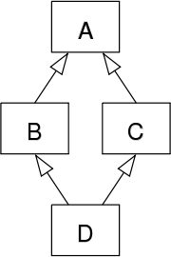The "diamond problem" (sometimes referred to as the "deadly diamond of death") is an ambiguity that arises when two classes B and C inherit from A, and class D inherits from both B and C. If there is a method in A that B and C have [overridden](https://en.wikipedia.org/wiki/Method_overriding_(programming)), and D does not override it, then which version of the method does D inherit: that of B, or that of C?