**RAJALAKSHMI ENGINEERING COLLEGE**

**RAJALAKSHMI NAGAR, THANDALAM – 602 105**



|  |
| --- |
| **CS19541**  **COMPUTER NETWORKS LABORATORY** |
| **Laboratory Manual Note Book** |

|  |
| --- |
| **Name : Mohan Vaithya.E**  **Year/Branch/Section : 3rd year - Computer Science and Design**  **Register No. : 221701037**  **Semester : 5**  **Academic Year : 2024-2025** |

**EXP NO : 1 CISCO PACKET TRACER**

**DATE : 13/07/24**

**AIM:**

To understand environment of CISCO PACKET TRACER to design simple network using hub.

**SOFTWARE USED:**

CISCO PACKET TRACER

**PROCEDURE:**

1. From the network component box, click and drag-and-drop the below components: a. 4 Generic PCs and One HUB

b. 4 Generic PCs and One switch

2. Click on Connections:

a. Click on Copper Straight-Through cable,

b. Select one of the PC and connect it to HUB using the cable. The link LED should glow  in green, indicating that the link is up. Similarly connect remaining 3 PCs to the HUB.

c. Similarly connect 4 PCs to the switch using copper straight-through cable.

Click on the PDU (message icon) from the common tool bar,

1. Drag and drop it on one of PC (source machine) and then drop it on another PC  (destination machine) connected to the HUB.
2. Observe the flow of PDU from source PC to destination PC by selecting the Realtime mode  of simulation.
3. Repeat step #3 to step #5 for the PCs connected to the switch.
4. Observe how HUB and switch are forwarding the PDU and write your observation and  conclusion about the behaviors of Switch and HUB.

**Network Design:**

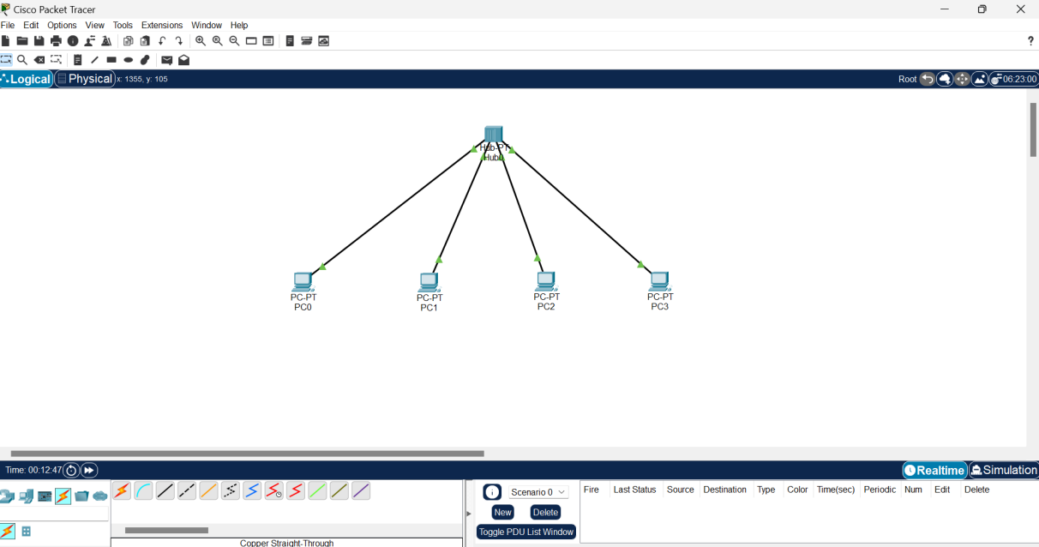

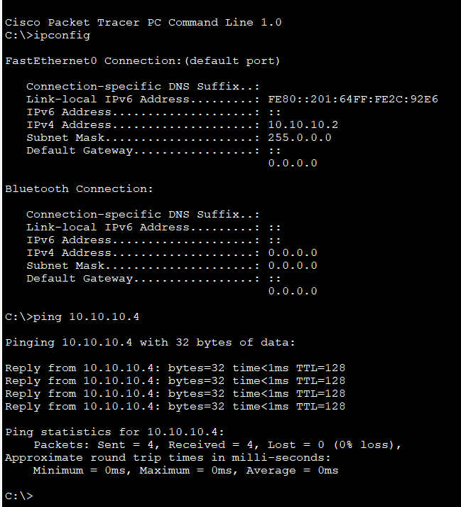

**RESULT:**

Thus, the network using a Hub has been designed in the CISCO PACKET TRACER successfully.