**RAJALAKSHMI ENGINEERING COLLEGE**

**RAJALAKSHMI NAGAR, THANDALAM – 602 105**



|  |
| --- |
| **CS19541**  **COMPUTER NETWORKS LABORATORY** |
| **Laboratory Manual Note Book** |

|  |
| --- |
| **Name : Mohan Vaithya.E**  **Year/Branch/Section : 3rd year - Computer Science and Design**  **Register No. : 221701037**  **Semester : 5**  **Academic Year : 2024-2025** |

**EXP NO : 2 LOCAL AREA NETWORK**

**DATE : 20/07/24**

**AIM:**

To setup and configure a LAN(Local Area Network) using a Switch in the CISCO PACKET TRACER.

**SOFTWARE USED:**

CISCO PACKET TRACER

**PROCEDURE:**

1. Plan and Design an appropriate network topology taking into account network  requirements and equipment location.
2. You can take 4 Computers, a Switch with 8, 16, or 24 ports which is sufficient for  networks of these sizes, and 4 Ethernet cables.
3. Connect your computers to network switch via an Ethernet cable, which is as simple as  plugging one end of the Ethernet cable into your computer and the other end into your network  switch.
4. Assign IP address to your PCs.
5. Configure a network switch.
6. Check the connectivity between switch and other machine by using ping command in  the command prompt of the device.
7. Select a folder, ->go to properties-> click Sharing tab->share it with everyone on the  same LAN.
8. Try to access the shared folder from others Computers of the network.

**LAN SETUP and CONFIGURATION:**

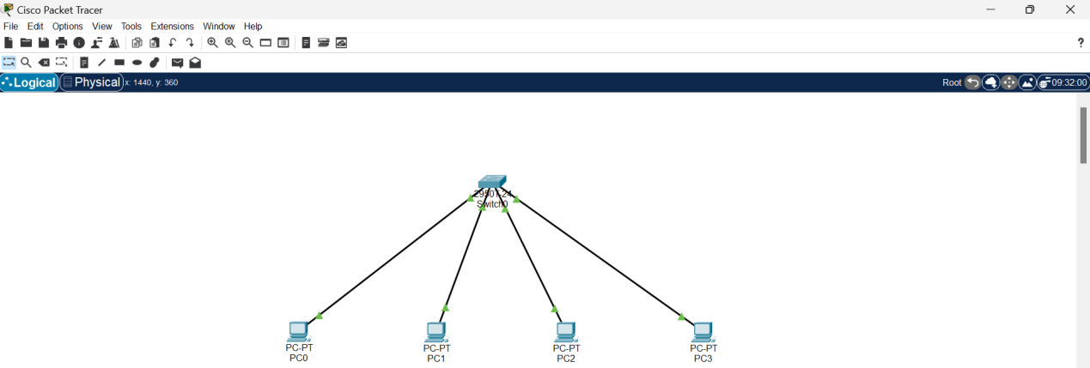

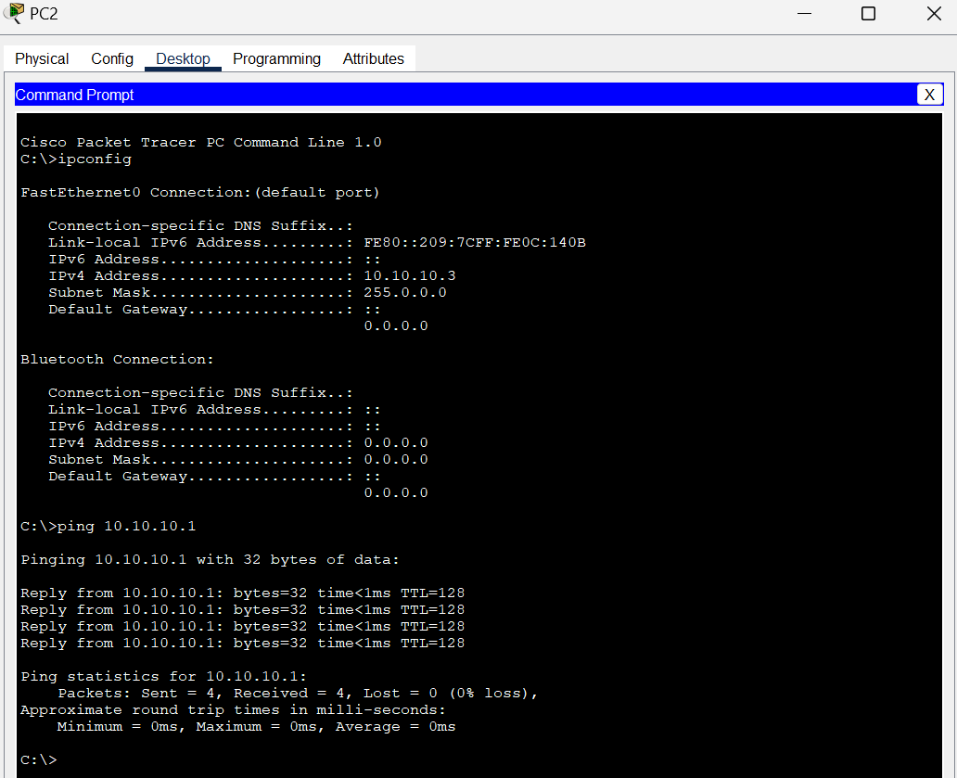

**RESULT**:

Thus, LAN(Local Area Network) setup and configuration using Switch in the CISCO PACKET TRACER has been executed successfully.