**RAJALAKSHMI ENGINEERING COLLEGE**

**RAJALAKSHMI NAGAR, THANDALAM – 602 105**



|  |
| --- |
| **CS19541**  **COMPUTER NETWORKS LABORATORY** |
| **Laboratory Manual Note Book** |

|  |
| --- |
| **Name : Mohan Vaithya.E**  **Year/Branch/Section : 3rd year - Computer Science and Design**  **Register No. : 221701037**  **Semester : 5**  **Academic Year : 2024-2025** |

**EXP NO : 5 FLOW CONTROL**

**DATE : 17/08/24**

**AIM:**

To write a C program to implement flow control at data link layer using SLIDING WINDOW Protocol.

**Software Used:**

Intelli J IDEA

**PROCEDURE**:

Sender Side:

1. Input Window size from the user.

2. Input a Text message from the user.

3. Consider 1 character per frame.

4. Create a frame with following fields [Frame no., DATA].

5. Send the frames. [Print the output on screen and save it in a file called Sender_Buffer.]

6. Wait for the acknowledgement from the Receiver. [Induce delay in the program]

7. Reader a file called Receiver_Buffer.

8. Check ACK field for the Acknowledgement number.

9. If the Acknowledgement number is as expected, send new set of frames accordingly, [overwrite the Sender_Buffer file with new frames] Else if NACK is received, resend the  frames accordingly. [Overwrite the Sender_Buffer with old frame].

Receiver Side:

1. Reader a file called Sender_Buffer.

2. Check the Frame no.

3. If the Fame no. are as expected, write the appropriate ACK no. in the Receiver_ Buffer file. Else write NACK no. in the Receiver_Buffer file.

**PROGRAM**:

#include<stdio.h>  
  
int main()  
{  
    int w,i,f,frames[50];  
  
    printf("Enter window size: ");  
    scanf("%d",&w);  
  
    printf("\nEnter number of frames to transmit: ");  
    scanf("%d",&f);  
  
    printf("\nEnter %d frames: ",f);  
  
    for(i=1;i<=f;i++)  
        scanf("%d",&frames[i]);  
  
    printf("\nWith sliding window protocol the frames will be sent in the following manner (assuming no corruption of frames)\n\n");  
    printf("After sending %d frames at each stage sender waits for acknowledgement sent by the receiver\n\n",w);  
  
    for(i=1;i<=f;i++)  
    {  
        if(i%w==0)  
        {  
            printf("%d\n",frames[i]);  
        printf("Acknowledgement of above frames sent is received by sender\n\n");  
        }  
        else  
            printf("%d ",frames[i]);  
    }  
  
    if(f%w!=0)  
        printf("\nAcknowledgement of above frames sent is received by sender\n");  
  
    return 0;  
}

**Output:**

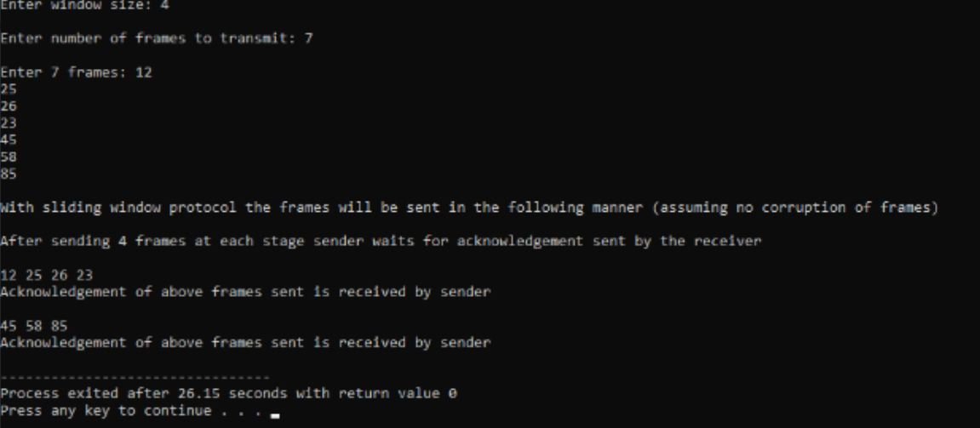

**RESULT**:

Thus, the C program to implement flow control at data link layer using SLIDING WINDOW Protocol.