**RAJALAKSHMI ENGINEERING COLLEGE**

**RAJALAKSHMI NAGAR, THANDALAM – 602 105**



|  |
| --- |
| **CS19541**  **COMPUTER NETWORKS LABORATORY** |
| **Laboratory Manual Note Book** |

|  |
| --- |
| **Name : Mohan Vaithya.E**  **Year/Branch/Section : 3rd year - Computer Science and Design**  **Register No. : 221701037**  **Semester : 5**  **Academic Year : 2024-2025** |

**EXP NO : 7 SUBNETTING**

**DATE : 31/08/24**

**AIM :**

To implement Subnetting in CISCO PACKET TRACER Simulator.

**Software used :**

CISCO PACKET TRACER

**PROCEDURE**:

1. Identify the network requirements to determine the number of subnets and hosts needed.
2. Calculate the subnet information by choosing an appropriate subnet mask and determining the available subnets and hosts per subnet.
3. Create the network topology in Cisco Packet Tracer by adding routers, switches, and PCs to the workspace and connecting them with appropriate cables.
4. Assign IP addresses to each device according to the subnetted network plan, ensuring that routers, switches, and PCs are within the correct subnets.
5. Configure the routers using the command-line interface (CLI) by assigning IP addresses to interfaces and enabling them.
6. Configure the switches to operate in access mode on the required ports through the CLI.
7. Configure the PCs by assigning the IP address, subnet mask, default gateway, and DNS server in the PC’s IP configuration.
8. Test the network by using the ping command from one PC to another to verify connectivity across the network.

**Implementation Of Subnetting in CISCO Packet Tracer:**

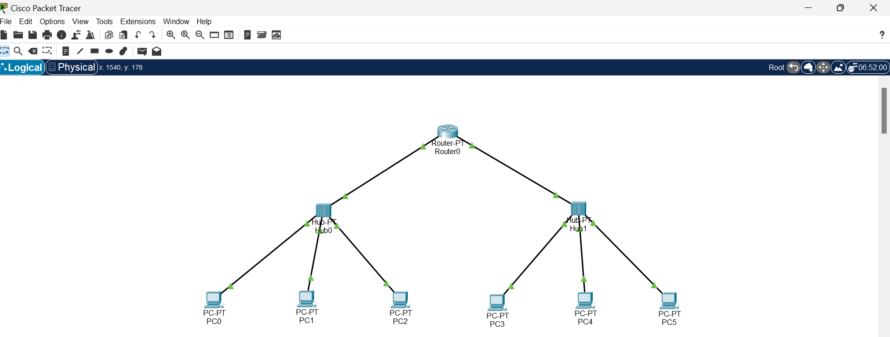

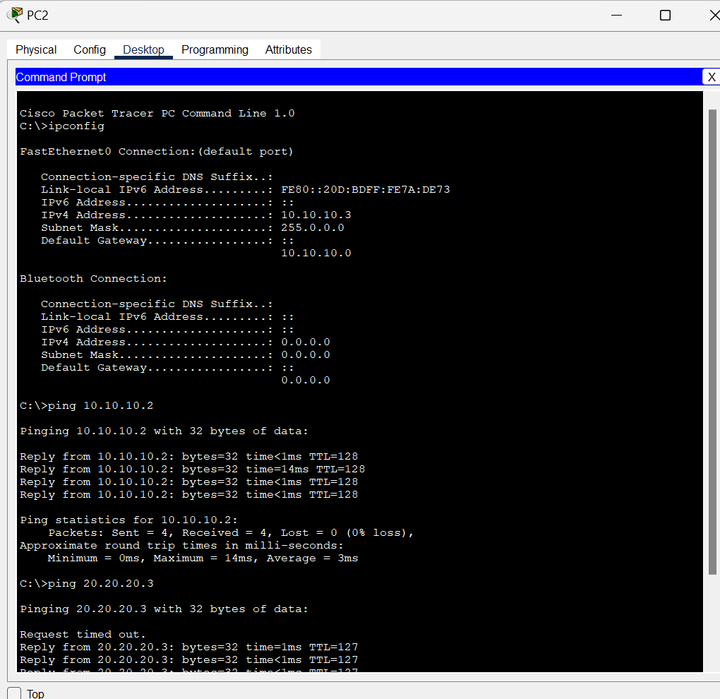

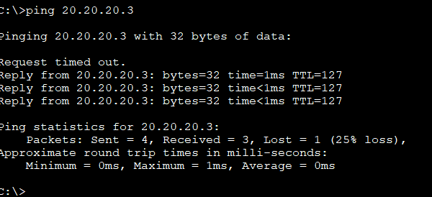

**RESULT:**

Thus, Subnetting has been implemented in CISCO Packet Tracer successfully.