**RAJALAKSHMI ENGINEERING COLLEGE**

**RAJALAKSHMI NAGAR, THANDALAM – 602 105**



|  |
| --- |
| **CS19541**  **COMPUTER NETWORKS LABORATORY** |
| **Laboratory Manual Note Book** |

|  |
| --- |
| **Name : Mohan Vaithya.E**  **Year/Branch/Section : 3rd year - Computer Science and Design**  **Register No. : 221701037**  **Semester : 5**  **Academic Year : 2024-2025** |

**EXP NO : 9 INTERNETWORKING WITH ROUTERS**

**DATE : 14/09/24**

**AIM:**

To design and configure a simple internetwork using a router.

**SOFTWARE USED:**

CISCO PACKET TRACER

**PROCEDURE:**

Step 1: Configuring Router1

1. Open the CLI for Router1.
2. Type enable to enter privileged mode.
3. Type config t to enter global configuration mode.
4. Configure FastEthernet0/0 with IP 192.168.10.1 255.255.255.0 and type no shutdown.
5. Configure FastEthernet0/1 with IP 192.168.20.1 255.255.255.0 and type no shutdown.

Step 2: Configuring PCs

1. Assign IP address 192.168.10.2, subnet mask 255.255.255.0, and gateway 192.168.10.1 to PC0.
2. Assign IP address 192.168.20.2, subnet mask 255.255.255.0, and gateway 192.168.20.1 to PC1.

Step 3: Connecting PCs to Router1

1. Connect PC0's FastEthernet0 to Router1's FastEthernet0/0 using a straight-through cable.
2. Connect PC1's FastEthernet0 to Router1's FastEthernet0/1 using a straight-through cable.

**DESIGNED INTERNETWORK TOPOLOGY:**

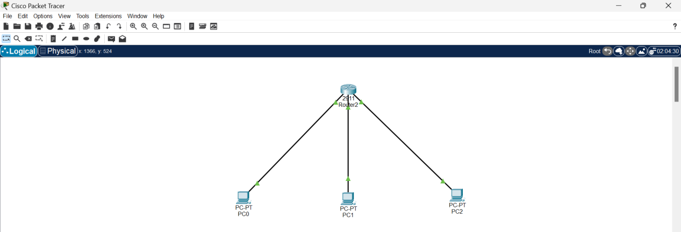

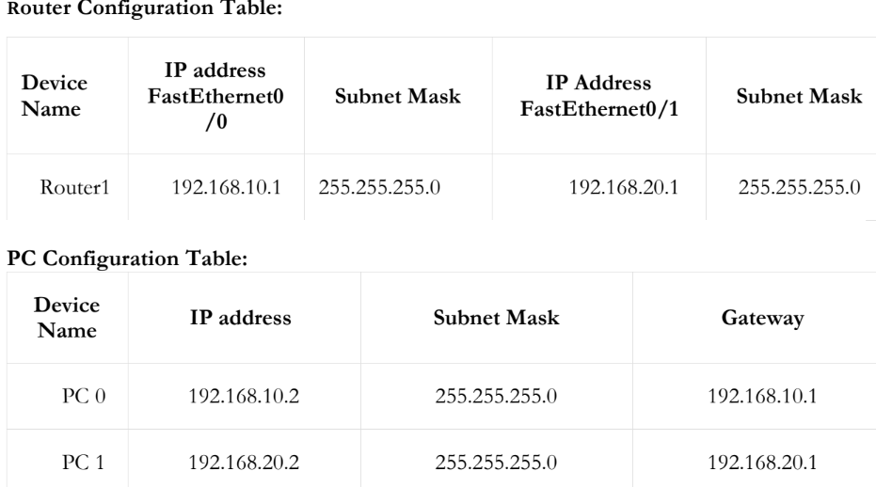

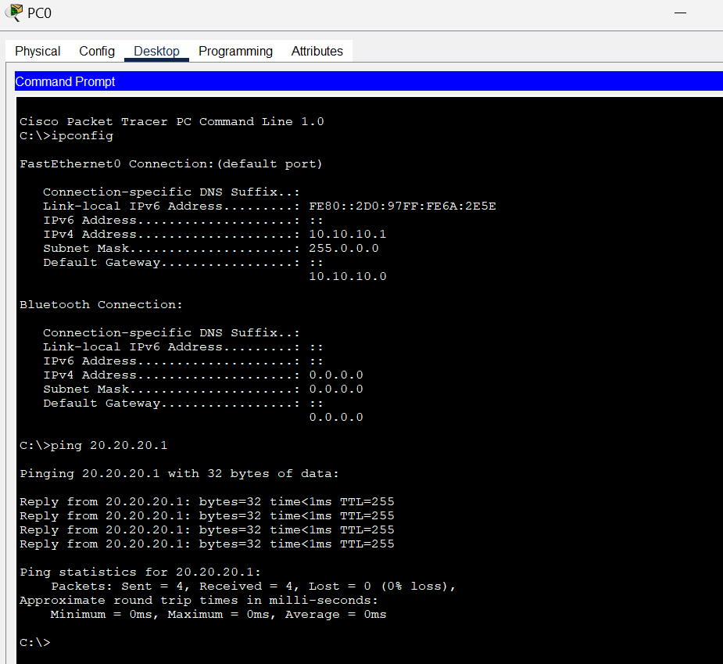

**RESULT:**

Thus, the simple internetwork using routers has been designed and configured in CISCO Packet Tracer successfully.