NFS Booting

Contents
- 1 What is NFS Booting?
- 2 What is 'Diskless booting'?
- 3 Configure the kernel and building kernel image
  - 3.1 Configure kernel for your board
  - 3.2 Configure kernel using menuconfig
  - 3.3 Build kernel image
- 4 Configure server and boot the board
  - 4.1 Configure TFTP Server:
  - 4.2 Update /etc/services
  - 4.3 Update /etc/fstab
  - 4.4 Update /etc/exportfs
  - 4.5 Update /etc/hosts.allow and /etc/hosts.deny
  - 4.6 Boot the board

What is NFS Booting?
Acronym of NFS is “Network File System”, this is a well known method for booting a board with kernel image. You boot your device using a file system which is present a remote machine. It is also called as ‘Diskless booting’. NFS allows remote hosts to mount file systems over a network and access those file systems as if they are mounted locally. You donot require to copy rootfile system onto your board.
- NFS operates over TCP/IP Network
- Enables you to mount a file system on a remote computer
- Directly access any of the files on that remote file system
There are many technologies to bring up the board, but we will see how to boot a board with NFS. This technology can be used to bring up the board effectively and efficiently. We term board as target and the host which is used for bringing up the board is called as NFS server. Typically your host machine can act as NFS server. Target can belong to ARM, powerpc or any other architecture.

What is 'Diskless booting'?
Diskless booting implies that a client computer does not have any disk storage when booting an operating system. In that case, the computer can load the kernel as well as the root filesystem from a remote NFS server over network.
Imagine you have 30 computers in your office, all of which need to access the same application. If you are managing the computers as an administrator, what would you do? It will be a waste of your time if you install the application on every computer. On the other hand, a diskless system can eliminate the problem. With a diskless system, you just need to install the application on a central NFS server, and then boot all 30 clients over network.
A diskless node (or diskless workstation) is a workstation or personal computer without disk drives, which employs network booting to load its operating system from a server. Diskless booting is using a remote system or systems to store the kernel and the filesystem that will be used on other computer(s). Fig.1 depicts the NFS.

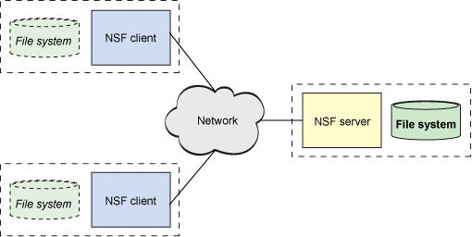
Fig1.Diagram depicting NFS
Below are the main steps of NFS Booting, each step is explained in detail further.
1. Configure the kernel and build kernel image to be used for booting the board
2. Configure server and boot the board

Configure the kernel and building kernel image
First of all decide the board on which you want to use NFS booting, Choose a board of your choice. ex :Beagle board, TI or any freescale board, etc. Check if it has ethernet port. Ethernet port is must in board as you boot through ethernet.
Select the kernel which you wish to port on to the board. After selecting a kernel version make sure it supports your board, you can check in arch/arm/configs dir and see if it has board specific file. If it doesnot contain any config file supporting your board you should change the kernel.

Configure kernel for your board
For example if you have 'panda board' we need to configure kernel for it. Assuming omap2plus_defconfig(we call it as board specific file) is used to enable configurations for panda board execute below command:
$make omap2plus_defconfig
Above command creates below output
# configuration written to .config

omap2plus_defconfig is saved to .config
In order to use nfsroot, NFS client support needs to be selected as built-in during configuration. Once this has been selected, the nfsroot option will become available. So, configure the kernel as below:

Configure kernel using menuconfig
$make menuconfig
Enable below flags : NFSD, ROOT_NFS, NFS_FS etc
>In Makefile change ARCH and CROSS_COMPILE flags and set accordingly.

Build kernel image
$make uImage
Above command creates kernel image in arch/arm/boot dir. This is called cross compiled image for your board. This is the image you are going to use for booting the board. Below diagram explains workings of NFS
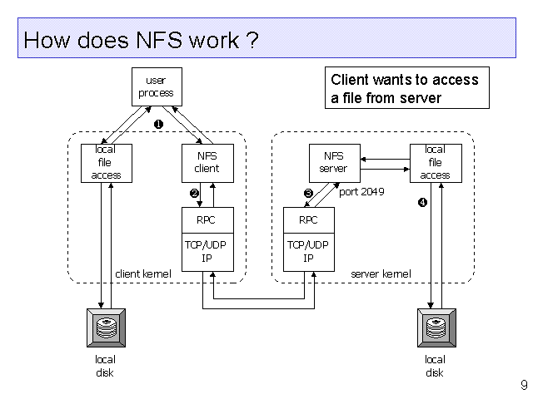
Fig2. How does NFS work?

Configure server and boot the board
Your host machine can act as NFS server, to behave as server configure it by following steps:
Before you can start NFS, you will need to have TCP/IP networking functioning correctly on your machine. Because NFS operates on TCP/IP. If you can use telnet, FTP, and so on, then chances are your TCP networking is fine.
Now start by installing necessary packages:
$ sudo apt-get install dhcp3-server tftpd-hpa syslinux nfs-kernel-server initramfs-tools tftpd

Configure TFTP Server:
(Assuming 172.16.6.108 as your host ip address, 172.16.6.222 as target address)
There needs to be a way to transfer boot files to board and this can be done with a TFTP server . It is a small FTP server which is needed for automated transfer of boot files between a client computer and server in the local network. The TFTP server will be used to transfer the bootloader, kernel, and initramfs or any other files to client that are required for booting the board.
Run the following to create the TFTP server's base directory with superuser privileges:
#mkdir /tftpboot
tftpboot should have world read/write permissions. Otherwise the client would not be able to boot from network.
#chmod 0777 /tftpboot
To configure TFTP server, create /etc/xinetd.d/tftp with the following contents:
#vim /etc/xinet.d/tftp
service tftp
{
protocol = udp
socket_type = dgram
wait = yes
user = root
server = /usr/sbin/in.tftpd
server_args = -s /tftpboot
disable = no
port = 69
}
Note : -s option for server_args should be present to work tftp properly
>Now copy the uImage that you built in above steps and rootfs to this directory
- copy uImage
#cp <path_to_your_kernel>/arch/arm/boot/uImage /tftpboot/
- Create a root file system for the board and copy to tftpboot dir
For ex:#cp -rf <path_to_rootfs>/rootfs/ /tftpboot/

Update /etc/services
Edit /etc/services file, enable tftp for port number 69
#vim /etc/services
tftp 69/udp
tftp 69/tcp

Update /etc/fstab
#vim /etc/fstab
172.16.6.108:/tftpboot/rootfs /nfs nfs soft,intr 0 0

Update /etc/exportfs
Configure the NFS server to export the client root filesystem. The /etc/exports file controls which file systems are exported to remote hosts and specifies options In its simplest form, the /etc/exports file only specifies the exported directory and the hosts permitted to access it
#vim /etc/exports
/tftpboot/rootfs *(rw,no_root_squash,sync,no_subtree_check)
the /tftpboot/rootfs is the directory that you want to share. If you share a directory, then all directories under it, within the same file system will be shared as well.
As an alternative way * can be replaced with ip of target board indicating target has access permission to host.
Below are the explanation for options used:
ro: The directory is shared read only; the client machine will not be able to write to it. This is the default.
rw: The client machine will have read and write access to the directory.
no_root_squash: By default, any file request made by user root on the client machine is treated as if it is made by user nobody on the server. (Excatly which UID the request is mapped to depends on the UID of user "nobody" on the server, not the client.) If no_root_squash is selected, then root on the client machine will have the same level of access to the files on the system as root on the server. This can have serious security implications, although it may be necessary if you want to perform any administrative work on the client machine that involves the exported directories. You should not specify this option without a good reason.
no_subtree_check: If only part of a volume is exported, a routine called subtree checking verifies that a file that is requested from the client is in the appropriate part of the volume. If the entire volume is exported, disabling this check will speed up transfers.
sync: By default, all but the most recent version (version 1.11) of the exportfs command will use async behavior, telling a client machine that a file write is complete - that is, has been written to stable storage - when NFS has finished handing the write over to the filesysytem. This behavior may cause data corruption if the server reboots, and the sync option prevents this.
Run the following command to reload modified /etc/exports.
# sudo exportfs -rv

Update /etc/hosts.allow and /etc/hosts.deny
#vim /etc/hosts.allow
portmap : 172.16.6.108 172.16.6.222
lockd : 172.16.6.108 172.16.6.222
rquotad : 172.16.6.108 172.16.6.222
mountd : 172.16.6.108 172.16.6.222
statd : 172.16.6.108 172.16.6.222
(Assuming 172.16.6.108 is address of your hostmachine(NFS server), 172.16.6.222 (ip of board))

#vim /etc/hosts.deny
portmap : ALL
lockd : ALL
mountd : ALL
rquotad : ALL
statd : ALL
These two files specify which computers on the network can use services on your machine. Each line of the file contains a single entry listing a service and a set of machines. When the server gets a request from a machine, it does the following:
> It first checks hosts.allow to see if the machine matches a description listed in there. If it does, then the machine is allowed access.
> If the machine does not match an entry in hosts.allow, the server then checks hosts.deny to see if the client matches a listing in there. If it does then the machine is denied access.
> If the client matches no listings in either file, then it is allowed access.
Restart all services :
$sudo exportfs -a
$sudo exportfs -rv
$sudo service nfs-kernel-server start
$sudo /etc/init.d/tftpd-hpa restart

Boot the board
Its time to boot the board. Please ensure below settings are done between host and target
- Board is powered up
- Connect ethernet cable between host and target, this is how kernel image and other files are copied to your board
- Connect serial port between host and target to get the boot logs.
Once board is given power keep pressing any button so that you will get minicom terminal. Update minicom settings are below:
| A - Serial Device : /dev/ttyS0 |
| B - Lockfile Location : /var/lock |
| C - Callin Program : |
| D - Callout Program : |
| E - Bps/Par/Bits : 115200 8N1 |
| F - Hardware Flow Control : No |
| G - Software Flow Control : No |
>Set server ip address:
#setenv serverip 172.16.6.108
>Set client ip address:
#setenv ipaddr 172.16.6.222
>Set bootargs :
#set bootargs root=/dev/nfs rw nfsroot=172.16.6.108:/tftpboot/rootfs,rsize=1024,wsize=1024 ip=172.16.6.222:172.16.6.110:172.16.6.1:255.255.255.0
::eth0 off ethaddr=<ur_machine_hwAddr> console=ttySAC1,115200
#tftp 0x32000000 uImage
Above command loads uImage from your host to target at address 0x32000000
NOTE: Please not the load address (32000000) is just an example, it varies from board to board. Use correct load adress for your board
#bootm 0x32000000
Boots the application image from memory 0x32000000
Here onwards kernel uncompresses and starts booting the board. Once everything is done board becomes ready for you.
NOTE : Above are confirmed steps for booting TI's DM6446/Freescale's IMX.25 boards.
Bootargs may change slightly as board changes.
Please go through the 'data sheet/board bring up doc' of your board and execute above steps.
References:
http://xmodulo.com/diskless-boot-linux-machine.html
http://oss.sgi.com/LDP/HOWTO/Net-HOWTO/x635.html
http://www.tldp.org/HOWTO/NFS-HOWTO/server.html

