Raspberry Pi

Contents
- 1 introduction
  - 1.1 General purpose input-output (GPIO) connector
- 2 Getting started with Noops
  - 2.1 How to get and install NOOBS
- 3 Raspberry Pi boot process
- 4 Cross compile the kernel for the Raspberry Pi
- 5 Setting up HDMI
- 6 Ethernet setting on Raspberry pi

introduction
The Raspberry Pi is a series of credit card–sized single-board computers developed in Wales, United Kingdom by the Raspberry Pi Foundation with the intention of promoting the teaching of basic computer science in schools and developing countries.
The Raspberry Pi is based on the Broadcom BCM2835 system on a chip (SoC),which includes an 700 MHz ARM1176JZF-S processor, VideoCore IV GPU and RAM.On the older beta model B boards, 128 MB was allocated by default to the GPU, leaving 128 MB for the CPU.On the first 256 MB release model B and model A).
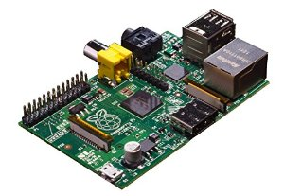

General purpose input-output (GPIO) connector
RPi A+, B+, 2B and Zero GPIO J8 40-pin pinout.[71] Models A and B have only the first 26 pins.
Model b GPIO PINS
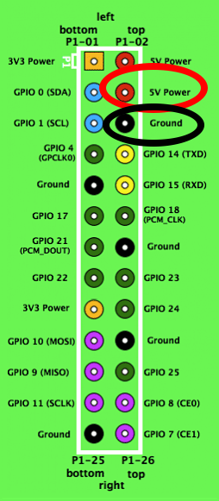

Getting started with Noops

How to get and install NOOBS
https://www.raspberrypi.org/downloads/noobs/

Using a computer with an SD card reader, visit the Downloads page.Click on the Download ZIP button under ‘NOOBS (offline and network install)’, and select a folder to save it to.Extract the files from the zip.
Format your SD card,Once your SD card has been formatted, drag all the files in the extracted NOOBS folder and drop them onto the SD card drive.The necessary files will then be transferred to your SD card.When this process has finished, safely remove the SD card and insert it into your Raspberry Pi.
First boot
Plug in your keyboard, mouse and monitor cables.Now plug in the USB power cable to your Pi.Your Raspberry Pi will boot, and a window will appear with a list of different operating systems that you can install. We recommend that you use Raspbian – tick the box next to Raspbian and click on Install.Raspbian will then run through its installation process. Note this can take a while.When the install process has completed, the Raspberry Pi configuration menu (raspi-config) will load. Here you are able to set the time and date for your region and enable a Raspberry Pi camera board, or even create users. You can exit this menu by using Tab on your keyboard to move to Finish.
Logging in and accessing the graphical user interface
The default login for 'Raspbian' is username 'pi' with the password 'raspberry'. Note you will not see any writing appear when you type the password. This is a security feature in Linux.
To load the graphical user interface type startx.

Raspberry Pi boot process
First, you need to know the RPi does not boot up like a conventional desktop computer. The VideoCore a.k.a the Graphics processor actually boots before the ARM CPU! Anyway,before we get into the details here’s a diagram of the RPi highlighting the Broadcom BCM2835 SoC.
The SoC (or System-on-Chip) contains the ARM CPU, the VideoCore Graphics Processor, ROM (Read-Only-Memory) chips, the SDRAM and so many other things. Basically, think of a SoC as your Motherboard and CPU compressed together into a single chip.
When you power on your Raspberry Pi, the first bits of code to run is stored in a ROM chip in the SoC and is built into the Pi during manufacture! This is the called the first-stage bootloader. The SoC is hardwired to run this code on startup on a small RISC Core (Reduced Instruction Set Computer). It is used to mount the FAT32 boot partition in your SDCard so that the second-stage bootloader can be accessed. So what is this ‘second-stage bootloader’ stored in the SD Card? It’s ‘bootcode.bin’. You might have seen this file if you had mounted the SD Card in Windows. Now here’s something tricky. The first-stage bootloader has not yet initialized your ARM CPU (meaning CPU is in reset) or your RAM. So, the second-stage bootloader also has to run on the GPU. The bootloader.bin file is loaded into the 128K 4 way set associative L2 cache of the GPU and then executed. This enables the RAM and loads start.elf which is also in your SD Card. This is the third-stage bootloader and is also the most important. It is the firmware for the GPU, meaning it contains the settings or in our case, has instructions to load the settings from config.txt which is also in the SD Card. You can think of the config.txt as the ‘BIOS settings’ (as is mentioned in the forum). Some of the settings you can control are (thanks to dom):
arm_freq : frequency of ARM in MHz. Default 700.
gpu_freq : Sets core_freq, h264_freq, isp_freq, v3d_freq together.
core_freq : frequency of GPU processor core in MHz. Default 250.
h264_freq: frequency of hardware video block in MHz. Default 250.
isp_freq: frequency of image sensor pipeline block in MHz. Default 250.
v3d_freq: frequency of 3D block in MHz. Default 250.
sdram_freq: frequency of SDRAM in MHz. Default 400.
The start.elf also splits the RAM between your GPU and the ARM CPU. The ARM only has access the to the address space left over by the GPU address space. For example, if the GPU was allocated addresses from 0x000F000 – 0x0000FFFF, the ARM has access to addresses from 0x00000000 – 0x0000EFFF. (These are not real address ranges. It’s just for demonstration purposes). Now what’s even funnier is that the ARM core perceives 0x00005001 as it’s beginning address 0x00000000. In other words, if the ARM core requests the address 0x0000000, the actual address in RAM is 0x00005001. Edit: The physical addresses perceived by the ARM core is actually mapped to another address in the VideoCore (0xC0000000 and beyond) by the MMU (Memory Management Unit) of the VideoCore. The config.txt is loaded after the split is done so you cannot specify the splitting amounts in the config.txt. However, different .elf files having different splits exist in the SD Card. So, depending on your requirement, you can rename those files to start.elf and boot the Pi. (The forums mention of having this functionality in a dynamic fashion, but I don’t know whether they have implemented it yet) [EDIT8/7/2014: As per Andrew’s comment it has been implemented in present firmware] In the Pi, the GPU is King!
Other than loading config.txt and splitting RAM, the start.elf also loads cmdline.txt if it exists. It contains the command line parameters for whatever kernel that is to be loaded. This brings us to the final stage of the boot process. The start.elf finally loads kernel.img which is the binary file containing the OS kernel (DUH!?) and releases the reset on the CPU. The ARM CPU then executes whatever instructions in the kernel.img thereby loading the operating system.
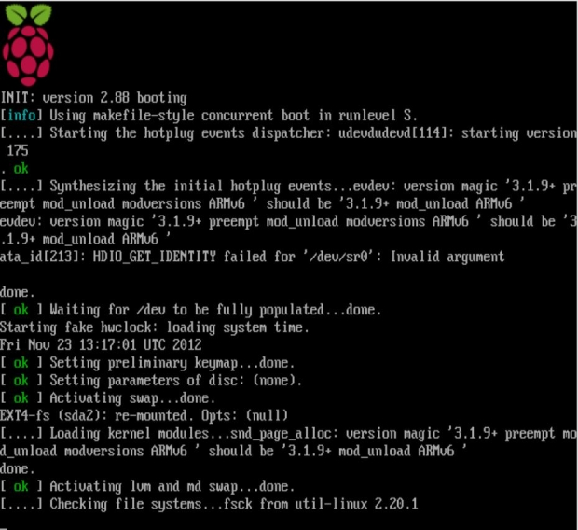

Cross compile the kernel for the Raspberry Pi
This tutorial will demonstrate how to cross compile the kernel for the Raspberry Pi on Ubuntu 12.04 LTS. The kernel is functional with both the Debian and Arch Linux Raspberry Pi images.
First, install the package dependencies, git and the cross-compilation tool chain:
sudo apt-get install git-core gcc-4.7-arm-linux-gnueabi
Create a symlink for the cross compiler:
sudo ln -s /usr/bin/arm-linux-gnueabi-gcc-4.7 /usr/bin/arm-Linux-gnueabi-gcc
Make a directory for the sources and tools, then clone them with git:
mkdir raspberry-pi
cd raspberry-pi
git clone https://github.com/raspberrypi/tools.git git clone https://github.com/raspberrypi/linux.git
cd linux
Generate the .config file from the pre-packaged raspberry pi one:
make ARCH=arm CROSS_COMPILE=/usr/bin/arm-linux-gnueabi- bcmrpi_defconfig
If you want to make changes to the configuration, run make menuconfig (optional):
make ARCH=arm CROSS_COMPILE=/usr/bin/arm-linux-gnueabi- menuconfig
Once you have made the desired changes, save and exit the menuconfig screen. Now we are ready to start the build. You can speed up the compilation process by enabling parallel make with the -j flag. The recommended use is ‘processor cores + 1′, e.g. 5 if you have a quad core processor:
make ARCH=arm CROSS_COMPILE=/usr/bin/arm-linux-gnueabi- -k -j5
Assuming the compilation was successful, create a directory for the modules:
mkdir ../modules
Then compile and ‘install’ the loadable modules to the temp directory:
make modules_install ARCH=arm CROSS_COMPILE=/usr/bin/arm-linux-gnueabi- INSTALL_MOD_PATH=../modules/
Now we need to use image tool-uncompressed.py from the tools repo to get the kernel ready for the Pi.
cd ../tools/mkimage/./imagetool-uncompressed.py ../../linux/arch/arm/boot/Image
This creates a kernel.img in the current directory. Plug in the SD card of the existing Debian image that you wish to install the new kernel on. Delete the existing kernel.img and replace it with the new one, substituting “boot-partition-uuid” with the identifier of the partion as it is mounted in Ubuntu.
sudo rm /media/boot-partition-uuid/kernel.img
sudo mv kernel.img /media/boot-partition-uuid/
Next, remove the existing /lib/modules and lib/firmware directories, substituting “rootfs-partition-uuid” with the identifier of the root filesystem partion mounted in Ubuntu.
sudo rm -rf /media/rootfs-partition-uuid/lib/modules/
sudo rm -rf /media/rootfs-partition-uuid/lib/firmware/
Go to the destination directory of the previous make modules_install, and copy the new modules and firmware in their place:
cd ../../modules/
sudo cp -a lib/modules/ /media/rootfs-partition-uuid/lib/
sudo cp -a lib/firmware/ /media/rootfs-partition-uuid/lib/
sync
That’s it! Exject the SD card, and boot the new kernel on the Raspberry Pi!

Setting up HDMI
You only need to read this when you DO get video, but it is in the wrong format/resolution!
Normally, optional video configuration settings are stored in the monitor itself, as the EDID data. When it starts up, the Raspberry Pi asks the monitor for information about itself. This information is returned by the monitor in a data structure called an EDID block (note that the TV/monitor must be typically be switched on before the Pi is booted for this to work), then used to configure the Pi so that it uses optimal settings for the monitor.
CEA (Consumer Electronics Association) and DMT (Display Monitor Timings) are two logical groups of configuration settings. Here follows a list of all CEA and DMT formats (as of CEA-861 E and DMT V1 r12 respectively). If you want to use any of these modes explicitly, set hdmi_group and hdmi_mode to the correct values in the config file. Note that not all modes are supported by the Raspberry Pi hardware (mainly the high resolution/high frame rate modes) and all explicit modes are subject to EDID support from the monitor/TV you are using.
If the file config.txt is not present or the output format is not set explicitly, the default output format is chosen as follows:
1. If the preferred format in EDID is supported, this will be chosen. 2. If the preferred format is not supported, then all the formats supported will be ranked according to some heuristics. The format with the highest score will be chosen.
If the chosen format is a DMT format, the default driven mode will be DVI. The user will need to set driving mode to 2 explicitly if HDMI output is desired. In DVI mode there will be no sound!
This is how to override the default format in config.txt:
1. Set hdmi_group = 1 (for CEA formats) or hdmi_group = 2 (for DMT formats)
2. Set hdmi_mode = x (where x is the code of the format of the respective group; see the list of CEA/DMT formats for details.)
3. If the chosen format is DMT, set hdmi_drive = 2 to enable HDMI output. (CEA modes are output as HDMI by default).
If you are unsure what formats are supported, set the output format to VGA 60Hz and then follow the instructions below to parse the EDID to find out what formats are supported. All executables are found under /opt/vc/bin.
1. Run “tvservice –m CEA” to give a list of CEA supported modes.
2. Run “tvservice –m DMT” to give a list of DMT supported modes.
3. Run “tvservice -s” to give you the current state.
Alternatively you can do the following:
1. Run “tvservice –d <file>” to capture a monitor’s EDID.
2. Pass this file to edidparser. Run “edidparser <file>”.
At this point, edidparser outputs the list of formats supported in EDID including formats not supported in Raspberry Pi, and it will show you which formats are filtered out. At the end of the output it will show which format is chosen as default. Note that edidparser is the internal EDID parsing code of Raspberry Pi with a command line front end.
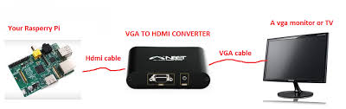

Ethernet setting on Raspberry pi
In that case it seems that the network device is OK. Try manually setting the network configuration.
Use your favourite editor on /etc/network/interfaces file. Make sure it looks like this:

auto eth0
iface eth0 inet dhcp
If that works, you should be good to go. If that doesn't work then set the IP address manually, you need to know the subnet, usually 192.168.0.0 or 192.168.1.0, and your router IP address,

auto eth0
iface eth0 inet static
address 192.168.0.55
netmask 255.255.255.0
gateway 192.168.0.254
If this works you should have network connection, man interfaces should give you more information on this file should you need it.
This will test whether you can get a network configuration loaded. If you can then se if you can ping your router.
