Real-Time Sensing on Android

Contents
- 1 Android sensor sub system
  - 1.1 Kernel
  - 1.2 HAL
  - 1.3 Sensor Service
  - 1.4 Sensor manager

Android sensor sub system
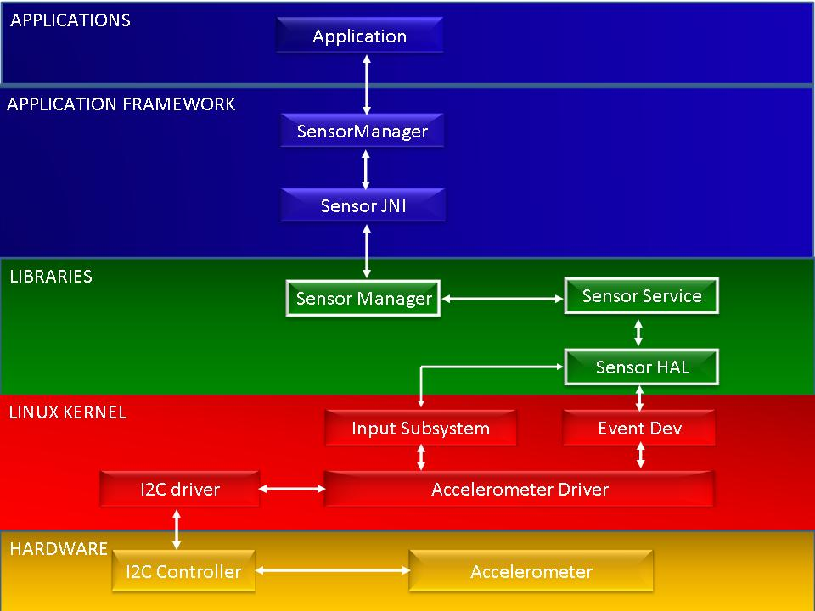

Kernel
This layer enables raw H/W access. Android uses linux's input sub system (evdev) for sensor devices.
* The input sub system is an abstraction layer between i/p devices and i/p handlers.

* The i/p devices capture physical inputs and produces i/p events.
* The i/p events then go through the i/p core and are dispatched to any subscribed handlers,
which in turn make them available through the standard UNIX file interface /dev/input/eventX.
* Thus, applications can access the raw sensors data as an i/p events by calling POSIX system calls.

HAL
It is a user space layer that interface with the kernel.
* It polls the i/p events from kernel (/dev/input/eventX) for reading sensor data
and provides a unifying H/W interfaces for other user space process.
* This layer also hides vendor specific details.
* HAL is loaded into User-Space process as a shared library.

Sensor Service
It Uses HAL to access raw sensor data. This layer is in fact part of a system process that starts from system boot time.
2 things-
* It re formats raw H/W sensor data using application friendly data structure.
* It fuses reading from multiple H/W sensors to generate S/W sensors data.

Sensor manager
Is an Android library linked to each application at run time.
* It Provides registration and de registration calls for app implemented event handlers.
* Once app registers an event handler, sensor Manger's sensor thread reads sensor data from a sensor service.

