Friday ,10th november :



Hypervisor
A hypervisor monitors the creation and running of virtual machines. It allows a large number of machines with different operating systems to run on a single host machine.

Type1 hypervisors directly run on the physical hardware. They control the hardware as well as manage the virtual machines. Type1 are also termed bare metal hypervisors.

Hypervisor type1 Choice. Xen or KVM?

Xen

The Xen Project began around 2004 at a time where there was no existing open source virtualization.Xen, which is a Type I Hypervisor – which means it sits a single layer above bare metal. It’s like a stripped down operating system, and it uses a function called “pass-through” to connect directly to PCI devices like RAM/CPU/NICs.

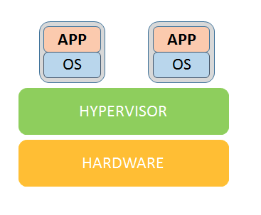

Type 1 hypervisor

The Xen Project is one of the leading open source virtualisation platforms. The Xen hypervisor is licensed under GPLv2. Like many of its competitors, Xen is also available in a commercial form from Citrix. Oracle VM is another commercial implementation of Xen. The Xen Project platform supports many cloud platforms such as Openstack, Cloudstack, etc. The Xen hypervisor provides an efficient and secure feature set for virtualisation of X86, IA64, ARM and other CPU architectures, and has been used to virtualise a wide range of guest operating systems, including Windows, Linux, Solaris and various versions of the BSD operating systems.

KVM

The Kernel Based Virtual Machine (KVM) is an open source project written for GNU/Linux that runs on x86 hardware. ... A complete virtualization system, there are many external programs written to manage KVM images.

References
[1] https://my.vmware.com/web/vmware/info/slug/datacenter_cloud_infrastructure/vmware_vsphere/6_0#open_source
[2] https://my.vmware.com/web/vmware/evalcenter?p=free-esxi6
[3] https://www.microsoft.com/en-us/evalcenter/evaluate-hyper-v-server-2012-r2
[4] https://en.wikipedia.org/wiki/Hyper-V
[5] http://xhypervisor.org/
[6] http://download.virtualbox.org/virtualbox/UserManual.pdf
[7] https://my.vmware.com/web/vmware/free#desktop_end_user_computing/vmware_workstation_player/12_0
[8] https://lwn.net/Articles/218766/
[9] http://lguest.ozlabs.org/
[10] https://linuxcontainers.org/
[11] http://linux-vserver.org/

14th Nov 2017

compiled xen-4.9.0 with tool chain gcc-linaro-arm-linux-gnueabihf-4.8-2014.04_linux.

With the help of scirpt :
make dist-xen XEN_TARGET_ARCH=arm64 CROSS_COMPILE=aarch64-linux-gnu-

we can find this with the help of link : https://wiki.xenproject.org/wiki/Xen_ARM_with_Virtualization_Extensions

tried to Create a base chroot using :

sbuild-createchroot --components=main,universe saucy /srv/chroots/saucy-armhf-cross http://archive.ubuntu.com/ubuntu/

Got error like :
E: Failed getting release file http://archive.ubuntu.com/ubuntu/dists/saucy/Release
E: Error running debootstrap at /usr/sbin/sbuild-createchroot line 200.

replaced saucy with trusty.

sbuild-createchroot --components=main,universe trusty /srv/chroots/trusty-arm64-cross http://archive.ubuntu.com/ubuntu/

Still got the same error :
E: Error running debootstrap at /usr/sbin/sbuild-createchroot line 200.

We have to change the code inside this file : vim /etc/schroot/schroot.conf

15th nov 2017

with the help of open network we run the same command

sbuild-createchroot --components=main,universe trusty /srv/chroots/trusty-arm64-cross http://archive.ubuntu.com/ubuntu/

Pacakges willl download
we will get like below

┌────────────────────────────────────────────────────────────────────────
│127.0.0.1 kadali localhost
└────────────────────────────────────────────────────────────────────────
I: Configured /usr/sbin/policy-rc.d:
┌────────────────────────────────────────────────────────────────────────
│#!/bin/sh
│echo "All runlevel operations denied by policy" >&2
│exit 101
└────────────────────────────────────────────────────────────────────────
I: Configured APT /etc/apt/sources.list:
┌────────────────────────────────────────────────────────────────────────
│deb http://archive.ubuntu.com/ubuntu/ trusty main universe
│deb-src http://archive.ubuntu.com/ubuntu/ trusty main universe
└────────────────────────────────────────────────────────────────────────
I: Please add any additional APT sources to /srv/chroots/trusty-arm64-cross/etc/apt/sources.list
I: schroot chroot configuration written to /etc/schroot/chroot.d/trusty-amd64-sbuild-hp1xQN.
┌────────────────────────────────────────────────────────────────────────
│[trusty-amd64-sbuild]
│type=directory
│description=Debian trusty/amd64 autobuilder
│directory=/srv/chroots/trusty-arm64-cross
│groups=root,sbuild
│root-groups=root,sbuild
│profile=sbuild
└────────────────────────────────────────────────────────────────────────
I: Please rename and modify this file as required.
mkdir /etc/sbuild/chroot
I: sudo chroot configuration linked as /etc/sbuild/chroot/trusty-amd64-sbuild.
I: Setting reference package list.
I: Updating chroot.
Ign http://archive.ubuntu.com trusty InRelease
Hit http://archive.ubuntu.com trusty Release.gpg
Hit http://archive.ubuntu.com trusty Release
Get:1 http://archive.ubuntu.com trusty/main Sources [1064 kB]
Get:2 http://archive.ubuntu.com trusty/universe Sources [6399 kB]
Hit http://archive.ubuntu.com trusty/main amd64 Packages
Hit http://archive.ubuntu.com trusty/universe amd64 Packages
Get:3 http://archive.ubuntu.com trusty/main Translation-en [762 kB]
Get:4 http://archive.ubuntu.com trusty/universe Translation-en [4089 kB]
Fetched 12.3 MB in 1min 22s (149 kB/s)
Reading package lists... Done
Reading package lists... Done
Building dependency tree... Done
Calculating upgrade... Done
0 upgraded, 0 newly installed, 0 to remove and 0 not upgraded.
I: Successfully set up trusty chroot.
I: Run "sbuild-adduser" to add new sbuild users.

Tried to run this command :
schroot -c trusty-arm64-cross
failed and end up with message :
W: line 18 [sid] priority: Could not parse value ‘3’
W: line 17 [sid]: Obsolete key ‘location’ used
I: This option has been removed, and no longer has any effect
E: trusty-arm64-cross: Chroot not found

16th nov 2017

How to delete a non-empty directory in Terminal?
Example :
root@kadali:/srv/chroots# rmdir saucy-armhf-cross/
rmdir: failed to remove ‘saucy-armhf-cross/’: Directory not empty

so we should use rm -rf saucy-armhf-cross/

17th nov 2017

Hypervisor ABI Compatibility:
The ABI for Xen on ARM was declared stable from Xen 4.4 onwards.
In computer software , an application binary interface (ABI) is the interface between two program modules, one of which is often a library and/or operating system and the other one is usually an application created by a regular programmer.

API: Application Program Interface
This is the set of public types/variables/functions that you expose from your application/library.
In C/C++ this is what you expose in the header files that you ship with the application.

ABI: Application Binary Interface
This is how the compiler builds an application.
It defines things (but is not limited to):How parameters are passed to functions (registers/stack).
- Who cleans parameters from the stack (caller/callee).
- Where the return value is placed for return.
- How exceptions propagate.

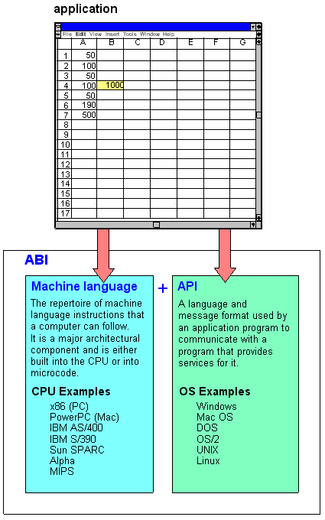

Failed to run the command :schroot -c trusty-arm64-cross
after that tried new command in the path /srv/chroots.
root@kadali:/srv/chroots# chroot trusty-arm64-cross

we entered in to the trusty-arm64-cross root .
After that tried to download the packages using command
:apt-get install vim-tiny wget sudo less pkgbinarymangler

failed to download the packages and end with error message :
Fetched 42.8 kB in 0s (309 kB/s)
E: Failed to fetch http://archive.ubuntu.com/ubuntu/pool/main/libl/liblockfile/liblockfile-bin_1.09-6ubuntu1_amd64.deb Size mismatch

E: Failed to fetch http://archive.ubuntu.com/ubuntu/pool/main/libl/liblockfile/liblockfile1_1.09-6ubuntu1_amd64.deb Size mismatch

E: Failed to fetch http://archive.ubuntu.com/ubuntu/pool/main/o/openssl/libssl1.0.0_1.0.1f-1ubuntu2_amd64.deb Size mismatch

E: Failed to fetch http://archive.ubuntu.com/ubuntu/pool/main/libi/libidn/libidn11_1.28-1ubuntu2_amd64.deb Size mismatch

E: Failed to fetch http://archive.ubuntu.com/ubuntu/pool/main/l/less/less_458-2_amd64.deb Size mismatch

E: Failed to fetch http://archive.ubuntu.com/ubuntu/pool/main/l/lockfile-progs/lockfile-progs_0.1.17_amd64.deb Size mismatch

E: Failed to fetch http://archive.ubuntu.com/ubuntu/pool/main/s/sudo/sudo_1.8.9p5-1ubuntu1_amd64.deb Size mismatch

E: Failed to fetch http://archive.ubuntu.com/ubuntu/pool/main/v/vim/vim-common_7.4.052-1ubuntu3_amd64.deb Size mismatch

E: Failed to fetch http://archive.ubuntu.com/ubuntu/pool/main/v/vim/vim-tiny_7.4.052-1ubuntu3_amd64.deb Size mismatch

E: Failed to fetch http://archive.ubuntu.com/ubuntu/pool/main/o/openssl/openssl_1.0.1f-1ubuntu2_amd64.deb Size mismatch

E: Failed to fetch http://archive.ubuntu.com/ubuntu/pool/main/c/ca-certificates/ca-certificates_20130906ubuntu2_all.deb Size mismatch

E: Failed to fetch http://archive.ubuntu.com/ubuntu/pool/main/w/wget/wget_1.15-1ubuntu1_amd64.deb Size mismatch

E: Failed to fetch http://archive.ubuntu.com/ubuntu/pool/main/a/advancecomp/advancecomp_1.18-1_amd64.deb Size mismatch

E: Failed to fetch http://archive.ubuntu.com/ubuntu/pool/main/o/optipng/optipng_0.6.4-1build1_amd64.deb Size mismatch

E: Failed to fetch http://archive.ubuntu.com/ubuntu/pool/main/p/pkgbinarymangler/pkgbinarymangler_121_all.deb Size mismatch

E: Unable to fetch some archives, maybe run apt-get update or try with –fix-missing?

20th Nov 2017 :

qualcumm written test.

21st Nov 2017:

I modified the source list information for local LAN to open network
for open network :
/etc/ap # cp souces.list sources.list_bak
for local lan :
/etc/apt# cp sources.list sourcs.list_ges

with the help of ftp I got the info :

ftp://172.16.2.4/Linux/

for fixing the problems
search for “synaptic package manager”
in edit option fix the broken packages.

22nd Nov 2017 :

modified the source list with

(chroot)# vi /etc/apt/sources.list
deb [arch=amd64] http://archive.ubuntu.com/ubuntu/ saucy main universe
deb-src [arch=amd64] http://archive.ubuntu.com/ubuntu/ saucy main universe

deb [arch=arm64] http://ports.ubuntu.com/ saucy main universe
after that successfully completed the Configuring an arm64 crossbuild chroot.

Build arm64 tools:
cp /usr/share/misc/config.{sub,guess} .

And next

CONFIG_SITE=/etc/dpkg-cross/cross-config.arm64 ./configure --build=x86_64-unknown-linux-gnu --host=aarch64-linux-gnu

next
make dist-tools CROSS_COMPILE=aarch64-linux-gnu- XEN_TARGET_ARCH=arm64

here end with an error :
install: cannot stat 'xen/COPYING': No such file or directory .

24rd Nov 2017:

virtually creating ip address :

system 1:

sudo ifconfig eth0:0 172.16.4.16 broadcast 172.16.9.255 netmask 255.255.255.0

eth0:0 ==> interface name

broadcat ==> broadcast ip address

netmask ==>default net mask

after that we have to access this virtual address in another system for that we need to add in route table that should be add in another system .

System 2:

sudo route add -net 172.16.4.0 gw 172.16.9.16 netmask 255.255.255.0 dev eth0

gw ==> ip address of the system acts as a gateway

netmask ==> default netmask

dev eth0 ==> interface name of the gw system

