1 Audio System 1 (Audio Basics)

1.1 Important attributes :
Loudness, Pitch, sound Quality, Samples, Sampler, Sampling, Quantization, encoding, channels, frames,

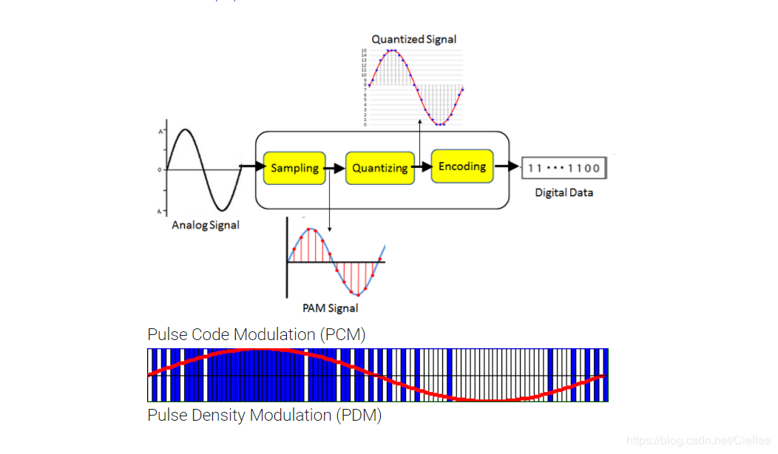

1.2 nyquist theorem for sampling
The Nyquist Theorem, also known as the sampling theorem, is a principle that engineers follow in the digitization of analog signals. ... According to the Nyquist Theorem, the sampling rate must be at least 2fmax, or twice the highest analog frequency component.
"When the sampled analog signal is restored, its highest frequency is only half the sampling frequency."In other words, if we want to completely reconstruct the original analog signal, the sampling frequency must be more than twice that.
For example, the range of human voice is 2 ~ 20kHZ, then the sampling frequency should be about 40kHZ. If the value is too small, the sound will be distorted. If the value is too large, it will not significantly improve the sound quality that the human ear can perceive.

1.2.1 Key Points :
* According to Nyquist theory, as long as the sampling frequency is not less than twice the highest frequency of the audio signal, the original sound can be restored without loss.
* Generally, the human ear can hear sound in the frequency range of about 20Hz to 20kHz. In order to ensure that the sound is not distorted, the sampling frequency should be above 40kHz.
* Commonly used audio sampling frequencies are: 8kHz, 11.025kHz, 22.05kHz, 16kHz, 37.8kHz, 44.1kHz, 48kHz, 96kHz, 192kHz, etc.

1.3 Quantization precision
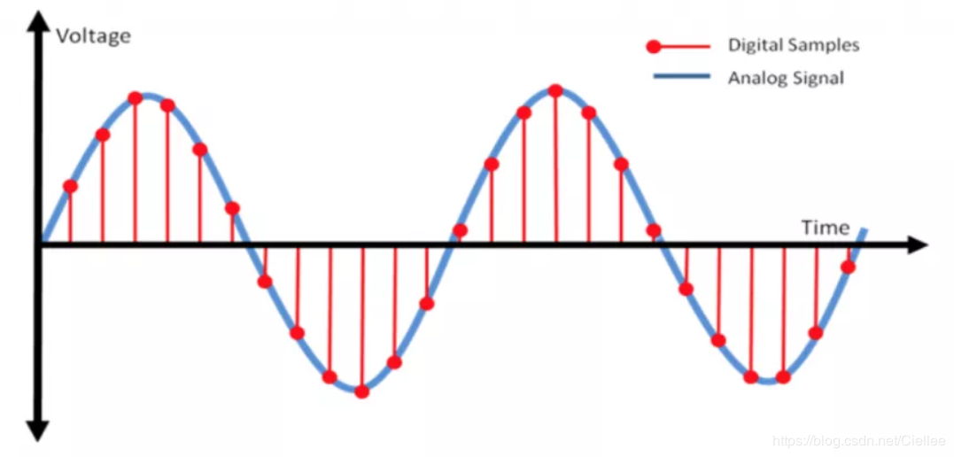

* Red sampled points are needed to be represent the size of numerical values and the size can be 4bits, 8bits, 16 bits etc...
*the number of bits The more it is, the more detailed it is, and the better the sound quality is, of course, the amount of data will also increase exponentially. Common bit widths are: 8bit or 16bit

1.4 audio frames:
* It is generally agreed that the amount of data in units of 2.5ms ~ 60ms is one frame of audio.
*This time is called "sampling time", and there is no special standard for its length. It is determined according to the requirements of the codec and the specific application.
*Assume that an audio signal has a sampling rate of 8kHz, two channels, a bit width of 16bit, and a frame of 20ms. The size of a frame of audio data is:
int size = 8000 x 2 x 16bit x 0.02s = 5120 bit = 640 byte
1.5 Encoding methods:
* The process of quantization is called encoding. According to different quantization strategies, many different encoding methods have been generated.
*Common encoding methods are: PCM and ADPCM.
1.6 audio compression formats
* The following is a brief list of common audio compression formats:
MP3, AAC, OGG, WMA, Opus, FLAC, APE, M4A, AMR, etc.
* This compressions are required for redundant signals.

2 Android audio subsystem :
2.1 code flow:
1. Application layer
2. Application framework
3. JNI
4. Native framework or libraries
5. Binders
6. Native Services
7. Hal
8. kernel
9. hardware
2.2 Audio Track API in Application Framework:
2.2.1 Audio Track API contains two data transfer modes
1. MODE_STATIC:
Creation mode where audio data is transferred from Java to the native layer only once before the audio starts. playing.
2. MODE_STREAM:
Creation mode where audio data is streamed from Java to the native layer as the audio is playing.
Audio Track API contains below stream types
STREAM_VOICE_CALL
STREAM_SYSTEM
STREAM_RING
STREAM_MUSIC
STREAM_ALARM
STREAM_NOTIFICATION
STREAM_DTMF
Why we need above stream types ?
These are android audio management strategy handled in audio policy manager.
1. Audio stream volume management. Adjust the volume of one type of audio stream without affecting other types of audio streams.
2. Select the appropriate output device according to the stream type; for example, when a wired headset is plugged in, the music sound (STREAM_MUSIC) will only be output to the wired headset, and the ringtone (STREAM_RING) will be output to both the wired headset and the amplifier

2.2.2 Example:
frameworks/base/media/java/android/media/AudioTrack.java +978
final AudioTrack track = new AudioTrack(
mAttributes, mFormat, mBufferSizeInBytes, mMode, mSessionId, mOffload);
mMode can be either MODE_STATIC or MODE_STREAM
functions:
public AudioTrack (int streamType,
int sampleRateInHz,
int channelConfig,
int audioFormat,
int bufferSizeInBytes,
int mode);
above function is a constructor.
static public int getMinBufferSize(int sampleRateInHz, int channelConfig, int audioFormat);
sampleRateInHz the source sample rate expressed in Hz.
channelConfig describes the configuration of the audio channels.
audioFormat the format in which the audio data is represented.
* Returns the estimated minimum buffer size required for an AudioTrack
* object to be created in the {@link #MODE_STREAM} mode.
To get more functions
https://developer.android.com/reference/android/media/AudioTrack.html
2.3 Audio Track API in Native Framework:
2.3.1 AudioTrack Native API four data transmission modes:
TRANSFER_CALLBACK,
TRANSFER_OBTAIN,
TRANSFER_SYNC,
TRANSFER_SHARED.
AudioTrack Native API audio stream type:
same stream types like application framework API with prefix AUDIO_

2.3.2 AudioTrack Native API output identification:
AUDIO_OUTPUT_FLAG_DIRECT,
AUDIO_OUTPUT_FLAG_PRIMARY,
AUDIO_OUTPUT_FLAG_FAST,
AUDIO_OUTPUT_FLAG_DEEP_BUFFER,
AUDIO_OUTPUT_FLAG_COMPRESS_OFFLOAD.
We use different output logos according to different playback scenarios, such as keypad sounds and game background sounds, which require high output delay, so we need to set AUDIO_OUTPUT_FLAG_FAST. For details, refer to ToneGenerator, SoundPool, and OpenSL ES.
2.4 how to get min frame count ?
2.4.1 Frame size:
frame represents a complete sound unit so one sound unit refers to a sample.
If we have two channels, sound unit will be two samples like 5.1 channel means
complete sound unit is 6 samples.
So, frameSize = channelCount * bytesPerSample
2.4.2 transmission delay:
transmission delay represents the transmission time of a period of audio data. Or one cycle of audio data(block).
Linus ALSA divides the data buffer into several blocks, when hardware interrupt is issued, DMA transmits the one block of data or one cycle of audio data.
PeriodSize = number of frames in a data block.
Transmission delay (latency) = periodSize / sampleRate.
2.4.3 Audio re sampling:
It is a process of converting the data from one sampling rate to another sampling rate.
Android Native audio system work at fixed sampling rate (48KHz) So, all audiotrack data needs to be resampled to 48KHz sampled rate.
Why do we do this re-sampling ?
There may be multiple audio tracks playing in the system at the same time, and the sampling rate of each audio track may be inconsistent.
for example, during the process of playing music, a cue sound comes, and then the music and cue sound need to be mixed and output To the hardware device, and the sample rate of the music is not the same as the sample rate of the prompt sound, the problem comes. If the sample rate of the hardware device is set to the sample rate of the music, the prompt sound will be distorted; therefore, the simplest and effective solution Yes: The sampling rate of the hardware device is fixed at a value. All audio tracks are re sampled to this sampling rate in the Audio Flinger, and then mixed to the hardware device to ensure that all audio tracks do not sound distorted.

+-----------------------------+--------------+--------------+
| | | | |buffer = 4 periods
+--------------+--------------+--------------+--------------+
^
|
+---+---+------+
| | | ... |period = 1024 frames
+---+---+------+
^
|
+---+
|L|R|frame = 2 samples (left + right)
There are 4 periods in this buffer, and an interrupt will be generated every time the DMA moves the data of a period, so moving the data in this buffer will generate 4 interrupts. Why does ALSA do this? Because the data buffer area may be large, one transmission may cause unacceptable delay; in order to solve this problem, alsa splits the buffer area into multiple cycles and transfers the data in cycles.
Now we can understand the AudioTrack :: getMinFrameCount () function

Some more about audio track:
To play a PCM file, follow the five steps below.
1.Configure basic parameters
2.Get the minimum buffer size
3.Create AudioTrack object
4.Get the PCM file and turn it into a DataInputStream
5.Start / stop playback

Audio track can only play decoded pcm streams for playback of pcm audio streams.
AudioTrack.MODE_STREAM, MODE_STATIC.
Sampling rate: mSampleRateInHz(48kHz)
Number of channels: mChannelConfig(MONO, STEREO)
Number of audio quantization bits: mAudioFormat (only supports 8bit and 16bit.)

Minimum buffer size:
mMinBufferSize depends on the three attributes of sampling rate, number of channels, and sampling depth.
After getting the mMinBufferSize, we can create an AudioTrack object.
public AudioTrack(int streamType, int sampleRateInHz, int channelConfig, int audioFormat, int bufferSizeInBytes, int mode)throws IllegalArgumentException {
}

and in JNI
frameworks/base/core/jni/android_media_AudioTrack.cpp
native_setup is called to create a local AudioTrack object and create a Storage object.
From this Storage, it is guessed that this may be the place to store audio data.

Next Get the PCM file and turn it into a DataInputStream
Later Start / stop playback, Pause playback etc ….

(1) Java part of Audio(frameworks / base / media / java / android / media)
The Java package related to Audio is android.media, which mainly contains several classes of AudioManager and Audio system.
(2) JNI part of Audio(frameworks / base / core / jni)
Generate library libandroid_runtime.so, JNI of Audio is one of them.
(3) Framework part of Audio(frameworks / base / include / media / and frameworks / base / media / libmedia / )
This part of the content is compiled into the library libmedia.so, which implements the core framework of the Audio system and provides the IAudioFlinger class interface.
In this class, two interfaces, IAudioTrack and IAudioRecorder, can be obtained, which are used for sound playback and recording, respectively.
AudioTrack and AudioRecorder implement IAudioTrack and IAudioRecorder respectively. The three interfaces IAudioFlinger.h, IAudioTrack.h, and IAudioRecorder.h are implemented through the lower layers.
AudioSystem.h, AudioTrack.h, and AudioRecorder.h are interfaces provided by the upper layer.They are used for local program calls and can also provide interfaces to the Java layer through JNI. From a functional point of view, AudioSystem is responsible for the comprehensive management function of the Audio system, and AudioTrack and AudioRecorder are responsible for the output and input of audio data, that is, playback and recording. The other interface is IAudioFlingerClient, which acts as a listener registered with IAudioFlinger, which is equivalent to using callback functions to obtain IAudioFlinger runtime information.

