Interfacing RTC with Raspberry Pi 3b
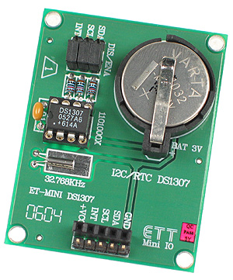
C DS1307 Pins | Raspberry Pi Ports
SDA | GPIO02 SDA1(pin - 03)
SCL | GPIO03 SCL1(pin - 05)
VCC | +5V(pin - 02 or 04)
GND | Ground

Real-time clock (RTC) counts seconds, minutes, hours, date of the month, month, day of the week, and year.
56-byte, battery-backed, nonvolatile (NV)RAM for data storage.
Two-wire serial interface.
Available in 8-pin DIP or SOIC.
The DS1307 uses an external 32.768kHz crystal.
The RTC registers are located in address locations 00h to 07h.
The RAM registers are located in address locations 08h to 3Fh.
The contents of the time and calendar registers are in the BCD format.

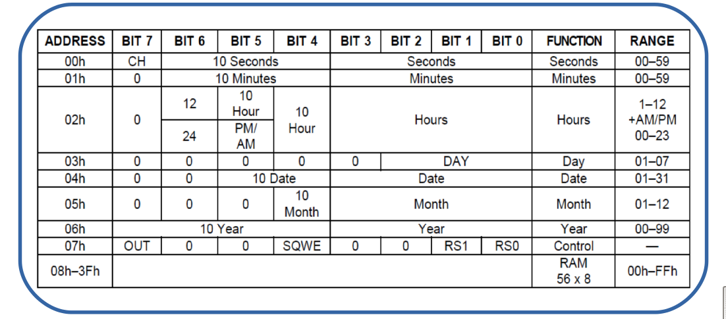

Device Tree:
- A device tree is a tree data structure with nodes that describe the physical devices in a system.
- On ARM all device tree source are located at /arch/arm/boot/dts/.
- Device tree compiler (dtc) is used to compile dts files and produce .dtb.
- The Device Tree Blob(.dtb) is the binary that gets loaded by the bootloader and parsed by the kernel at boot time.

Linux I2C Device Driver
This is a generalized interface to declare I2C buses & devices and functionalities of I2C.
We need to manage them according to the standard Linux driver model and perform input/output operations...!!!

Important structures
- struct i2c_driver[4]
- struct i2c_client[5]
- struct i2c_board_info[6]
- struct i2c_algorithm[7]
- struct i2c_adapter
- struct i2c_message
I2C Device Driver Implementation
Here, I have treated I2C slave as character device and, according to that, I have developed character device driver.

Initialization function for driver module
module_init() :
- Setting up a char device - alloc_chrdev_region()
- Allocate and register structure of type struct cdev - cdev_alloc()
- Tell the kernel about it - cdev_add()
- Create the class of character device - class_create()
- Create the device of the class - device_create()
- Register i2c driver to the Kernel - i2c_add_driver()
Probing of Device:
probe() : Purpose of probe() function is to detect devices residing on the bus & to create device nodes corresponding to these devices. The kernel calls the driver's probe() function once for each device. Probe function starts the per-device initialization: initializing hardware, allocating resources, and registering the device with the kernel.
- In order to probe the slave device, it is essential to make entry in the appropriate .dts(device tree source) file of board on which you are working (Raspberry Pi, in this case).
- Once you make the entry in DTS, you need to compile the DTS file using DTC(Device Tree Compiler)(Refer above section)[[8]].

