I2C Architecture
Introduction:

- I2C is a peripheral bus proposed by phillips.
- I2C intended to allow multiple slaves communicate with one or more masters.
- I2C is only for shorter distance.
- I2C required two signal wires(SDA, SCL).
- The master is always drives the SCL and slaves are the devices responds to the master.
- Both master and slave can share the data over i2c bus but always controlled by master means slaves nerver initiates the transfer.
I2C protocol:
- In i2c data transfered in messages.
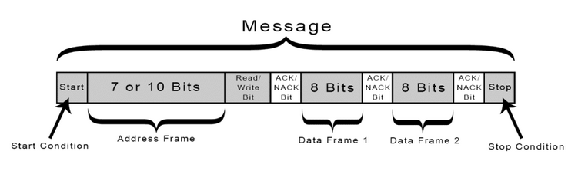
- Message contains start/sop condition, address frame, multiple data frames, read/write bit, ACK/NACK bit for each data frame.

- Start Condition:The SDA line switches from a high voltage level to a low voltage level before the SCL line switches from high to low. Stop Condition:The SDA line switches from a low voltage level to a high voltage level after the SCL line switches from low to high.
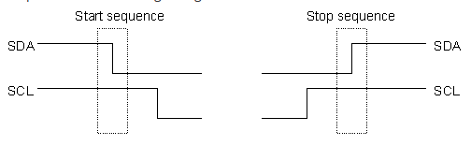

- Address Frame:A 7 or 10 bit sequence unique to each slave that identifies the slave when the master wants to talk to it.
- Read/Write Bit:A single bit specifying whether the master is sending data to the slave (low voltage level) or requesting data from it (high voltage level).
- ACK/NACK Bit:Each frame in a message is followed by an acknowledge/no-acknowledge bit. If an address frame or data frame was successfully received, an ACK bit is returned to the sender from the receiving device.
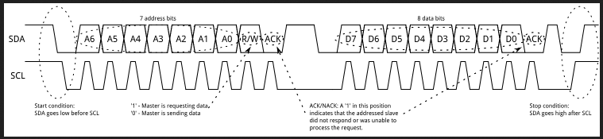
How data transfering:
- data transfered in sequence of 8 bits and these bits placed on the SDA line starting with MSB.
- SCL line will take 9 pulses (8 pulses for 8 bit data 1 pulse for ACK/NACK bit)
- If receiving device sends back the low ACK back, its ready to accept another 8 bits of data
if receiving device sends back the high ACK back, it can accept any data
- and master will terminate by transfering sop sequence.
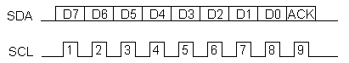

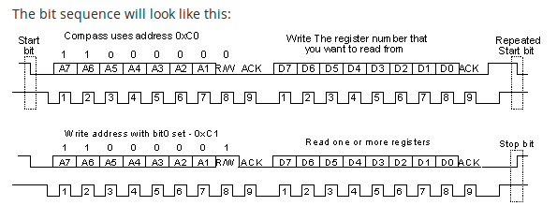
Write to slave:
- The first thing that will happen is that the master will send out a start sequence, This will allert all the slaves in the bus
- master will send the device address,the slave which matches with the address will continue with the transaction
- slave will decide that the read/write.(0 for write , 1 for read)
- Master will send data bytes it can continue the sending data (slave will automatically increment internal registers after each byte received.)
- finally master will send the stop sequence.
Read from slave:
- This is a little more complicated - but not too much more. Before reading data from the slave device, master must tell it which of its internal addresses it want to read. So a read of the slave actually starts off by writing to it.
- Same as when master want to write to it: send the start sequence, the I2C address of the slave with the R/W bit low (even address) and the internal register number you want to write to.

- Now send another start sequence (sometimes called a restart) and the I2C address again - this time with the read bit set. Then read as many data bytes as master wish and terminate the transaction with a stop sequence.

