Serial Peripheral Interface:
- It is a synchronous serial communication interface used for short distance communication developed by motorola.
- SPI communicate in full duplex mode using master slave architecture
- single master multiple slaves.
- With individual slave select line(SS) specific slave device will communicate with master.
- SPI is four wired serial bus( uses shift registers concept)
- SCLK, MOSI, MISO, SS
SPI communication:
- master configures the clock to start communication.
- Master will select the slave device using SS line (SS will be low in this case)
- during each clock a full duplex data transmission will occur.
- The master sends a bit on the MOSI line ans slave reads it. Similary slave send bit on MISO line and master reads it.
- This sequence maintained in one direction.
- Transmission involves two shift registers (for master and selected slave)
- data will be shifted with MSB first. On the clock edge both master nad slave shift out the bit.
SPI modes :
- SPI have four modes depends on CPOL and CPHA
CPOL: clock polarity
CPOL=0 is a clock which idles at 0, and each cycle consists of a pulse of 1. The leading edge is a rising edge, and the trailing edge is a falling edge.
CPOL=1 is a clock which idles at 1, and each cycle consists of a pulse of 0. The
leading edge is a falling edge, and the trailing edge is a rising edge.

CPHA: Clock Phase

For CPHA=0, the data changes on the trailing edge of the preceding clock cycle,
captures on the leading edge of the clock cycle. Data is valid until the trailing edge
of the current clock cycle. For the first cycle, the first bit must be on the MOSI line
before the leading clock edge.

For CPHA=1, the data changes on the leading edge of the current clock cycle,
captures on the trailing edge of the clock cycle. Data is valid until the leading edge
of the following clock cycle.

- SPI Mode decides Sampling Edge and Toggling Edge for the data.
- SPI interface transmit and receive data simultaneously on MOSI and MISO.
- Clock polarity (CPOL) and clock phase (CPHA) define a clock format to be used by the SPI bus.
- Depending on CPOL parameter, SPI clock may be inverted or non-inverted. CPHA parameter is used to shift the sampling phase.
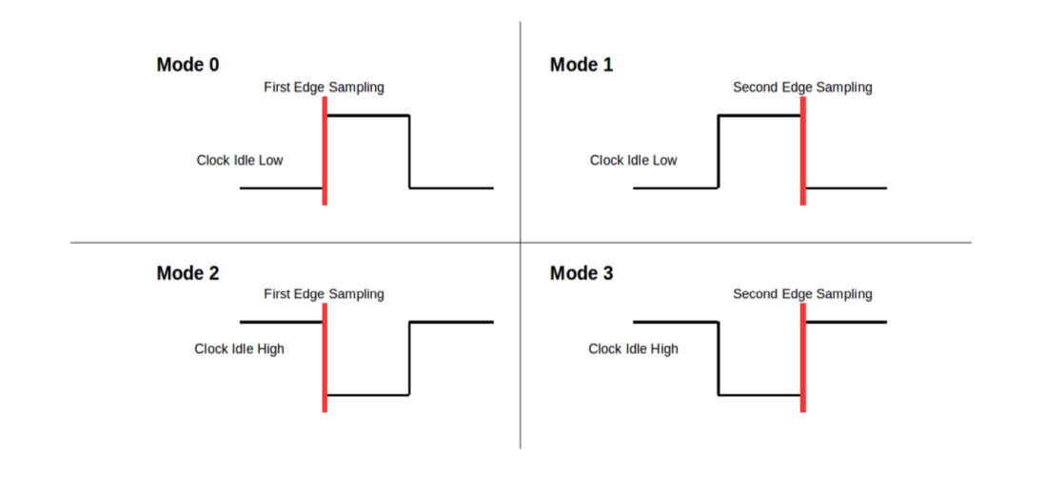

Mode 0
The clock idle state is zero. The data must be available before the first rising clock signal. The data on MISO and MOSI lines must be stable while the clock is high and can be changed when the clock is low. The data is captured on the clock's low-to-high transition and propagated on high-to-low clock transition.
Mode 1
The clock idle state is zero. The first rising clock signal can be used to prepare the data. The data on MISO and MOSI lines must be stable while the clock is low and can be changed when the clock is high. The data is captured on the clock's high-to-low transition and propagated on low-to-high clock transition.
Mode 2
The clock idle state is one. The data must be available before the first falling clock signal. The data on MISO and MOSI lines must be stable while the clock is low and can be changed when the clock is high. The data is captured on the clock's high-to-low transition and propagated on low-to-high clock transition.
Mode 3
The clock idle state is one. The first clock signal falling can be used to prepare the data. The data on MISO and MOSI lines must be stable while the clock is high and can be changed when the clock is low. The data is captured on the clock's low-to-high transition and propagated on high-to-low clock transition.

Working of Shift Register:
- These type of registers used in the SPI communication receives the number of bits same as that of transmitted bits simultaneously.
- If it transmits single bit from one end, simultaneously, it receives single bit at other end (Full Duplex).

