**ASSIGNMENT-1**

**Create a VPC with 2 subnets and 2 route tables and internet gateway**

* **Launch an instance**
* **Attach instance with EBS**

**Create VPC (Virtual Private Cloud)**

Search for VPC in search space of AWS home page and click on VPC (fig-1)

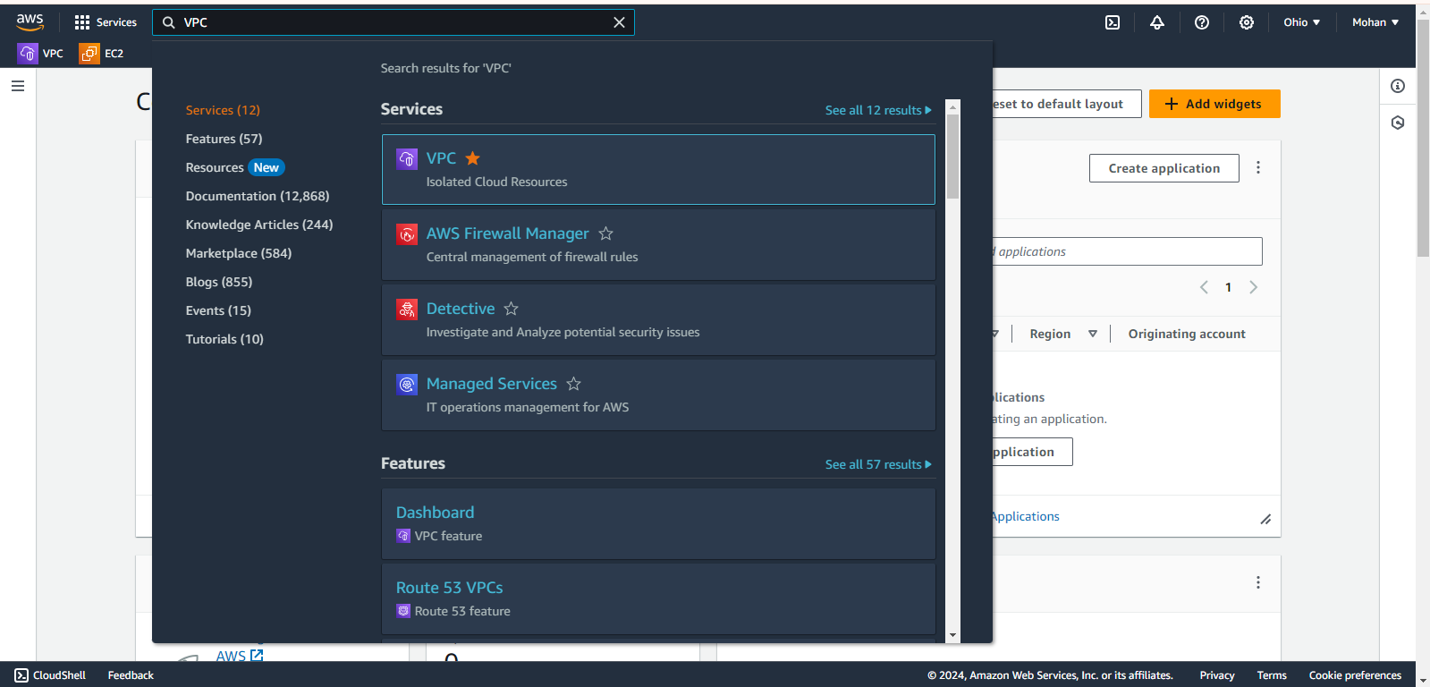

Fig : 1

Now click on **Your VPCs** option under Virtual private cloud (Fig-2)

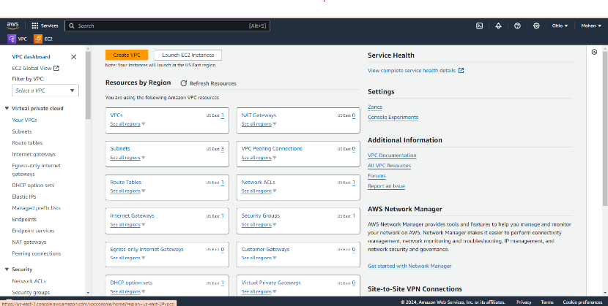

Now click on Create VPC to create our custom VPC (Fig : 3)

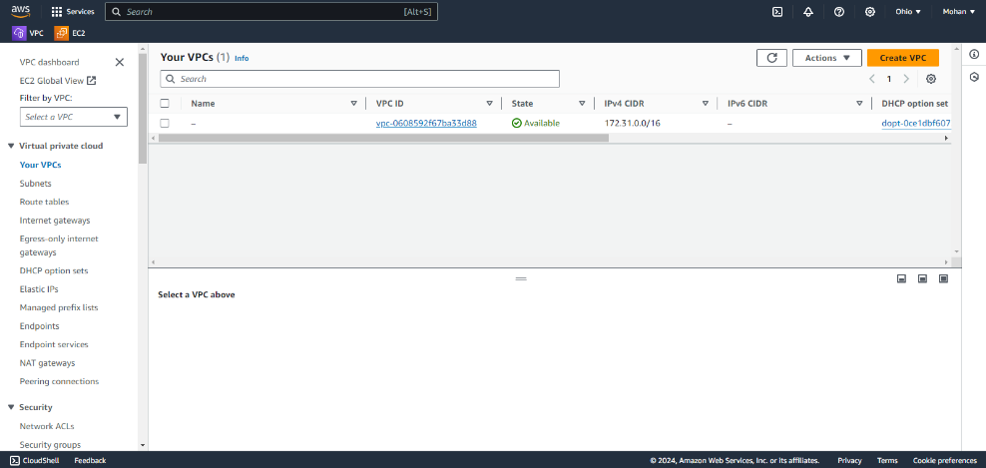

Fig : 3

Now We have to enter the details for our VPC and finally click on Create VPC(Fig -4)

Details:-

Resources to Create: VPC Only

Name Tag : Example (my-first-vpc)

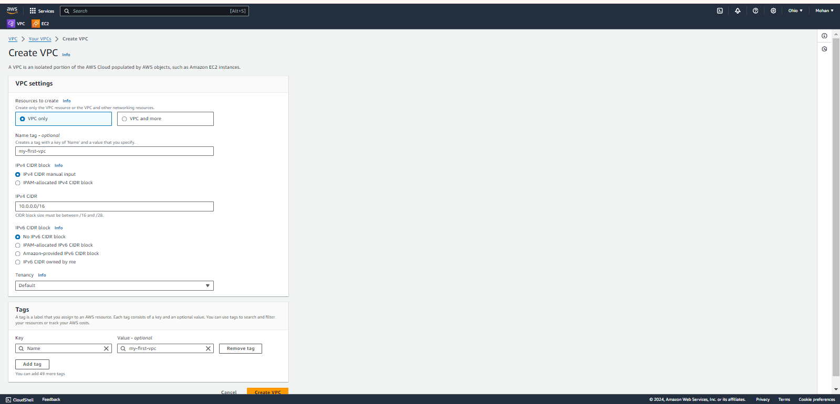

Fig : 4

We have created our custom VPC successfully.

**Create** **Internet gateway**

Now click on **Internet gateway** option under VPC(Virtual Private Cloud) (Fig-5)

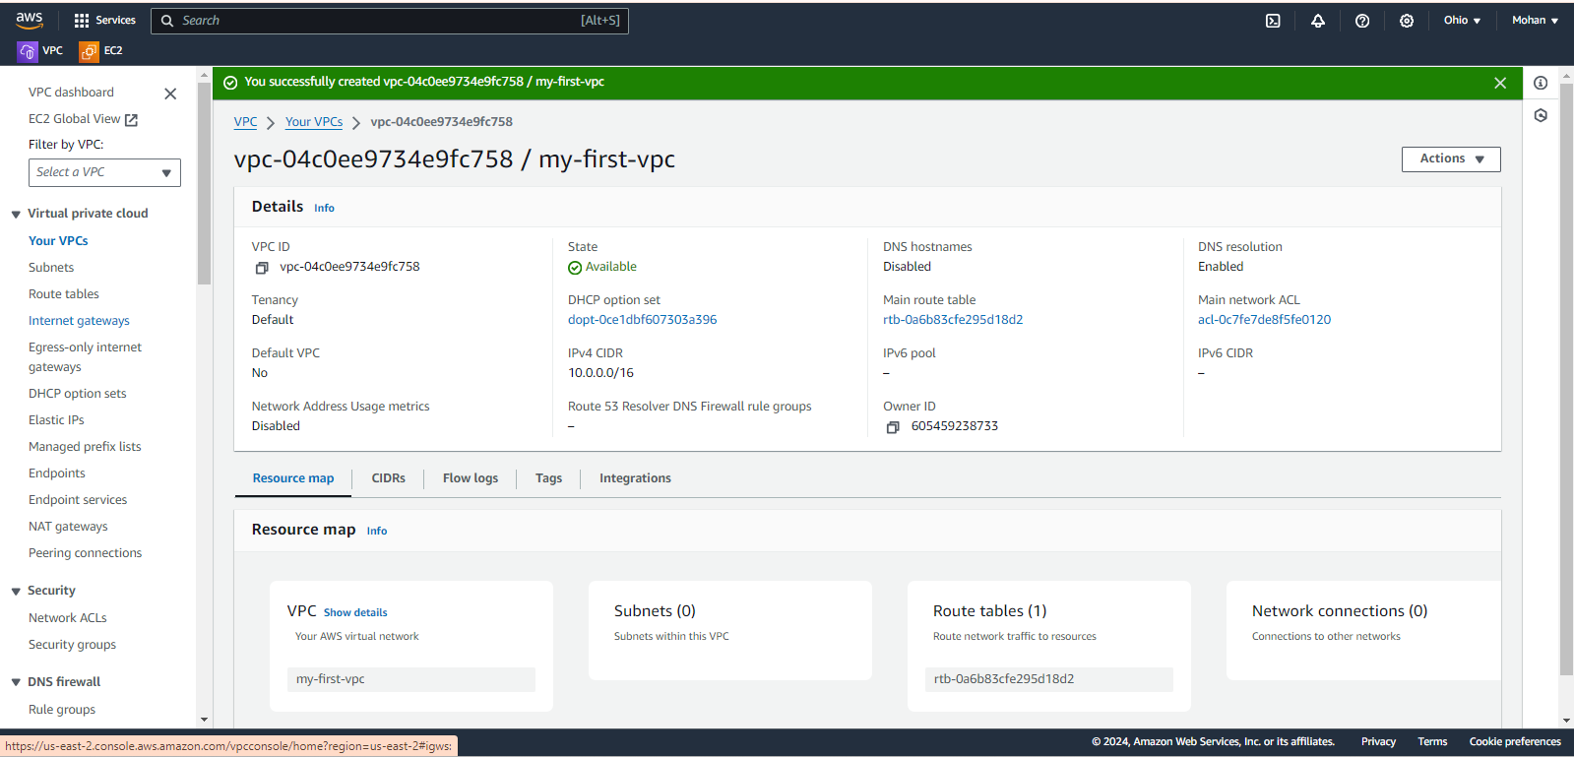

Fig : 5

Now click on Create internet gateway. (Fig-6)

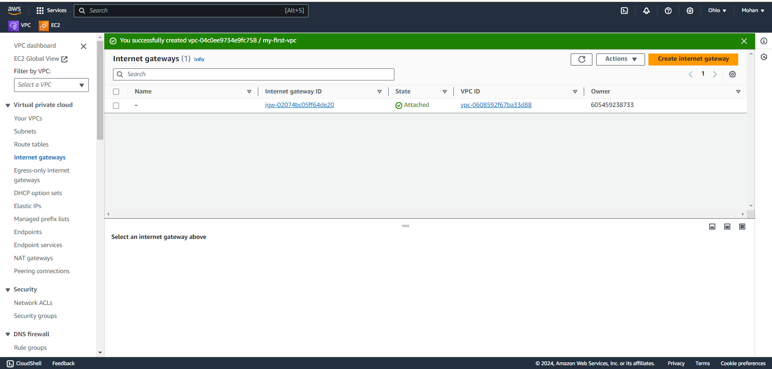

Fig : 6

Now, we have to name our internet gateway (Ex : my-igw) and finally click on Create internet gateway. (Fig-7)

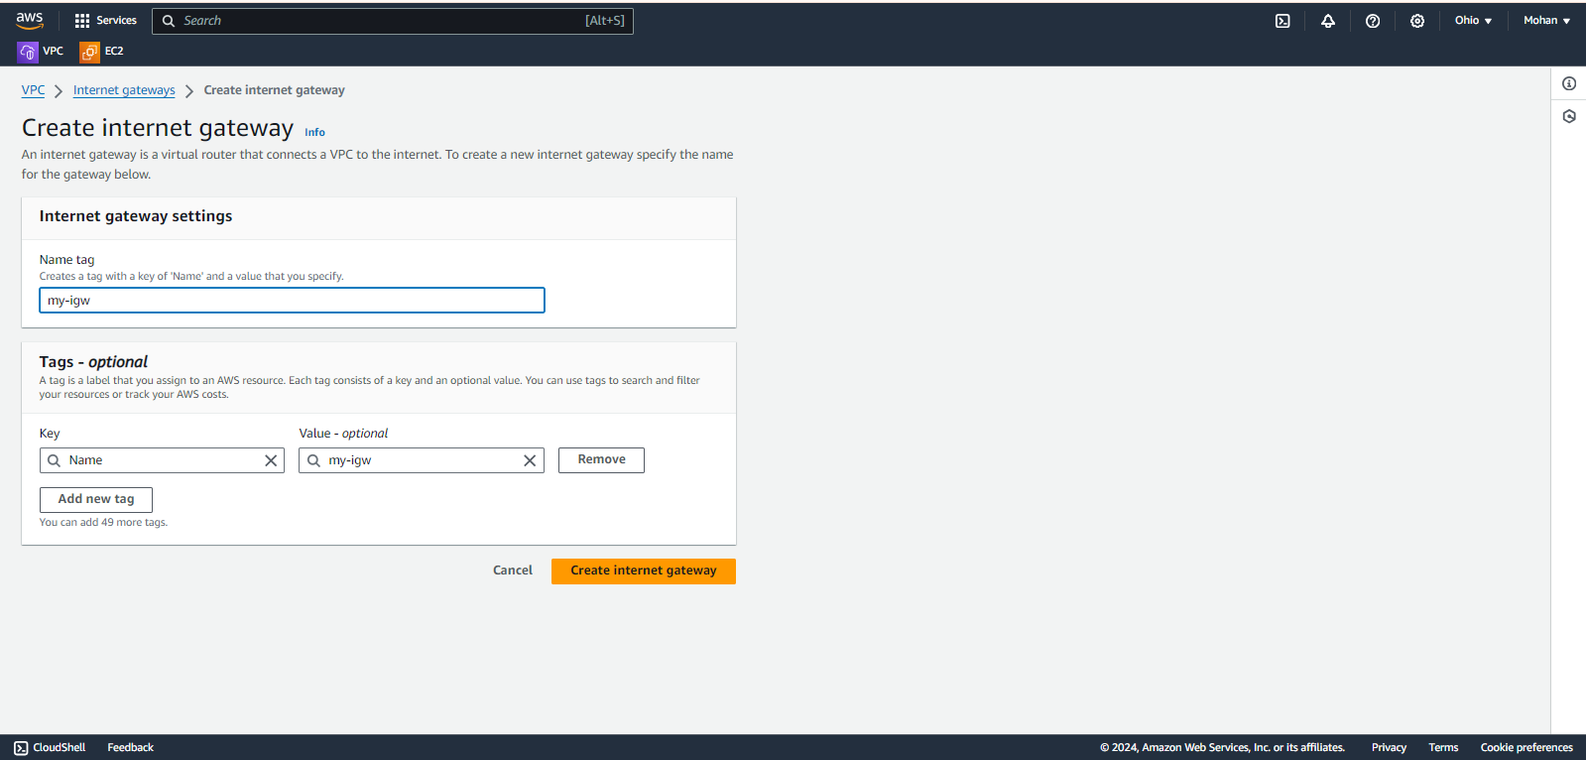

Fig : 7

We have created **internet gateway** successfully.

Now click on **Actions** and click on **Attach to VPC** option to attach internet gateway to VPC. (Fig-8)

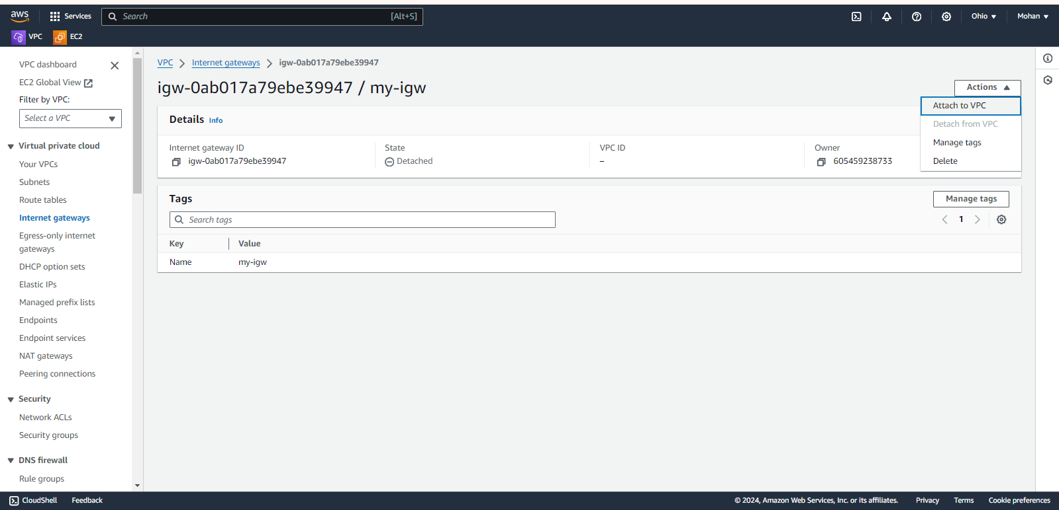

Fig : 8

Under Available VPCs section, select our custom VPC that we already created and finally click on Attach internet gateway. (Fig: 9)

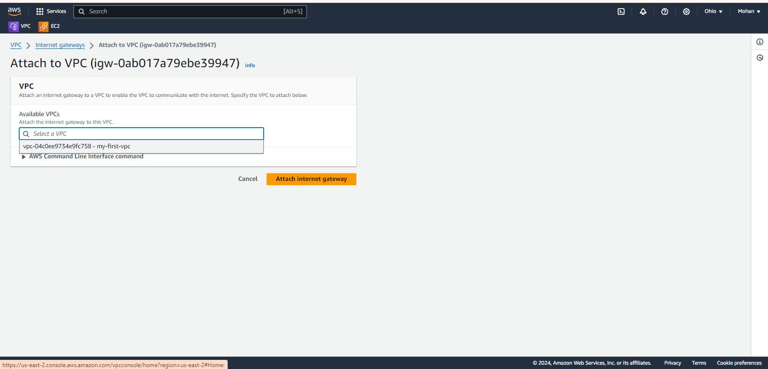

Fig : 9

We have attached internet gateway to VPC successfully.

Now we have to create 2 subnets (one is public and another one is private).

To Create Subnets click on **Subnets** option under VPC(Virtual Private Cloud) and click on Create subnet. (Fig-10)

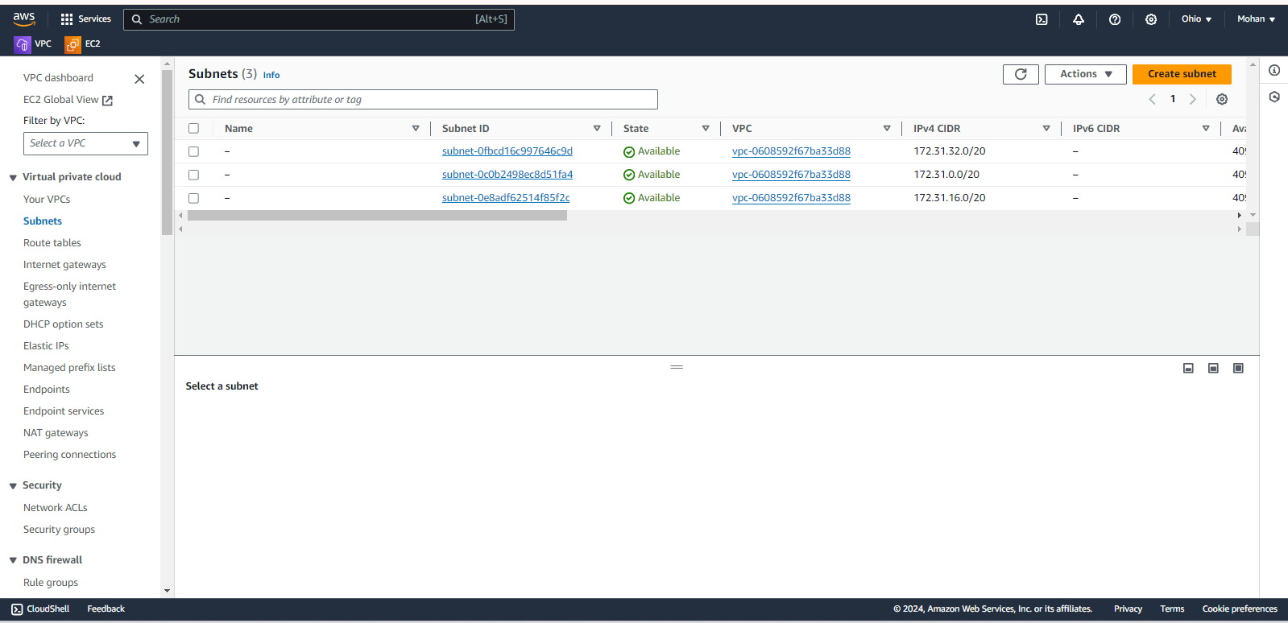

Fig : 10

Now we have to select our custom VPC (Fig-11)

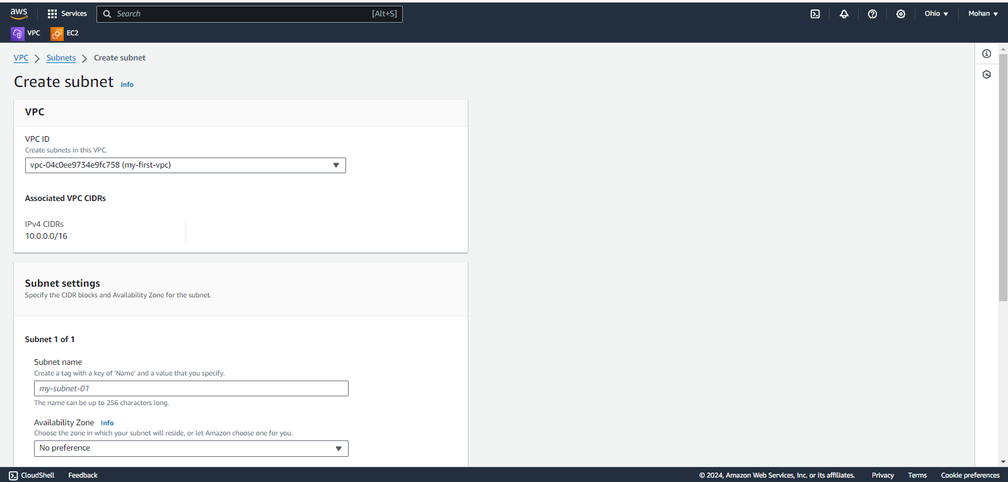

Fig : 11

Then we have to mention some details like Subnet name (my-public-subnte-1), we have to select Availability zone and we have to enter CIDR under IPv4 subnet CIDR block and finally click on Create subnet button. (Fig-12)

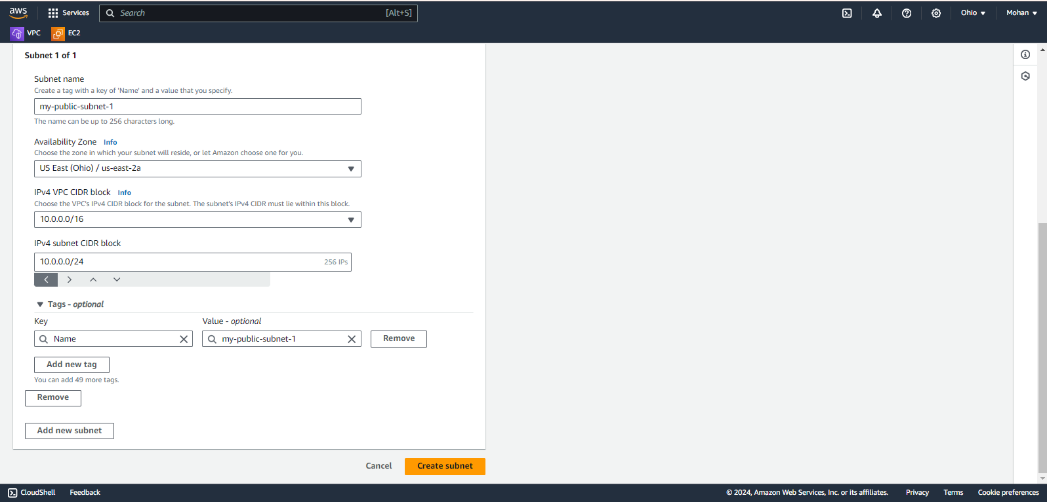

Fig : 12

Now we have to create one more subnet (name: my-private-subnet-2, Availability zone is 1b and CIDR is 10.0.2.0/24)

Go to **Subnets** and we can see our two subnets (Fig-13)

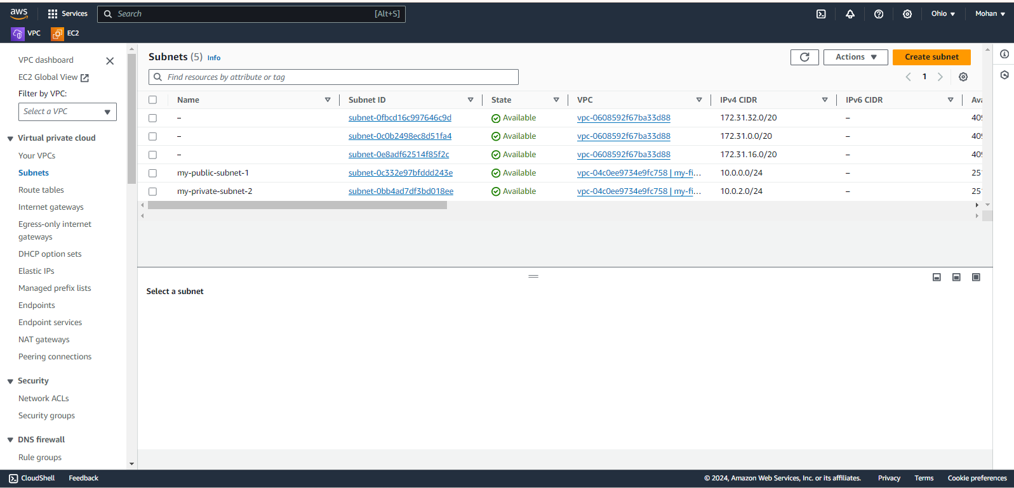

Fig : 13

Now we have to create 2 route tables (one is public and another one is private)

Click on **Route tables** option under VPC(Virtual Private Cloud) and click on Create route table (Fig-14).

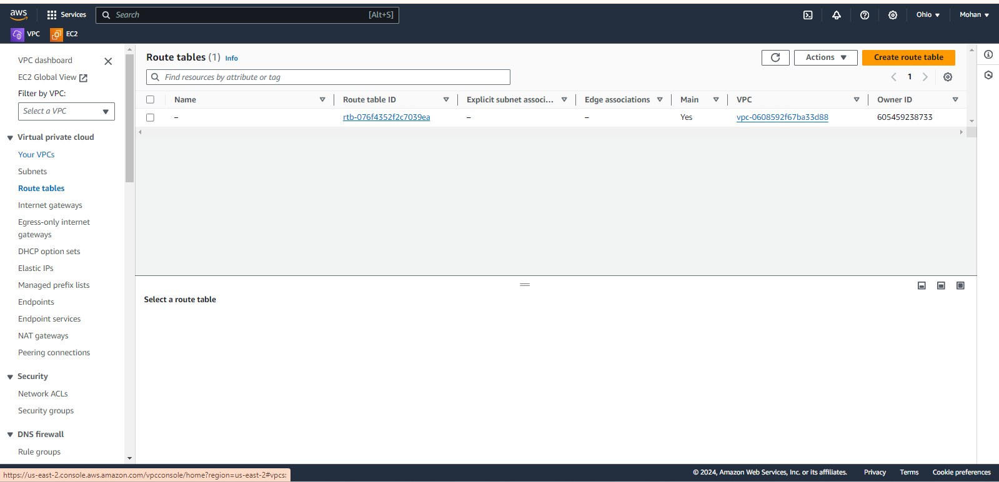

Fig : 14

Then we have to mention some details like we have to name our route table(my-public-RT) and select our custom VPC and finally click on Create route table (Fig-15).

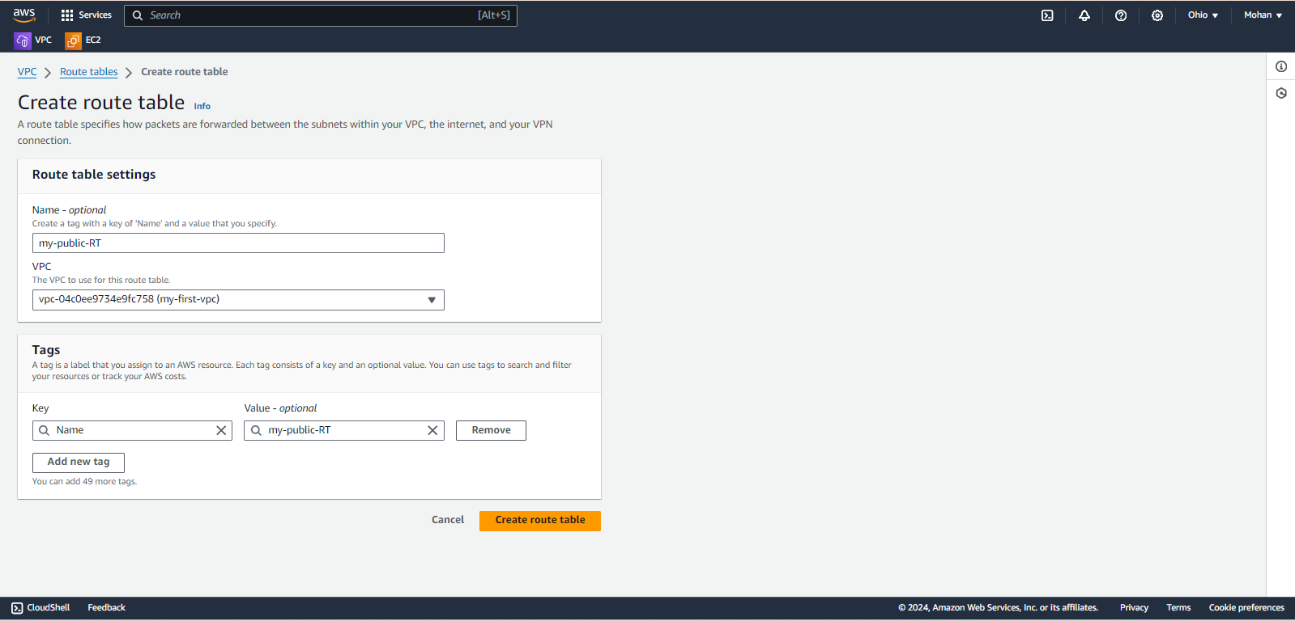

Fig : 15

Now click on **Actions**, click on **Edit routes(**Fig-16)

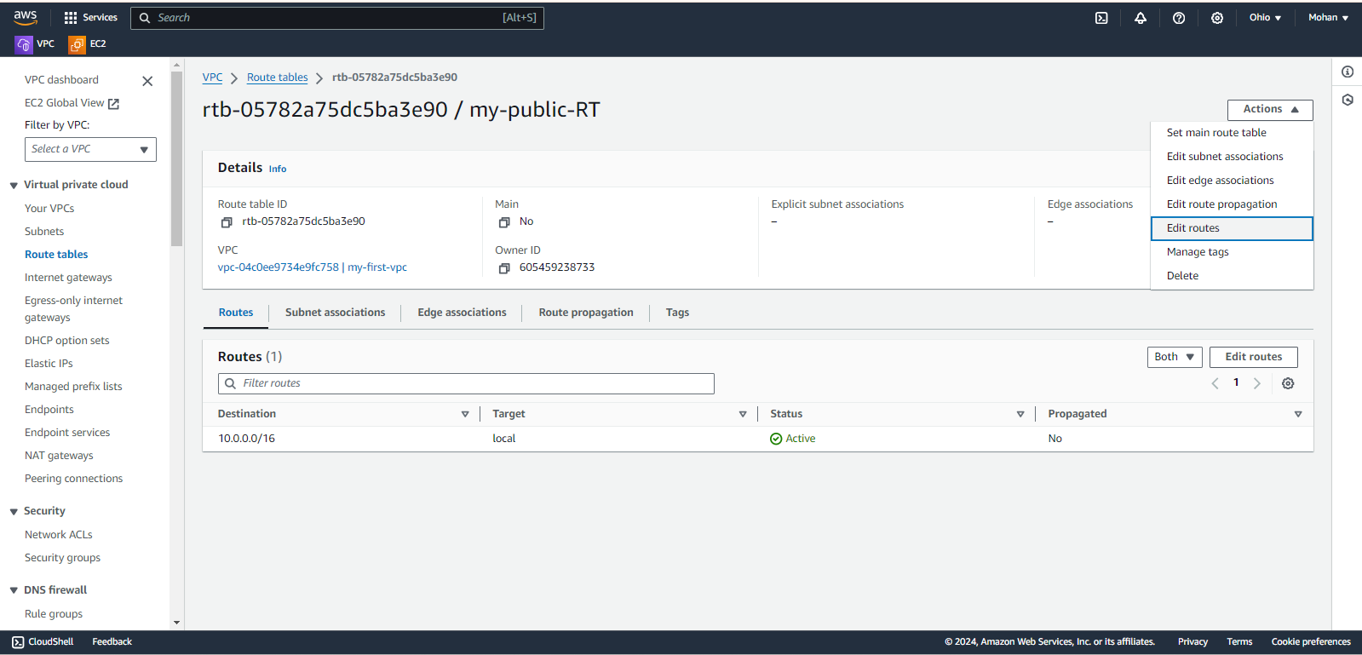

Fig : 16

Click on **Add route**.(Fig-17)

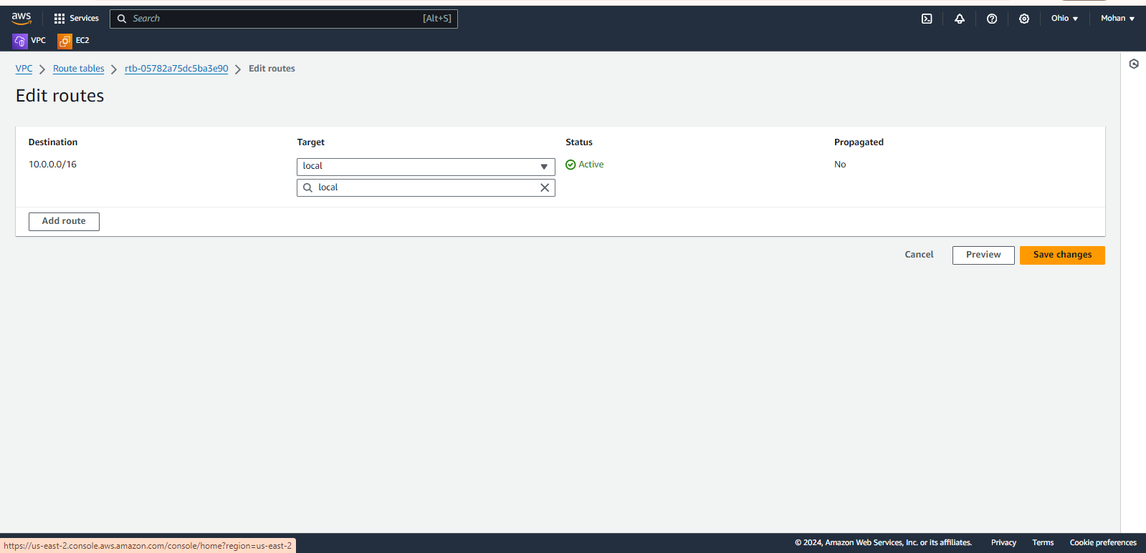

Fig : 17

Now Select 0.0.0.0/0 as Destination, Select Internet gateway from drop down list and choose our Internet gateway and finally click on Save changes (Fig-18).

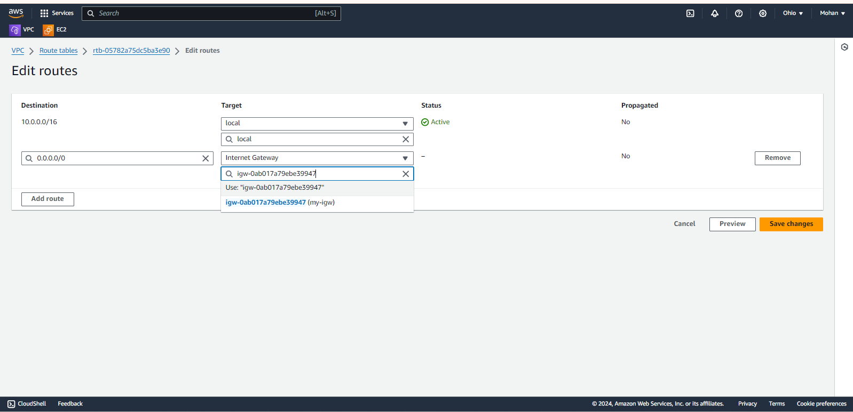

Fig : 18

Now click on **Subnet associations** and click on **Edit subnet associations(** Fig : 19).

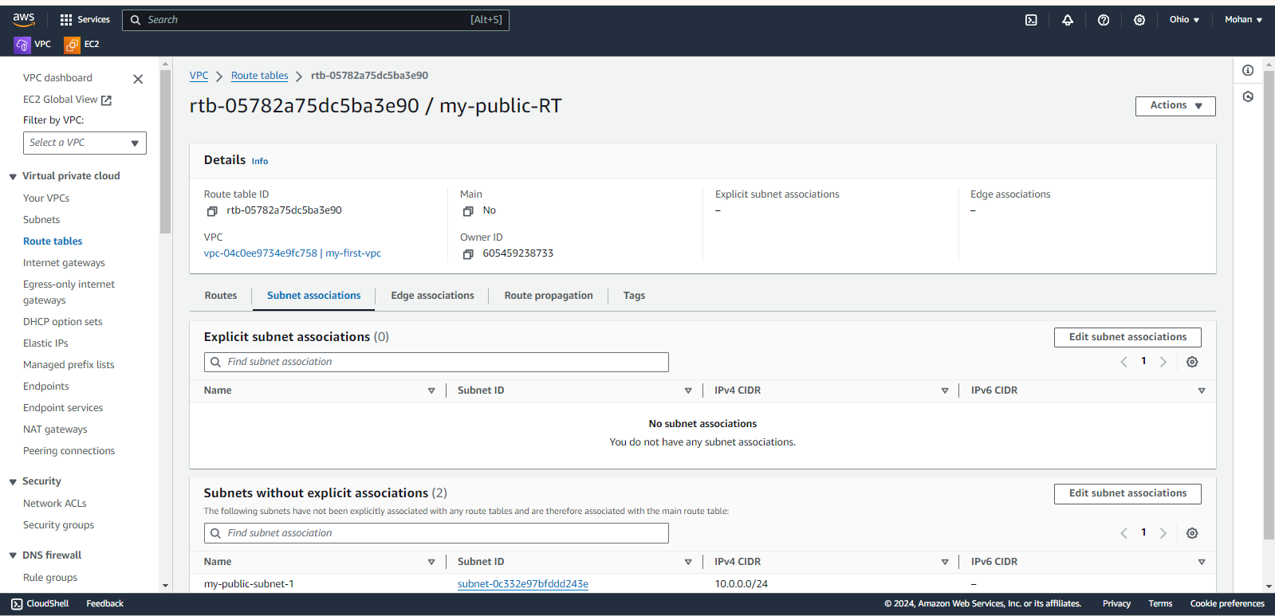

Fig : 19

Now Select public subnet check box and click on Save associations. (Fig-20)

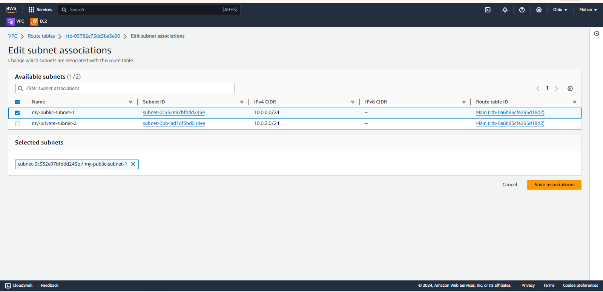

Fig : 20

Create one more route table (my-private-RT) and associate with private subnet.

*Note: Here for private route table, we are not going to give internet gateway because we want to make it as private. If we give internet gateway it will become public.

**EBS volume**

Search for EC2 in search bar of AWS home page and click on EC2 (Fig-21)

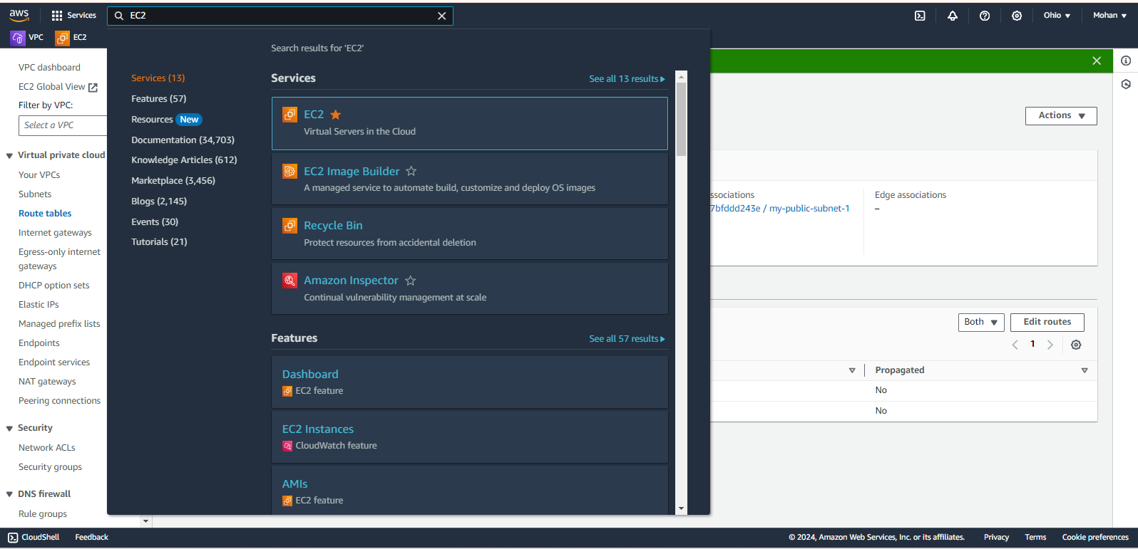

Fig : 21

Now click on **instances** option under EC2 and click on Launch instance. (Fig-22)

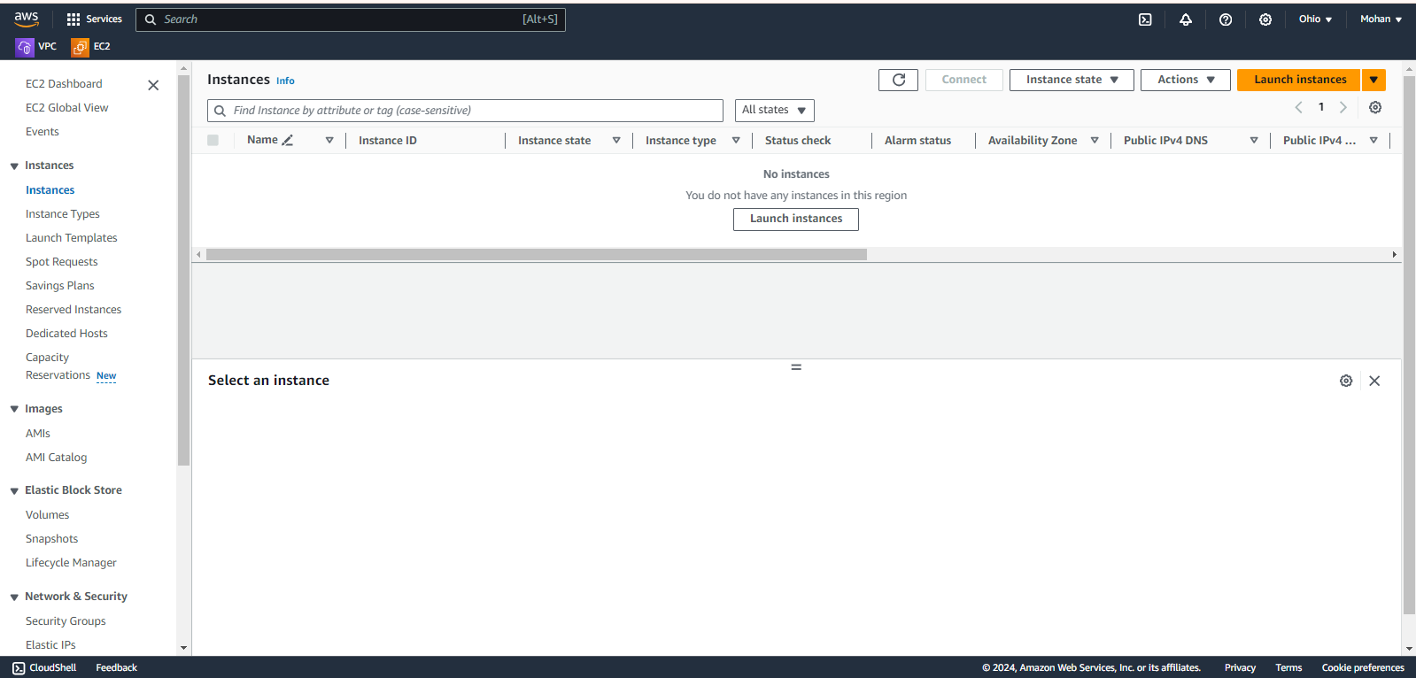

Fig : 22

Name our instance of your choice (for ex: my-ec2). Select OS of your choice (I have selected Amazon Linux) (Fig-23)

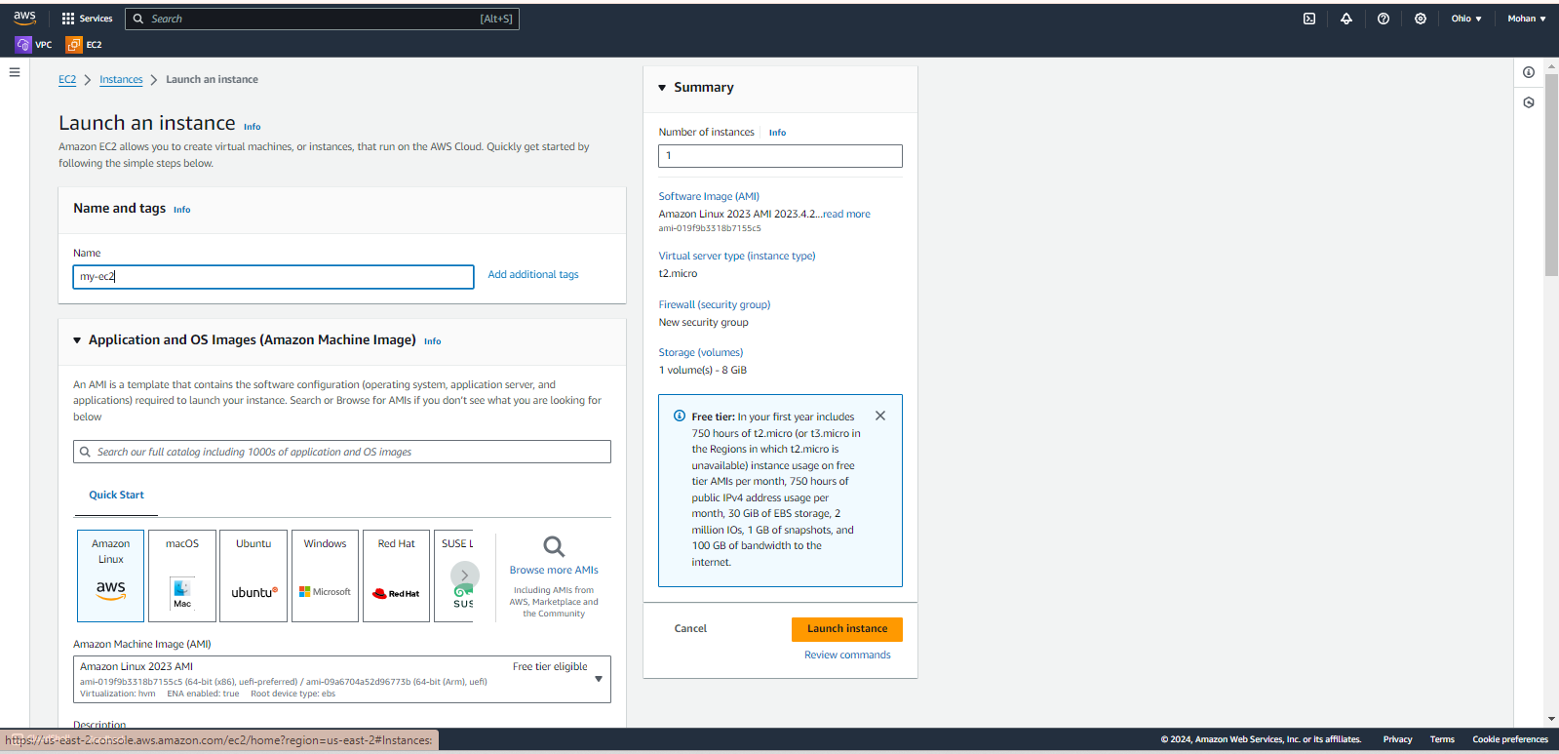

Fig : 23

We have to create a key pair.

So click on Create new key pair option (Fig-27)

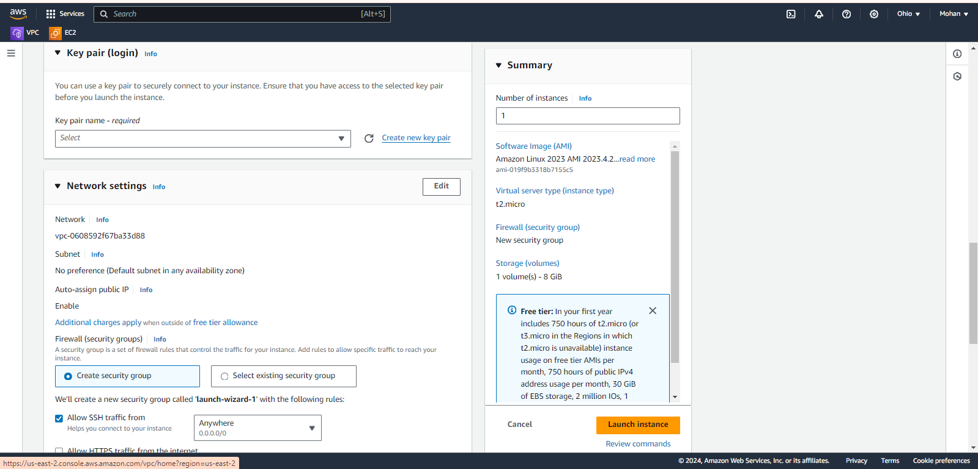

Fig : 24

Give name to our key pair and click on Create key pair button. (Fig-25)

(key pair name for example ebs-key)

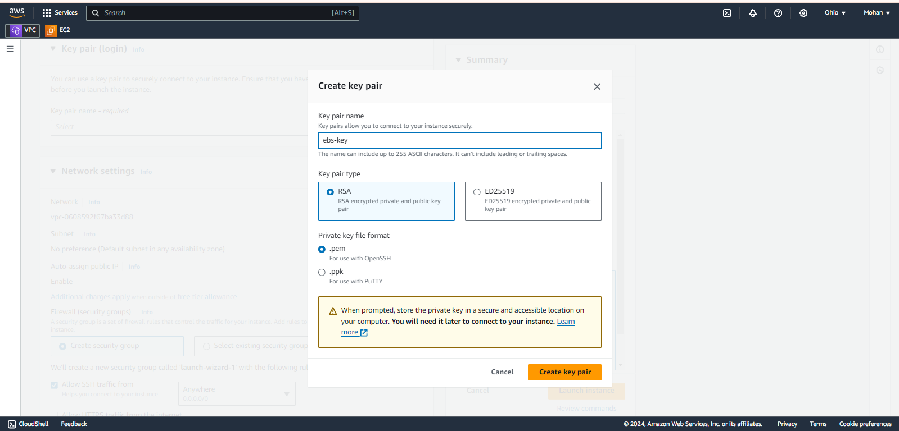

Fig : 25

In Network settings area, click on **Edit** and configure with our custom VPC. (Fig-26)

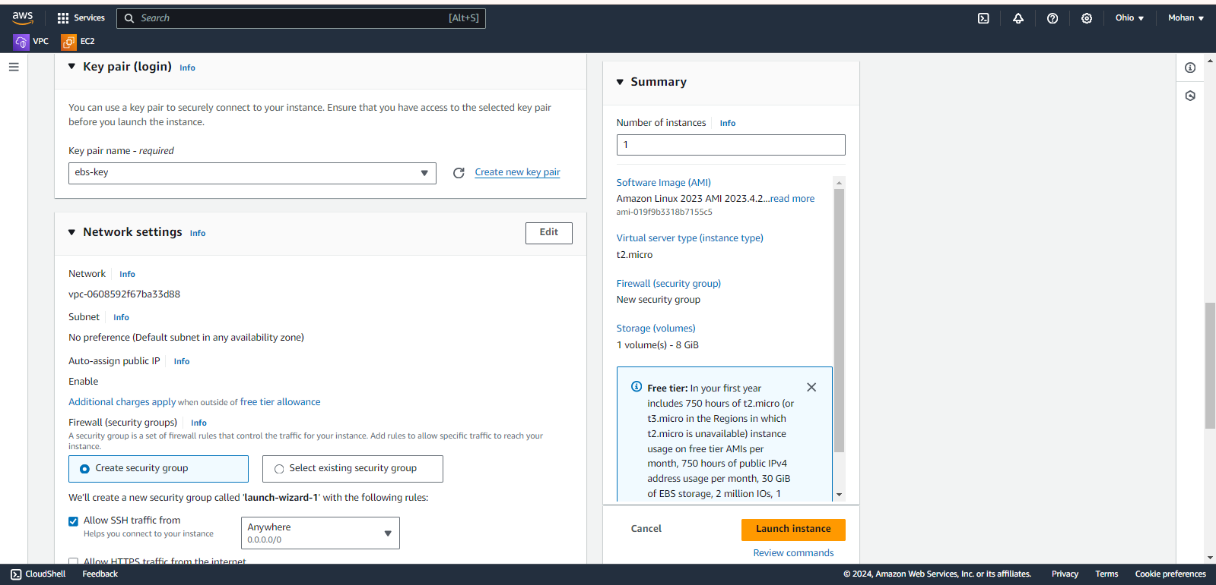

Fig : 26

Here select our custom VPC, select availability zone under subnet, Enable the Auto-assign public IP option and finally Launch instance (Fig-27).

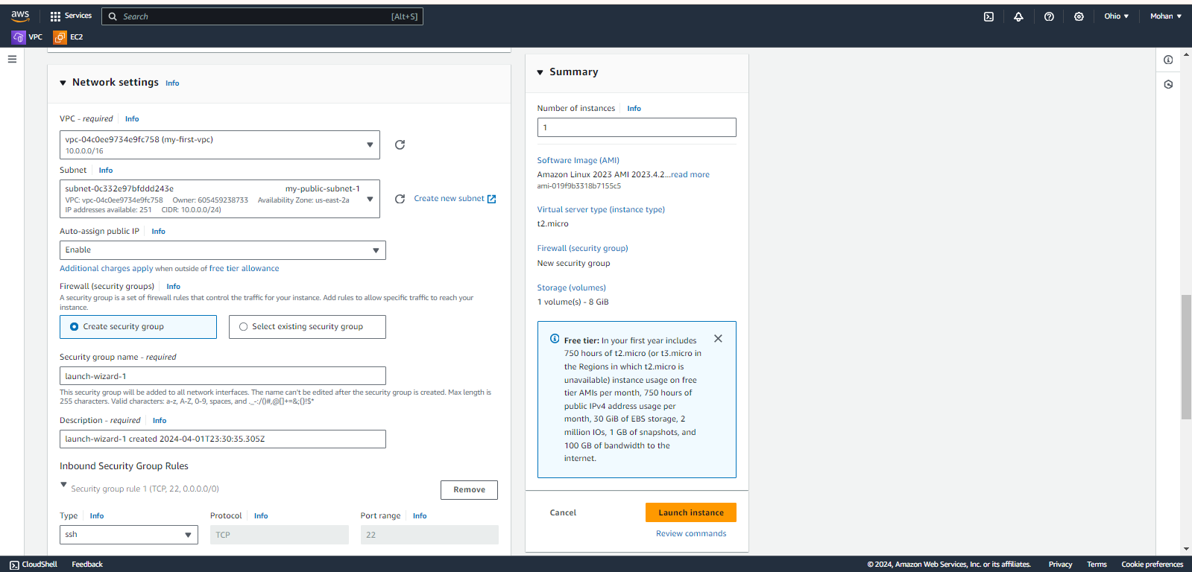

Fig : 27

We have lanchued **instances** successfully.

Now click on **instances** and see our instance is in running state, if not please do refresh (Fig-28).

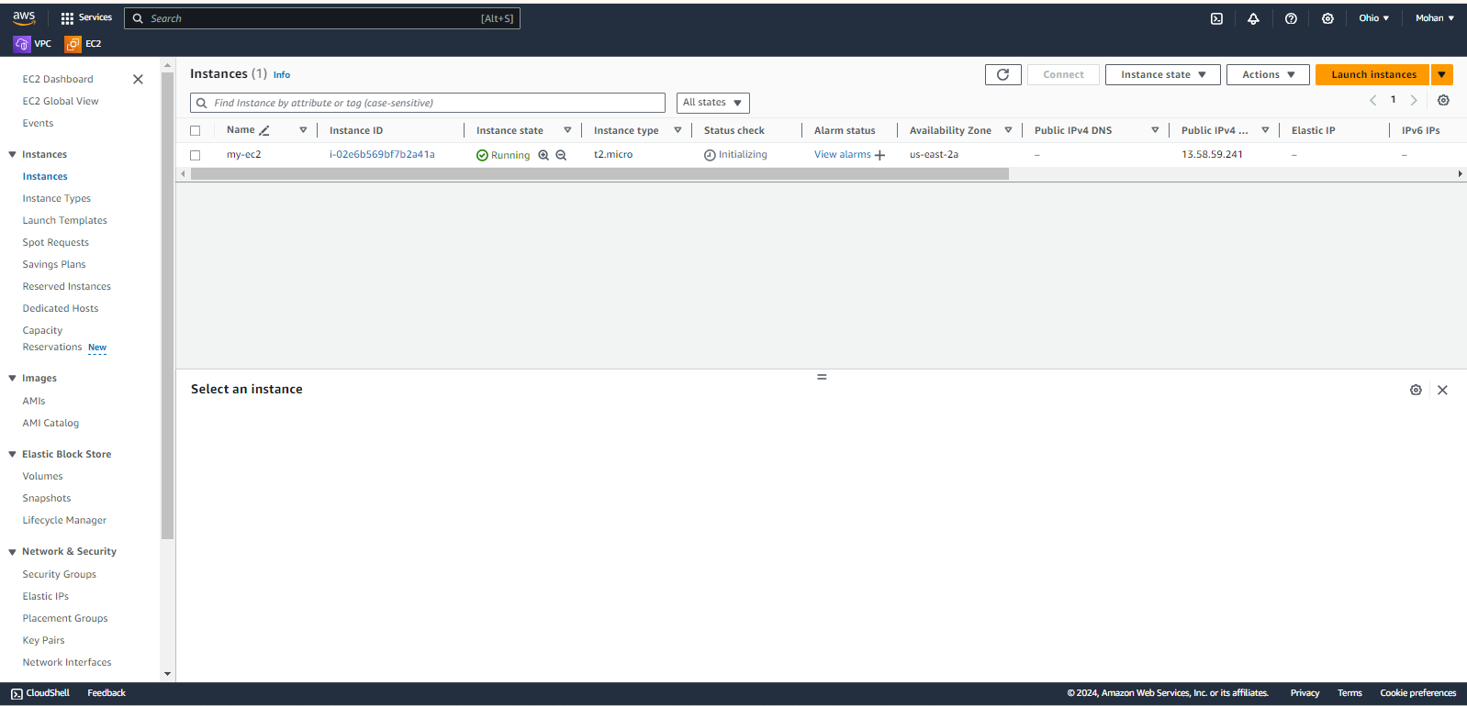

Fig : 28

**Create new volume**

To create new volume, click on **Volumes** option from menu under **Elastic Block Store** andclick on Create volume option.

Now Volume settings page will open and here we have to select Volume type based on our requirement, we have to mention size, we have to specify the availability zone and finally click on Create volume button (Fig-29).

*Note: We have to create EBS storage in same availability zone that our instance is running.

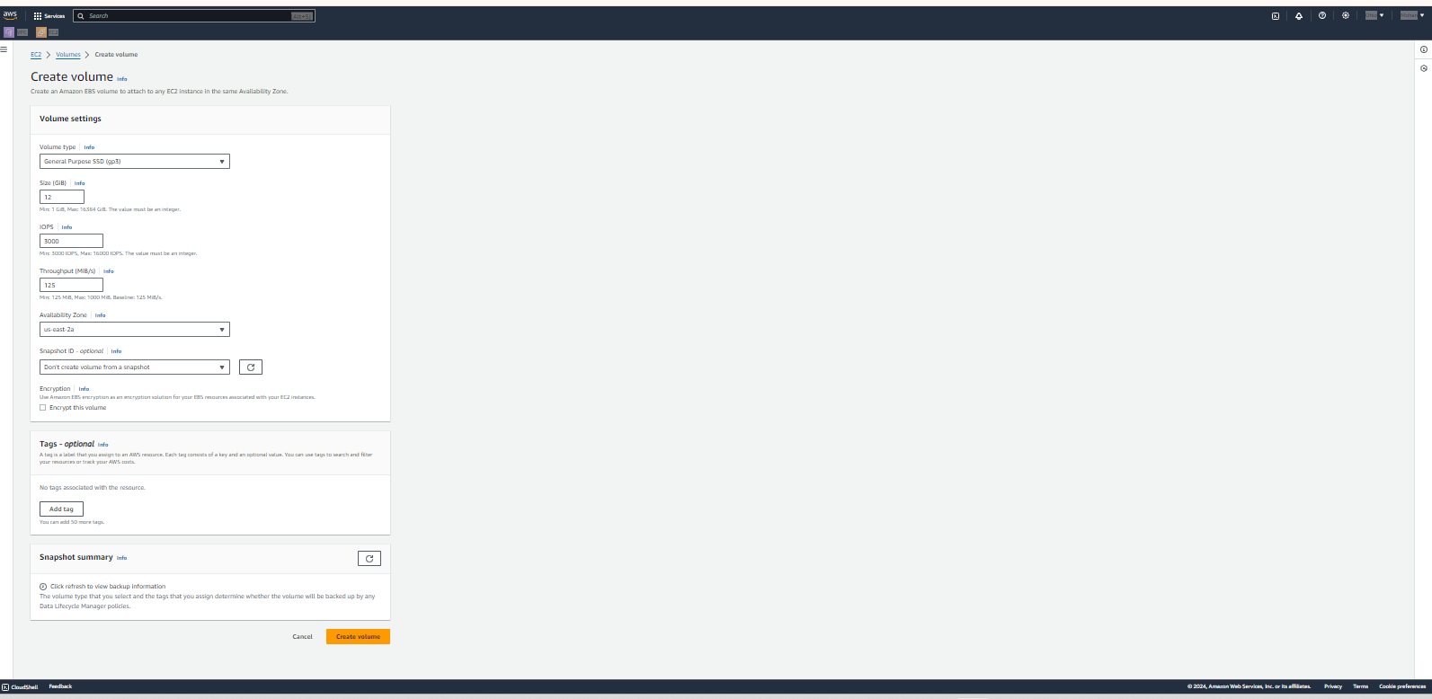

Fig : 29

Now we can see our new volume of 12Gib created successfully (Fig-30).

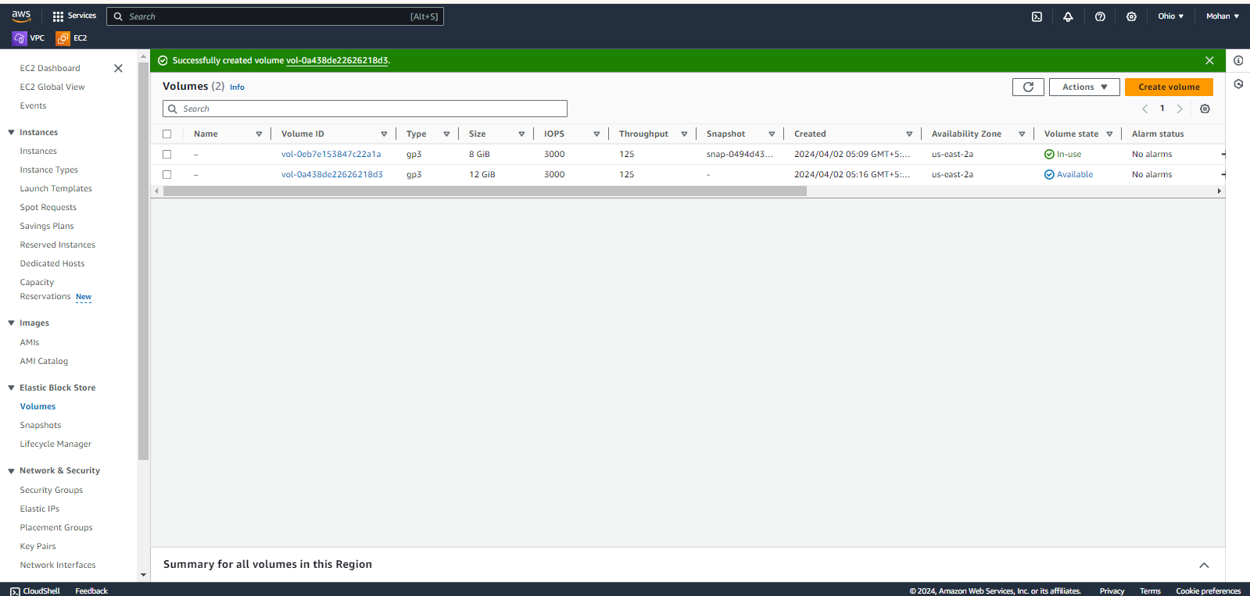

Fig : 30

Now, select our volume, click on **Actions** and Click on **Attach volume**. (Fig-31)

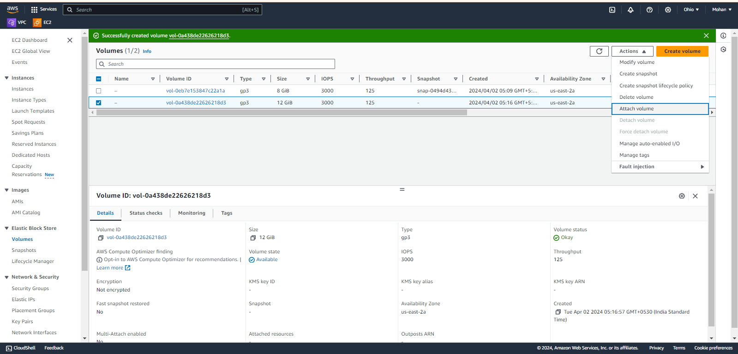

Fig : 31

Now we have to select our instance and finally click on Attach volume button (Fig-32).

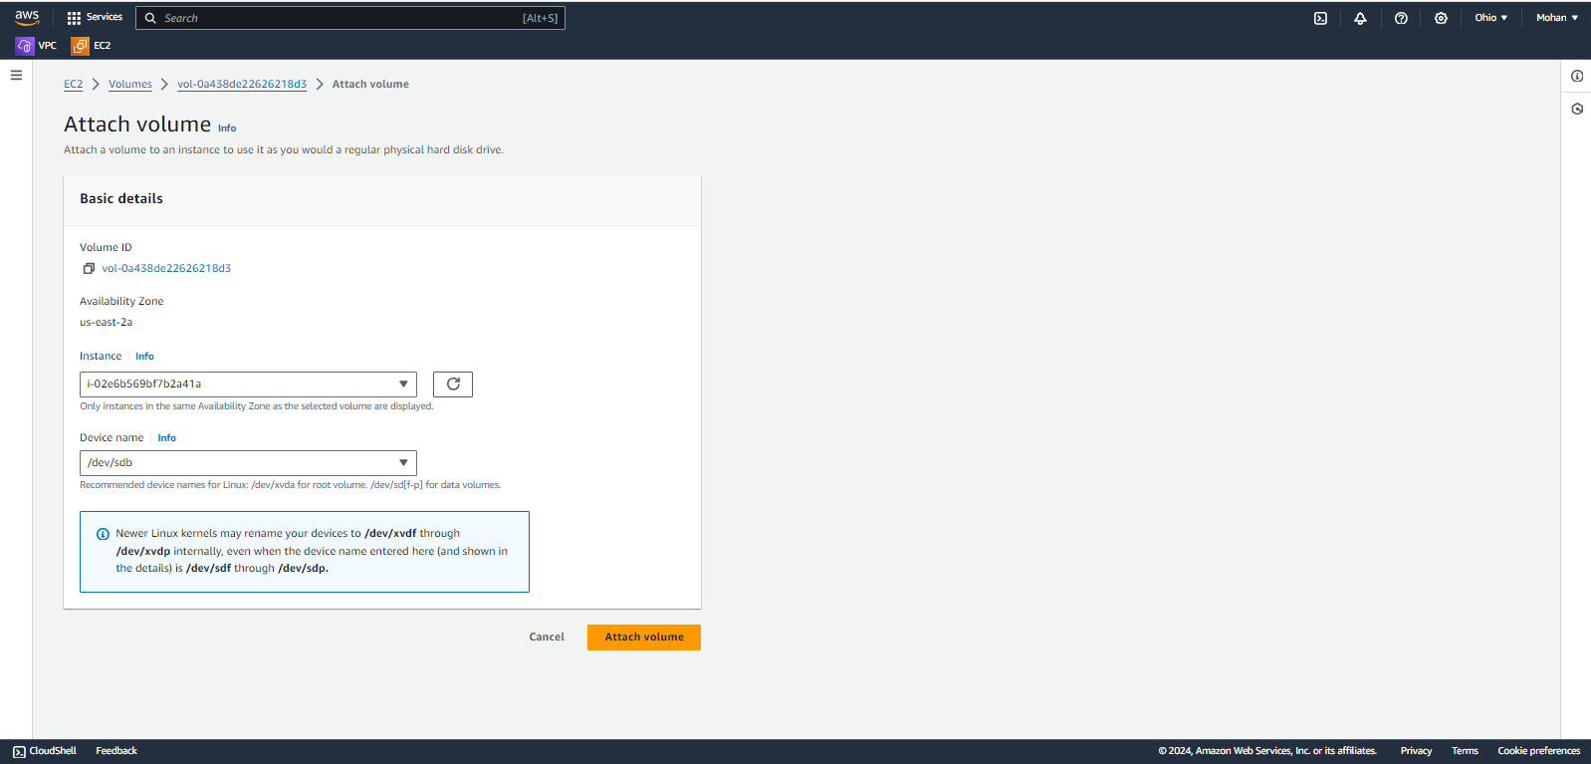

Fig : 32

Go to instances, select our instance and click on **Connect** (refer Fig-33)

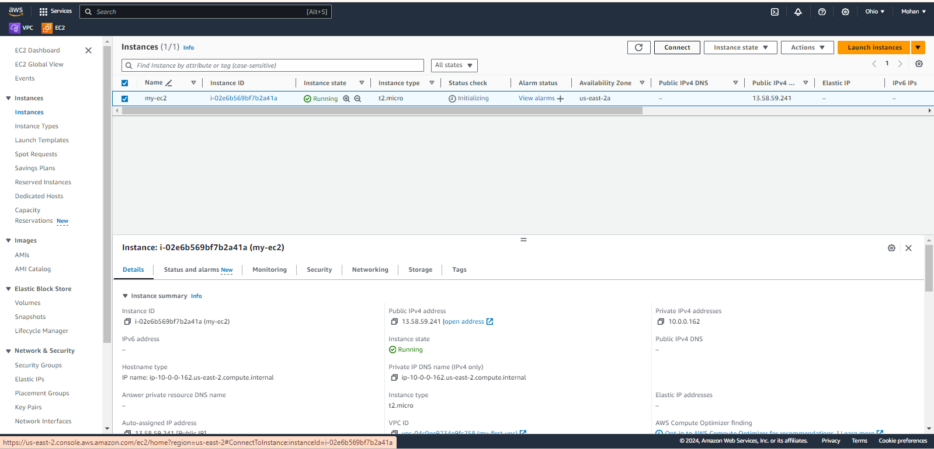

Fig : 33

Click on Connect button in instance connect page (Fig-34)

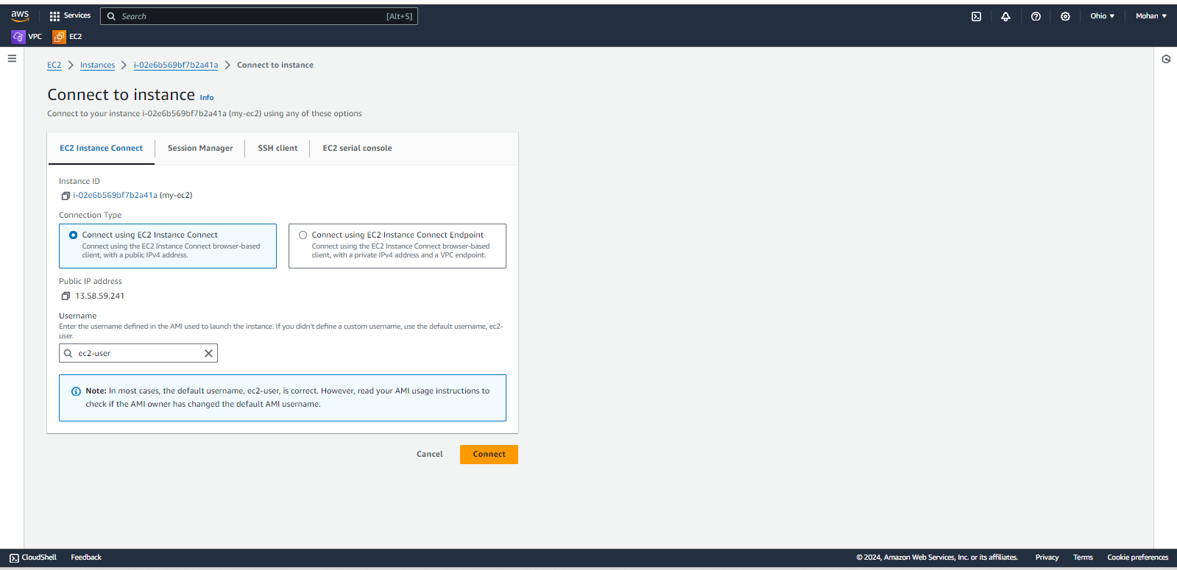

Fig : 34

Now we have connected to our server.

Give sudo -i to change to root user (Fig-35)

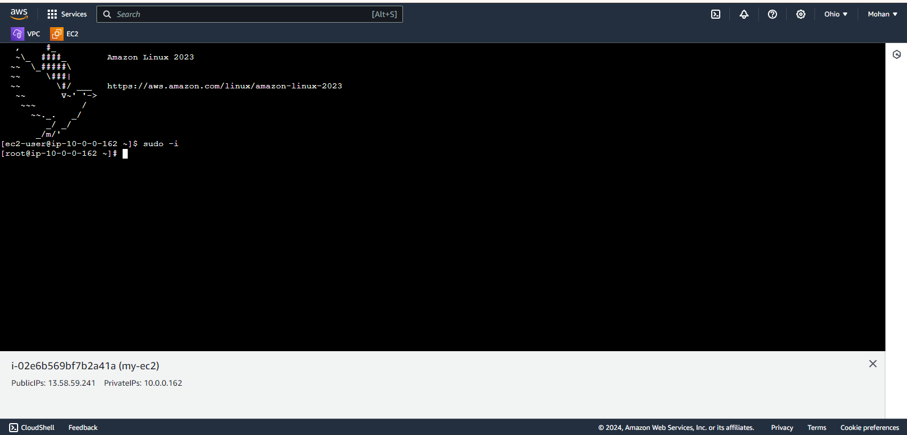

Fig : 35

Now we have to check disk space, block devices and file system.

* df –h to check the disk space(Fig-36)
* lsblk to list out block devices (after giving lsblk, it will show our block device. Here it is xvdb) (Fig-36)
* file –s /dev/xvdb to check whether we have file system on this device (Fig-36).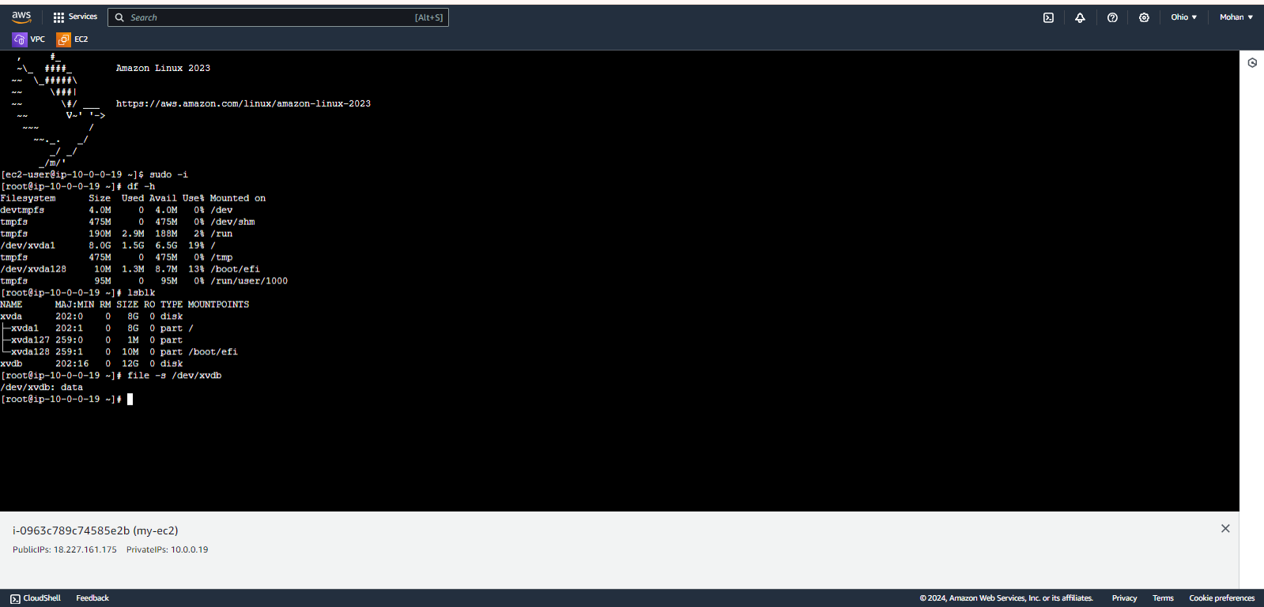

Fig : 36

From above its clear that we don’t have a file system. To create file system use below command and check do we have file system or not. (Fig-37)

* mkfs -t xfs /dev/xvdf

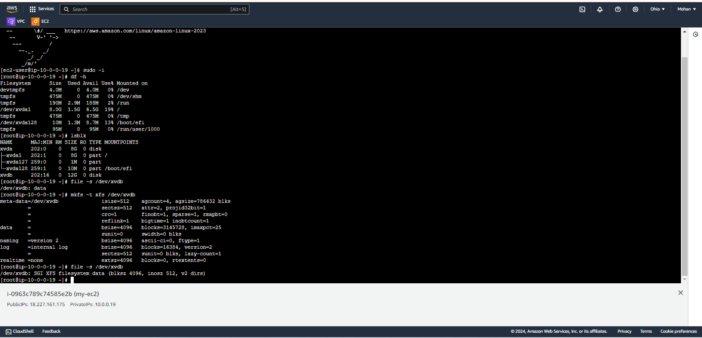

Fig : 37

From Fig-37 it’s clear that now we have file system.

Now create one nested directory to mount our volume.

* To create nested directory use command mkdir –p kote/mohan
* Finally mount volume by using command mount /dev/xvdb kote/mohan
* Finally give df –h to check whether our volume is attached or not (Fig-38).

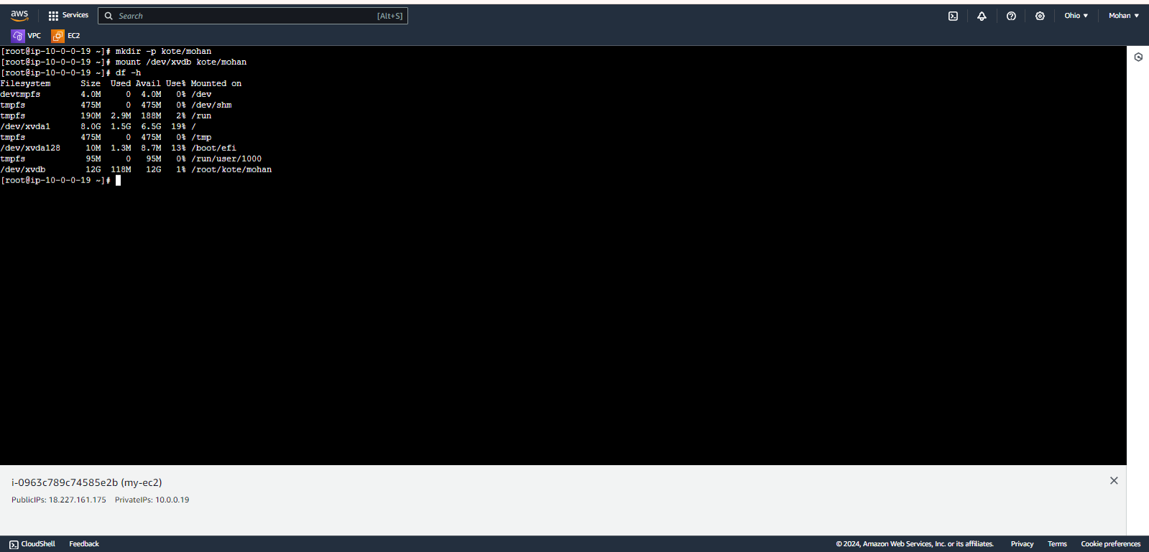

Fig : 38