End-to-End MLOps Pipeline for Heart Disease Prediction
Course: MLOps (S1-25_AIMLCZG523)
Assignment: Experimental Learning Assignment – I
Students Name: MOHAN K R(2024AA05419), SATHWIK H R(2024AA05903), T J SHREYAS(2024AA05418), CHANDRA SEKHAR MAHANTA(2024AA05902), ATUL AGARWAL(2023AC05656)
1. Introduction
Machine Learning (ML) models are increasingly deployed in real-world systems to support critical decision-making. However, developing a high-accuracy model alone is insufficient for production use. Modern ML systems require reproducibility, automation, scalability, continuous integration, monitoring, and deployment strategies—collectively addressed by Machine Learning Operations (MLOps).
This project presents a complete end-to-end MLOps pipeline for predicting the presence of heart disease using clinical data from the UCI Machine Learning Repository. The objective is not only to train a predictive model but also to demonstrate industry-aligned practices such as automated data handling, experiment tracking, CI/CD pipelines, containerization, Kubernetes-based deployment, and monitoring.
The solution mirrors real-world production scenarios by separating experimentation from deployment, enforcing reproducibility, and ensuring observability of the deployed system.

2. Problem Statement
Cardiovascular disease is one of the leading causes of mortality worldwide. Early detection and risk assessment can significantly improve patient outcomes. Given patient clinical attributes such as age, blood pressure, cholesterol levels, and ECG results, the goal is to predict whether a patient is likely to have heart disease.
The problem is formulated as a binary classification task, where:
- 0 → No presence of heart disease
- 1 → Presence of heart disease
The final solution must expose this prediction capability through a production-ready API and demonstrate the full MLOps lifecycle.
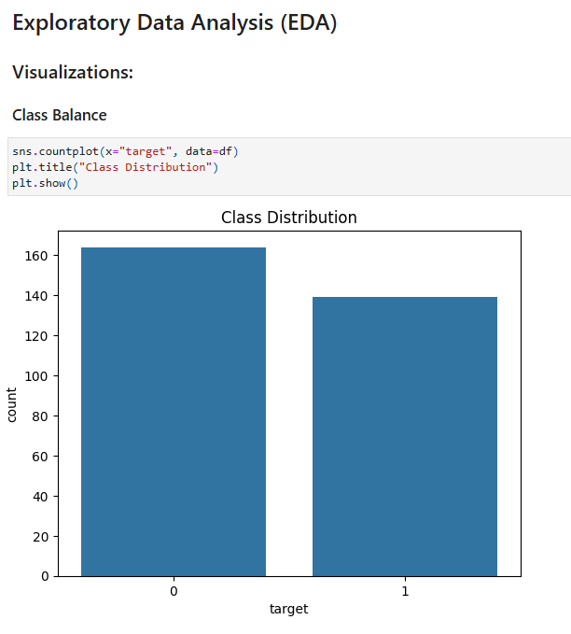

3. Dataset Description
3.1 Dataset Source
- Dataset Name: Heart Disease UCI Dataset
- Source: UCI Machine Learning Repository
- File Used: processed.cleveland.data
3.2 Features
The dataset contains 13 clinical features:
- Age
- Sex
- Chest pain type (cp)
- Resting blood pressure (trestbps)
- Serum cholesterol (chol)
- Fasting blood sugar (fbs)
- Resting ECG results (restecg)
- Maximum heart rate achieved (thalach)
- Exercise-induced angina (exang)
- ST depression induced by exercise (oldpeak)
- Slope of peak exercise ST segment (slope)
- Number of major vessels (ca)
- Thalassemia (thal)
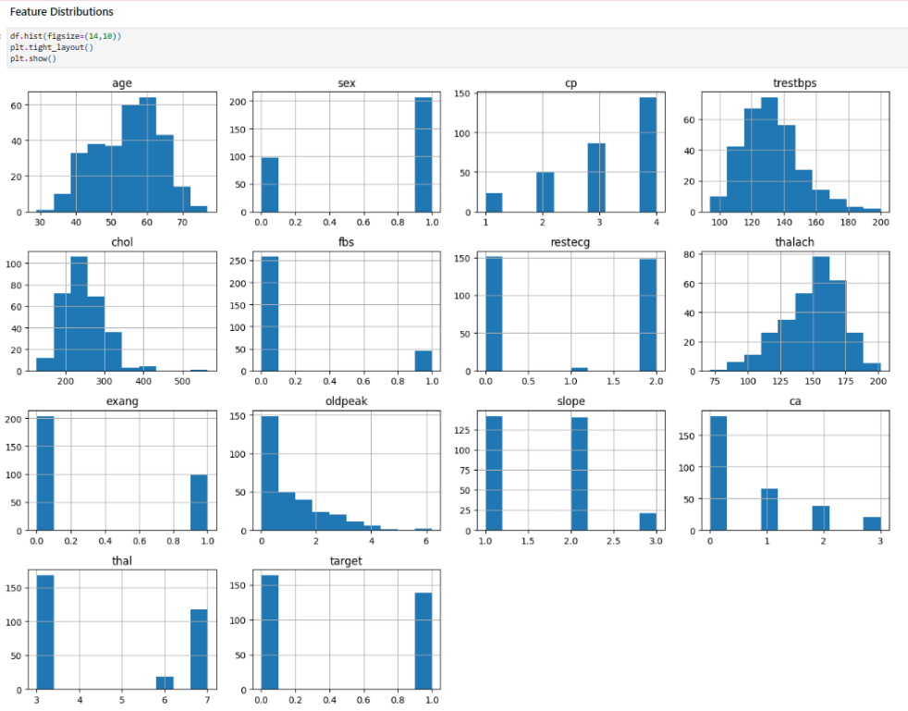
3.3 Target Variable
The original dataset contains multi-class labels. For this project, the target was transformed into a binary label:
- target = 0 → No heart disease
- target = 1 → Presence of heart disease

4. Data Acquisition and Preprocessing
4.1 Automated Dataset Download
To ensure reproducibility, the dataset is downloaded programmatically using a Python script. This avoids manual dependency on local files and ensures that the project can be executed from a clean environment.
Key steps include:
- Downloading the dataset from the UCI repository
- Assigning proper column names
- Handling missing values represented by ?
- Converting data types to numeric format
- Filling missing values using median imputation
The cleaned dataset is saved as data/heart_disease.csv.

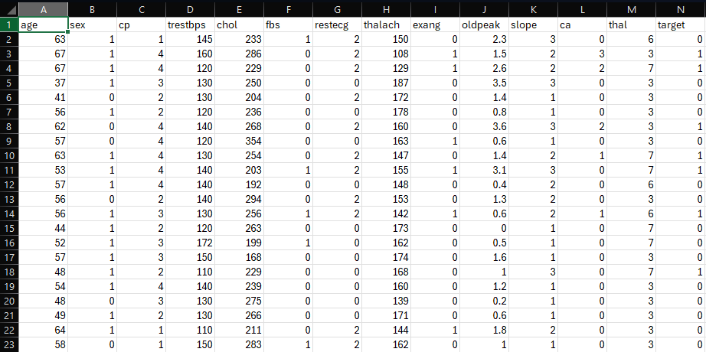

5. Exploratory Data Analysis (EDA)
Exploratory Data Analysis was performed to understand the distribution, relationships, and quality of the data.
5.1 Class Distribution
The dataset shows a moderately balanced distribution between positive and negative heart disease cases, making it suitable for standard classification algorithms.
5.2 Feature Distributions
Histograms were plotted for numerical features such as age, cholesterol, and resting blood pressure to identify skewness and outliers.
5.3 Correlation Analysis
A correlation heatmap was generated to analyze relationships between features and the target variable. Features such as chest pain type, maximum heart rate, and exercise-induced angina showed notable correlation with heart disease presence.
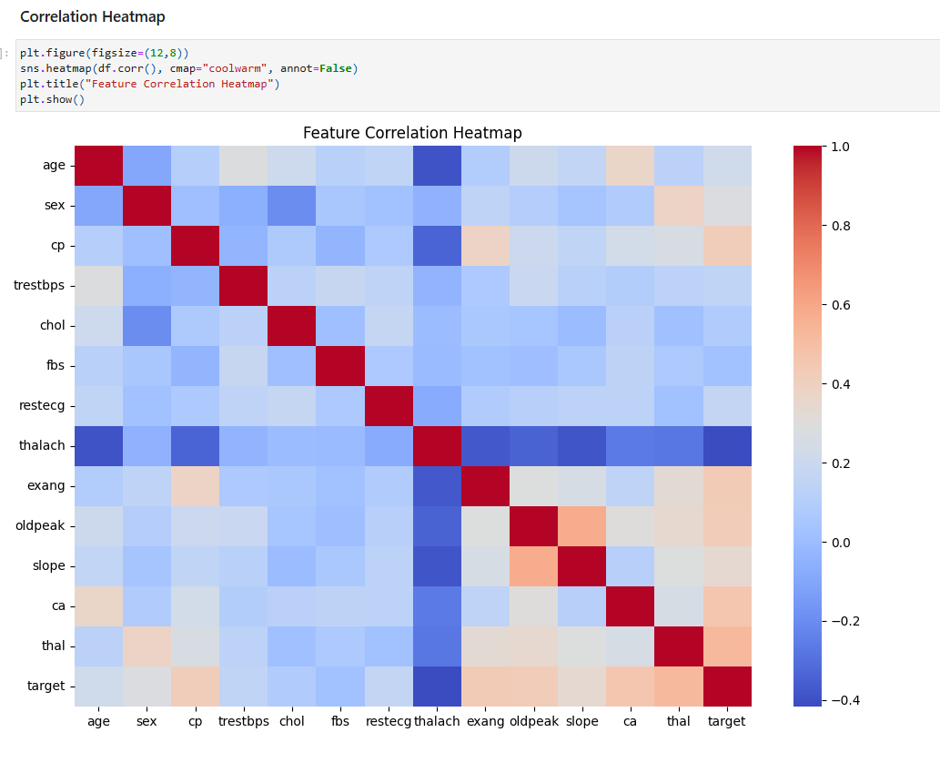
6. Feature Engineering and Model Development
6.1 Feature Engineering
- All numerical features were standardized using StandardScaler
- Missing values were handled prior to scaling
- No categorical encoding was required due to numeric representation
6.2 Model Selection
Two classification models were evaluated:
- Logistic Regression
- Random Forest Classifier
Logistic Regression was selected as the final model due to:
- Strong baseline performance
- Interpretability
- Faster training and inference
- Suitability for clinical decision support
6.3 Model Evaluation
The model was evaluated using:
- Accuracy
- Precision
- Recall
- ROC-AUC score
Cross-validation was used to ensure stable performance across different data splits.

7. Experiment Tracking
Experiment tracking was implemented using MLflow during the experimentation phase. The following were logged:
- Model parameters
- Evaluation metrics
- Training runs
This enabled comparison of different models and hyperparameters and ensured transparency in the experimentation process.

8. Model Packaging and Reproducibility
8.1 Model Serialization
The final trained model was saved using joblib as:
artifacts/heart_model.pkl
8.2 Reproducible Environment
A requirements.txt file was created containing all dependencies required to run the project. This ensures that the project can be executed consistently across environments.
To avoid compatibility issues, the final model training was performed in the same environment used for deployment.

9. CI/CD Pipeline Implementation
9.1 CI/CD Tool
GitHub Actions was used to implement the CI/CD pipeline.
9.2 Pipeline Stages
The pipeline includes the following automated steps:
- Code checkout
- Dependency installation
- Linting using flake8
- Unit testing using pytest
- Model training
- Artifact upload
9.3 Unit Testing
Unit tests validate:
- Existence of the trained model artifact
- Successful loading of the model
- Correct inference output shape
- Valid prediction values
Pipeline logs and artifacts are stored for each run.

10. Model Serving and Containerization
10.1 API Development
A REST API was developed using FastAPI with the following endpoints:
- /predict – returns prediction and confidence score
- /health – health check for monitoring
10.2 Docker Containerization
The API was containerized using Docker with a lightweight Python base image. The Docker image includes:
- Application code
- Trained model artifact
- All runtime dependencies
The container was tested locally before deployment.

11. Production Deployment Using Kubernetes
11.1 Kubernetes Environment
A local Kubernetes cluster was provisioned using Minikube with Docker as the container runtime.
11.2 Deployment Manifests
The application was deployed using Kubernetes YAML manifests:
- deployment.yaml – defines pods and replicas
- service.yaml – exposes the API using NodePort
11.3 Accessing the API
The API is accessed locally using the Minikube service URL:
minikube service heart-api-service --url
Swagger UI is available at:
http://<MINIKUBE_URL>/docs

12. Monitoring and Logging
12.1 Application Logging
Request and response logging was implemented using FastAPI middleware. Logs capture:
- Incoming requests
- Response status codes
- Processing time
12.2 Health Monitoring
A /health endpoint was added to enable service health checks and readiness probes in Kubernetes.
Logs can be viewed using:
kubectl logs deployment/heart-api

13. Architecture Overview
The architecture follows a production-aligned MLOps design:
- Experimentation in Google Colab
- Final training in deployment environment
- CI/CD automation using GitHub Actions
- Containerized serving with Docker
- Kubernetes deployment with Minikube
- Monitoring via logs and health endpoints
(Architecture diagram included in the report.)

14. Conclusion
This project successfully demonstrates a complete end-to-end MLOps pipeline, covering data acquisition, model development, automation, deployment, and monitoring. By integrating modern DevOps and ML engineering practices, the solution is reproducible, scalable, and production-ready.
The project highlights the importance of operationalizing ML models beyond experimentation and reflects real-world workflows used in industry.

15. Future Enhancements
Possible future improvements include:
- Deployment to a managed cloud Kubernetes service (EKS/GKE/AKS)
- Model registry using MLflow Model Registry
- Advanced monitoring using Prometheus and Grafana
- Automated retraining based on data drift detection
- Exporting models to ONNX for cross-platform compatibility

16. References
- UCI Machine Learning Repository – Heart Disease Dataset
- Scikit-learn Documentation
- FastAPI Documentation
- Docker Documentation
- Kubernetes Documentation
- GitHub Actions Documentation

