MKRYPT CYBERSECURITY DETECTION SERIES - BEGINNER
Top 20 Production KQL
Detection Rules Runbook
A standardized engineering handbook containing production-grade Kusto Query Language (KQL) detection logic, visual attack architecture diagrams, MITRE ATT&CK mappings, and analyst triage workflows for onboarding new enterprise SOC environments.
Target Platform: | Microsoft Sentinel / Microsoft Defender XDR / Azure Data Explorer
Framework Alignment: | MITRE ATT&CK Enterprise Matrix (Tactics TA0001 - TA0040)
Target Audience: | SOC Analysts (L1/L2/L3), Detection Engineers, Threat Hunters
Series Edition: | Foundational to Advanced Enterprise Detections

Executive Overview & Master Detection Matrix
This runbook provides 20 foundational detection rules structured with dedicated single-page layouts. Each page includes formal detection metadata, visual kill-chain attack diagrams, copy-ready KQL queries, false-positive baselining advice, and standard operating procedures (SOP) for triage.
# | Detection Title | Primary Tactic & Technique | Severity
01 | Office Applications Spawning Script Interpreters | Execution | High
02 | Certutil Payload Download & Decoding (LOLBin) | Defense Evasion, Ingress Tool Transfer | High
03 | PowerShell Base64 Encoded Execution | Execution, Defense Evasion | Medium
04 | Windows Script Host External Network Connection | Execution, Command and Control | High
05 | Scheduled Task Creation via Native Command Line | Persistence, Execution | Medium
06 | Persistence via Registry Run / RunOnce Keys | Persistence | High
07 | New Service Installation Executing from User/Temp Paths | Persistence, Privilege Escalation | High
08 | Privileged Local/Domain Group Membership Manipulation | Privilege Escalation, Persistence | High
09 | Windows Security/System Event Log Clearance | Defense Evasion | High
10 | Tampering with Antivirus & Defender Controls | Defense Evasion | High
11 | Masquerading: Core System Binaries in Non-Standard Paths | Defense Evasion | High
12 | Volume Shadow Copy Deletion (Ransomware Precursor) | Impact | Critical
13 | LSASS OpenProcess Handle Scrape for Credential Dumping | Credential Access | High
14 | Password Spraying Anomaly Across Multiple User Accounts | Credential Access | Medium
15 | Rapid Sequence of Active Directory Reconnaissance Utilities | Discovery | Medium
16 | Lateral Movement via PsExec Execution Artifacts | Lateral Movement, Execution | High
17 | Remote Task Scheduling via Native Schtasks Commands | Lateral Movement, Persistence | High
18 | Entra ID Global Administrator / High Privileged Role Assignment | Privilege Escalation, Persistence | Critical
19 | OAuth Application Secret or Certificate Injection | Persistence, Defense Evasion | High
20 | Outbound Beaconing to Dynamic DNS / Tunneling Infrastructure | Command and Control | Medium

RULE #01 | Office Applications Spawning Script Interpreters
MITRE TACTIC | Execution | MITRE TECHNIQUE | T1059.005
LOG SOURCE / TABLE | DeviceProcessEvents | ALERT SEVERITY | High
Threat Scenario & Context: Detects Microsoft Office executables (Word, Excel, Outlook) spawning command shells or scripting interpreters such as cmd, powershell, wscript, or certutil, which is a classic macro/exploit weaponization vector.

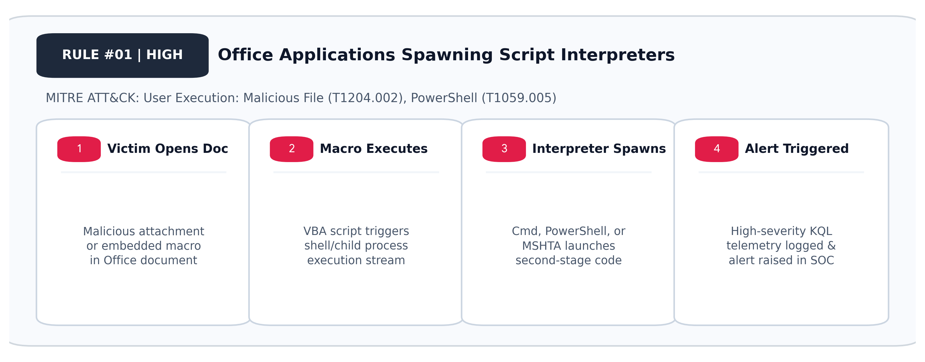

Production KQL Detection Logic
// Alert: Office App Spawning Script Interpreter
DeviceProcessEvents
| where InitiatingProcessFileName in~ (
"winword.exe", "excel.exe", "powerpnt.exe", "outlook.exe"
)
| where FileName in~ (
"cmd.exe", "powershell.exe", "pwsh.exe", "wscript.exe",
"cscript.exe", "mshta.exe", "certutil.exe", "bitsadmin.exe"
)
| project TimeGenerated, DeviceName, AccountName, FileName,
ProcessCommandLine, InitiatingProcessFileName,
InitiatingProcessCommandLine
| extend MitreTactic = "Execution", MitreTechnique = "T1204.002"
False Positives & Tuning | Legitimate enterprise add-ins or macros running custom scripts. Add exclusions by parent command line and digital signing status.
SOC Triage & Response | 1. Isolate endpoint immediately.  2. Inspect InitiatingProcessCommandLine and dropped email attachment.  3. Collect network connections made by child process.

RULE #02 | Certutil Payload Download & Decoding (LOLBin)
MITRE TACTIC | Defense Evasion, Ingress Tool Transfer | MITRE TECHNIQUE | T1140
LOG SOURCE / TABLE | DeviceProcessEvents | ALERT SEVERITY | High
Threat Scenario & Context: Detects certutil.exe invoked with switches such as -urlcache or -decode, commonly abused to download second-stage malware or unpack obfuscated scripts under a trusted Microsoft binary.

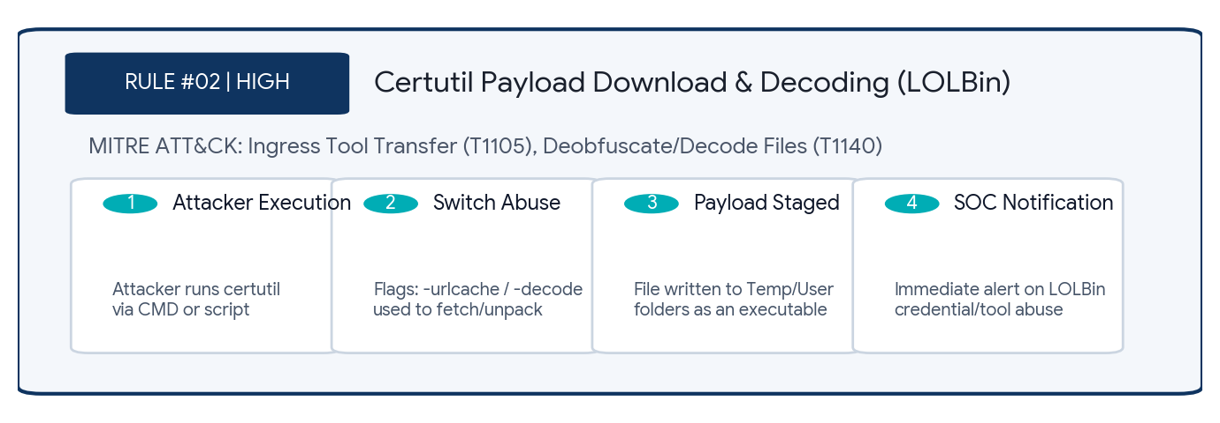
Production KQL Detection Logic
// Alert: Certutil Download or Base64 Decode
DeviceProcessEvents
| where FileName =~ "certutil.exe"
or ProcessVersionInfoOriginalFileName =~ "certutil.exe"
| where ProcessCommandLine has_any (
"-urlcache", "/urlcache", "-split", "/split", "-decode", "/decode"
)
| project TimeGenerated, DeviceName, AccountName, ProcessCommandLine,
InitiatingProcessCommandLine
| extend MitreTactic = "DefenseEvasion", MitreTechnique = "T1140"
False Positives & Tuning | Automated enterprise certificate provisioning scripts decoding base64 certificates. Filter on specific system service accounts.
SOC Triage & Response | 1. Identify the URL or file path in ProcessCommandLine.  2. Submit target payload to sandbox.  3. Review initiating parent process tree.

RULE #03 | PowerShell Base64 Encoded Execution
MITRE TACTIC | Execution, Defense Evasion | MITRE TECHNIQUE | T1059.001
LOG SOURCE / TABLE | DeviceProcessEvents | ALERT SEVERITY | Medium
Threat Scenario & Context: Identifies PowerShell instances spawned with encoded command arguments (-enc, -encodedcommand), commonly employed by cyber threat actors to bypass static command-line inspection and string matching.

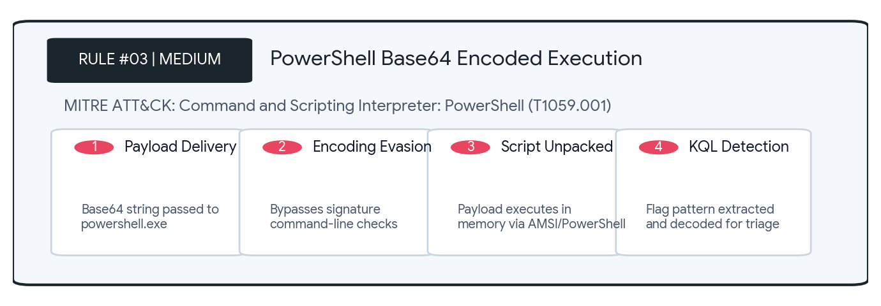
Production KQL Detection Logic
// Alert: PowerShell Encoded Execution
DeviceProcessEvents
| where FileName in~ ("powershell.exe", "pwsh.exe")
| where ProcessCommandLine has_any (
"-e ", "-enc ", "-encodedcommand ", "/e ", "/enc "
)
| project TimeGenerated, DeviceName, AccountName, ProcessCommandLine,
InitiatingProcessFileName
| extend MitreTactic = "Execution", MitreTechnique = "T1059.001"
False Positives & Tuning | Legitimate enterprise administration scripts (Microsoft Exchange Management, SCCM, Intune scripts).
SOC Triage & Response | 1. Decode the Base64 command using CyberChef.  2. Verify initiating parent process.  3. Inspect child network connections and script block logs (EID 4104).

RULE #04 | Windows Script Host External Network Connection
MITRE TACTIC | Execution, Command and Control | MITRE TECHNIQUE | T1071
LOG SOURCE / TABLE | DeviceNetworkEvents | ALERT SEVERITY | High
Threat Scenario & Context: Monitors wscript.exe and cscript.exe making successful outbound network connections to public IP addresses, a primary indicator of VBScript/JScript staging droppers or beaconing activity.

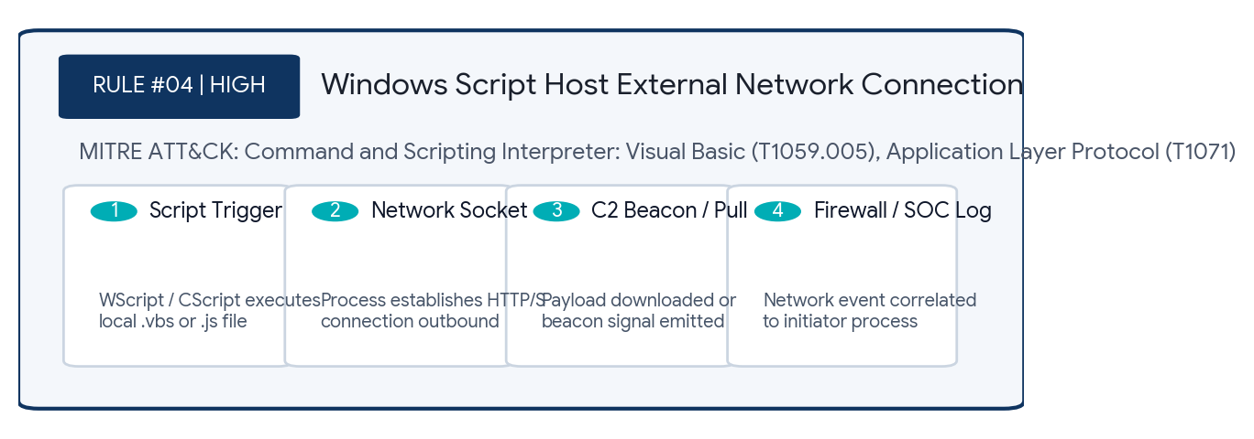
Production KQL Detection Logic
// Alert: Wscript/Cscript Outbound Connection
DeviceNetworkEvents
| where InitiatingProcessFileName in~ ("wscript.exe", "cscript.exe")
| where ActionType == "ConnectionSuccess"
| where RemoteIPType != "Private" and RemotePort in (80, 443, 8080, 8443)
| project TimeGenerated, DeviceName, InitiatingProcessFileName,
RemoteIP, RemoteUrl, RemotePort
| extend MitreTactic = "Execution", MitreTechnique = "T1059.005"
False Positives & Tuning | Very rare in well-configured environments. Legacy enterprise IT logon scripts may communicate with external telemetry.
SOC Triage & Response | 1. Check reputation of RemoteIP and RemoteUrl on VirusTotal/Threat Intel.  2. Isolate host.  3. Retrieve script file referenced in process history.

RULE #05 | Scheduled Task Creation via Native Command Line
MITRE TACTIC | Persistence, Execution | MITRE TECHNIQUE | T1053.005
LOG SOURCE / TABLE | DeviceProcessEvents | ALERT SEVERITY | Medium
Threat Scenario & Context: Detects command-line creation or modification of Windows Scheduled Tasks using schtasks.exe pointing to scripting shells, user directories, or suspicious staging paths.

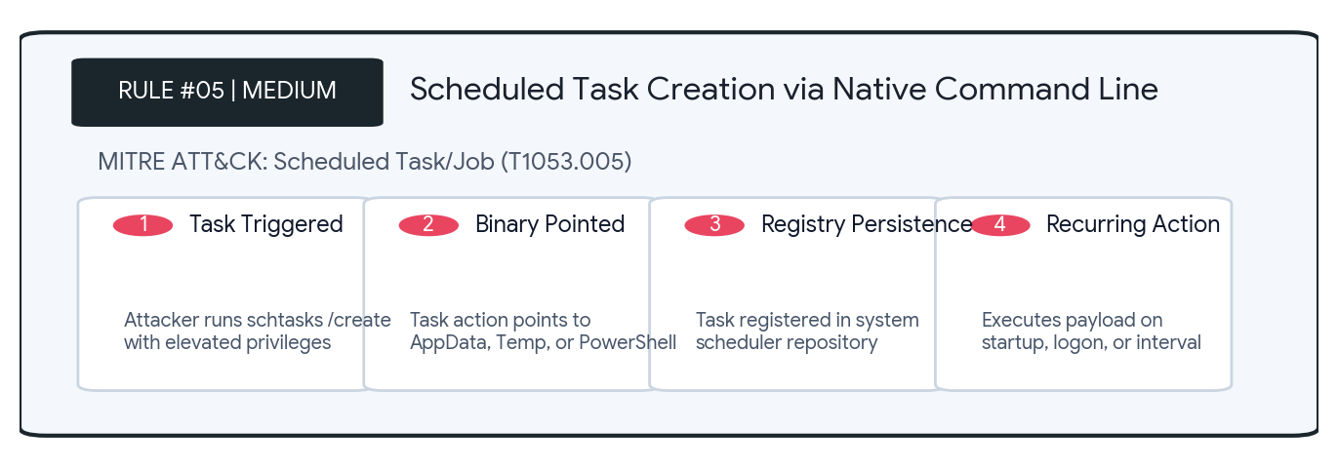
Production KQL Detection Logic
// Alert: Schtasks Creation or Modification
DeviceProcessEvents
| where FileName =~ "schtasks.exe"
| where ProcessCommandLine has_any ("/create", "/change")
| where ProcessCommandLine has_any (
"powershell", "cmd", "wscript", "rundll32",
"regsvr32", "AppData", "Temp"
)
| project TimeGenerated, DeviceName, AccountName, ProcessCommandLine,
InitiatingProcessCommandLine
| extend MitreTactic = "Persistence", MitreTechnique = "T1053.005"
False Positives & Tuning | Application updaters (Google Chrome, Edge, Zoom, Adobe) creating auto-update tasks. Baseline by vendor digital signatures.
SOC Triage & Response | 1. Parse task name (/tn) and program (/tr).  2. Inspect author and run permissions.  3. Delete suspicious task using schtasks /delete if malicious.

RULE #06 | Persistence via Registry Run / RunOnce Keys
MITRE TACTIC | Persistence | MITRE TECHNIQUE | T1547.001
LOG SOURCE / TABLE | DeviceRegistryEvents | ALERT SEVERITY | High
Threat Scenario & Context: Tracks writes or modifications to Registry Run or RunOnce keys pointing to executable binaries, scripts, or LOLBins designed to maintain persistence across user logons and reboots.

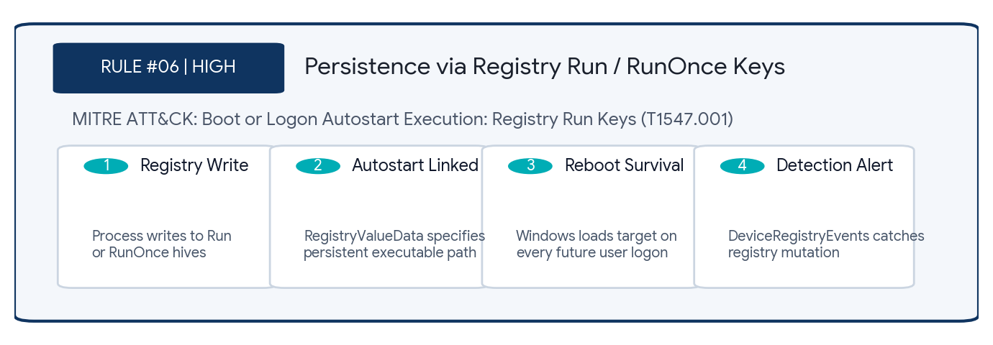
Production KQL Detection Logic
// Alert: Run Key Value Added/Modified
DeviceRegistryEvents
| where ActionType in ("RegistryValueSet", "RegistryKeyCreated")
| where RegistryKey has_any (@"\CurrentVersion\Run", @"\CurrentVersion\RunOnce")
| where RegistryValueData has_any (
".exe", ".dll", ".ps1", ".vbs", ".bat", "powershell", "wscript"
)
| project TimeGenerated, DeviceName, RegistryKey, RegistryValueName,
RegistryValueData, InitiatingProcessFileName
| extend MitreTactic = "Persistence", MitreTechnique = "T1547.001"
False Positives & Tuning | Legitimate newly installed software registering system tray utilities or startup helpers.
SOC Triage & Response | 1. Verify vendor and signature of the file in RegistryValueData.  2. Review hash in threat intelligence feeds.  3. Remove rogue registry key.

RULE #07 | New Service Installation Executing from User/Temp Paths
MITRE TACTIC | Persistence, Privilege Escalation | MITRE TECHNIQUE | T1543.003
LOG SOURCE / TABLE | SecurityEvent | ALERT SEVERITY | High
Threat Scenario & Context: Detects the creation of Windows services (Event ID 7045) where the binary path references user-writable or temporary directories (e.g., AppData, Temp, PerfLogs).

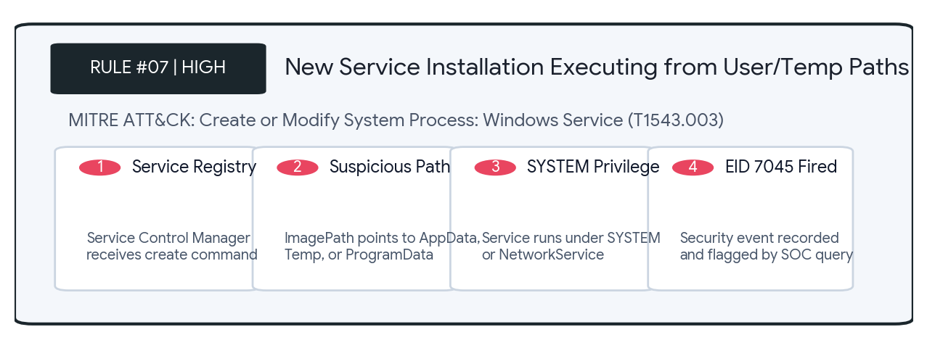
Production KQL Detection Logic
// Alert: Service Installed Executing from User/Temp Paths
SecurityEvent
| where EventID == 7045
| extend ServicePath = tostring(EventData.ImagePath)
| where ServicePath has_any (
@"C:\Users\", @"\AppData\", @"\Temp\",
@"\PerfLogs\", @"C:\ProgramData\"
)
| project TimeGenerated, Computer, ServiceName = EventData.ServiceName,
ServicePath, Account
| extend MitreTactic = "Persistence", MitreTechnique = "T1543.003"
False Positives & Tuning | Developer utilities, portable tools, or uninstaller stubs executing from temporary locations during software deployment.
SOC Triage & Response | 1. Check ServiceName and Account that initiated creation.  2. Scan ServicePath executable.  3. Stop and delete service with sc.exe stop / sc.exe delete.

RULE #08 | Privileged Local/Domain Group Membership Manipulation
MITRE TACTIC | Privilege Escalation, Persistence | MITRE TECHNIQUE | T1098
LOG SOURCE / TABLE | SecurityEvent | ALERT SEVERITY | High
Threat Scenario & Context: Detects addition of users to sensitive local or domain administrative groups (such as Administrators, Domain Admins, Remote Desktop Users) using Event IDs 4728 and 4732.

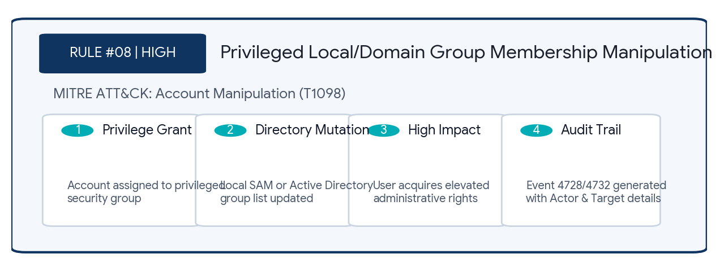
Production KQL Detection Logic
// Alert: User Added to Privileged Group
SecurityEvent
| where EventID in (4728, 4732)
| extend TargetGroup = tostring(TargetUserName),
AddedMember = tostring(MemberName),
SubjectUser = tostring(SubjectUserName)
| where TargetGroup in~ (
"Administrators", "Domain Admins",
"Enterprise Admins", "Remote Desktop Users"
)
| project TimeGenerated, Computer, TargetGroup, AddedMember, SubjectUser
| extend MitreTactic = "PrivilegeEscalation", MitreTechnique = "T1098"
False Positives & Tuning | Legitimate IT Helpdesk provisioning or automated JIT (Just-In-Time) access workflows. Correlate with approved change request IDs.
SOC Triage & Response | 1. Confirm authorization of SubjectUser and change ticket.  2. If unauthorized, revoke membership immediately.  3. Audit recent logon activity for AddedMember.

RULE #09 | Windows Security/System Event Log Clearance
MITRE TACTIC | Defense Evasion | MITRE TECHNIQUE | T1070.001
LOG SOURCE / TABLE | SecurityEvent | ALERT SEVERITY | High
Threat Scenario & Context: Monitors intentional clearing of Windows Security (Event ID 1102) or System (Event ID 104) event logs, a hallmark post-exploitation tactic to eliminate forensic evidence.

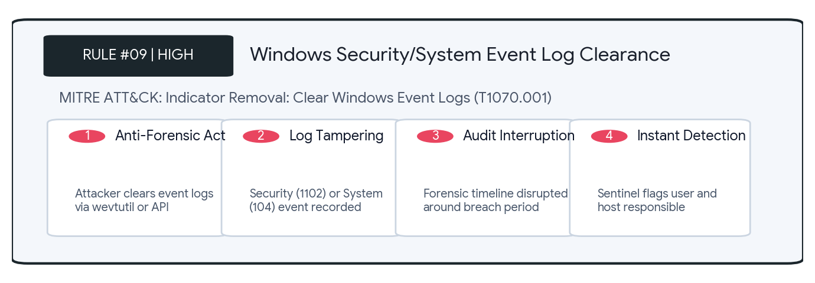
Production KQL Detection Logic
// Alert: Audit Log Cleared
SecurityEvent
| where EventID in (1102, 104)
| project TimeGenerated, Computer, Activity, SubjectUserName,
SubjectDomainName
| extend MitreTactic = "DefenseEvasion", MitreTechnique = "T1070.001"
False Positives & Tuning | Automated log rollover scripts or system maintenance during OS imaging/provisioning.
SOC Triage & Response | 1. Identify the user account in SubjectUserName.  2. Review preceding commands and logon sessions on Computer before the log wipe.  3. Isolate system.

RULE #10 | Tampering with Antivirus & Defender Controls
MITRE TACTIC | Defense Evasion | MITRE TECHNIQUE | T1562.001
LOG SOURCE / TABLE | DeviceProcessEvents | ALERT SEVERITY | High
Threat Scenario & Context: Detects attempts to disable Windows Defender real-time monitoring, add path exclusions, unload minifilter drivers, or stop antivirus services via CLI/PowerShell.

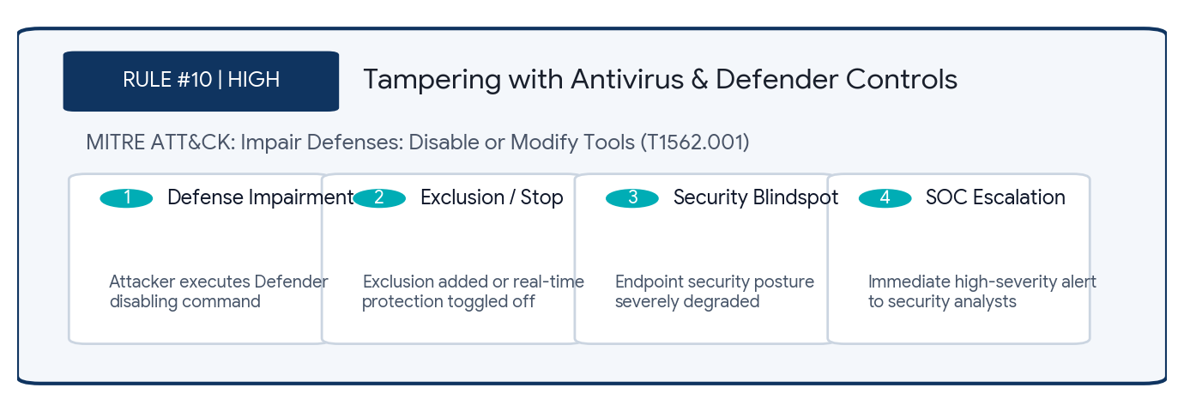
Production KQL Detection Logic
// Alert: Tampering with Antivirus / Defender Settings
DeviceProcessEvents
| where ProcessCommandLine has_any (
"Set-MpPreference -DisableRealtimeMonitoring $true",
"Add-MpPreference -ExclusionPath",
"sc config WinDefend start= disabled",
"net stop WinDefend"
) or (FileName =~ "fltmc.exe" and ProcessCommandLine has "unload")
| project TimeGenerated, DeviceName, AccountName, ProcessCommandLine,
InitiatingProcessFileName
| extend MitreTactic = "DefenseEvasion", MitreTechnique = "T1562.001"
False Positives & Tuning | DevOps setup scripts configuring folder exclusions for heavy compile builds. Verify change management tickets.
SOC Triage & Response | 1. Restore Defender settings (Set-MpPreference -DisableRealtimeMonitoring $false).  2. Identify the process that executed the command.  3. Full AV scan.

RULE #11 | Masquerading: Core System Binaries in Non-Standard Paths
MITRE TACTIC | Defense Evasion | MITRE TECHNIQUE | T1036.005
LOG SOURCE / TABLE | DeviceProcessEvents | ALERT SEVERITY | High
Threat Scenario & Context: Detects critical system binaries (e.g., svchost.exe, lsass.exe, explorer.exe) executing outside their legitimate directory structures (System32, SysWOW64, WinSxS).

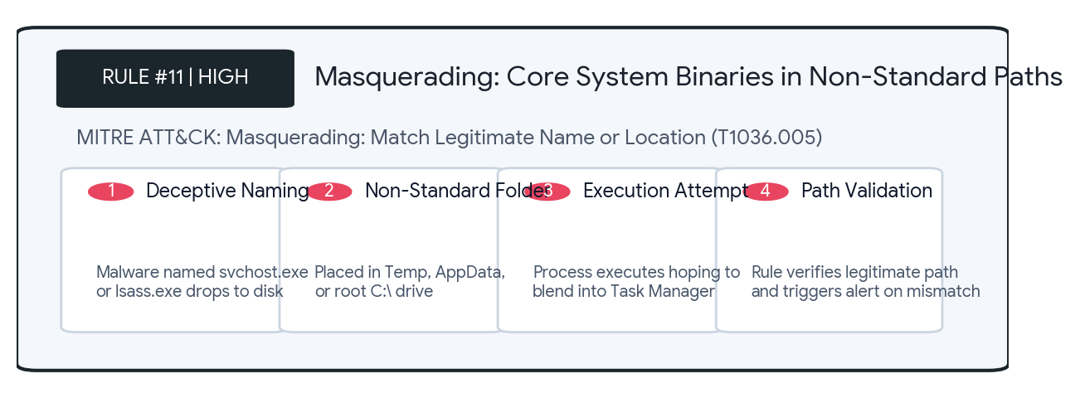
Production KQL Detection Logic
// Alert: Core System Binary Running Outside System32
DeviceProcessEvents
| where FileName in~ (
"svchost.exe", "lsass.exe", "smss.exe", "services.exe",
"csrss.exe", "explorer.exe"
)
| where not(FolderPath has_any (
@"C:\Windows\System32", @"C:\Windows\SysWOW64", @"C:\Windows\WinSxS"
))
| project TimeGenerated, DeviceName, FileName, FolderPath,
ProcessCommandLine, AccountName
| extend MitreTactic = "DefenseEvasion", MitreTechnique = "T1036.005"
False Positives & Tuning | Extremely low. Very few legitimate applications name their binaries after protected core Windows services.
SOC Triage & Response | 1. Terminate process immediately.  2. Collect binary hash and quarantine file.  3. Review persistence mechanisms and network connections.

RULE #12 | Volume Shadow Copy Deletion (Ransomware Precursor)
MITRE TACTIC | Impact | MITRE TECHNIQUE | T1490
LOG SOURCE / TABLE | DeviceProcessEvents | ALERT SEVERITY | Critical
Threat Scenario & Context: Detects commands commonly utilized by ransomware operators (vssadmin, wbadmin, wmic, bcdedit) to delete volume shadow copies and disable boot recovery before encryption.

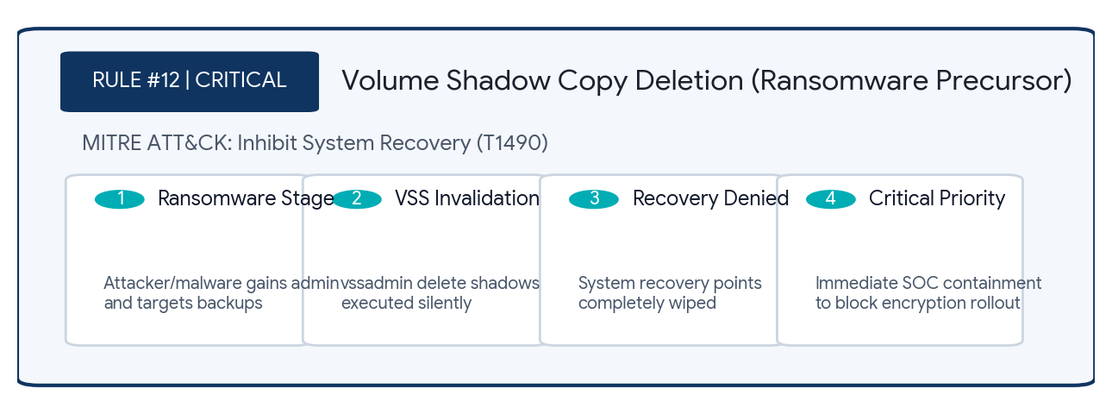
Production KQL Detection Logic
// Alert: VSS and Recovery Invalidation
DeviceProcessEvents
| where (FileName =~ "vssadmin.exe" and ProcessCommandLine has_all ("delete", "shadows"))
or (FileName =~ "wbadmin.exe" and ProcessCommandLine has "delete")
or (FileName =~ "wmic.exe" and ProcessCommandLine has_all ("shadowcopy", "delete"))
or (FileName =~ "bcdedit.exe" and ProcessCommandLine has_any (
"recoveryenabled No", "bootstatuspolicy ignoreallfailures"
))
| project TimeGenerated, DeviceName, FileName, ProcessCommandLine,
InitiatingProcessFileName
| extend MitreTactic = "Impact", MitreTechnique = "T1490"
False Positives & Tuning | Legitimate enterprise backup software purging outdated snapshots prior to creating full images. Verify backup service account.
SOC Triage & Response | 1. CRITICAL: Isolate device from network immediately.  2. Check for active bulk file encryption/renaming.  3. Engage Incident Response.

RULE #13 | LSASS OpenProcess Handle Scrape for Credential Dumping
MITRE TACTIC | Credential Access | MITRE TECHNIQUE | T1003.001
LOG SOURCE / TABLE | DeviceEvents | ALERT SEVERITY | High
Threat Scenario & Context: Detects unauthorized processes requesting memory read permissions (PROCESS_VM_READ / PROCESS_ALL_ACCESS) against the Local Security Authority Subsystem Service (LSASS).

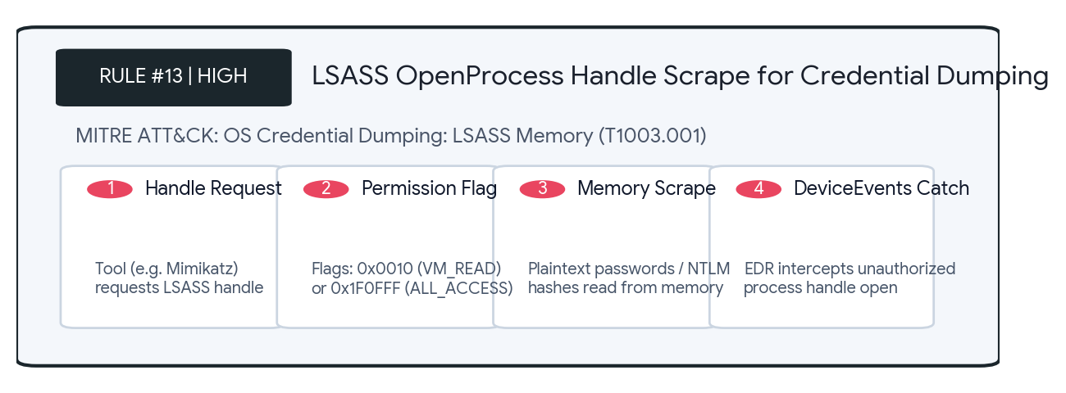
Production KQL Detection Logic
// Alert: Suspicious OpenProcess on LSASS
DeviceEvents
| where ActionType == "OpenProcessHandle"
| where FileName =~ "lsass.exe"
| where not(InitiatingProcessFileName in~ (
"csrss.exe", "services.exe", "MsMpEng.exe", "svchost.exe"
))
| where AdditionalFields has_any ("0x0010", "0x1f0fff")
| project TimeGenerated, DeviceName, InitiatingProcessFileName,
InitiatingProcessCommandLine
| extend MitreTactic = "CredentialAccess", MitreTechnique = "T1003.001"
False Positives & Tuning | Third-party endpoint protection agents, IT monitoring tools, or password managers. Whitelist approved vendor binaries.
SOC Triage & Response | 1. Review InitiatingProcessFileName and hash.  2. Reset passwords for any accounts logged into that endpoint.  3. Check for lateral movement.

RULE #14 | Password Spraying Anomaly Across Multiple User Accounts
MITRE TACTIC | Credential Access | MITRE TECHNIQUE | T1110.003
LOG SOURCE / TABLE | SigninLogs | ALERT SEVERITY | Medium
Threat Scenario & Context: Identifies an external or internal IP address attempting authentication against a high distinct count of enterprise user accounts within a 1-hour window using invalid credentials.

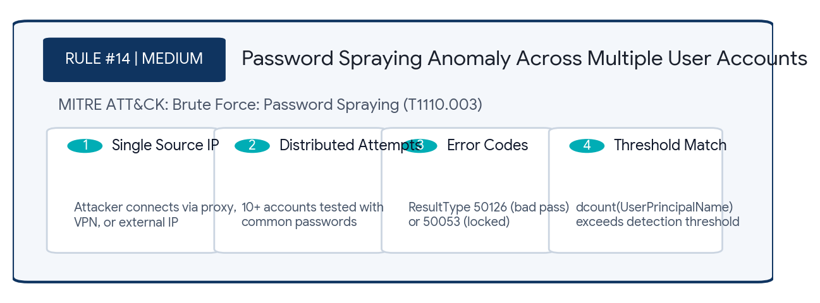
Production KQL Detection Logic
// Alert: Password Spray Pattern Detected
SigninLogs
| where TimeGenerated >= ago(1h)
| where ResultType in (50126, 50053) // Invalid password or Account locked
| summarize FailedUserCount = dcount(UserPrincipalName),
TargetedUsers = make_set(UserPrincipalName, 10)
by IPAddress
| where FailedUserCount >= 10
| project IPAddress, FailedUserCount, TargetedUsers
| extend MitreTactic = "CredentialAccess", MitreTechnique = "T1110.003"
False Positives & Tuning | Misconfigured enterprise identity federation proxy or internal SSO gateway routing user failures under a single NAT gateway IP.
SOC Triage & Response | 1. Check IP reputation on IPQualityScore / AbuseIPDB.  2. Verify if any sign-in succeeded from the same IP (ResultType == 0).  3. Block IP on firewall.

RULE #15 | Rapid Sequence of Active Directory Reconnaissance Utilities
MITRE TACTIC | Discovery | MITRE TECHNIQUE | T1482
LOG SOURCE / TABLE | DeviceProcessEvents | ALERT SEVERITY | Medium
Threat Scenario & Context: Detects rapid bursts of native discovery utilities (nltest, net, whoami, dsquery, klist) executed within a 10-minute window on a single endpoint, signalling active reconnaissance.

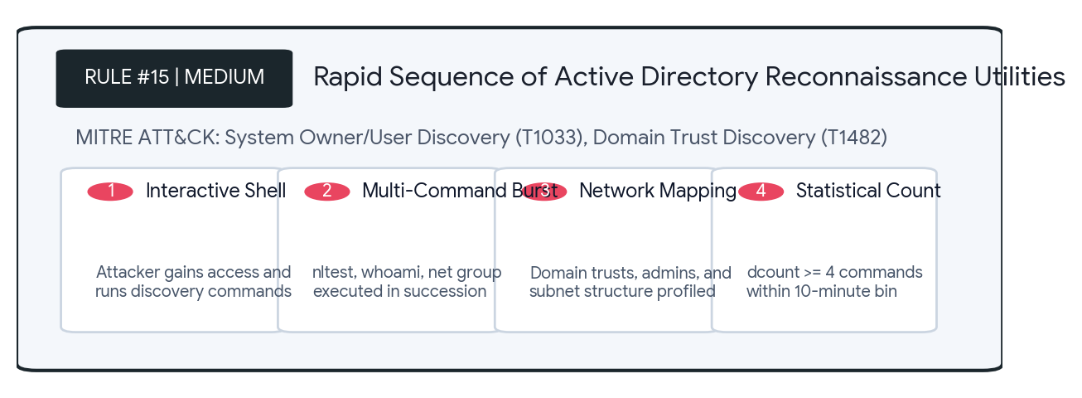
Production KQL Detection Logic
// Alert: Rapid Sequence of Reconnaissance Utilities
DeviceProcessEvents
| where TimeGenerated >= ago(30m)
| where FileName in~ (
"nltest.exe", "net.exe", "whoami.exe", "dsquery.exe",
"klist.exe", "systeminfo.exe", "ipconfig.exe"
)
| summarize CmdCount = dcount(FileName),
CommandsRun = make_set(ProcessCommandLine)
by DeviceName, AccountName, bin(TimeGenerated, 10m)
| where CmdCount >= 4
| extend MitreTactic = "Discovery", MitreTechnique = "T1033"
False Positives & Tuning | System administrators troubleshooting network/domain connectivity manually or running custom diagnostics scripts.
SOC Triage & Response | 1. Contact AccountName to confirm if troubleshooting was active.  2. Check preceding process lineage (parent process).  3. Monitor for lateral movement.

RULE #16 | Lateral Movement via PsExec Execution Artifacts
MITRE TACTIC | Lateral Movement, Execution | MITRE TECHNIQUE | T1021.002
LOG SOURCE / TABLE | DeviceProcessEvents | ALERT SEVERITY | High
Threat Scenario & Context: Detects the presence and execution of PsExec service binaries (psexesvc.exe) and command lines, indicating remote code execution across administrative SMB shares (ADMIN$).

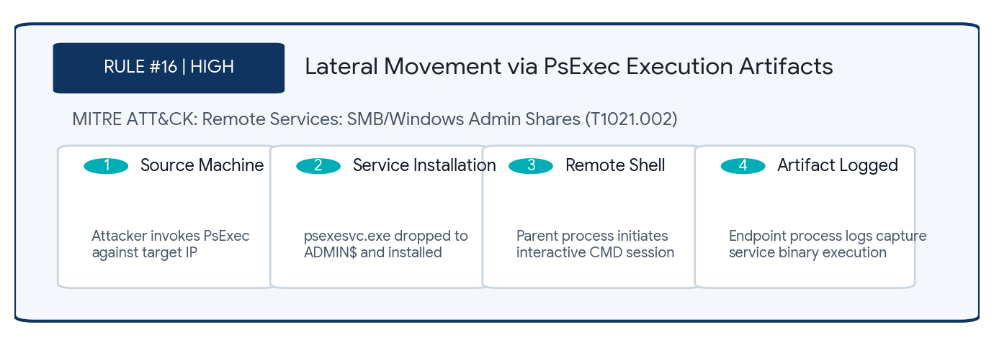
Production KQL Detection Logic
// Alert: PsExec Execution Artifact Detected
DeviceProcessEvents
| where FileName =~ "psexesvc.exe"
or InitiatingProcessFileName =~ "psexesvc.exe"
or ProcessCommandLine has "psexec"
| project TimeGenerated, DeviceName, AccountName, FileName,
ProcessCommandLine, InitiatingProcessFileName
| extend MitreTactic = "LateralMovement", MitreTechnique = "T1021.002"
False Positives & Tuning | Authorized IT sysadmin maintenance or vulnerability scanners (Nessus, Qualys). Baseline known admin source IP ranges.
SOC Triage & Response | 1. Trace originating IP from SMB session logs (Event ID 4624/5140). 2. Inspect command executed via PsExec. 3. Isolate source and destination.

RULE #17 | Remote Task Scheduling via Native Schtasks Commands
MITRE TACTIC | Lateral Movement, Persistence | MITRE TECHNIQUE | T1053.005
LOG SOURCE / TABLE | DeviceProcessEvents | ALERT SEVERITY | High
Threat Scenario & Context: Detects the use of schtasks.exe with the /s parameter to remotely register scheduled tasks on remote network computers using native RPC/SMB protocols.

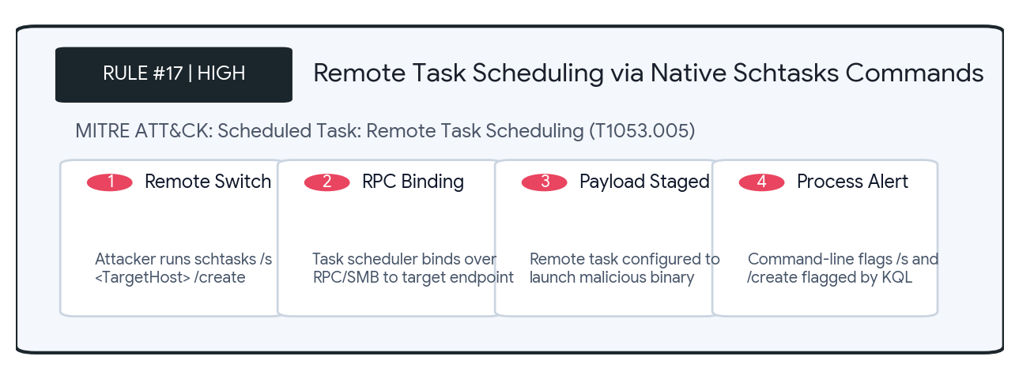
Production KQL Detection Logic
// Alert: Remote Task Scheduling
DeviceProcessEvents
| where FileName =~ "schtasks.exe"
| where ProcessCommandLine has "/s " and ProcessCommandLine has "/create"
| project TimeGenerated, DeviceName, AccountName, ProcessCommandLine,
InitiatingProcessCommandLine
| extend MitreTactic = "LateralMovement", MitreTechnique = "T1053.005"
False Positives & Tuning | Legacy central software deployment scripts. Modern environments utilize Intune, SCCM, or Ansible.
SOC Triage & Response | 1. Identify the target host passed in the /s argument. 2. Verify account privileges. 3. Check target host task scheduler logs (EID 106).

RULE #18 | Entra ID Global Administrator / High Privileged Role Assignment
MITRE TACTIC | Privilege Escalation, Persistence | MITRE TECHNIQUE | T1098.003
LOG SOURCE / TABLE | AuditLogs | ALERT SEVERITY | Critical
Threat Scenario & Context: Audits Microsoft Entra ID (Azure AD) administrative role grants, alerting immediately whenever an identity is granted Tier-0 directory roles such as Global Administrator.

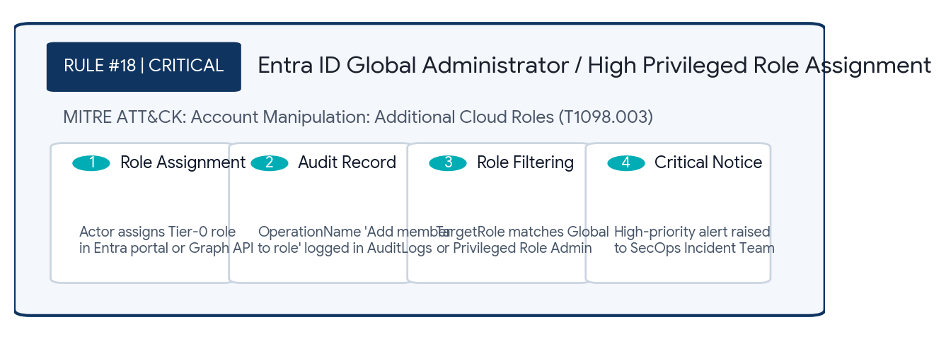
Production KQL Detection Logic
// Alert: Global Administrator or High Privileged Role Assigned
AuditLogs
| where OperationName in~ (
"Add member to role", "Add eligible member to role"
)
| extend TargetRole = tostring(parse_json(
tostring(TargetResources[0].modifiedProperties)
)[0].newValue)
| where TargetRole has_any (
"Global Administrator", "Privileged Role Administrator",
"Security Administrator"
)
| extend TargetUser = tostring(TargetResources[0].userPrincipalName)
| extend InitiatedByActor = tostring(InitiatedBy.user.userPrincipalName)
| project TimeGenerated, TargetRole, TargetUser, InitiatedByActor, Result
| extend MitreTactic = "PrivilegeEscalation", MitreTechnique = "T1098.003"
False Positives & Tuning | Approved PIM (Privileged Identity Management) elevations. Filter out legitimate PIM workflows by verifying InitiatedBy app IDs.
SOC Triage & Response | 1. Validate with Cloud Architecture team if change was scheduled. 2. Check initiating actor MFA and IP reputation. 3. Revoke role assignment if unapproved.

RULE #19 | OAuth Application Secret or Certificate Injection
MITRE TACTIC | Persistence, Defense Evasion | MITRE TECHNIQUE | T1098
LOG SOURCE / TABLE | AuditLogs | ALERT SEVERITY | High
Threat Scenario & Context: Detects the addition of cryptographic credentials (client secrets or certificates) to existing Entra ID Enterprise Applications, a primary persistence mechanism for cloud adversaries.

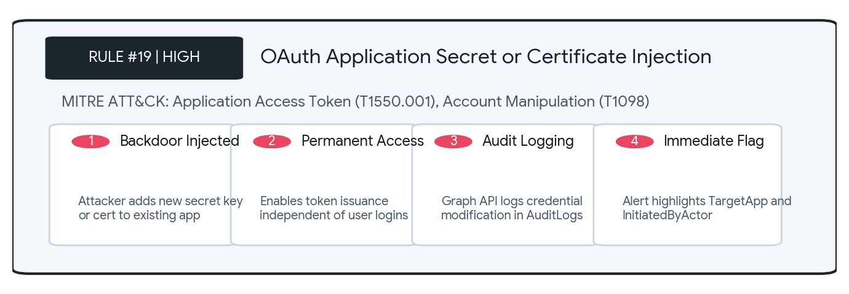
Production KQL Detection Logic
// Alert: Secret/Certificate Added to Application
AuditLogs
| where OperationName has_any (
"Update application – Certificates and secrets management",
"Add service principal credentials"
)
| extend TargetApp = tostring(TargetResources[0].displayName)
| extend InitiatedByActor = tostring(InitiatedBy.user.userPrincipalName)
| project TimeGenerated, OperationName, TargetApp, InitiatedByActor, Result
| extend MitreTactic = "Persistence", MitreTechnique = "T1098"
False Positives & Tuning | DevOps automated credential rotation pipelines (e.g. Terraform, KeyVault automation). Baseline automation Service Principals.
SOC Triage & Response | 1. Check TargetApp permissions (e.g., Mail.ReadWrite, Directory.ReadWrite.All). 2. Verify who generated the secret. 3. Invalidate compromised secret.

RULE #20 | Outbound Beaconing to Dynamic DNS / Tunneling Infrastructure
MITRE TACTIC | Command and Control | MITRE TECHNIQUE | T1071.001
LOG SOURCE / TABLE | DeviceNetworkEvents | ALERT SEVERITY | Medium
Threat Scenario & Context: Monitors internal endpoints initiating successful network connections to Dynamic DNS providers or reverse tunneling services commonly leveraged for C2 traffic and data exfiltration.

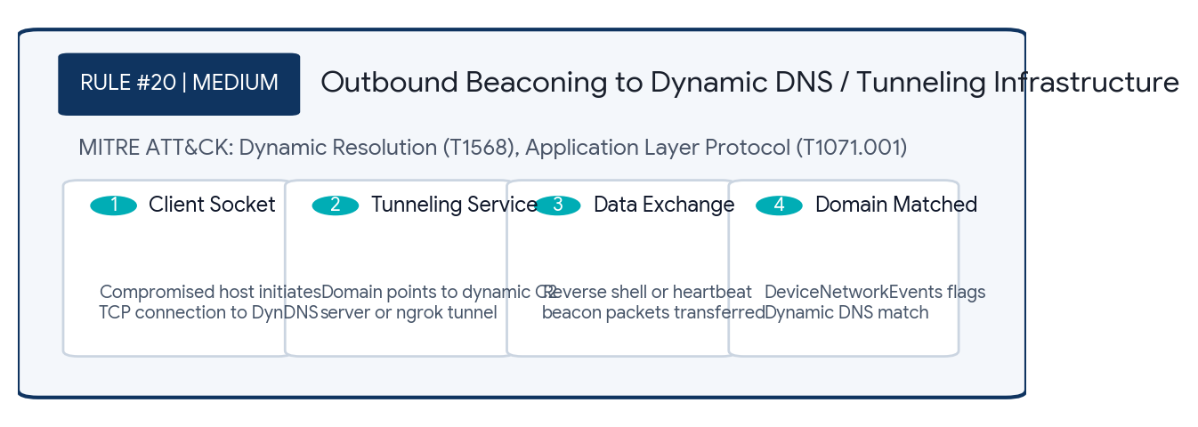
Production KQL Detection Logic
// Alert: Network Connection to Dynamic DNS Domain
let DynDNSDomains = dynamic([
"duckdns.org", "no-ip.com", "ddns.net", "hopto.org",
"zapto.org", "sytes.net", "ngrok.io", "portmap.io"
]);
DeviceNetworkEvents
| where ActionType == "ConnectionSuccess"
| where RemoteUrl has_any (DynDNSDomains)
| project TimeGenerated, DeviceName, InitiatingProcessFileName,
RemoteUrl, RemoteIP, RemotePort
| extend MitreTactic = "CommandAndControl", MitreTechnique = "T1568"
False Positives & Tuning | Developers using ngrok.io for authorized local webhook testing. Require security exception requests for developer tunneling tools.
SOC Triage & Response | 1. Identify the InitiatingProcessFileName and PID.  2. Terminate the connection and isolate the host.  3. Inspect internal ports exposed via tunnel.

