**Predicts - Ad Match**

This site documents Predicts Project Ad Match component

Predicts project Ad Match component is aimed at enhancing sales productivity by recommending properties for customers. When a sales person is engaged with a given customer, the system suggests properties that the customer has not yet advertised on, but might be of interest to the customer. The system analyzes customer's advertisement history; matches it with other customers' advertisement history; finds other similar advertisers and then finds out which properties they have advertised on and might be useful to the given advertiser.

Predicts uses Apache Mahout libraries for generating recommendations. It takes data from various sources such as YCRM, UAD. Its User Interface is based on Ace Framework.

User Interface uses services provided by Predicts Services module. The services module provides services such as 'get similar companies', 'get recommendations', 'get company details', 'get company list' (for auto complete) etc. Services module has been implemented using Yahoo Web Services which runs on Spring framework and returns JSON result in REST based web services.

Please click on following links to get more information on overall architecture

* [Architecture](http://sp2-crmarch-001.ads.pool.corp.sp2.yahoo.com:4080/predictsdoc/predictsArchitecture.html)
* [Data Model](http://sp2-crmarch-001.ads.pool.corp.sp2.yahoo.com:4080/predictsdoc/predictsDataModel.html)
* [Back End Processing](http://sp2-crmarch-001.ads.pool.corp.sp2.yahoo.com:4080/predictsdoc/predictsBackEndProcessing.html)
* [Web Services](http://sp2-crmarch-001.ads.pool.corp.sp2.yahoo.com:4080/predictsdoc/predictsWebServices.html)
* [Home](http://sp2-crmarch-001.ads.pool.corp.sp2.yahoo.com:4080/predictsdoc/index.html)
* This page documents Predicts Project architecture.

### Introduction

### Architecture

* Predicts architecture is divided into three layers: User Interface, Services, Data. User Interface layer is concerned about rendering the recommendations in an engaging manner and interacting with services layer to get and set data. Services layer uses data layer to read and write data that User Interface layer needs.   
  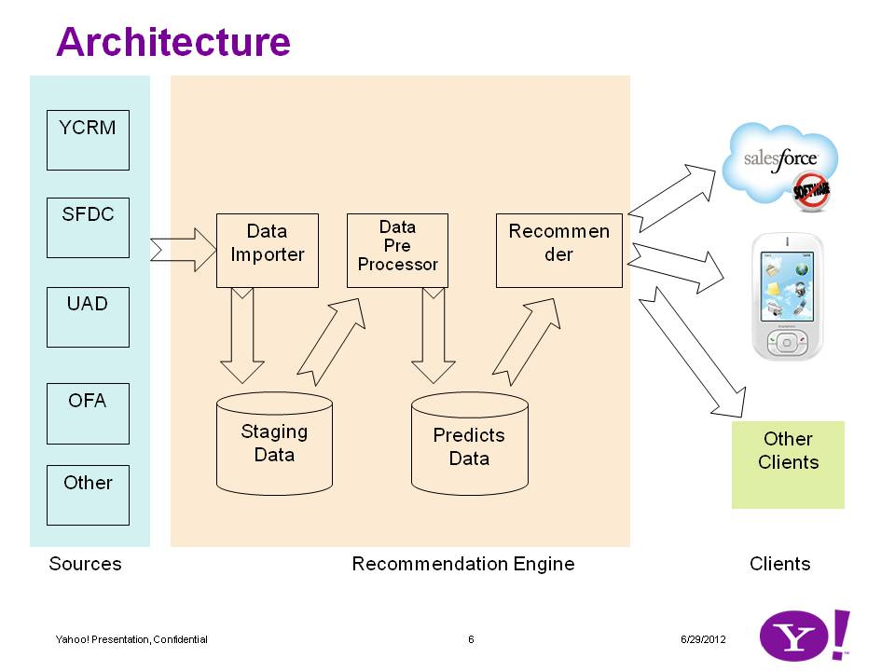
* The image describes the three main components. Currently only YCRM source is ready. We hope that UAD source will be ready in the week of 7/1/12.
* There are two sets of tables in Predicts. First set of tables is the staging tables. These tables serve as a staging platform for incoming data. This helps isolate the second set of tables. Second set of tables consists of predicts tables. These tables contain data required by the algorithm.
* There are several components that process the data to make it usable by recommender engine. A component Data Importer imports data from the source (such as YCRM) and stores the data into Staging table. Second component Data Processor process this data and populates predicts tables. Recommender uses predicts tables to generate recommendation. Note: Apache Mahout library as of now does not work with database. Therefore we have built an interface through flat files.   
  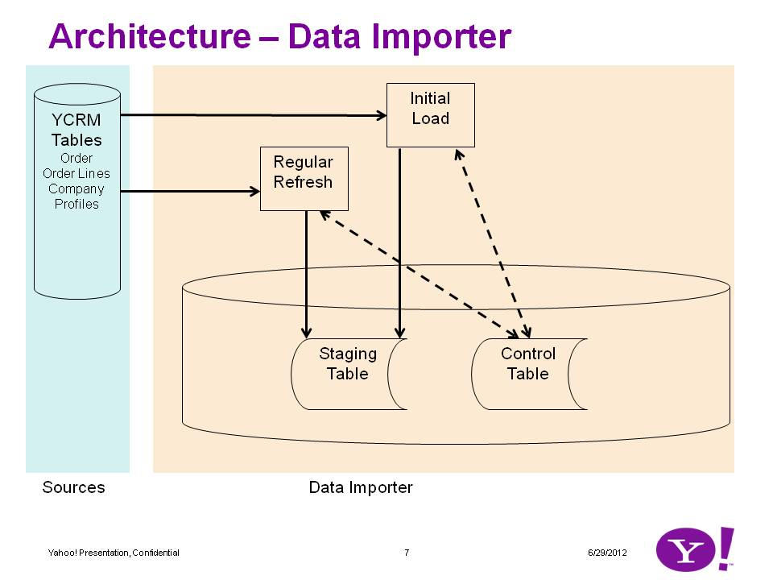
* Data Importer has two roles: Initial load, regular refresh.
* Initial load queries the source for data starting from a certain date in the past and gets data until system date. It updates a control table with the last import date.
* Regular refresh queries last processing date from the control table and then uses that as a start date to pull data from source table. It updates the control table with the last import date.
* As of 7/3/12 the importer works with YCRM. As soon as UAD schema becomes available we will build an importer to pull data from that source.   
  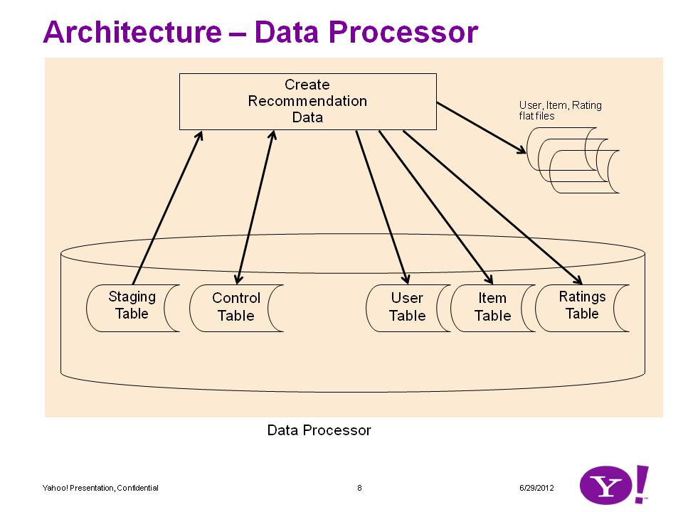
* Data processor pulls data from the staging tables and writes data to predicts tables. As noted above, Predicts involves three essential tables. User table contains data about customers. Item table contains data about properties. Rating table contains data about which customer purchased which property. The source for these is a flat staging table. The data procerror reads the staging table and then populates the three tables.
* User table - Processor queries if a customer with the same name and address exists. If it doesn't exist, it creates the user. It matches the customer's name and address to ensure that if there are duplicate records they can be taken care of. YCRM contains some customers whose name and address is exact same but for some reason there are two or more records. The data processor recognizes this and inserts only one customer.
* Item table - Processor queries if an item with same propPath exists. If there is none, it enters a record.
* Rating table - Processor queries the table to see if for same customer and item a record exists. If yes, then it increments aggregateSum column and updates the rating record. If not then it adds a record to rating.
* All the above queries include Project Name. For YCRM data the name is PREDICTSYCRM. This allows us to isolate data from various sources into their own 'buckets'. When UAD data becomes avaialble then it will be under a project PREDICTSUAD.
* The processor uses control table to record when it processed last.
* NOTE: There is another program that reads data from predicts tables and generates data files. As noted above currently the database libraries of Apache Mahout are not working. Therefore current version of Predicts Recommender works from flat files.   
  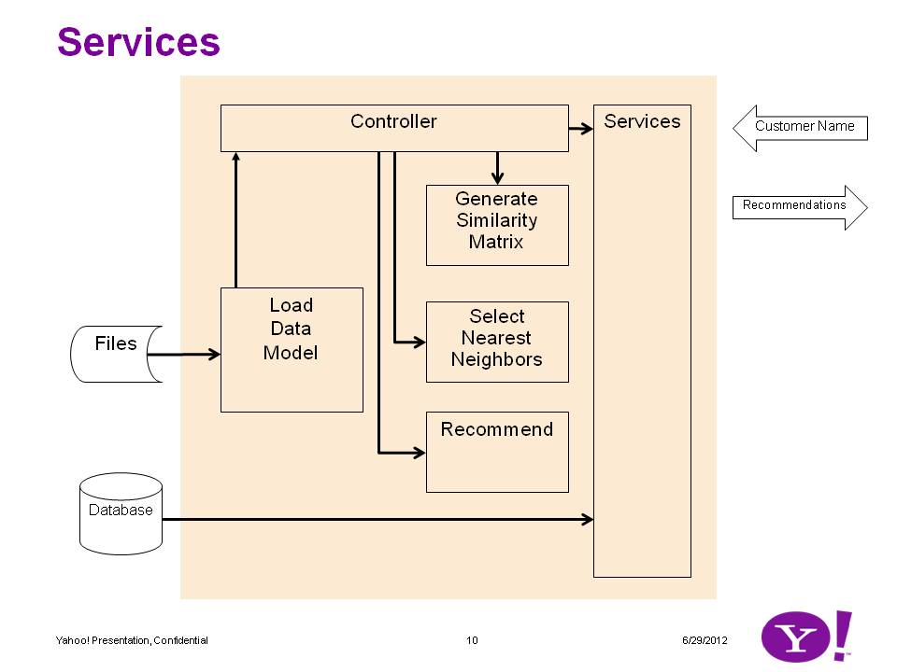
* There are two tpes of services: algorithm based services and database based services.
* Algorithm based services include recommendation, getting similar companies, getting similar items. These services work with a recommendation infrastructure. The infrastructure consists of a controller which loads the user, item and rating data into memory. As a request comes, the controller generates similarity matrix and generates similar companies (neighborhood) and then based on that generates recommendation.
* Database based services include getting company details, getting item details, getting a list of companies based on input string etc. These services go directly to the database to do these operations.   
  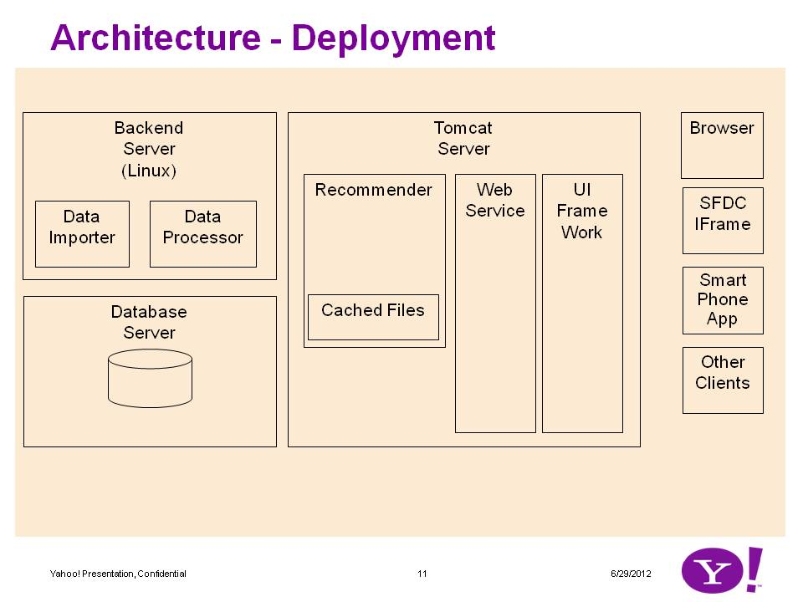
* Deployment architecture diagram shows various subsystems. They need not be on separate computer.
* Backend Server contains the data importer, data processor and the program that generates flat files. Currently these are run manually. But in steady state these will be scheduled using cron.
* Database server is a regular Oracle RDBMS.
* Tomcat server contains the recommender classes. It runs off of flat files that are stored with the package. Web services layer calls recommender for algorithm based services and database for database based services. UI framework uses services.
* Clients use UI framework. Currently we are using only browsers such as IE, Chrome, Firefox. But in future the UI can be embedded into various other clients. Since the interface is through web services (JSON based) there is no special deployment needed at the client.
* [Home](http://sp2-crmarch-001.ads.pool.corp.sp2.yahoo.com:4080/predictsdoc/index.html)
* This site documents Predicts Project data schema.   
  [Predicts Tables](http://sp2-crmarch-001.ads.pool.corp.sp2.yahoo.com:4080/predictsdoc/predictsDataModel.html#predictsTables)   
  [YCRM Staging Table](http://sp2-crmarch-001.ads.pool.corp.sp2.yahoo.com:4080/predictsdoc/predictsDataModel.html#YCRMStagingTable)   
  [UAD Staging Tables](http://sp2-crmarch-001.ads.pool.corp.sp2.yahoo.com:4080/predictsdoc/predictsDataModel.html#UADStagingTables)

### Predicts Tables

* [Back to Top](http://sp2-crmarch-001.ads.pool.corp.sp2.yahoo.com:4080/predictsdoc/predictsDataModel.html#top)

### Predicts Tables

* Predicts tables are used by the algorithm and the database based services. There are three tables.
* User - Table that contains customer data
* Item - Table that contains data about properties which are purchased by customers
* Rating - Table that contains the association of customer to properties
* describe customer
* Name Null Type
* -------------- -------- -------------
* ID NOT NULL NUMBER(15)
* CUSTOMERNAME VARCHAR2(100) - Name
* CUSTOMERID VARCHAR2(50) - Unique id such as Siebel Row Id
* ADDRSTREET1 VARCHAR2(200)
* ADDRSTREET2 VARCHAR2(100)
* ADDRSTREET3 VARCHAR2(100)
* ADDRCITY VARCHAR2(50)
* ADDRSTATE VARCHAR2(10)
* ADDRPROVINCE VARCHAR2(50)
* ADDRCOUNTRY VARCHAR2(30)
* ADDRPOSTALCODE VARCHAR2(30)
* CATEGORY VARCHAR2(50)
* PARENTCATEGORY VARCHAR2(30)
* DESCRIPTION VARCHAR2(400)
* PROJECT VARCHAR2(100) - Used to collect a set of data such as YCRM, UAD
* CREATEDON DATE
* CREATEDBY VARCHAR2(30)
* DELETEDFLAG VARCHAR2(1)
* CUSTOMERSTATUS VARCHAR2(20)
* describe item
* Name Null Type
* ---------------- -------- -------------
* ID NOT NULL NUMBER(15)
* TYPE VARCHAR2(100) - PROPERTY, TARGETING etc.
* ITEMNAME VARCHAR2(255) - Property Path (not URL)
* POSITION VARCHAR2(255) - LREC, N, SKY etc
* SPACEID VARCHAR2(255) - Numeric Space Id
* ROOTPROPERTYNAME VARCHAR2(255) - Top property such as Sport, Finance, OMG etc
* CPM VARCHAR2(255) - Not used in 1.0
* COMSCORE VARCHAR2(255) - Not available in YCRM
* CLICKTHROUGHRATE VARCHAR2(255) - Not available in YCRM
* DESCRIPTION VARCHAR2(400)
* PROJECT VARCHAR2(100) - Used to collect a set of data such as YCRM, UAD
* CREATEDON TIMESTAMP(6)
* CREATEDBY VARCHAR2(30)
* DELETEDFLAG VARCHAR2(1)
* ITEMSTATUS VARCHAR2(20)
* describe rating
* Name Null Type
* ------------ -------- -------------
* ID NOT NULL NUMBER(15)
* USERID NUMBER(15) - Customer Id
* ITEMID NUMBER(15) - Property Id
* RATINGTYPE VARCHAR2(20) - If BOOL, it has 1.0 otherwise it can vary
* RATING NUMBER(15,2) - Value of rating
* AGGREGATESUM NUMBER(15,2) - Total times a customer bought this property
* PROJECT VARCHAR2(100) - Used to collect a set of data such as YCRM, UAD
* CREATEDON DATE
* CREATEDBY VARCHAR2(30)
* DELETEDFLAG VARCHAR2(1)
* RATINGSTATUS VARCHAR2(20)

### Key Concepts

* Project - This is a top level container which will be used to collect various data sets.
* CPM and Position - These are placement level fields. They don't make sense at property level. Although they were included in item table for predicts, they will not be used in version 1 and may be factored out.
* Root Property Name - This is the top level property such as Sports, Finance, OMG! etc. In YCRM there is a field X_PROPERTY which has some good values but not all the values are good. We are hoping that when UAD data becomes available the quality of this field will become better.

### YCRM Staging Table

* [Back to the Top](http://sp2-crmarch-001.ads.pool.corp.sp2.yahoo.com:4080/predictsdoc/predictsDataModel.html#top)
* This table contains customer and property information taken from YCRM.
* Some columns are not used now but may be used in future. Some columns were included for debugging purpose. These are not actively used in recommendation but help investigate if something needs investigation.
* describe stagingycrm
* Name Null Type
* -------------------- -------- --------------
* LINEID NOT NULL VARCHAR2(15)
* LINETYPE VARCHAR2(10) - Debug field
* ORDERNUMBER VARCHAR2(30) - Debug field
* CUSTOMERID VARCHAR2(15)
* CUSTOMER VARCHAR2(100)
* ADDRSTREET1 VARCHAR2(200)
* ADDRSTREET2 VARCHAR2(100)
* ADDRSTREET3 VARCHAR2(100)
* ADDRCITY VARCHAR2(50)
* ADDRSTATE VARCHAR2(10)
* ADDRPROVINCE VARCHAR2(50)
* ADDRCOUNTRY VARCHAR2(30)
* ADDRPOSTALCODE VARCHAR2(30)
* CATEGORY VARCHAR2(50)
* PARENTCATEGORY VARCHAR2(30)
* MARKET VARCHAR2(30) - Future use
* RUBYLINEID VARCHAR2(15) - Debug field
* APTLINEID VARCHAR2(30) - Debug field
* PROPPATH VARCHAR2(255)
* POSITION VARCHAR2(255) - Future use
* SPACEID VARCHAR2(255)
* ROOTPROPERTYNAME VARCHAR2(255)
* CPM VARCHAR2(255) - Future use
* ORDERSTATUS VARCHAR2(30)
* MEDIANETAMOUNT NUMBER(22,7) - Future use
* MEDIAGROSSAMOUNT NUMBER(22,7) - Future use
* AUDIENCETARGETING VARCHAR2(2000) - Future use
* CONTENTTARGETING VARCHAR2(2000) - Future use
* ADATTRIBUTETARGETING VARCHAR2(2000) - Future use
* FREQUENCYTARGETING VARCHAR2(2000) - Future use
* RUBYTARGETING VARCHAR2(2000) - Future use
* LINECREATEDON DATE
* LINEUPDATEDON DATE
* CREATEDON TIMESTAMP(6)
* CREATEDBY VARCHAR2(30)
* PROCESSEDON DATE - Once line is processed it is stamped so line is not processed again
* PROCESSEDBY VARCHAR2(30) - Future use
* PROCESSEDSTATUS VARCHAR2(20) - Future use
* PROCESSMESSAGE VARCHAR2(200) - Future use
* ARCHIVEDFLAG VARCHAR2(1) - N for active records
* DELETEDFLAG VARCHAR2(20) - N for active records
* DATASOURCE VARCHAR2(20) - Tells if data came from YCRM, UAD etc
* ENVIRONMENT VARCHAR2(20) - Tells if data came from production, QA, etc
* PROJECT VARCHAR2(100) - Collects all the data into one bucket PREDICTSYCRM holds YCRM sourced data

### UAD Staging Tables

* [Back to the top](http://sp2-crmarch-001.ads.pool.corp.sp2.yahoo.com:4080/predictsdoc/predictsDataModel.html#top)
* desc fact_comcore
* Name Null Type
* -------- ---- ------
* SPACE_ID NUMBER
* COMSCORE NUMBER
* desc fact_revn_book_traf
* Name Null Type
* -------------------------- ---- ------
* SPACE_ID NUMBER
* TRAF_DLVR_IMPRESSIONS_PRNT NUMBER
* TRAF_DLVR_CLICKS_PRNT NUMBER
* TRAF_DLVR_CONVERSIONS_PRNT NUMBER
* TRAF_DLVR_IMPRESSIONS_CHLD NUMBER
* TRAF_DLVR_CLICKS_CHLD NUMBER
* TRAF_DLVR_CONVERSIONS_CHLD NUMBER
* TRAF_DLVR_IMPRESSIONS NUMBER
* TRAF_DLVR_CLICKS NUMBER
* TRAF_DLVR_CONVERSIONS NUMBER
* TRAF_DLVR_CLICKTROUGH_PRNT NUMBER
* TRAF_DLVR_CLICKTROUGH_CHLD NUMBER
* TRAF_DLVR_CLICKTROUGH NUMBER
* desc lkp_advertiser
* Name Null Type
* ------------------ -------- ------------------
* ADVERTISER_ID NOT NULL NUMBER
* CRM_ADVERTISER_ID NOT NULL VARCHAR2(15 CHAR)
* ADVERTISER_NAME VARCHAR2(300 CHAR)
* ADV_PRNT_CATEGORY VARCHAR2(30 CHAR)
* ADV_ADDR_LINE_1 VARCHAR2(300 CHAR)
* ADV_ADDR_LINE_2 VARCHAR2(300 CHAR)
* ADV_ADDR_LINE_3 VARCHAR2(300 CHAR)
* ADV_ADDR_CITY VARCHAR2(255 CHAR)
* ADV_ADDR_STATE VARCHAR2(90 CHAR)
* ADV_ADDR_ZIPCODE VARCHAR2(30 CHAR)
* ADV_ADDR_COUNTRY VARCHAR2(30 CHAR)
* ADV_CURRENCY_ID NUMBER
* ADV_CURRENCY_CODE VARCHAR2(3 CHAR)
* ADV_TIME_ZONE_ID NUMBER
* ADV_TIME_ZONE_NAME VARCHAR2(64 CHAR)
* ADV_ACTIVE_FLAG CHAR(1 CHAR)
* SRC_CREATED_DATE DATE
* SRC_UPDATED_DATE DATE
* CREATED_DATE NOT NULL DATE
* CREATED_BY NOT NULL VARCHAR2(30 CHAR)
* UPDATED_DATE DATE
* UPDATED_BY VARCHAR2(30 CHAR)
* desc lkp_content
* Name Null Type
* ---------------------- -------- ------------------
* CONTENT_ID NOT NULL NUMBER
* SPACE_ID NOT NULL NUMBER
* SPACE_ID_NAME VARCHAR2(4000)
* SPACE_ID_PATH VARCHAR2(4000)
* PROPERTY_ID NOT NULL NUMBER
* PROPERTY_NAME VARCHAR2(512 CHAR)
* PROP_SHORT_NAME VARCHAR2(10 CHAR)
* PROPERTY_PATH VARCHAR2(512 CHAR)
* PROP_OBSOLETE_FLAG VARCHAR2(1)
* TOP_PROPERTY_ID NOT NULL NUMBER
* TOP_PROPERTY_NAME VARCHAR2(512 CHAR)
* TOP_PROP_SHORT_NAME VARCHAR2(10 CHAR)
* TOP_PROPERTY_PATH VARCHAR2(512 CHAR)
* PROP_MAIN_COUNTRY_ID NOT NULL NUMBER
* PROP_MAIN_COUNTRY_CODE VARCHAR2(3 CHAR)
* CONTENT_FLOOR_PRICE NUMBER
* SRC_CREATED_DATE DATE
* SRC_CREATED_BY VARCHAR2(200 CHAR)
* SRC_UPDATED_DATE DATE
* SRC_UPDATED_BY VARCHAR2(200 CHAR)
* CREATED_DATE NOT NULL DATE
* CREATED_BY NOT NULL VARCHAR2(30 CHAR)
* UPDATED_DATE DATE
* UPDATED_BY VARCHAR2(30 CHAR)
* desc lkp_currency
* Name Null Type
* ---------------- -------- ------------------
* CURRENCY_ID NOT NULL NUMBER
* CURRENCY_CODE NOT NULL VARCHAR2(3 CHAR)
* CURRENCY_NAME NOT NULL VARCHAR2(100 CHAR)
* DATA_SOURCE_ID NOT NULL NUMBER
* DATA_SOURCE_CODE NOT NULL VARCHAR2(10 CHAR)
* SRC_CREATED_DATE DATE
* SRC_CREATED_BY VARCHAR2(200 CHAR)
* SRC_UPDATED_DATE DATE
* SRC_UPDATED_BY VARCHAR2(200 CHAR)
* CREATED_DATE NOT NULL DATE
* CREATED_BY NOT NULL VARCHAR2(30 CHAR)
* UPDATED_DATE DATE
* UPDATED_BY VARCHAR2(30 CHAR)
* desc lkp_order
* Name Null Type
* ----------------------- -------- -------------------
* ORDER_ID NOT NULL NUMBER
* CRM_ORDER_ID VARCHAR2(15 CHAR)
* UAD_ORDER_ID NUMBER
* CRM_UAD_ORDER_ID NUMBER
* CRM_ORDER_NUM VARCHAR2(30 CHAR)
* CRM_ORDER_DESC VARCHAR2(255 CHAR)
* UAD_ORDER_NAME VARCHAR2(1000 CHAR)
* ORD_STATUS_ID NOT NULL NUMBER
* ORD_STATUS_CODE VARCHAR2(40 CHAR)
* ORD_START_DATE DATE
* ORD_START_DATE_ADV_TZ DATE
* ORD_END_DATE DATE
* ORD_END_DATE_ADV_TZ DATE
* ORD_COMMITTED_DATE DATE
* ORD_CANCELLED_DATE DATE
* ORD_HOUSE_AD_FLAG VARCHAR2(1 CHAR)
* ORD_RMX_Y_BILL_FLAG VARCHAR2(1 CHAR)
* ORD_MME_IO_TYPE_CODE VARCHAR2(2 CHAR)
* ORD_BILL_TERMS_ID NOT NULL NUMBER
* ORD_BILL_TERMS_CODE VARCHAR2(40 CHAR)
* ORD_INVC_METHOD_ID NOT NULL NUMBER
* ORD_INVC_METHOD_CODE VARCHAR2(40 CHAR)
* ORD_GROSS_COST NUMBER
* ORD_NET_COST NUMBER
* ORD_CURRENCY_ID NOT NULL NUMBER
* ORD_CURRENCY_CODE VARCHAR2(3 CHAR)
* USD_CORP_CURR_EXCH_RATE NUMBER
* USD_PLAN_CURR_EXCH_RATE NUMBER
* ORD_TIME_ZONE_ID NOT NULL NUMBER
* ORD_TIME_ZONE_NAME VARCHAR2(64 CHAR)
* ADVERTISER_ID NOT NULL NUMBER
* CRM_SRC_CREATED_DATE DATE
* CRM_SRC_UPDATED_DATE DATE
* UAD_SRC_CREATED_DATE DATE
* UAD_SRC_UPDATED_DATE DATE
* CREATED_DATE NOT NULL DATE
* CREATED_BY NOT NULL VARCHAR2(30 CHAR)
* UPDATED_DATE DATE
* UPDATED_BY VARCHAR2(30 CHAR)
* desc lkp_placement_line
* Name Null Type
* ----------------------------- -------- -------------------
* LINE_ID NOT NULL NUMBER
* ORDER_ID NUMBER
* CRM_ORDER_ITEM_ID VARCHAR2(15 CHAR)
* UAD_ORDER_LINE_ID NUMBER
* CRM_ORDER_ITEM_LINE_NUM NUMBER(10)
* CRM_ORD_ITEM_DESC_TEXT VARCHAR2(250 CHAR)
* UAD_ORDER_LINE_NAME VARCHAR2(255 CHAR)
* LINE_STATUS_ID NUMBER
* LINE_STATUS_CODE VARCHAR2(40 CHAR)
* LINE_START_DATE DATE
* LINE_START_DATE_ADV_TZ DATE
* LINE_END_DATE DATE
* LINE_END_DATE_ADV_TZ DATE
* LINE_EXPIRATION_DATE DATE
* LINE_ACTIVATED_DATE DATE
* LINE_COMMITTED_DATE DATE
* LINE_CANCELLED_DATE DATE
* LINE_DELETED_DATE DATE
* LINE_DELETED_FLAG VARCHAR2(1 CHAR)
* LINE_BUY_TYPE_ID NUMBER
* LINE_BUY_TYPE_CODE VARCHAR2(30 CHAR)
* LINE_PRIC_TYPE_ID NUMBER
* LINE_PRIC_TYPE_CODE VARCHAR2(40 CHAR)
* LINE_REVN_MODEL_ID NUMBER
* LINE_REVN_MODEL_CODE VARCHAR2(40 CHAR)
* LINE_MME_REVN_TYPE_CODE VARCHAR2(30)
* LINE_DLVR_MODEL_ID NUMBER
* LINE_DLVR_MODEL_CODE VARCHAR2(40 CHAR)
* LINE_INV_CLS_ID NUMBER
* LINE_INV_CLS_CODE VARCHAR2(10 CHAR)
* LINE_PRODUCT_ID NUMBER
* LINE_PRODUCT_CODE VARCHAR2(30)
* LINE_GROSS_FLOOR_PRICE_AC_RC NUMBER
* LINE_GROSS_FLOOR_PRICE_CRM_QI NUMBER
* LINE_GROSS_FLOOR_PRICE_CRM_OI NUMBER
* LINE_NET_TARG_PRICE NUMBER
* LINE_GROSS_COST NUMBER
* LINE_CURRENCY_ID NUMBER
* LINE_CURRENCY_CODE VARCHAR2(3 CHAR)
* ADV_CORP_CURR_EXCH_RATE NUMBER
* USD_CORP_CURR_EXCH_RATE NUMBER
* USD_PLAN_CURR_EXCH_RATE NUMBER
* LINE_TIME_ZONE_ID NUMBER
* LINE_TIME_ZONE_NAME VARCHAR2(64 CHAR)
* BOOK_CONTENT_ID NUMBER
* BOOK_AD_POSITION_ID NUMBER
* BOOK_AD_POSITION_NAME VARCHAR2(3000 CHAR)
* BOOK_AD_POS_SP_ID_FLOOR_PRICE NUMBER
* BOOK_AD_POS_SP_ID_ORD_CURR_ID NUMBER
* BOOK_AD_POS_SP_ID_ORD_CURR_CD VARCHAR2(3 CHAR)
* CRM_SRC_CREATED_DATE DATE
* CRM_SRC_UPDATED_DATE DATE
* UAD_SRC_CREATED_DATE DATE
* UAD_SRC_UPDATED_DATE DATE
* CREATED_DATE NOT NULL DATE
* CREATED_BY NOT NULL VARCHAR2(30 CHAR)
* UPDATED_DATE DATE
* UPDATED_BY VARCHAR2(30 CHAR)
* desc lkp_time_zone
* Name Null Type
* ------------------- -------- -----------------
* TIME_ZONE_ID NOT NULL NUMBER
* TIME_ZONE_NAME NOT NULL VARCHAR2(64 CHAR)
* OFFSET_FROM_UTC_MIN NUMBER(38)
* CREATED_DATE NOT NULL DATE
* CREATED_BY NOT NULL VARCHAR2(30 CHAR)
* UPDATED_DATE DATE
* UPDATED_BY VARCHAR2(30 CHAR)
* <.pre>
* [Home](http://sp2-crmarch-001.ads.pool.corp.sp2.yahoo.com:4080/predictsdoc/index.html) Top   
  [Data Processing](http://sp2-crmarch-001.ads.pool.corp.sp2.yahoo.com:4080/predictsdoc/predictsBackEndProcessing.html#dataProcessing)   
  [Queries](http://sp2-crmarch-001.ads.pool.corp.sp2.yahoo.com:4080/predictsdoc/predictsBackEndProcessing.html#queries)

### Data Processing

* [Back to the top](http://sp2-crmarch-001.ads.pool.corp.sp2.yahoo.com:4080/predictsdoc/predictsBackEndProcessing.html#top)
* This page describes the back end processes that ensure the data is obtained, processed and made available to the algorithm.
* YCRM Data Processing: Data from YCRM S_ORDER_ITEM is queried and moved to STAGINGYCRM table. Program MoveYCRMDataToYCRMStagingTable does this processing.
* **MoveYCRMDataToYCRMStagingTable** - This process moves data from YCRM tables to STAGINGTCRM table. It runs four queries one by one and gets data from YCRM. We are not running all the four queries as 'union all' because it takes a lot of time on the database side. We split the queries in four sub queries. See [below](http://sp2-crmarch-001.ads.pool.corp.sp2.yahoo.com:4080/predictsdoc/predictsBackEndProcessing.html#queries) for details on the queries.
* **MoveStagingYCRMDataToPredictsTables** - This program reads a record from stagingycrm table. Then it creates a record in customer table. It first checks if a customer with same name and address exists. If yes, then it doesn't add a new record. It stores the record's Id. Then it does the same for item. After that it writes to ratings table. Before entering a record into rating table, it checks if a rating exists for the customer and item. If it does then it increments aggregateSum column and saves the record. If none exists then it adds the record.
* **MovePredictsDataToFiles** - This program would not be necessary once the database connectivity from Apache Mahout is resolved. Until then this program generates files. It reads ratings table and generates flat files. Same with customer and item.   
  It generates four types of rating files   
    ratingBOOLUserItem - This is a boolean rating file for user's preference for item   
    ratingBOOLItemUser - This is a boolean rating file for item's preference for user. In version 1 we don't use it.   
    ratingFREQUserItem - This is a frequency rating file for user's preference for item   
    ratingFREQItemUser - This is a frequency rating file for item's preference for user. In version 1 we don't use it.
* Frequency rating files are generated using the aggregateSum column of rating table. The aggregate sum tells how many times a customer has purchased a property. We are hoping to use this mertics to enhance the rating. We will imply the rating as if customer gave the rating. Higher the number of times a customer purchased a property, higher the rating. As of 7/3/12 this is not generating great result because most of the customers still have purchased only 1 which takes this to Boolean rating. This needs some more research.

### Queries

* [Back to the top](http://sp2-crmarch-001.ads.pool.corp.sp2.yahoo.com:4080/predictsdoc/predictsBackEndProcessing.html#top)
* The importer reads from several tables. There are two sources APT and Ruby. For each there are two situations: advertiser and agency. Due to the fact that for agency orders, the actual advertiser name is stored in a different field, we have to use two queries. Therefore there are four queries as given below.
* **Source - APT, Advertiser order**
* select
* line.row_id lineId, -- Unique id to identify this record - Using s_order_item's row_id
* 'APT' lineType,
* ord.order_num orderNumber, -- Not used in 1.0 For debug only
* company.row_id customerId, -- Row Id of the customer
* company.name customer, -- Name of the customer
* addr.addr addrStreet1,
* addr.addr_line_2 addrStreet2,
* addr.addr_line_3 addrStreet3,
* addr.city addrCity,
* addr.state addrState,
* addr.province addrProvince,
* addr.zipcode addrPostalCode,
* addr.country addrCountry,
* company.x_category category,
* company.x_ycrm_par_cat parentCategory,
* ordx.attrib_48 market, -- Not used in 1.0
* line.x_ruby_order_line_id rubyLineId,
* line.x_yan_plcmnt_id aptLineId,
* line.x_profile propPath, -- This is the property where advertisement is done
* line.x_position position,
* line.x_line_id spaceid,
* line.x_property rootPropertyName,
* line.x_gross_cpm cpm,
* ord.status_cd orderStatus, -- Not used in 1.0
* linex.attrib_15 mediaNetAmount, -- Not used in 1.0
* line.x_gross_amnt mediaGrossAmount, -- Not used in 1.0
* line.x_yan_adgrp_prof audienceTargeting, -- Not used in 1.0
* line.x_yan_plcmnt_prof contentTargeting, -- Not used in 1.0
* line.x_yan_ad_attrib_prof adAttributeTargeting, -- Not used in 1.0
* line.x_yan_freq_prof frequencyTargeting, -- Not used in 1.0
* null rubyTargeting, -- Not used in 1.0
* line.created lineCreatedOn,
* line.last_upd lineUpdatedOn
* from
* siebel.s_order ord,
* siebel.s_order_x ordx,
* siebel.s_order_item line,
* siebel.s_order_item_x linex,
* siebel.s_org_ext company,
* siebel.s_addr_org addr
* where
* line.created >= '01-Jan-2011' -- Start date
* and line.created <= sysdate -- End date is always today
* and line.order_id = ord.row_id -- Joins order header with order line
* and ord.row_id = ordx.par_row_id -- Joins order header to extension table
* and line.row_id = linex.par_row_id -- Joins order line to its extension table
* and line.prod_id = '1-36D4KF' -- Ensures only media product is chosen
* and line.x_profile not in ('/', '/site', '/mail') -- Exclude very common and generic sites
* and line.x_profile is not null -- x_profile contains the property path - So it must have value
* and line.par_order_item_id is null -- Exclude children of auto flight - For auto flight header, the parent is null
* and ord.status_cd in ('Committed', 'Completed', 'Exception', 'Running') -- Order status
* and ordx.attrib_48 is not null -- Market
* and ord.accnt_id = company.par_row_id -- This is advertiser query, so advertiser row id is in accnt_id
* and ord.x_agency_id is null -- and agency_id should be null
* and line.x_ruby_order_line_id is null -- This is APT query so Ruby line id should be null
* and line.x_yan_plcmnt_id is not null -- This is APT query so APT Placement Id should NOT be null
* and company.pr_addr_id = addr.row_id (+) -- Outer join to company's primary address
* **Source - APT, Agency order**
* select
* line.row_id lineId,
* 'APT' lineType,
* ord.order_num orderNumber,
* company.row_id customerId,
* company.name customer,
* addr.addr addrStreet1,
* addr.addr_line_2 addrStreet2,
* addr.addr_line_3 addrStreet3,
* addr.city addrCity,
* addr.state addrState,
* addr.province addrProvince,
* addr.zipcode addrPostalCode,
* addr.country addrCountry,
* company.x_category category,
* company.x_ycrm_par_cat
* parentCategory,
* ordx.attrib_48 market,
* line.x_ruby_order_line_id rubyLineId,
* line.x_yan_plcmnt_id aptLineId,
* line.x_profile propPath,
* line.x_position position,
* line.x_line_id spaceid,
* line.x_property rootPropertyName,
* line.x_gross_cpm cpm,
* ord.status_cd orderStatus,
* linex.attrib_15 mediaNetAmount,
* line.x_gross_amnt mediaGrossAmount,
* line.x_yan_adgrp_prof audienceTargeting,
* line.x_yan_plcmnt_prof contentTargeting,
* line.x_yan_ad_attrib_prof adAttributeTargeting,
* line.x_yan_freq_prof frequencyTargeting,
* null rubyTargeting,
* line.created lineCreatedOn,
* line.last_upd lineUpdatedOn
* from
* siebel.s_order ord,
* siebel.s_order_x ordx,
* siebel.s_order_item line,
* siebel.s_order_item_x linex,
* siebel.s_org_ext company,
* siebel.s_addr_org addr
* where
* line.created >= '01-Jan-2011'
* and line.created <= sysdate
* and line.order_id = ord.row_id
* and ord.row_id = ordx.par_row_id
* and line.row_id = linex.par_row_id
* and line.prod_id = '1-36D4KF'
* and line.x_profile not in ('/', '/site', '/mail')
* and line.x_profile is not null
* and line.par_order_item_id is null
* and ord.status_cd in ('Committed', 'Completed', 'Exception', 'Running')
* and ordx.attrib_48 is not null
* and ord.x_agency_id = company.par_row_id -- This is an agency order, so company name is in agency_id (why? see next line)
* and ord.x_agency_id is not null -- Agency id is in accnt_id, and company id is in agency_id (go figure! :-)
* and line.x_ruby_order_line_id is null
* and line.x_yan_plcmnt_id is not null
* and company.pr_addr_id = addr.row_id (+)
* **Source - Ruby, Advertiser order**
* select
* line.row_id lineId,
* 'RUBY' lineType,
* ord.order_num orderNumber,
* company.row_id customerId,
* company.name customer,
* addr.addr addrStreet1,
* addr.addr_line_2 addrStreet2,
* addr.addr_line_3 addrStreet3,
* addr.city addrCity,
* addr.state addrState,
* addr.province addrProvince,
* addr.zipcode addrPostalCode,
* addr.country addrCountry,
* company.x_category category,
* company.x_ycrm_par_cat parentCategory,
* ordx.attrib_48 market,
* line.x_ruby_order_line_id rubyLineId,
* line.x_yan_plcmnt_id aptLineId,
* line.x_profile propPath,
* line.x_position position,
* line.x_line_id spaceid,
* line.x_property rootPropertyName,
* line.x_gross_cpm cpm,
* ord.status_cd orderStatus,
* linex.attrib_15 mediaNetAmount,
* line.x_gross_amnt mediaGrossAmount,
* line.x_yan_adgrp_prof audienceTargeting,
* line.x_yan_plcmnt_prof contentTargeting,
* line.x_yan_ad_attrib_prof adAttributeTargeting,
* line.x_yan_freq_prof frequencyTargeting,
* prof.targeting_string rubyTargeting,
* line.created lineCreatedOn,
* line.last_upd lineUpdatedOn
* from
* siebel.s_order ord,
* siebel.s_order_x ordx,
* siebel.s_order_item line,
* siebel.s_order_item_x linex,
* siebel.s_org_ext company,
* siebel.s_addr_org addr,
* siebel.cx_ycrm_profile prof
* where
* line.created >= '01-Jan-2011'
* and line.created <= sysdate
* and line.order_id = ord.row_id
* and ord.row_id = ordx.par_row_id
* and line.row_id = linex.par_row_id
* and line.prod_id = '1-36D4KF'
* and line.x_profile not in ('/', '/site', '/mail')
* and line.x_profile is not null
* and line.par_order_item_id is null
* and ord.status_cd in ('Committed', 'Completed', 'Exception', 'Running')
* and ordx.attrib_48 is not null
* and ord.accnt_id = company.par_row_id
* and ord.x_agency_id is null
* and line.x_ruby_order_line_id is not null
* and line.x_yan_plcmnt_id is null
* and company.pr_addr_id = addr.row_id (+)
* and line.x_ycrm_profile_id = prof.row_id (+) -- Outer join to Ruby Profile to get Ruby targeting
* **Source - Ruby, Agency order**
* select
* line.row_id lineId,
* 'RUBY' lineType,
* ord.order_num orderNumber,
* company.row_id customerId,
* company.name customer,
* addr.addr addrStreet1,
* addr.addr_line_2 addrStreet2,
* addr.addr_line_3 addrStreet3,
* addr.city addrCity,
* addr.state addrState,
* addr.province addrProvince,
* addr.zipcode addrPostalCode,
* addr.country addrCountry,
* company.x_category category,
* company.x_ycrm_par_cat parentCategory,
* ordx.attrib_48 market,
* line.x_ruby_order_line_id rubyLineId,
* line.x_yan_plcmnt_id aptLineId,
* line.x_profile propPath,
* line.x_position position,
* line.x_line_id spaceid,
* line.x_property rootPropertyName,
* line.x_gross_cpm cpm,
* ord.status_cd orderStatus,
* linex.attrib_15 mediaNetAmount,
* line.x_gross_amnt mediaGrossAmount,
* line.x_yan_adgrp_prof audienceTargeting,
* line.x_yan_plcmnt_prof contentTargeting,
* line.x_yan_ad_attrib_prof adAttributeTargeting,
* line.x_yan_freq_prof frequencyTargeting,
* prof.targeting_string rubyTargeting,
* line.created lineCreatedOn,
* line.last_upd lineUpdatedOn
* from
* siebel.s_order ord,
* siebel.s_order_x ordx,
* siebel.s_order_item line,
* siebel.s_order_item_x linex,
* siebel.s_org_ext company,
* siebel.s_addr_org addr,
* siebel.cx_ycrm_profile prof
* where
* line.created >= '01-Jan-2011'
* and line.created <= sysdate
* and line.order_id = ord.row_id
* and ord.row_id = ordx.par_row_id
* and line.row_id = linex.par_row_id
* and line.prod_id = '1-36D4KF'
* and line.x_profile not in ('/', '/site', '/mail')
* and line.x_profile is not null
* and line.par_order_item_id is null
* and ord.status_cd in ('Committed', 'Completed', 'Exception', 'Running')
* and ordx.attrib_48 is not null
* and ord.x_agency_id = company.par_row_id
* and ord.x_agency_id is not null
* and line.x_ruby_order_line_id is not null
* and line.x_yan_plcmnt_id is null
* and company.pr_addr_id = addr.row_id (+)
* and line.x_ycrm_profile_id = prof.row_id (+)
* UAD Data Processing: To be done.