Indesign Styling and xml Tagging

1. Styling tool have three type of styling
   1. Characters
   2. Paragraphs
   3. Objects

This version of tool will support characters style and paragraphs.

Object style will be released in the next version.

1. Styling is based on xml file.
   1. Format of xml file will be as follows

All characters style should be in “<character>” tag.

All paragraphs style should be in “<paragraph>” tag.

All object style should be in “<object>” tag.

Each character style should have style name element name and root element based on DTD.

<cstyle name="Bold" txelm="emphasis[type=bold@role=]" roots="para|quote|poem|emphasis[type=italic]" />

Style name:

Style name should not be empty.

Here “name” attribute is style name “Bold”, style name must be unique and should not repeated, also case sensitive.

name=”Bold” (valid)

name=”Italic” (valid)

name=”para” (valid)

name=”” (not valid, should not be blank)

name=”section/para@” (not valid, should not have special characters)

Element name:

Element name should not be empty.

“txelem” attribute is xml element name, element name can be multiple and it should be separated by “/”, for example:

If we want to tag some text with single tag.

txelem=”emphasis[type=bold@role=name=]”

Same text can be tagged multiple.

txelem=”emphasis[type=bold@role=name=]/emphasis[type=italic]”

emphasis is element name and if element have any attributes it should be given around “[]” square brackets.

[type=bold@role=@name=bold]

Name and value of attribute should be separated by “=” symbol as above.

Attributes value can be empty and it should be left empty as above (i.e. “role=”).

Multiple attributes can be given with separated by “@” symbol as above.

Root elements:

Root element should not empty.

roots="para|quote|poem|emphasis[type=italic]"

Multiple or single root element is accepted, this can changed according with the DTD.

Text or paragraphs is tagged according to the root elements, if root does not match then text or paragraphs won’t be styled or tagged.

For paragraphs if root element is document root then root element is created along with element tag.

Features of Tools:

1. Based on selection tool will automatically detect type of styling.

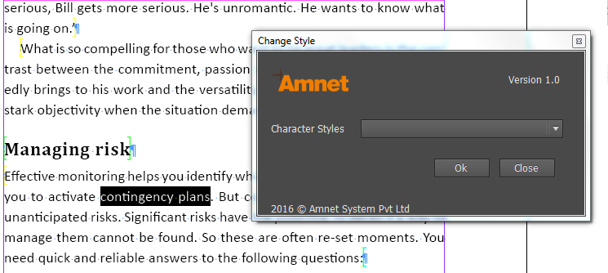

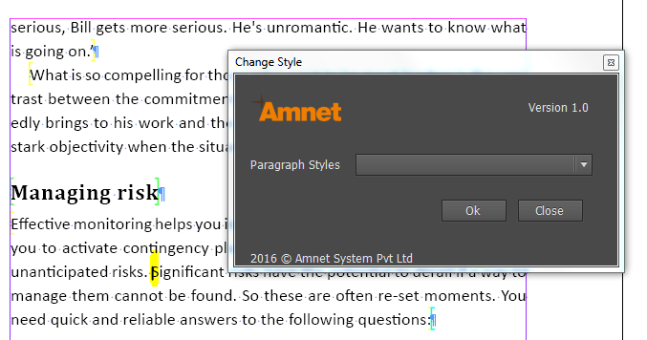

1. Single/Multiple paragraphs can be styled

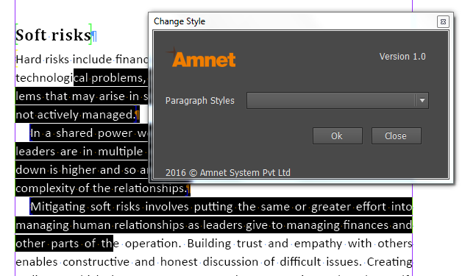

1. Tool will delete unwanted tags inside the selection.
2. Tool will detect type of style automatically and list styles accordingly, for example if selection type is text then character style will be listed, this will save time to find style name in the list, as the list will have only characters styles.
3. Auto correction of tagging if some tags are not placed properly, tool will detect those tag and correct it automatically.
4. User friendly UI, much easier to style.

Script location:

1. Please copy folder to system adobe script path
2. Default path will be “C:\Program Files\Adobe\Adobe InDesign CC 2015 (32-bit)\Scripts\Scripts Panel”
3. Run Style_Change.jsx

