1)O-1 Knapsack Problem  
  
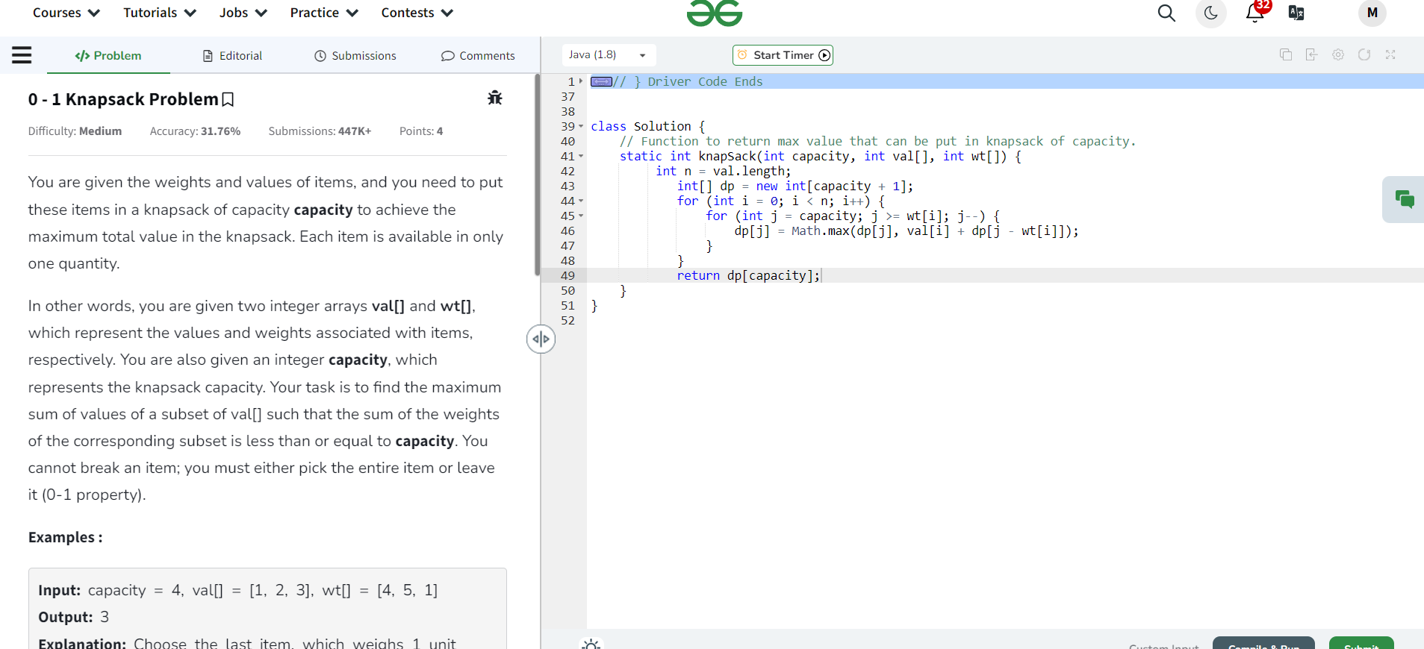

Time Complexity: o(n)

2) Palindrome Linked List  
  
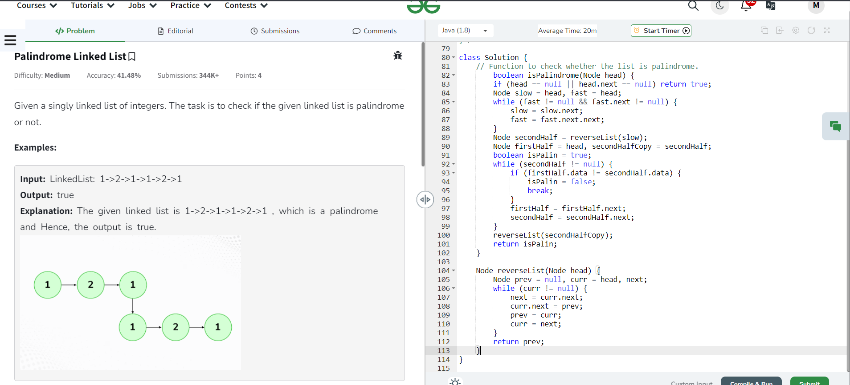

Time Complexity: O(n)

3) Floor in Sorted Array

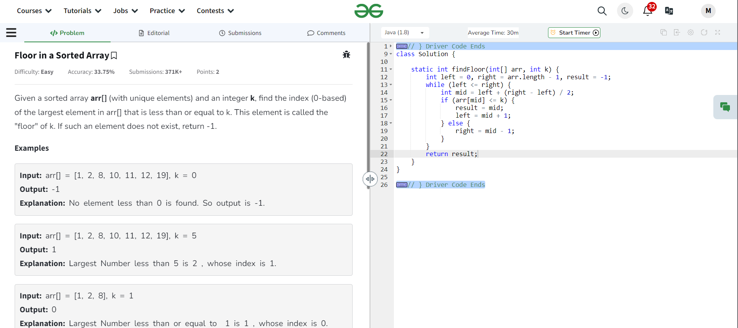

Time Complexity: O(logn)

4) Check two Arrays are equal  
  
  
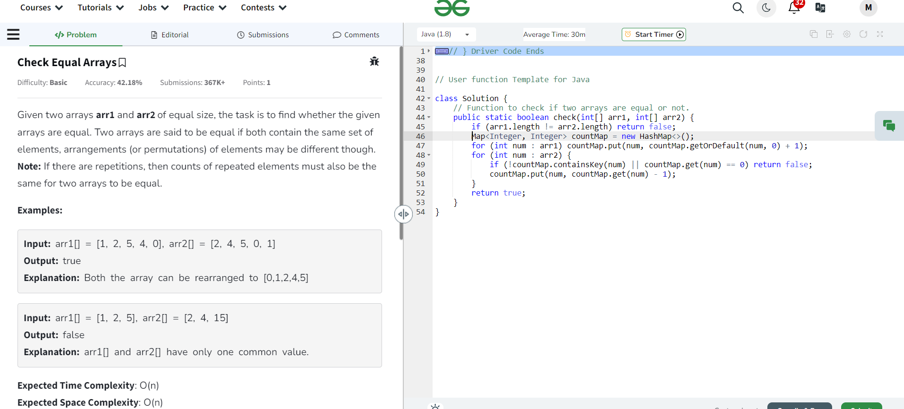

Time Complexity: O(n)

5) Balanced Tree Check

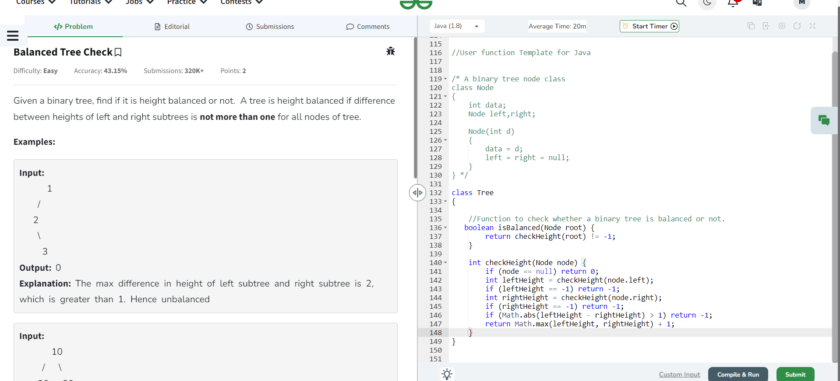  
  
Time Complexity: O(n)