1) Bubble Sort

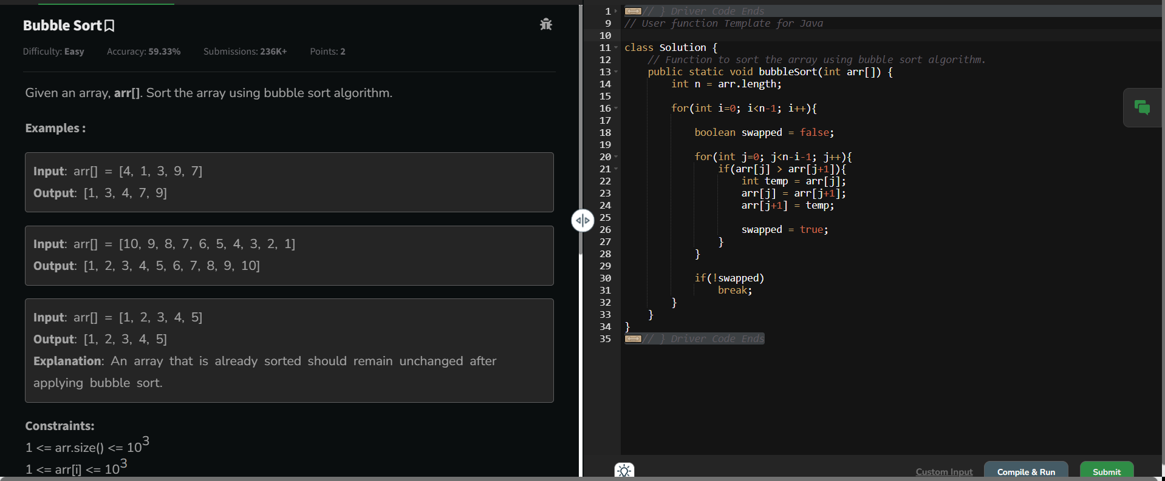

Time Complexity: O(n ^ 2)

2) Quick Sort

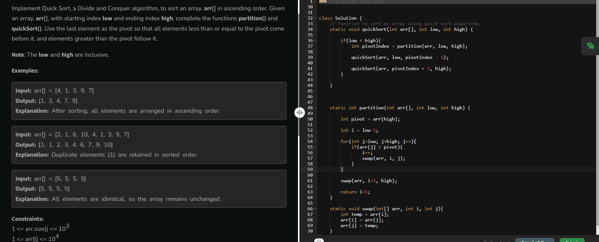

Time Complexity: O(n ^ 2)

3) Non Repeating Character

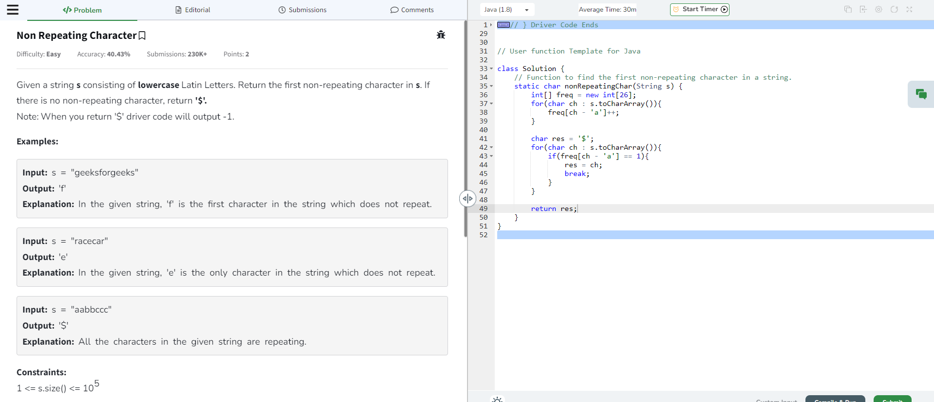

Time Complexity: O(n)

4) Edit Distance  
  
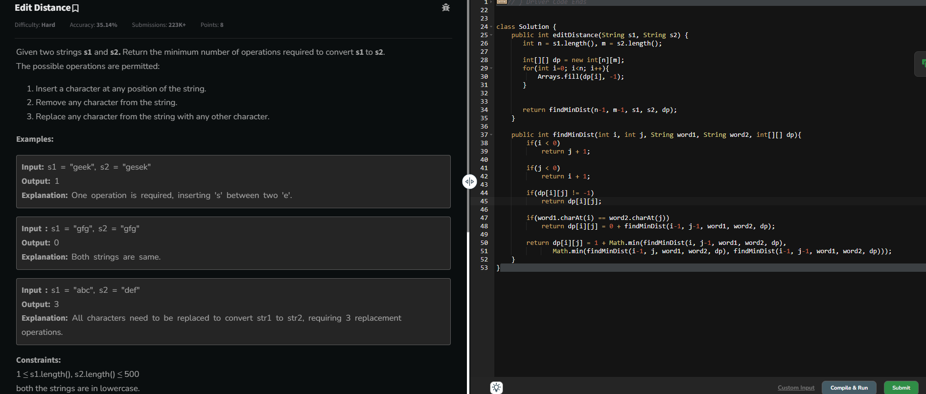

Time Complexity: O(n \* m)

5) K Largest Elements

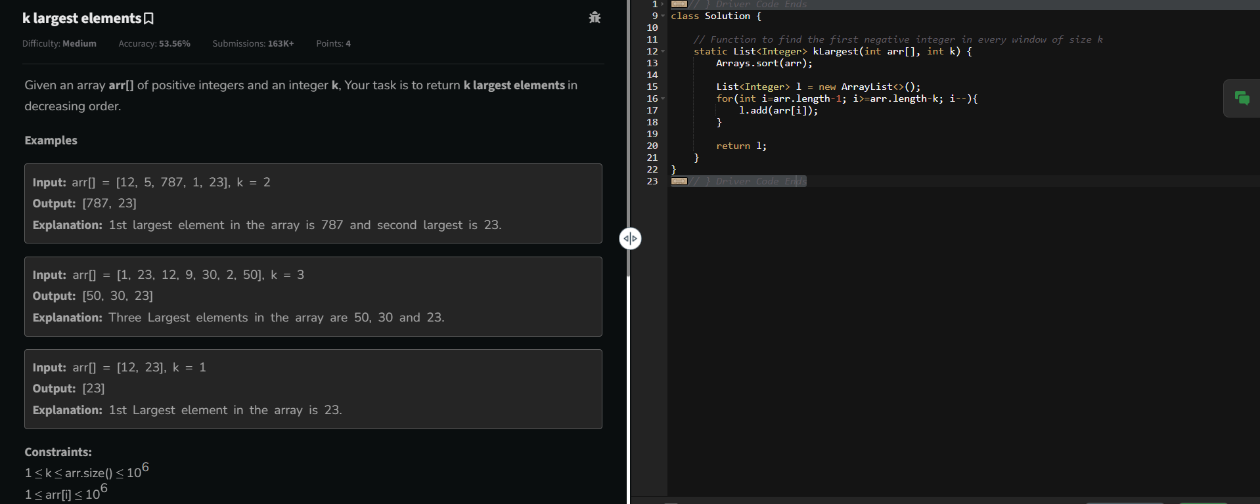

Time Complexity: O(log n)

6) Form the Largest Number

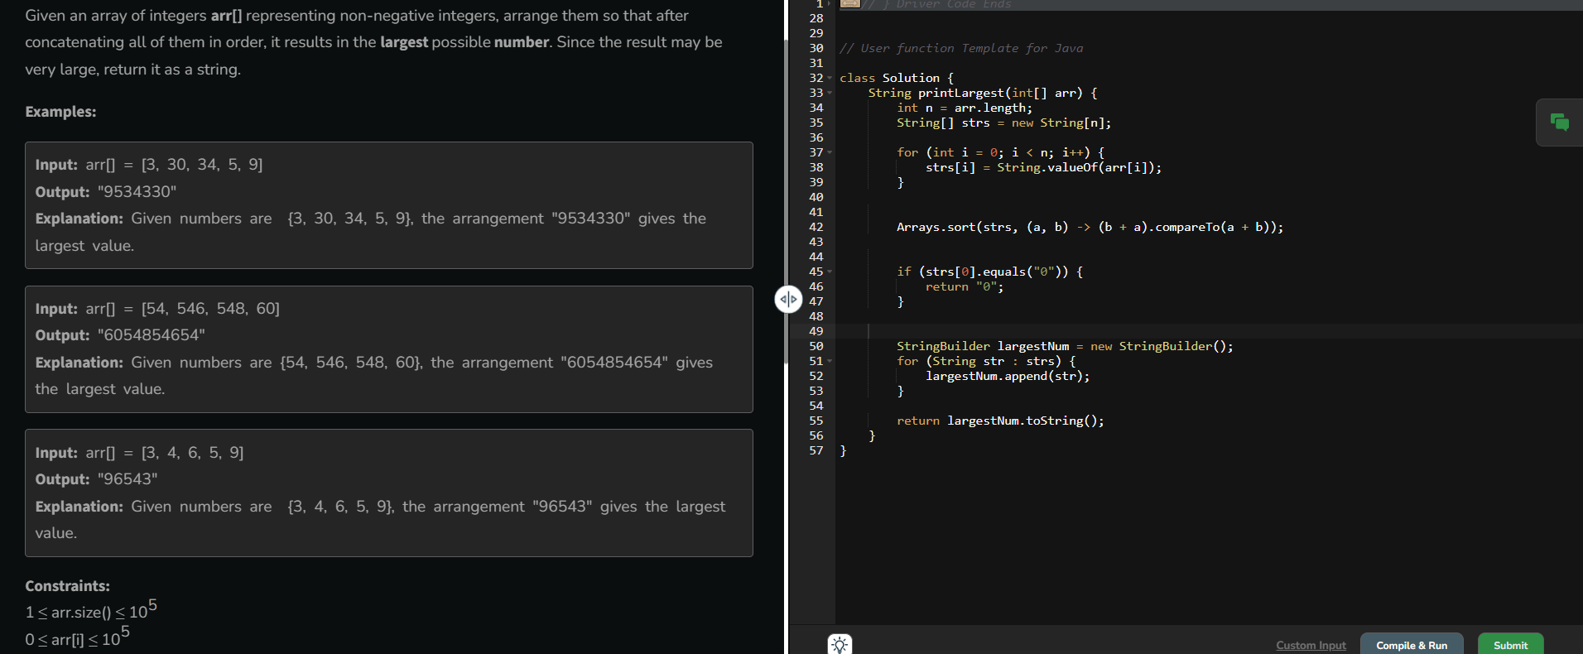

Time Complexity: O(log n)