Python- Django-apps Deployment
Process Handbook
Version 1.0



Prepared By

11-01-2024

CONFIDENTIAL

This document is being submitted on the understanding that the contents would not be divulged to any third party without prior written consent .

Change Log

Date | Name | Description
11-01-2024 | S.Bhuvana | Version 1.0

Contents

1. Introduction 5
2. Deployment Process Phases 6
3. FLOWCHART FOR Deployment Process Phases 7
4. Ip allocation and port allocation 8
5. Check app works on Django webserver 9
6. Create project under the inetpub/wwwroot 10
7. Configure Windows Defender Firewall 11
8. Configure IIS on VM 12
9. Configure SSL 19
10. Configure IIS To Access our Website Using An IP Address 20
Appendix A – SoN and Response to SoN Review Checklist 22

1. Introduction
This documentation provides a step-by-step guide to deploy a Django application using Internet Information Services (IIS) on a Windows server. Follow these instructions to ensure a smooth deployment process for your Django project.
Prerequisites
- Python installed on the server
- Internet Information Services (IIS) installed
- pip installed for managing Python packages
2. Deployment Process Phases
1. Set Up Virtual Environment
Create a virtual environment for your Django project and install required Python packages:
- python -m venv venv venv\Scripts\activate pip install -r requirements.txt
2. Configure Django Settings
Update the settings.py file with production configurations, such as ALLOWED_HOSTS and database settings.
- DEBUG = False
- ALLOWED_HOSTS = ['*']
3. Configure IIS
- Install the httpplatformhandler module
- www.iis.net/downloads/microsoft/httpplatformhandler downloadhttpplatformhandler
4. Configure Web.config
Create a web.config file in your Django project directory for IIS configuration. Define handlers, modules, and other settings.
5. Restart IIS
Restart IIS to apply changes:
- iisreset

Workflow for Deployment Process
(If applicable)
Ip allocation and port allocation
Ip allocation and port allocation
Check app works on Django webserver
Create project under the inetpub/wwwroot
Configure Windows Defender Firewall
Configure IIS on VM
Configure SSL
Configure IIS To Access our Website Using An IP Address
Whitelisting MNW IP’s to access the endpoint

Ip allocation and port allocation
- Allocate an IP address and port for your Django app
- Configure Network Security Group (NSG).
- Raise a request with the Head Office (HO) IT team for IP and port allocation.
.

Check App Works on Django Webserver
- Verify that the Django app functions correctly on the Django web server

Create Project Under the inetpub/wwwroot
Create a project directory under inetpub/wwwroot to host the Django app.
- Copy the project folder and paste it under wwwroot.It will be fine.
for Example ‪C:\inetpub\wwwroot\probe
- check application run successfully under this directory
- If not , Install all its dependencies mentioned in requirements.txt
- If requirements.txt is not available then while running this application it will show error .then fix those errors by installing e.g pip install django pip install setuptools ,.... like
Once it run successfully then break it by pressing ctrl+ break



Configure Windows Defender Firewall
- Open A Port In Windows Firewall
- Go to Start→ Administrative Tool→ Windows Firewall with Advanced Security.
- At the Windows Firewall window, click on Inbound Rules.
- Under the Actions pane, click on New Rule, and New Inbound Rule Wizard will be opened. On this window, select the Port radio button and click on Next.
- On the next screen, select TCP and Specific local ports radio button. Specify a port number (upon which you set the binding in IIS) in the Specific local ports field and click Next.
- On the next screen, select Allow the connection and click Next.
- Select the profile where you want to apply this rule and click Next.
- Specify the Name and Description for the newly created rule & click Finish.
- Once you allow the port number in Windows Firewall, you will be able to access your website via an IP address like http://VPS-IP Address:81

Configure IIS on VM using http platform
- add website in IIS manager under sites
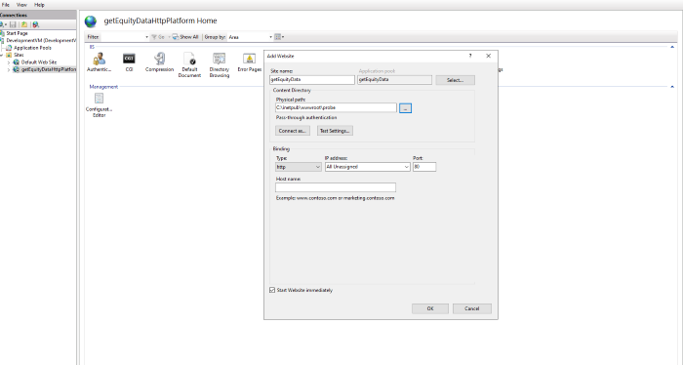
- https://www.iis.net/downloads/microsoft/httpplatformhandler download http plat form handler
- check for IIS Manager > Server Level > Feature Delegation > Handler Mappings > Read/Write

- Configure http Platform IIS Manager > Sites > getEquityDataHttpPlatform > Configuration Editor > system.webServer/httpPlatform
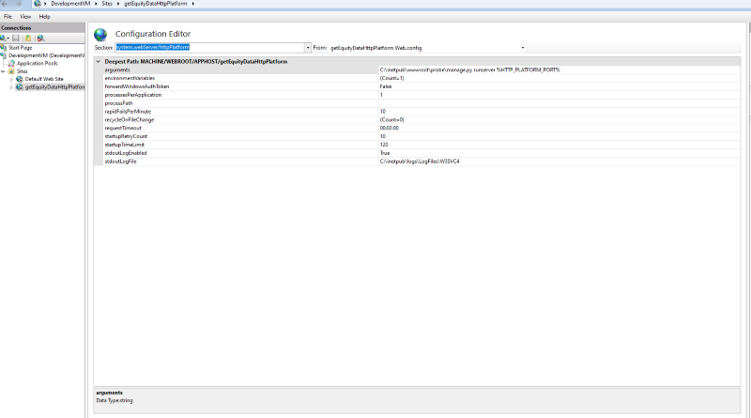

- In Environmental variables click on ... dots on the value side . clickon Add in that add key SERVER_PORT and value : %HTTP_PLATFORM_PORT% .processPath : C:\Python312\python.exe stdoutLogEnabled: True
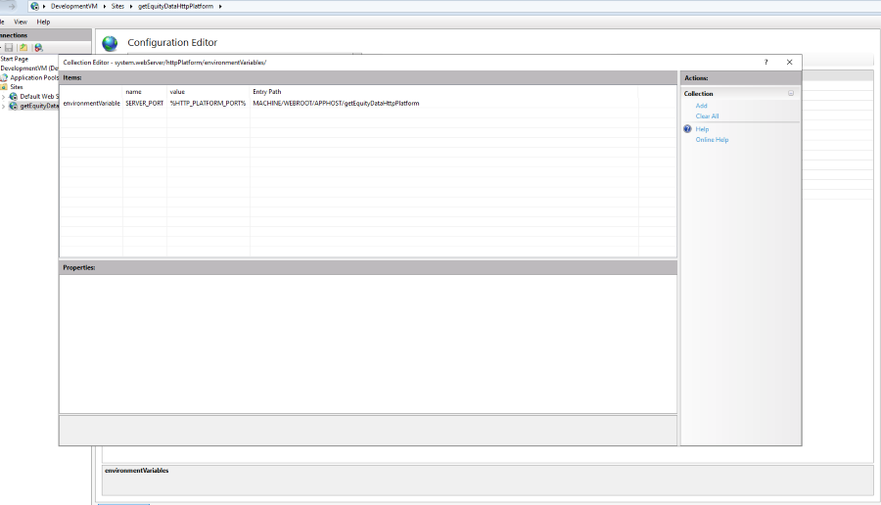

- IS manager > Sites > getEquityDataHttpPlatform > Configuration Editor > appSettings
- PYTHONPATH : C:\inetpub\wwwroot\probe
- WSGI_HANDLER: django.core.wsgi.get_wsgi_application()
- DJANGO_SETTINGS_MODULE : probe.settings ( we get this from wsgi file inside wsgi.py file)
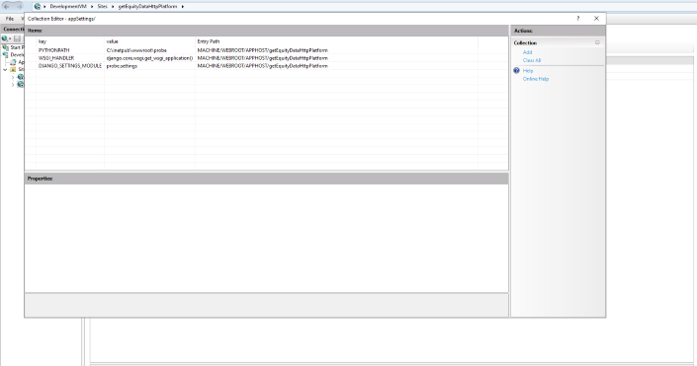

- IIS manager > Sites > getEquityDataHttpPlatform > Handler Mappings > Add Module Mapping
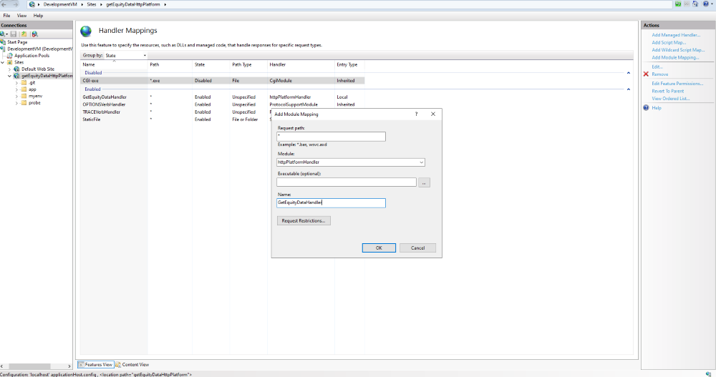

- Clickon Request Restrictions… uncheck the checkbox of Invoke Handler only if request is mapped to
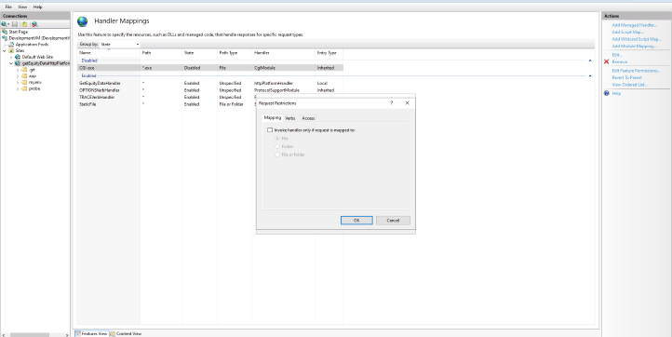

- check ‪C:\inetpub\wwwroot\probe\web file configuration
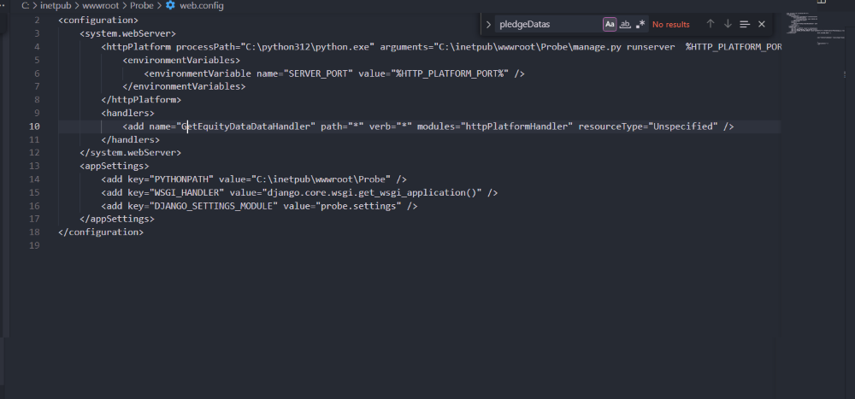

Configure SSL
- Coordinate with the HO IT Team to obtain and install SSL certificates for secure communication.
- Ip whitelisting has to be done.Add ip in the NSG Rule.
- Activate the domain name by HO IT Team.

Configure IIS to Access Website Using an IP Address
Adjust IIS settings to enable access to the Django website using the allocated IP address.
Add A Binding In IIS
- In the Connections pane of IIS, expand the Sites and select the website which you want to access via IP address.
- Click on the Bindings link, and you will see the current bindings of that website.Click on Add button to add a new binding.In the Add Site Binding window, select 'http' as the website type. Select an IP address from the drop-down list you want to bind. You won't bind the new website on port 80 without Host Header Value (Hostname), as other websites (along with their Host Header Values) are also bound on port 80.So,specify a port number (other than the default port 80) that you wish to bind to this new website. Keep Hostname as blank, click OK, and then Close. Once the binding is added in IIS Manager, the next step is allowing a port in Windows Firewall.
- Using https clickon SSL settings for corresponding site
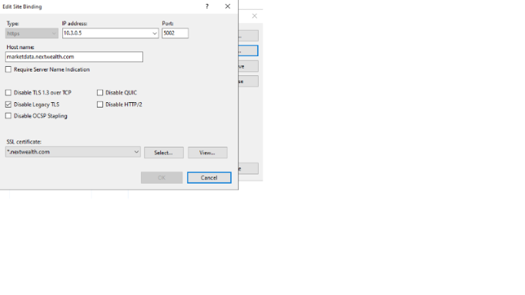
One can also Edit Bindings :
- In the Connections pane of IIS, expand the Sites and select the website which you want to access via IP address.
- Click on the Bindings link, and you will see the current bindings of that website.
- click on the already created bindings
- There change the ip address and port number as allocated in the defender firewall
- Only for https Use ssl setting to host via domain name if using http don’t configure ssl settings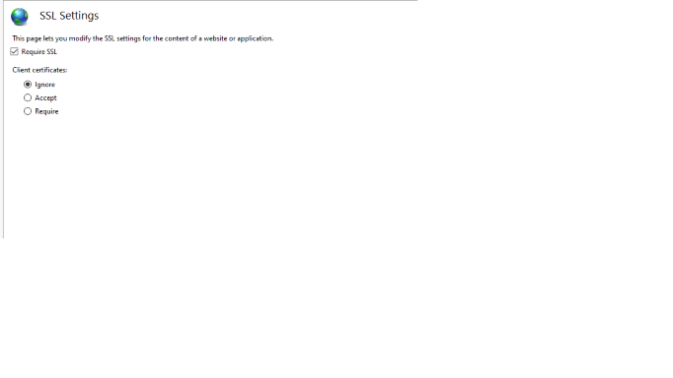Under Manage Websites
- Restart the service
Under Browse Websites
- Click on the link
Coordinate with both the HO Team and MNW Team to whitelist the respective endpoint for accessing

Appendix A – Deployment Checklist for Django Application using IIS

Deployment Reference
xCo Project manager’s / onsite coordinator’s name |  |  | YCO Project manager’s name
S.No | Checklist |  |  | Yes / No | Remarks
 | A. Common to SoN and SoN Response Review
 | Ensure that the Django application is fully developed and tested.
 | Confirm that all necessary dependencies are installed.
 | Configure the production database settings in Django
 | Update and review the Django settings for production.
 | Install the "httpplatformhandler" module for IIS.
 | Configure httpplatformhandler settings for the Django application.
 | Set up firewalls and security groups.
 | Domain or IP is correctly configured in the web server
 | Establish a backup strategy for both code and database.
 | Web application is accessible over HTTP .
 | SSL certificate is obtained for the domain.
 | Configure SSL certificates if the application requires HTTPS.
 | Is the period of validity explicitly mentioned in the SoN and SoN Response?
 | Is the scope of work for deploying Django with IIS clearly understood and documented?
 | Is it required to conduct a feasibility study for the deployment process?
 | Are the list of deliverables and the delivery mechanism for the deployment defined in detail?

Deployment Sign-off:
Reviewed By Name: Date:

Approved By Name: Date:

