Heaps

In this chapter, we introduce another sorting algorithm. Like merge sort, but unlike insertion sort, heapsort's running time is O(n lg n). Like insertion sort, but unlike merge sort heapsort sorts in place: only a constant number of array elements are stored outside the input array at any time. Thus, heapsort combines the better attributes of the two sorting algorithms we have already discussed.

Heapsort also introduces another algorithm design technique: the use of a data structure, in this case one we call a "heap," to manage information during the execution of the algorithm. Not only is the heap data structure useful for heapsort, but it also makes an efficient priority queue. The heap data structure will reappear in algorithms in later chapters.

We note that the term "heap" was originally coined in the context of heapsort, but it has since come to refer to "garbage-collected storage," such as the programming languages Lisp and Java provide. Our heap data structure is not garbage-collected storage, and whenever we refer to heaps in this book, we shall mean the structure defined in this chapter.

6.1 Heaps

The (binary) heap data structure is an array object that can be viewed as a nearly complete binary tree, as shown in Figure 6.1.

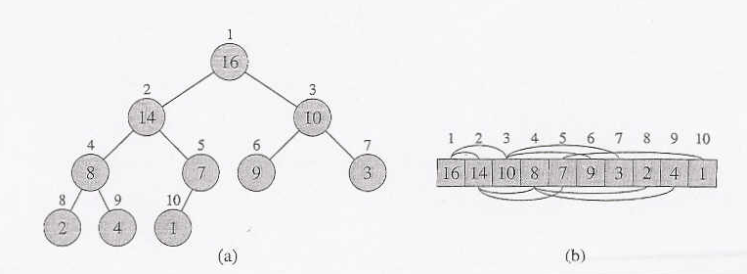
Figure 6.1 A heap viewed as (a) a binary tree and (b) an array. The number within the circle at each node in the tree is the value stored at that node. The number above a node is the corresponding index in the array. Above and below the array are lines showing parent-child .relationships; parents are always to the left of their children. The tree has height three; the node at index 4 (with value 8) has height one.

Each node of the tree corresponds to an element of the array that stores the value in the node. The tree is completely filled on all levels except possibly the lowest, which is filled from the left up to a point. An array A that represents a heap is an object with two attributes: length [A], which is the number of elements in the array, and heap-size[A], the number of elements in the heap stored within array A. That is, although A[1 ..length[A]] may contain valid numbers, no element past A [heap-size [A]], where heap-size[A] ≤ length[A], is an element of the heap.

The root of the tree is A[1], and given the index i of a node, the indices of its parent PARENT(i), left child LEFT(i), and right child RIGHT(i) can be computed simply:

PARENT(i)
return ⎣i /2⎦

LEFT (i)
return 2i

RIGHT (i)
return 2i + 1

On most computers, the LEFT procedure can compute 2i in one instruction by simply shifting the binary representation of i left one bit position. Similarly, the RIGHT procedure can quickly compute 2i + 1 by shifting the binary representation of i left one bit position and adding in a 1 as the low-order bit. The PARENT procedure can compute ⎣i /2⎦ by shifting i right one bit position. In a good implementation of heap sort, these three procedures are often implemented as "macros" or "in-line" procedures.

There are two kinds of binary heaps: max-heaps and min-heaps. In both kinds, the values in the nodes satisfy a heap property, the specifics of which depend on the kind of heap. In a max-heap, the max-heap property is that for every node i other than the root,

A[PARENT(i)] ≥ A[i]

that is, the value of a node is at most the value of its parent. Thus, the largest element in a max-heap is stored at the root, and the subtree rooted at a node contains values no larger than that contained at the node itself. A min-heap is organized in the opposite way; the min-heap property is that for every node i other than the root,

A[PARENT(i)] ≤ A[i]

The smallest element in a min-heap is at the root.

For the heapsort algorithm, we use max-heaps. Min-heaps are commonly used in priority queues. We shall be precise in specifying whether we need a max-heap, or a min-heap for any particular application. In the remaining of this chapter we will refer only to max-heaps and we will simply call them "heaps".

Viewing a heap as a tree, we define the height of a node in a heap to be the number of edges on the longest simple downward path from the node to a leaf, and we define the height of the heap to be the height of its root. Since a heap of n elements is based on a complete binary tree, its height is ϑ(lgn). We shall see that the basic operations on heaps run in time at most proportional to the height of the tree and thus take 0(lg n) time. The remainder of this chapter presents some basic procedures and shows how they are used in a sorting algorithm and apriority-queue data structure.

The HEAPIFY procedure, which runs in 0(lg n) time, is the key to maintaining the heap property.

The BUILD-HEAP procedure, which runs in linear time produces a heap from an unordered input array.

The HEAPSORT procedure, which runs in O(n lg n) time; sorts an array in place.

The HEAP-INSERT, HEAP-EXTRACT-MAX, HEAP INCREASE-KEY, and HEAP-MAXIMUM procedures, which run in 0(lgn) time, allow the heap data structure to be used as a priority queue.

Exercises

6.1-1
What are the minimum and maximum numbers of elements in a heap of height h?

6.1-2
Show that an n-element heap has height ⎣lg n⎦.

6.1-3
Show that in any sub-tree of a max-heap, the root of the sub tree contains the largest value occurring anywhere in that sub-tree.

6.1-4
Where in a max-heap might the smallest element reside assuming that all elements are distinct?

6.1-5
Is an array that is in sorted order a min-heap?

6.1-6
Is the sequence (23, 17, 14, 6, 13, 10, 1,5,7, 12) a max-heap?

6.1-7
Show that, with the array representation for storing an n-element heap, the leaves are the nodes indexed by ⎣n/2⎦ + 1, ⎣n/2⎦ + 2,. . . , n.

6.2 Maintaining the heap property

HEAPIFY is a most important subroutine for manipulating heaps. Its inputs are an array A and an index i into the array. When HEAPIFY is called, it is assumed that the binary trees rooted at LEFT(i) and RIGHT(i) are heaps, but that A[i] may be smaller than its children, thus violating the heap property. The function of HEAPIFY is to let the value at A[i] "float down" in the heap so that the subtree rooted at index i becomes a heap.

HEAPIFY(A, i)
1. l ← LEFT(i)
2. r ← RIGHT(i)
3. if l ≤ heap-size[A] and A[l] > A[i]
4. then largest ← l
5. else largest ← i
6. if r≤ heap-size[A] and A[r] > A[largest]
7. then largest ← r
8. if largest ≠ i
9. then exchange A[i] ↔ A[largest]
10. HEAPIFY(A, largest)
Figure 6.2 illustrates the action of HEAPIFY. At each step, the largest of the elements A[i], A[LEFT(i)], and A[RIGHT(i)] is determined, and its index is stored in largest. If A[i] is largest, then the subtree rooted at node i is a heap and the procedure terminates. Otherwise, one of the two children has the largest element, and A[i] is swapped with A[largest], which causes node i and its children to satisfy the heap property. The node indexed by largest, however, now has the original value A[i], and thus the subtree rooted at largest may violate the heap property. Consequently, HEAPIFY must be called recursively on that subtree.
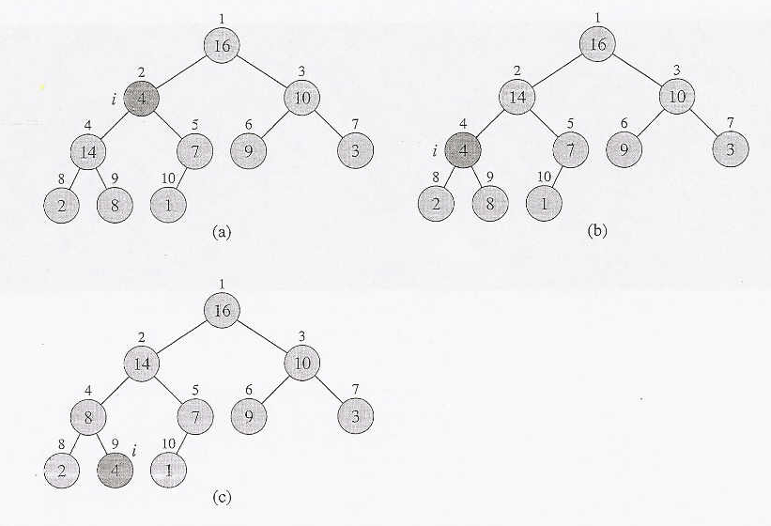
Figure 6.2 The action of HEAPIFY(A, 2), where heap-size[A] = 10. {a) The initial con- figuration, with A[2] at node i = 2 violating the heap property since it is not larger than both children. The heap property is restored for node 2 in (b) by exchanging A[2] with A[4], which destroys the heap property for node 4. The recursive call HEAPIFY(A, 4) now has i = 4. After swapping A[4] with A[9], as shown in (c), node 4 is fixed up, and the recursive call HEAPIFY(A,9) yields no further change to the data structure.

The running time of HEAPIFY on a subtree of size n rooted at given node i is the ϑ(l) time to fix up the relationships among the elements A[i], A[LEFT(i)], and A[RIGHT(i)], plus the time to run HEAPIFY on a subtree rooted at one of the children of node i. The children's subtrees each have size at most 2n/3, the worst case occurs when the last row of the tree is exactly half full, and the running time of HEAPIFY can therefore be described by the recurrence

T(n) ≤ T(2n/3) + ϑ(1)

The solution to this recurrence, by case 2 of the master theorem, is T (n) = O(lg n). Alternatively, we can characterize the running time of HEAPIFY on a node of height h as O(h).

Exercises

6.2-1
Using Figure 6.2 as a model, illustrate the operation of HEAPIFY(A, 3) on the array A = (27, 17, 3, 16, 13, 10, 1, 5, 7, 12, 4, 8, 9, 0).

6.2-2
Starting with the procedure MAX - HEAPIFY, write pseudo-code for the procedure MIN-HEAPIFY(A, i), which performs the corresponding manipulation on a min- heap. How does the running time of MIN - HEAPIFY compare to that of MAX- HEAPIFY?

6.2-3
What is the effect of calling MAX-HEAPIFY(A, i) when the element A[i] is larger than its children?

6.2-4
What is the effect of calling MAX-HEAPIFY(A, i) for i > heap-size[A]/2?

6.2-5
The code for MAX - HEAPIFY is quite efficient in terms of constant factors, except possibly for the recursive call in line 10, which might cause some compilers to produce inefficient code. Write an efficient MAX-HEAPIFY that uses an iterative control construct (a loop) instead of recursion.

6.2-6
Show that the worst-case running time of MAX-HEAPIFY on a heap of size n is Ω(lg n). (Hint: For a heap with n nodes, give node values that cause MAX- HEAPIFY to be called recursively at every node on a path from the root down to a leaf.)

6.3 Building a heap

We can use the procedure HEAPIFY in a bottom-up manner to convert an array A[1. .n], where n = length [A], into a heap. Now, it can be proven that the elements in the sub array A [(⎣n/2⎦ + 1) . . n] are all leaves of the tree, and so each is a l-element heap to begin with. The procedure BUILD-HEAP goes through the remaining nodes of the tree and runs HEAPIFY on each one.
BUILD-HEAP (A)
1. heap-size[A] ← length[A]
2. for i ← ⎣length[A]/2⎦ downto 1
3. do HEAPIFY(A, i)

Figure 6.3 shows an example of the action of BUILD-HEAP. To show why BUILD- HEAP works correctly, we use the following loop invariant:

At the start of each Iteration of the for loop of lines 2-3, each node i +1, i + 2, .. ., n is the root of a heap.

We need to show that this invariant is true prior to the first loop iteration, that each iteration of the loop maintains the invariant, and that the invariant provides a useful property to show correctness when the loop terminates.

Initialization: Prior to the first iteration of the loop, i = ⎣n /2⎦. Each node ⎣n /2⎦ + 1, ⎣n /2⎦ + 2, , n is a leaf and is thus the root of a trivial heap.

Maintenance: To see that each iteration maintains the loop invariant, observe that the children of node i are numbered higher than i. By the loop invariant, therefore, they are both roots of heaps. This is precisely the condition required for the call HEAPIFY(A, i) to make node i a heap root. Moreover, the HEAPIFY call preserves the property that nodes i + .1, i + 2, . . ., n are all roots of heaps. Decrementing i in the for loop update reestablishes the loop invariant for the next iteration.

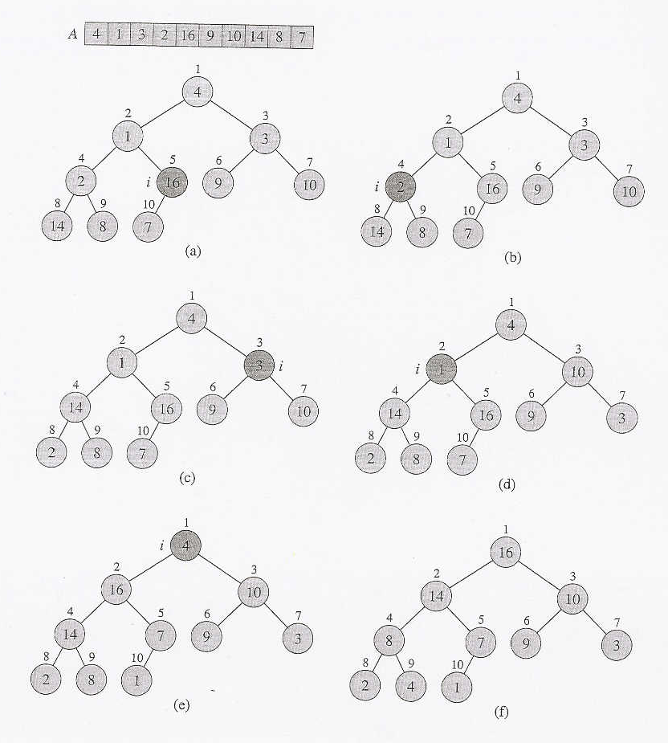
Figure 6.3 The operation of BUILD-HEAP, showing the data structure before the call to HEAPIFY in line 3 of BUILD-HEAP. (a) A l0-element input array A and the binary tree it represents. The figure shows that the loop index i refers to node 5 before the call HEAPIFY(A, i). (b) The data structure that results. The loop index i for the next iteration refers to node 4. (c)-(e) Subsequent iterations of the for loop in BUILD-HEAP. Observe that whenever HEAPIFY is called on a node, the two sub-trees of that node are both heaps. (f) The heap after BUILD-HEAP finishes.
Termination: At termination, i = 0. By the loop invariant, each node 1, 2, , n is the root of a heap. In particular, node 1 is.

We can compute a simple upper bound on the running time of BUILD-HEAP as follows. Each call to HEAPIFY costs 0(lg n) time, and there are O(n) such calls. Thus, the running time is O(n lg n). This upper bound, though correct, is not asymptotically tight.

We can derive a tighter bound by observing that the time for HEAPIFY to run at a node varies with the height of the node in the tree, and the heights of most nodes are small.

Our tighter analysis relies on the properties that an n-element heap has height ⎣lg n⎦ and at most ⎣n /2^{h+1}⎦ nodes of any height h.

The time required by HEAPIFY when called on a node of height h is O(h) so we can express the total cost of BUILD-HEAP as being bounded from above by
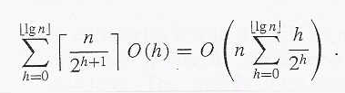
The last summation can be evaluated by substituting x = 1/2 in the formula (A.8), which yields
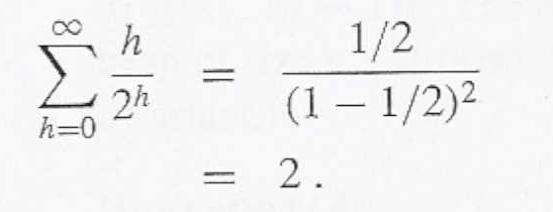

Thus, the running time of BUILD-HEAP can be bounded as

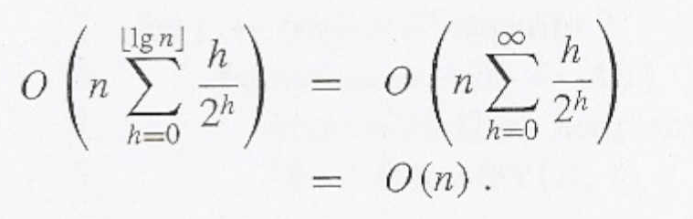

Hence, we can build a max-heap from an unordered array in linear time.

We can build a min-heap by the procedure BUILD-MIN-HEAP, which is ,the same as BUILD-MAX-HEAP but with the call to MAX-HEAPIFY in line 3 replaced by a call to MIN-HEAPIFY (see Exercise 6.2-2). BUILD-MIN-HEAP produces a mill-heap from an unordered linear array in linear time.

Exercises

6.3-1
Using Figure 6.3 as a model, illustrate the operation of BUILD-MAX-HEAP on the array A =(5, 3, 17, 10, 84, 19, 6, 22, 9).

6.3-2
Why do we want the loop index i in line 2 of BUILD-MAX-HEAP to decrease from ⎣length[A]/2⎦ to 1 rather than increase from 1 to ⎣length[A]/2⎦ ?

6.3-3
Show that there are at most ⎡n/2^{h+l} ⎤ nodes of height h in any n-element heap.

Problem:
Verify the property that "In an n-element heap there are at most ⎡n/2^{h+1}⎤ nodes of height h"

Proof by example: Assume a complete binary tree with n = 15. Measuring the height "h" of the tree from the bottom up we have that the 2³ = 8 leaves are at a height h = 0. The following row up consists of 2² = 4 nodes and these nodes are at a height h = 1. The next row up consists of 2¹ = 2 nodes and these nodes are at a height h = 2. Lastly, the root of this tree is at h = 3 and consists of 2⁰ = 1 node. Now, since n = 15 and measuring the height h from the bottom up, we verify the formula above for all of these cases as follows:

At height h = 3 we have at most ⎡15/2³⁺¹⎤ = ⎡15/16⎤ = ⎡0.9375⎤ = 1=2⁰ node.
At height h = 2 we have at most ⎡15/2²⁺¹⎤ = ⎡15/8⎤ = ⎡1.875⎤ = 2 = 2¹nodes.
At height h = 1 we have at most ⎡15/2¹⁺¹⎤ = ⎡15/4⎤ = ⎡3.75⎤ = 4 = 2² nodes.
At height h = 0 we have at most ⎡15/2⁰⁺¹⎤ = ⎡15/2⎤ = ⎡7.5⎤ = 8 = 2³ nodes.

and the property above is “demonstrated”.

Another important property can be derived from the fact that n = 2^{h+1}-1 and thus n+1 = 2^{h+1}, that is: lg(n+1) = h+1. From this we conclude that: h ≤ lg n < h+1, that is: the time required by a procedure such as HEAPIFY when called on a node at height h is O(h) = O(lg n).

6.4 The heapsort algorithm

The heapsort algorithm starts by using BUILD-HEAP to build a heap on the input array A[1 . . n], where n = length[A].

Since the maximum element of the array is stored at the root A[l], it can be put into its correct final position by exchanging it with A[n].

If we now "discard" node from the heap (by decrementing heap-size[A]), we observe that A[1 .. (n-1)] can easily be made into a heap. The children of the root remain heaps, but the new root element may violate the heap property. All that is needed to restore the heap property, however, is one call to HEAPIFY(A, 1), which leaves a heap in A[1 .. (n - 1)]. The heapsort algorithm then repeats this process for the heap of size n-1 down to a heap of size 2.

HEAPSORT(A)
1 BUILD-HEAP(A)
2 for i ← length[A] downto 2
3 do exchange A[l] ↔ A[i]
4 heap-size[A] ← heap-size[A] -1
5 HEAPIFY(A, l)

Figure 6.4 shows an example of the operation of heapsort after the heap is initially built. Each heap is shown at the beginning of an iteration of the for loop of lines 2-5.

The HEAPSORT procedure takes time O(n lg n), since the call to BUILD-HEAP takes time O(n) and each of the n - 1 calls to HEAPIFY takes time 0(lg n).

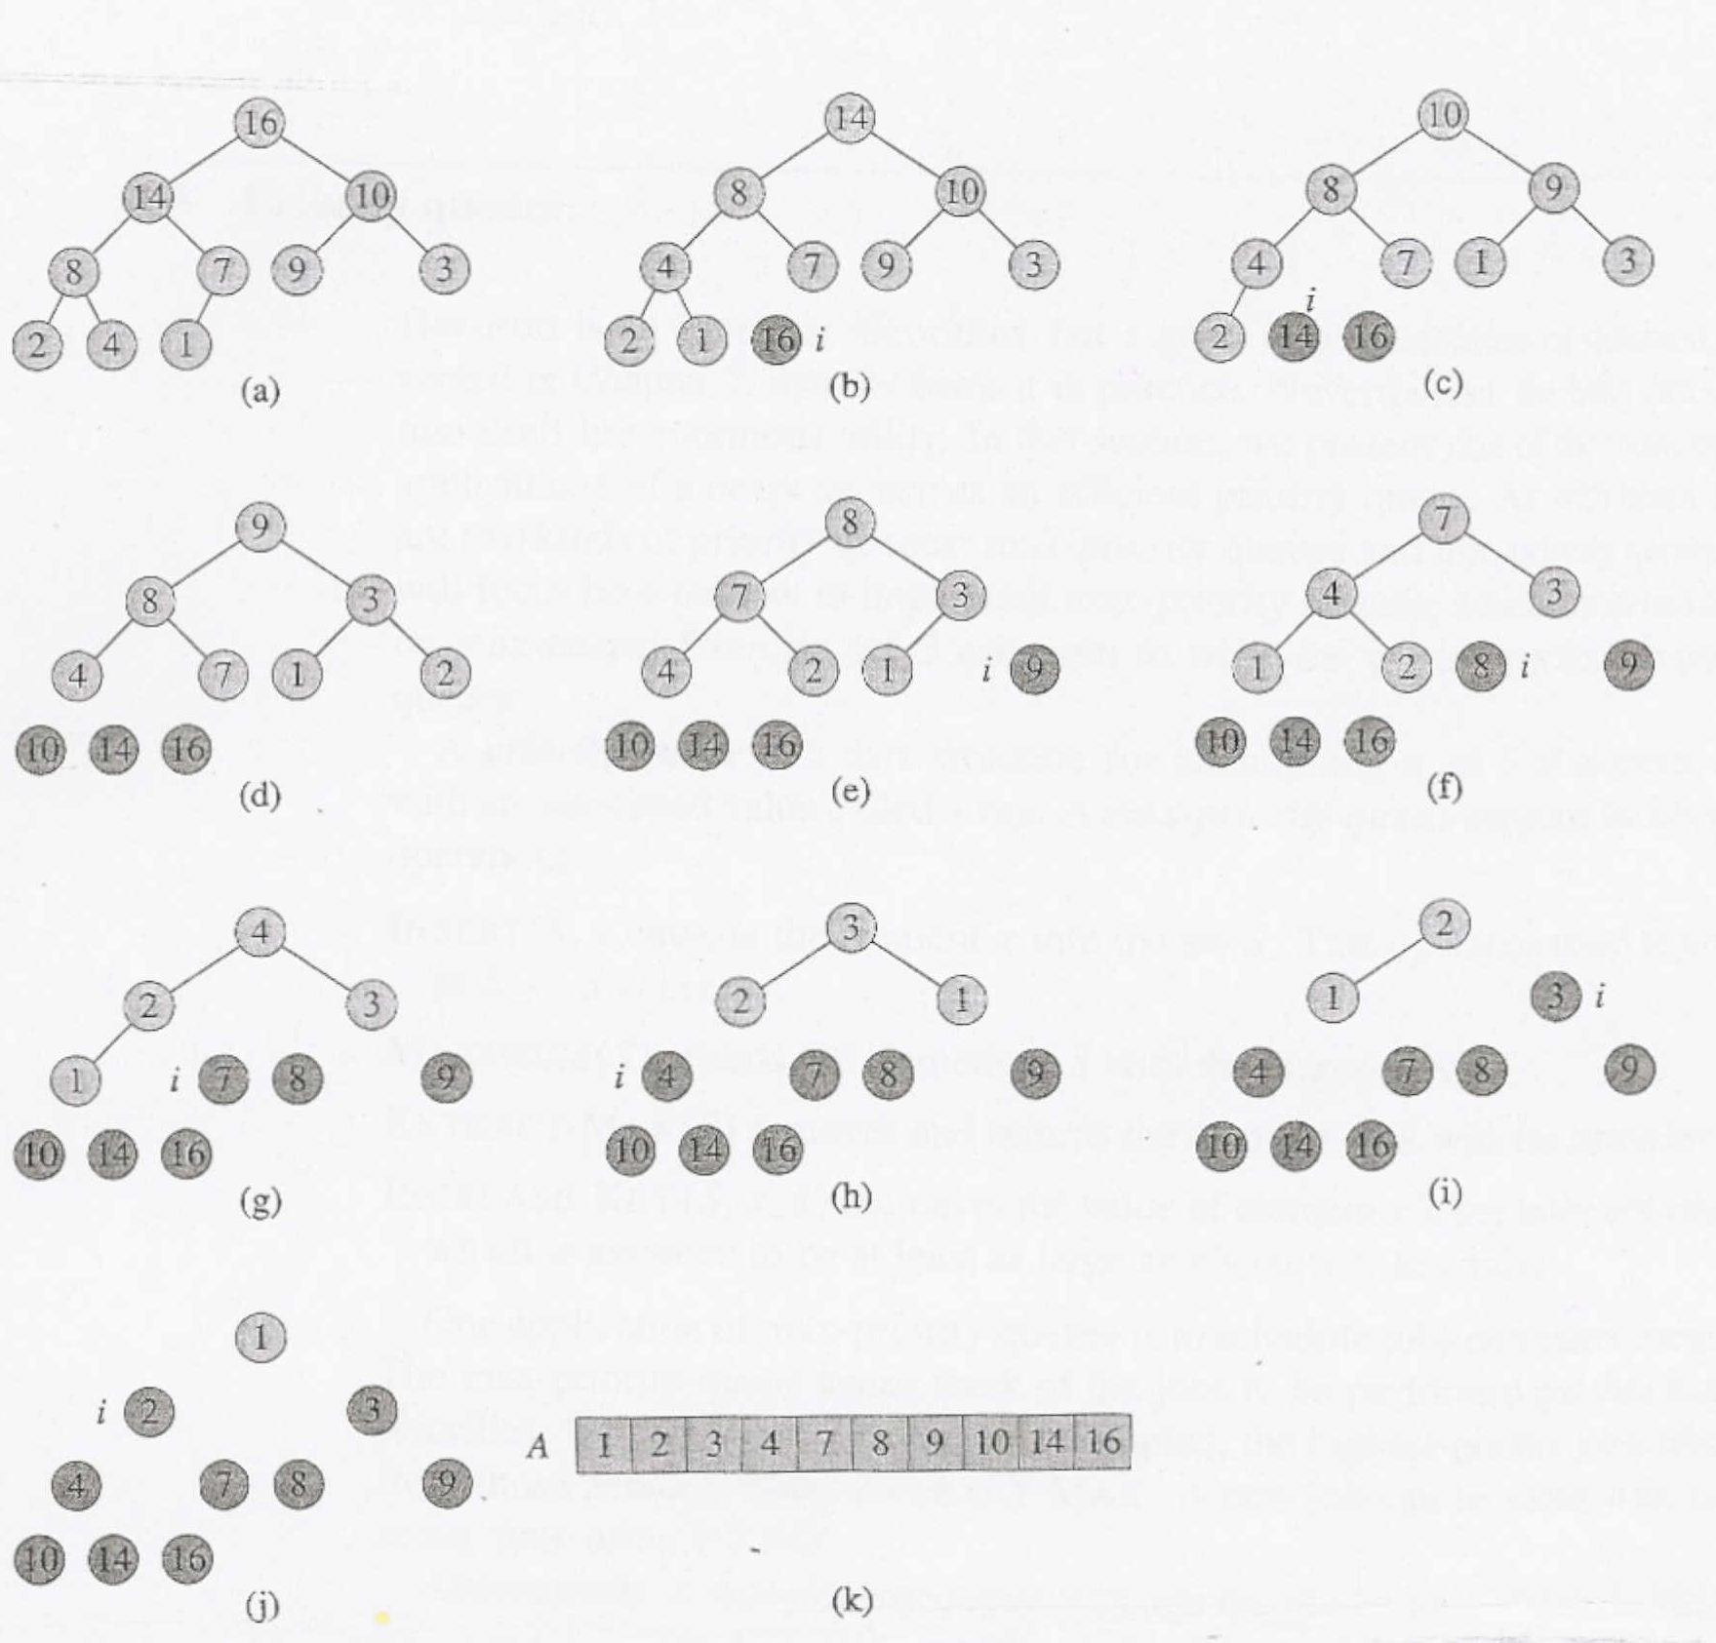
Figure 6.4 The operation of HEAPSORT. (a) The heap data structure just after it has been built by BUILD-HEAP. (b)-(j) The heap just after each call of HEAPIFY in line 5. The value of i at that time is shown. Only lightly shaded nodes remain in the heap. (k) The resulting sorted array A.

Exercises

6.4-1
Using Figure 6.4 as a model, illustrate the operation of HEAPSORT on the array A = (5, 13, 2, 25, 7, 17, 20, 8, 4).

6.4-2
Argue the correctness of HEAP SORT using the following loop invariant:
At the start of each iteration of the for loop of lines 2-5, the sub-array A[l..i] is a max-heap containing the i smallest elements of A[l . .n], and the sub-array A[i+ 1. .. n] contains the n - i largest elements of A[l . . n], sorted.

6.4-3
What is the running time of heapsort on an array A of length n that is already sorted in increasing order? What about decreasing order?

6.4-4
Show that the worst-case running time of heapsort is Ω(n lg n).

6.4-5 *
Show that when al the elements are distinct, the best-case running time of heapsort is Ω(n lg n).

