cs312: INTRODUCTION

1.1 WHAT IS AN ALGORITHM?

The word algorithm comes from the name of a Persian author, Abu Ja'far Mohammed ibn Musa al Khowarizmi (c. 825 A.D.) who wrote a textbook on mathematics.

An examination of the latest edition of Webster's dictionary defines its meaning as "any special method of solving a certain kind of problem."

But this word has taken on a special significance in computer science, where algorithm has come to refer to a precise method useable by a computer for the solution of a problem. This is what makes the notion of an algorithm different from words such as process, technique or method.

Typical algorithms we will include in this class relate to sorting and searching.

To sort means to arrange or classify according to certain set of rules. Example: "sort your homework grades in ascending order".

To search means to seek, to look over carefully in order to find something, to explore, to examine, to probe.

Definition:
An Algorithm is a finite set of instructions which, if followed, accomplish a particular task. Every algorithm MUST satisfy the following criteria:

(1) input: there are one (zero) or more quantities which are externally supplied
(2) output: at least one quantity is produced
(3) definiteness: each instruction must be clear and unambiguous
(4) finiteness: for all cases an algorithm MUST terminate after a finite number of steps.
(5) effectiveness: each instruction must be feasible, that is, it must be sufficiently basic that it can be carried out using only paper and pen.

In formal Computer Science one distinguishes between an algorithm and a program. A program does not necessarily terminate, that is, does not necessarily satisfy condition (4).

One important example of such a program for a computer is its operating system which never terminates (except for system crashes) but continues in a wait loop until more jobs are entered.

An algorithm is composed of a finite set of steps, each of which may require one or more operations.

The study of algorithms includes many important and active areas of research. There are perhaps 5 distinct areas of study one can identify:

- Algorithm Design
- Algorithm Analysis
- Algorithm Expression
- Algorithm Validation
- Algorithm (program)Testing

Our emphasis will be on the first two areas of study. For the third area we will limit ourselves to the use of pseudocode.

What separates pseudocode from real code is that in pseudocode we employ whatever expressive method is most clear and concise to specify a given algorithm.

Trying to specify the essence of an algorithm sometimes the clearest method is just plain English.

Lastly, pseudocode is not concerned with issues related to programming languages such as modularity, error handling, data abstraction, issues with syntax, etc.

Analyzing even a simple algorithm can be a challenge. The mathematical tools required may include discrete combinatorics, elementary probability theory, algebraic dexterity, and the ability to identify the most significant terms in a formula.

Because the behavior of an algorithm may be different for each possible input, we need a means for summarizing that behavior in simple, easily understood formulas.

The time taken by a procedure depends on the input. For example, sorting a thousand numbers takes longer than sorting three numbers.

Moreover, a given sorting algorithm can take different amounts of time to sort two input sequences of the same size depending on how nearly sorted they already are.

In general, the time taken by an algorithm grows with the size of the input, so it is traditional to describe the running time of a program as a function of the size of its input.

To do so, we need to define the terms "running time" or “time complexity” and "size of input" or “space complexity” more carefully.

We shall indicate which input size measure is being used with each problem we study.

The running time of an algorithm on a particular input is the number of primitive operations or "steps" executed.

This is called time complexity of the algorithm. In this class we will most concerned about measuring algorithms time complexity or running time (“the time it takes”).

It is convenient to define the notion of step so that it is as machine-independent as possible.

We will adopt the following view:

A constant amount of time is required to execute each line of our pseudocode.

In the analysis of algorithm, we could look at both the best case and the worst case.

We shall usually concentrate on finding only the worst-case running time, that is, the longest running time for any input of size n.

In measuring the time complexity of an algorithm we shall make one more simplifying abstraction known as the rate of growth or order of growth, of the running time that really interests us.

We usually consider one algorithm to be more efficient than another if its worst-case running time has a lower order of growth. (This evaluation may be in error for small inputs, but for large inputs the best algorithm clearly is faster.)

Measuring the run time of an algorithm

Consider the following pseudo-code:

sum ← 0 // that is, put a zero in variable “sum”, zero out location identified by the
//name “sum”. That is, initially variable sum is zero.

for i ← 1 to n //define a “looping” or “repetitive” activity using a “for” loop and
//variable i such that i takes values from 1 until n.

do sum ← sum + i*i //start increasing variable “sum” with the square of
//variable “i”, that is, by “i*i”.
end //finish the program.

It must be clear that the only input required for this code to execute is “n”.

To any input of size “n” this algorithm will run in an associated time T(n). This T(n) is the time complexity of the algorithm or simply the time it takes this algorithm (program) to execute.

Let’s “measure/calculate” T(n):
- sum ← 0
- for i ← 1 to n
- do sum ← sum + i*i
- end

We start by doing step 1: sum ← 0, which the computer does in a constant time “C1”.

Next we get into the looping activity. To execute statements (2) and (3) the computer takes also a constant time C2 for (2) and C3 for (3). However this is done “n” times with a total time given by: n*(C2+C3)

Lastly statement (4) is executed once for a constant time C4.

Adding all of these terms we get:

T(n) = C1 + (C2 + C3)*n + C4 = K1 +K2*n

The constants K1 and K2 vary with the computer but the running time will always be a linear function of “n”

This is the general idea we will be working with… but we need some basic Algebra!
1.2 BASIC ARITHMETIC/ALGEBRAIC FOMULAE-

Sequences and Series - Basic definitions

Consider the set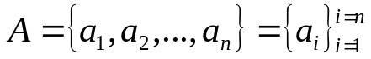. A sequ-ence is typically defined as a function from the set N = {1,2, ..., n} to a set A to generate the elements a_{i}'s of A.

A sequence can be finite (if n is a finite number) or otherwise infinite (an infinite number of elements).

Counting is defined as putting the elements of a set in correspondence with the set of natural numbers {1, 2, ...} so by definition since the set of natural number is infinite, an infinite set can be countable. Non-countable sets are called uncountable.

Assume that i is a natural number.

A sequence is called increasing if a_{i} < a_{i+1} for all i.
It is called non-decreasing if a_{i} ≤ a_{i+1} for all i.
It is called decreasing if a_{i} > a_{i+1} for all i.
It is called non-increasing if a_{i} ≥ a_{i+1} for all i.

Examples:

10, 12, 14, 27, 51. increasing (<).
10, 12, 12, 14, 27, 51. non-decreasing (≤).
27, 12, 6, 5, 2, -1 decreasing
27, 12, 12, 12, 6, 5, 3 non-increasing

Example:
the sequence 100 is by default increasing, non-increasing, decreasing, non-increasing and this is a totally uninteresting case.

Example:
the sequence given by a_{i} = 1/i for all i ≥ 1, is decreasing.

Assume that a, x, b are all real numbers. A number a is said to be an upper bound for a set X if x ≤ a for all x ∈ X. It is said a lower bound if x ≥ a for all x ∈ X.

A number a is said to be the least upper bound (lub) or supremum of X if a is a upper bound for X and it is the smallest upper bound, that is, if b is an upper bound then a ≤ b.

A number a is said to be the greatest lower bound (glb) or infimum of X if a is a lower bound for X and it is the largest lower bound, that is, if b is an lower bound then a ≥ b.

Examples:
1 is upper bound for the set X = {1 – 1/x | x > 0}. Notice that X in this case does not contain 1.

9 is the lub for the sequence 2, 4, 7, 8, 9.
2 would be its glb.

Series
A series is a summation of the terms of a sequence. There are finite series and infinite series.

The summation symbol used everywhere is the Greek capital letter s: Σ. Where
Σ a_{i} = a₁ + a₂ + a₃ + … + a_{n}.

The multiplication (product) symbol used is the Greek letter P: Π. Where
Π a_{i} = a₁ * a₂ * a₃ * … * a_{n}.

The most important series to be considered are the arithmetic and the geometric series.

We will prove some of these formulas.

1. Prove the following important Arithmetic Series:
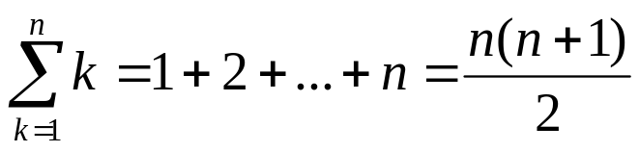
Proof (using only elementary techniques):
We write the finite sum increasingly starting from 1 until n and the we write the sum again decreasingly starting from n until 1.
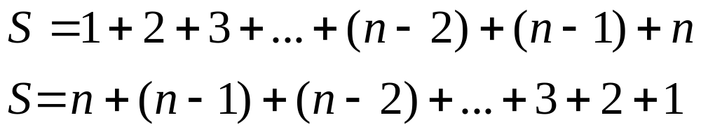
adding these two sums we get on the LHS “2S” and on the RHS n times the term (n+1), since we add 1+ n, then 2 + (n–1), next 3 + (n–2), and so on until we add n + 1, that is:

2S = n(n+1) ⇒ S = n(n+1)/2, which we write as shown above.

An important Geometric Series is: 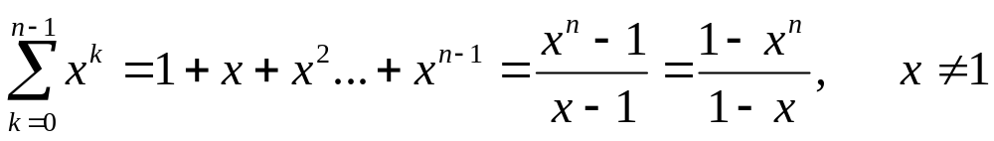

Another important Geometric Series is:

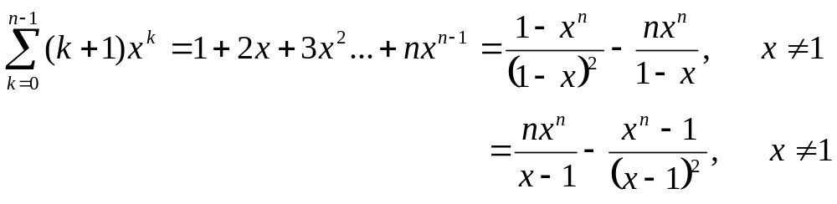
An important Infinite Series is: 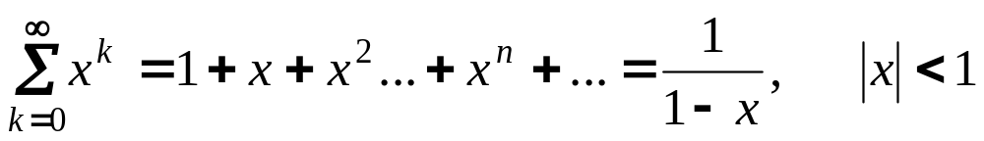

These are the two basic symbols that are required and should be well know in their properties and specific applications:

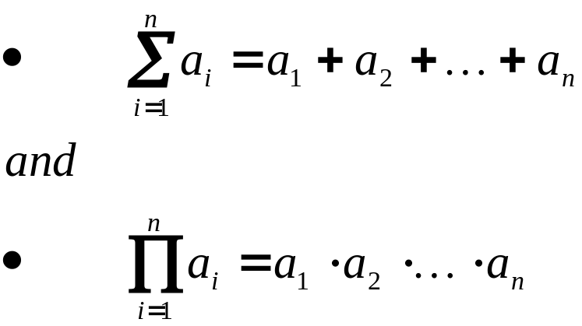

sometimes n, the upper limit of the "sum" (or the "product") symbol, is interpreted to mean "infinite" (∞) and in this case the sum (product) may not exist and we say that the series diverges, otherwise the series converges.

General Formulas we may use in addition to the previous formulas are given below.

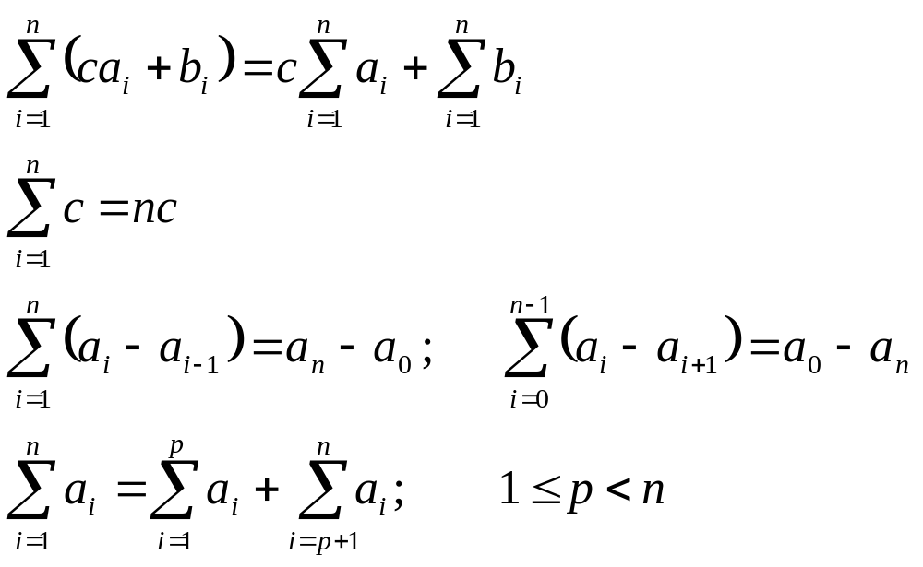

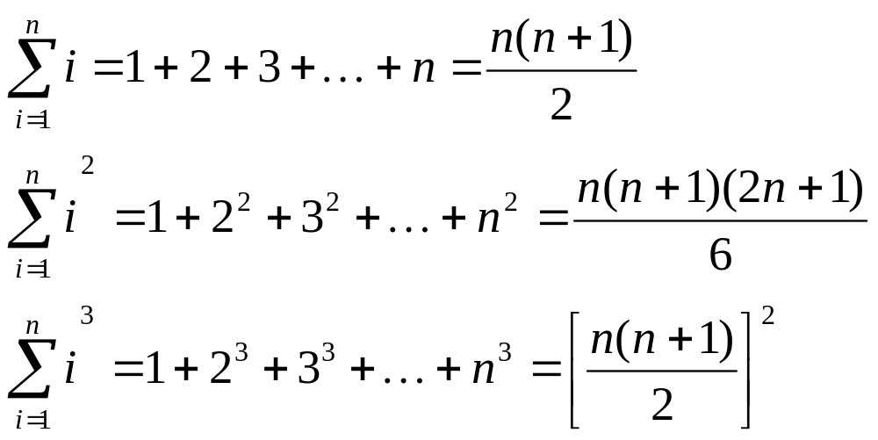

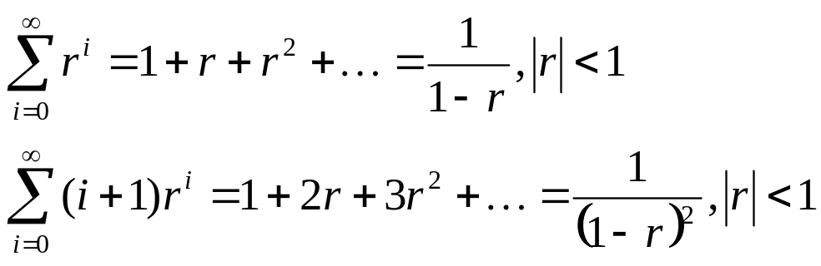

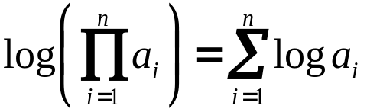

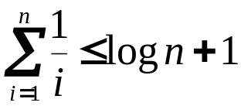 (this formula is known as the harmonic series)
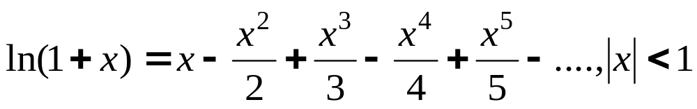

Logarithms

The definition of logarithms (logs) is given by the equation:

a^{x} = N, also written as: x = log_{a} N

which reads x equals logarithm base a of N.

Example:
find x = log₂ 32 ↔ 2^{x} = 32 = 2⁵ → x = 5.

The logs base 10 and base "e" (natural or neperian) are given in most calculators. We use Log or ln or Ln or log_{e} for the natural logarithms.

Logs base 2 are also very popular and they are indicated by using the symbol "lg" for them.

All logarithms are equivalent by means of the following very important transformation formula:

log_{b} N = log_{a} N/log_{a}b

Logs Notation:

lg N = log₂ N
ln N = log_{e} N
log N = log₁₀ N
lg^{k} N = (lg N)^{k}
lglg N = lg(lg N) ( that is lglg N ≠ (lg N)² )

Logs Theorems (most used ones have an *)

N = a^{loga N}
*log_{a} a = 1
*log_{a} 1 = 0
log_{a} (NM) = log_{a} N + log_{a} M
*log_{a} N^{m} = m log_{a} N
log_{a} (M/N) = log_{a} M - log_{a} N
*log_{b} N = log_{a} N/log_{a}b (Ex: lg 37 = log 37/log 2 = ln 37/ln 2)
(log_{b} a) (log_{a} b) = 1
log_{a} (1/M) = - log_{a} M
*N^{logaM} = M^{logaN} (Ex: 5^{lg n} = n^{lg 5} = n^{2.32})

The Binomial Theorem

Case 1: n is a natural number.
This is one of the most useful theorems. It will be used many times. Since n is a natural number the expansion consists of n+1 terms given by

where the C coefficients are the binomial coefficients given by the expression:

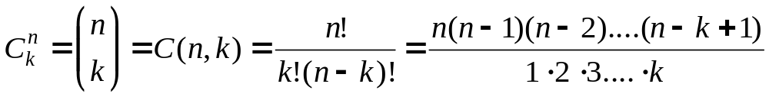

Using the formula given above, it is easy to prove the following properties:

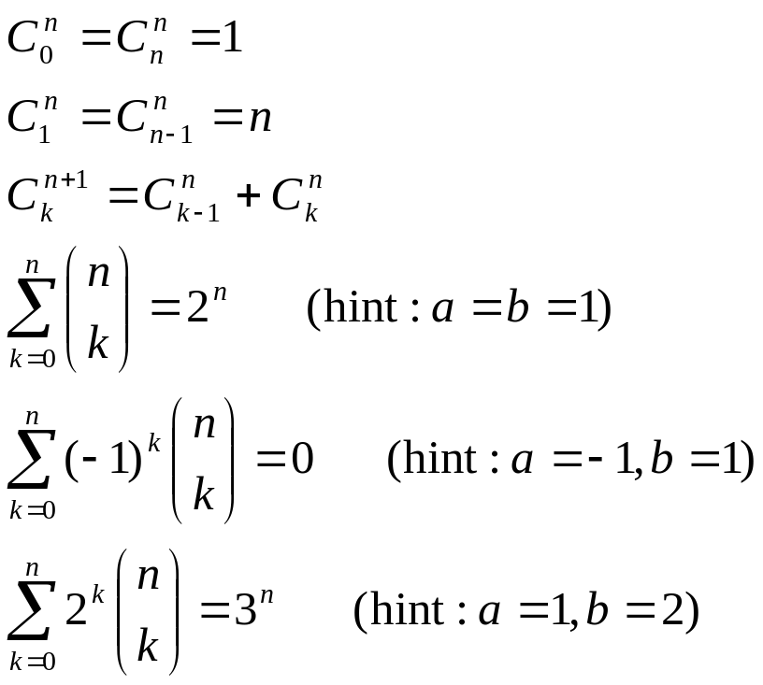
The most common type of problems include using the general formula for the (k+1)^{th} term:

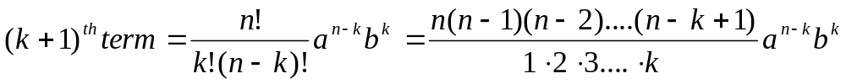

Notice that this is the (k+1)^{th} term and NOT the k^{th} term. The reason for this is that the count of terms begins with the 1st term when k = 0.

A couple of typical examples illustrate the most “difficult cases where these formulas are used.

Example:
Evaluate the 27th term in the expression of (2x² – 3/x²)¹⁰³.

Solution: In this case n = 103, k+1 = 27, a = 2x² and b = 3/x². Then use the formula for the (k+1)^{th} term with k = 26, that is, the 27th term is given by:

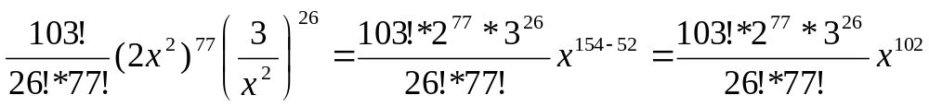

Example:
Find the term without “x” in the expression of (2x² – 3/x²)¹²⁸.

Solution: In this case n = 128, a = 2x², b = 3/x² and the (k+1)^{th} term is given by:
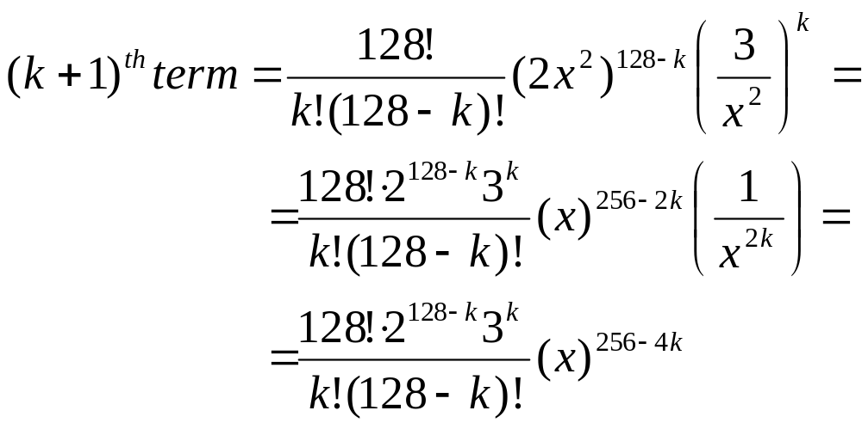

we have that the exponent of x is given by: 2(128-k) – 2(k). To have a term without “x” this exponent must be “0”, that is: 2(128-k) – 2(k) =256 – 4k = 0 ⇒ k = 64.

Therefore the term without “x” is given by: 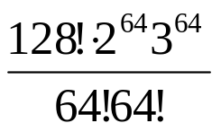

Case 2: n is not a natural number nor zero:

In this case the binomial expansion is infinite, that is:

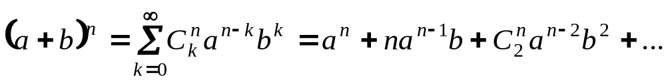

This is the most interesting case and we will see many application. However, first let's consider a most convenient expansion:
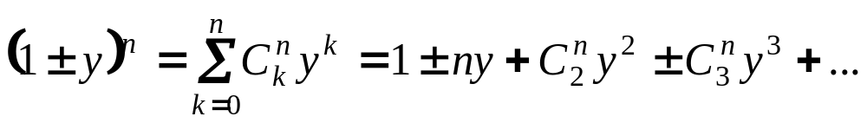

better expressed as follows:

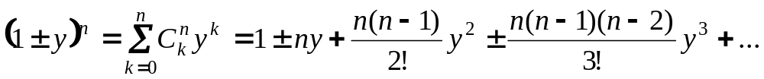

This expansion may be used in most cases provided that in general we factor the binomial as follows:
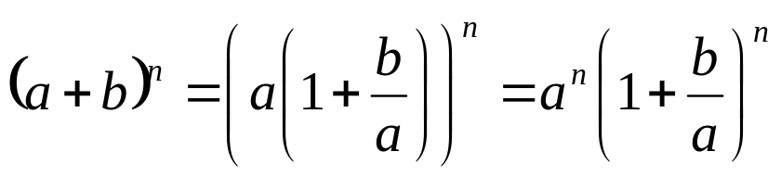

Calling y = b/a we can use the expansion above immediately.

Example using the expansion of (1+y)^{n}:

Expand (1 + x)^{1/2} using the binomial theorem. We know that:

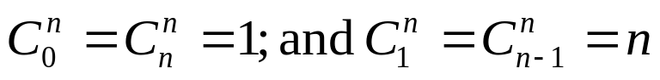

Answer

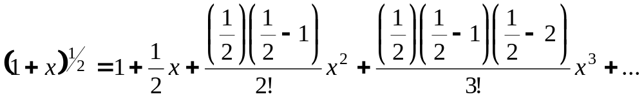

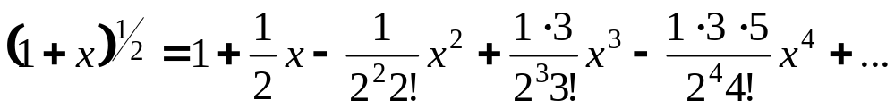

then we find the “general pattern” for the coefficients to find the “expected” answer:

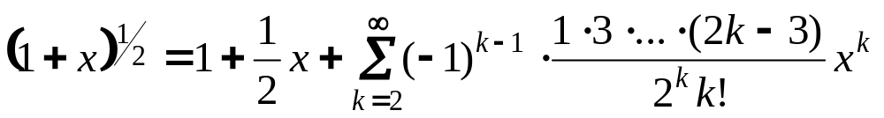.

Another example using the expansion of (1+y)^{n}:

Expand (1 + x)⁻³ using the binomial theorem.

Answer
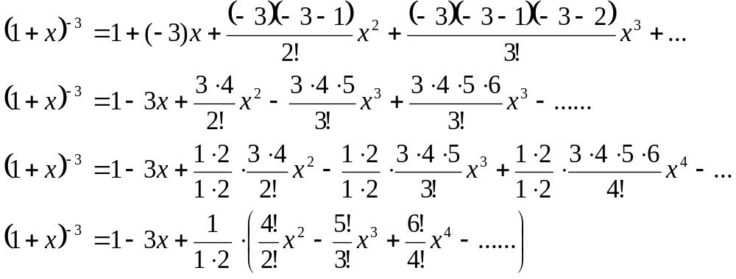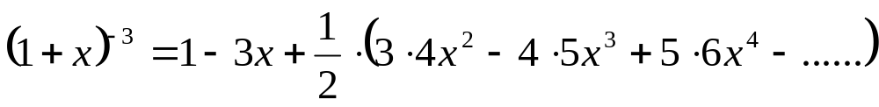
or
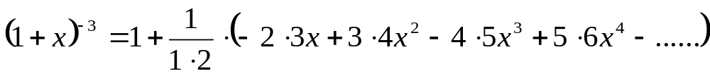

by now the pattern should be evident:

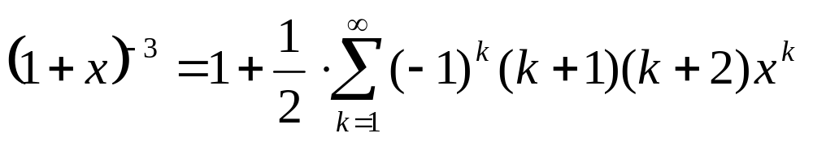

Another more complex example:
Expand using the binomial expansion: 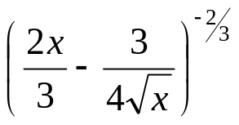use as a pattern the expansion of:

we will work this type of problems in class.

Answer:

In this case: n=-2/3, a=2x/3 and b=3/4sqrt(x). Hence:

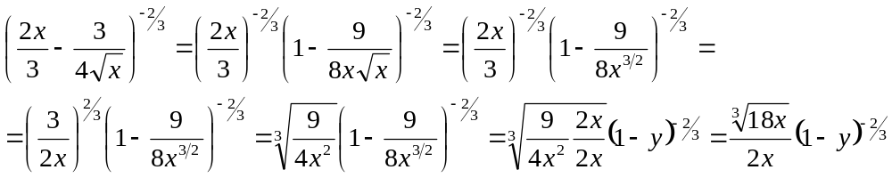
where: 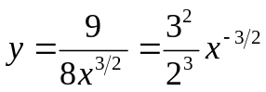.
Expand (1-y)^{n} using the previous formula and following the pattern of previous examples and we are done.
