1.3 A SIMPLE SORTING ALGORITHM

As we stated earlier, to sort means to arrange or classify according to certain set of rules. We will use a sorting example: "sort your homework grades in ascending order".

The input is the array of all the grades of a student: Gi = [82, 65, 27, 92, 44, 57, 66, 98].

The sorting algorithm (which accepts an array of positive numbers as an input) will order them in ascending order and thus the output will be the array:
Go = [27, 44, 57, 65, 66, 82, 92, 98].

To practice we will use a sorting algorithm called "Insertion Sort" whose pseudocode is given below. The pseudocode for insertion sort is presented as a procedure called INSERTION-SORT, which takes as a parameter an array A[1..n] containing a sequence of length n that is to be sorted. (In the code, the number n of elements in A is denoted by length[A].

Comments to the pseudo code are indicated by a double slash "//". The input numbers are sorted in place, that is the numbers are rearranged within the array A, with at most a constant number of them stored outside the array at any time. The input array A contains the sorted output sequence when INSERTION-SORT is finished
INSERTION-SORT(A)

1 for j ← 2 to length[A]
2 do key ← A[j]
3 i ← j - 1
4 while i > 0 and A[i] > key
5 do A[i+1] ← A[i]
6 i ← i - 1
7 A[i+ 1] ← key

Let's show how this algorithm works for array A = [82, 65, 27, 93, 44, 57, 66] with length[A] = 7.

The index j indicates the "current grade" being inserted into the array. Array elements A[1 ... j-1] constitute the currently sorted array, and elements A[j+1... n] correspond to the grades still on the array. The index j moves left to right through the array.

At each iteration of the "outer" for loop, the element A[j] is picked out of the array (line 2). Then, starting in position j – 1, elements are successively moved one position to the right until the proper position for A[j] is found (lines 4-7), at which point it is inserted (line 8).

Input array: 82 65 27 93 44 57 66
Line 2: put A[2] into variable key, that is: key = 65
Line 4: make i = j – 1 = 1
Line 5: the fact that A[1] =82 > key= 65 is verified and thus proceed to step 6
Line 6: do A[2] = 82
Line 7: do i = 0
Line 8: make A[1] = 65 and exit the while loop since i = 0. Go back to the for loop and increase j to its next value, that is j = 3 and we are ready to proceed to the next iteration of the algorithm. At this point array A = [65, 82, 27, 93, 44, 57, 66]

Let's execute one additional iteration to see the algorithm's working "pattern":

Input array: 65 82 27 93 44 57 66
Line 2: put A[3] into variable key, that is: key = 27
Line 4: make i = j – 1 = 2
Line 5: the fact that A[2] =82 > key= 27 is verified and thus proceed to step 6
Line 6: do A[3] = 82
Line 7: do i = 1
Line 8: make A[2] = 27 and continue the while loop since i = 1. Back to line 5

Line 5: the fact that A[1] =65 > key= 27 is verified and thus proceed to step 6
Line 6: do A[2] = A[1] = 65
Line 7: do i = 0
Line 8: make A[1] = 27 and exit the while loop since i = 0. Go back to the for loop and increase j to its next value, that is j = 4 and we are ready to proceed to the next iteration of the algorithm. At this point array A = [27, 65, 82, 93, 44, 57, 66]

The figure below summarizes the steps of the algorithm. The position of index j is indicated by the grade that is being underlined.

82 65 27 93 44 57 66
65 82 27 93 44 57 66
27 65 82 93 44 57 66
27 65 82 93 44 57 66
27 44 65 82 93 57 66
27 44 57 65 82 93 66
27 44 57 65 66 82 93 done.

EXERCISE
Re-do the previous example writing the state of the array every time there is a change.
Include the corresponding values of “j”, “i” and “key.
EXERCISE ANSWER:
STEP | j | key | i | ARRAY |  | SUMMARY
1 | 2 | ** | *** | 82, 65, 27, 93, 44, 57, 66 |  | 82, 65, 27, 93, 44, 57, 66 | 0
2 |  | 65 | *** |  |  | 82, 82, 27, 93, 44, 57, 66 | 1
3 |  |  | 1 |  |  | 65, 82, 27, 93, 44, 57, 66 | 2
5 |  |  |  | 82, 82, 27, 93, 44, 57, 66 |  | 65, 82, 82, 93, 44, 57, 66 | 3
6 |  |  | 0 |  |  | 65, 65, 82, 93, 44, 57, 66 | 4
7 |  |  |  | 65, 82, 27, 93, 44, 57, 66 |  | 27, 65, 82, 93, 44, 57, 66 | 5
1 | 3 |  |  |  |  | 27, 65, 82, 93, 44, 57, 66 | 6
2 |  | 27 |  |  |  | 27, 65, 82, 93, 93, 57, 66 | 7
3 |  |  | 2 |  |  | 27, 65, 82, 82, 93, 57, 66 | 8
5 |  |  |  | 65, 82, 82, 93, 44, 57, 66 |  | 27, 65, 65, 82, 93, 57, 66 | 9
6 |  |  | 1 |  |  | 27, 44, 65, 82, 93, 57, 66 | 10
5 |  |  |  | 65, 65, 82, 93, 44, 57, 66 |  | 27, 44, 65, 82, 93, 93, 66 | 11
6 |  |  | 0 |  |  | 27, 44, 65, 82, 82, 93, 66 | 12
7 |  |  |  | 27, 65, 82, 93, 44, 57, 66 |  | 27, 44, 65,65, 82, 93, 66 | 13
1 | 4 |  |  |  |  | 27, 44, 57,65, 82, 93, 66 | 14
2 |  | 93 |  |  |  | 27, 44, 57,65, 82, 93, 93 | 15
3 |  |  | 3 |  |  | 27, 44, 57,65, 82, 82, 93 | 16
7 |  |  |  | 27, 65, 82, 93, 44, 57, 66 |  | 27, 44, 57,65, 66, 82, 93 | 17
1 | 5
2 |  | 44
3 |  |  | 4
5 |  |  |  | 27, 65, 82, 93, 93, 57, 66
6 |  |  | 3
5 |  |  |  | 27, 65, 82, 82, 93, 57, 66
6 |  |  | 2
5 |  |  |  | 27, 65, 65, 82, 93, 57, 66
6 |  |  | 1
7 |  |  |  | 27, 44, 65, 82, 93, 57, 66
1 | 6
2 |  | 57
3 |  |  | 5
5 |  |  |  | 27, 44, 65, 82, 93, 93, 66
6 |  |  | 4
5 |  |  |  | 27, 44, 65, 82, 82, 93, 66
6 |  |  | 3
5 |  |  |  | 27, 44, 65,65, 82, 93, 66
6 |  |  | 2
7 |  |  |  | 27, 44, 57,65, 82, 93, 66
1 | 7
2 |  | 66
3 |  |  | 6
5 |  |  |  | 27, 44, 57,65, 82, 93, 93
6 |  |  | 5
5 |  |  |  | 27, 44, 57,65, 82, 82, 93
6 |  |  | 4
7 |  |  |  | 27, 44, 57,65, 66, 82, 93

1.4 ANALYSIS OF THE INSERTION SORT ALGORITHM

We will focus our analysis on the time complexity of this algorithm. The time taken by the INSERTION-SORT procedure depends on the input: sorting a thousand numbers takes longer than sorting three numbers. Moreover, INSERTION-SORT can take different amounts of time to sort two input sequences of the same size depending on how nearly sorted they already are.

In the following discussion, our expression for the running time of INSERTION-SORT will evolve from a messy formula that uses all the statement costs c_{i} to a much simpler notation that is more concise and more easily manipulated. This simpler notation will also make it easy to determine whether one algorithm is more efficient than another.

We start by presenting the INSERTION-SORT procedure with the time "cost" of each statement and the number of times each statement is executed. For each j = 2, 3,..., n, where n = length[A], we let t_{k} be the number of times the while loop test in line 5 is executed. We assume that comments are not executable statements, and so they take no time. Also it should be noted that the first statement of the loop is executed one more time than the body of the loop (when the condition is last checked and not satisfied).

INSERTION-SORT(A) cost times

1 for j ← 2 to length[A] { c1 n
2 do key ← A[j] c2 n-1
3 i ← j - 1 c3 n - 1
4 while(i > 0 and A[i] > key) c4 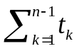
5 do A[i + 1] ← A[i] c5 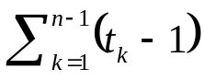
6 i ← i-1 c6
7 A[i + 1] ← key } c7 n - 1

The running time of the algorithm is the sum of running times for each statement executed; a statement that takes c_{i} steps to execute and is executed n times will contribute c_{i}n to the total running time.

To compute T(n), the running time of INSERTION-SORT, we sum the products of the cost and times columns, obtaining

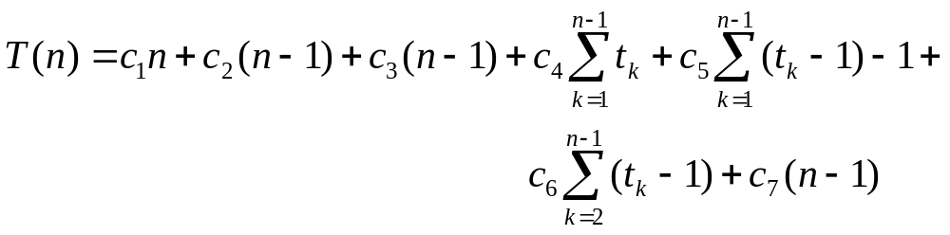

Even for inputs of a given size, an algorithm's running time may depend on which input of that size is given. For example, in INSERTION-SORT, the best case occurs if the array is already sorted. For each j = 2, 3, . . . , n, we then find that A[i] ≤ key in line 5 when i has its initial value of j - 1. Thus t_{k} = 1 for j = 2, 3, . . . , n, and the best-case running time is

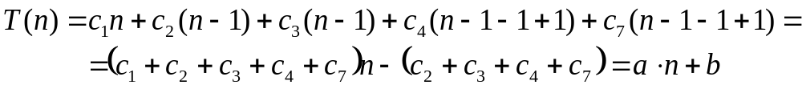

This running time can be expressed as a*n + b for constants a and b that depend on the statement costs c_{i}; it is thus a linear function of n.

If the array is in reverse sorted order, that is, in decreasing order, the worst case results.
We must compare each element A[j] with each element in the entire sorted sub array A[1 ... j - 1], for j = 2, 3,..., n, that is a total: n – 2 + 1 = n-1 times, and so t_{k} = k. We can write:

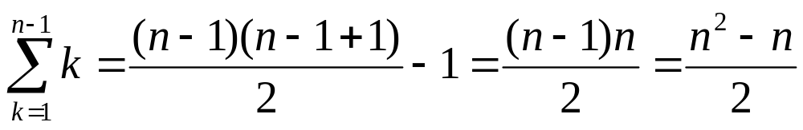

and

we find that in the worst case, the running time of INSERTION-SORT is

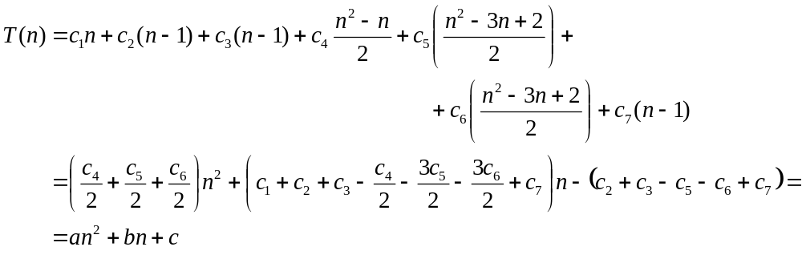

this worst case running time can be expressed as an² + bn + c for constants a, b, and c that again depend on the statement costs c_{i}; it is thus a quadratic function of n.

We have used some simplifying abstractions to ease our analysis of the INSERTION-SORT procedure.

First, we ignored the actual cost of each statement, using the constants c_{i} to represent these costs. Then, we observed that even these constants give us more detail than we really need: the worst case running time is an² + bn + c for some constants a, b, and c that depend on the statement costs c_{i}.

We thus ignored not only the actual statement costs, but also the abstract costs c_{i}.

1.5 ANALYSIS OF THE MERGE SORT ALGORITHM

The merge sort algorithm closely follows the divide-and-conquer paradigm. Intuitively, it operates as follows.

Divide: Divide the n-element sequence to be sorted into two subsequences of ~ n/2 elements each.
Conquer: Sort the two subsequences recursively using merge sort.
Combine: Merge the two sorted subsequences to produce the sorted answer.

We note that the recursion "bottoms out" when the sequence to be sorted has length 1, in which case there is no work to be done since every sequence of length 1 is already in sorted order.

The key operation of the merge sort algorithm is the merging of two sorted sequences in the "combine" step.

To perform the merging, we use an auxiliary procedure MERGE(A, p, q, r), where A is an array and p, q, and r are indices numbering elements of the array such that p ≤ q < r.

The procedure assumes that the sub-arrays A[p . . q] and A[q + 1 . . r] are in sorted order.

It merges them to form a single sorted sub-array that replaces the current sub array A[p . . r] in a time which is proportional to r – p + 1, that is, proportional to the number of elements being sorted.

We can now use the MERGE procedure as a subroutine in the merge sort algorithm.

The procedure MERGE-SORT(A, p, r) sorts the elements in the sub array A[p . . r].

If p ≥ r, the sub array has at most one element and is therefore already sorted.

Otherwise, the divide step simply computes an index q that partitions A[p . . r] into two subarrays: A[p.. q], containing ⎡ n/2⎤ elements, and A[q + 1 .. r], containing ⎣ n/2⎦ elements.

(The expression ⎡x⎤, "top" of x, denotes the least integer greater than or equal to x, and ⎣x⎦, "bottom" of x, denotes the greater integer less than or equal to x.)

MERGE-SORT(A, p, r)

1 if p < r
2 then q ← ⎣(p + r)/2⎦
3 MERGE-SORT(A, p, q)
4 MERGE-SORT(A, q + 1, r)
5 MERGE(A, p, q, r)

To sort the entire sequence A = (A[1], A[2],... , A[n]), we call MERGE-SORT(A, 1, length[A]), where once again length[A] = n.

If we look at the operation of the procedure bottom-up when n is a power of two, the algorithm consists of merging pairs of 1-item sequences to form sorted sequences of length 2, merging pairs of sequences of length 2 to form sorted sequences of length 4, and so on, until two sequences of length n/2 are merged to form the final sorted sequence of length n.

The figure below illustrates this process.

82 65 27 27
65 merge 2 82 65 44
27 27 82 57
93 merge 2 93 merge 4 93 65
44 44 44 66
57 merge 2 57 57 82
66 merge 1 66 merge 3 66 merge 7 93

Recurrence:
When an algorithm contains a recursive call to itself, its running time can often be described by a recurrence equation or recurrence, which describes the overall running time on a problem of size n in terms of the running time on smaller inputs.

We can then use mathematical tools to solve the recurrence and provide bounds on the performance of the algorithm.

A recurrence for the running time of a divide-and-conquer algorithm is based on the three steps of the basic paradigm.

As before, we let T(n) be the running time on a problem of size n.

If the problem size is small enough, say n ≤ c for some constant c, the straightforward solution takes constant time T₀.

Suppose we divide the problem into sub-problems, each of which is 1/b the size of the original.

If we take D(n) time to divide the problem into sub-problems and C(n) time to combine the solutions to the sub-problems into the solution to the original problem, we get the recurrence

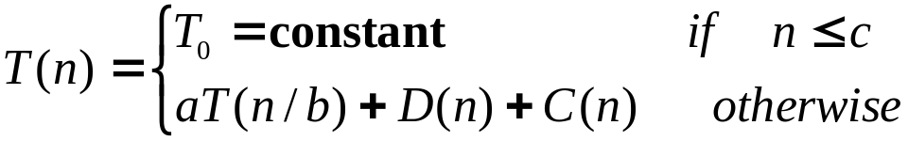

(We shall see how to solve equations of this form.)

Although the pseudocode for MERGE-SORT works correctly when the number of elements is not even, our recurrence-based analysis is simplified if we assume that the original problem size is a power of two. Each divide step then yields two subsequences of size exactly n/2. (This assumption does not affect the order of growth of the solution to the recurrence.)

We reason as follows to set up the recurrence for T(n), the worst-case running time of merge sort on n numbers. Merge sort on just one element takes constant time. When we have n > 1 elements, we break down the running time as follows.

Divide: The divide step just computes the middle of the sub array, which takes constant time. Thus: D(n) = d₀ =constant.

Conquer: We recursively solve two sub-problems, each of size n/2, which contributes 2T(n/2) to the running time.

Combine: We have already noted that the MERGE procedure on an n-element sub array takes time proportional to n so C(n) = c₀n.

When we add the functions D(n) and C(n) for the merge sort analysis, we are adding a function that is proportional to n, that is, c₀n, and a function that is constant, that is d₀. This sum is a linear function of n, that is, c₁n. Adding it to the 2T(n/2) term from the "conquer" step gives the recurrence for the worst-case running time T(n) of merge sort:

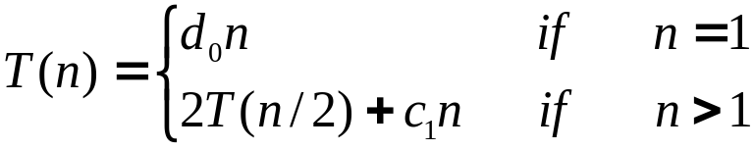

We shall show that T(n) is proportional to (n lg n), where lg n stands for log₂ n. For large enough inputs, merge sort, with its proportional to (n lg n) running time, outperforms insertion sort, whose running time proportional to n² in the worst case.

1.6 TWO INTERESTING PROBLEMS

Problem 1:
Algorithms devised to solve the same problem often differ dramatically in their efficiency. These differences can be much more significant than the difference between a personal computer and a supercomputer. As an example, let us put a supercomputer running insertion sort against a small personal computer running merge sort. They each must sort an array of one million numbers. Suppose the supercomputer executes 100 million (10⁸) instructions per second, while the personal computer executes only one million (10⁶) instructions per second. To make the difference even more dramatic, suppose that the world's craftiest programmer codes insertion sort in machine language for the supercomputer, and the resulting code requires 2n² supercomputer instructions to sort n numbers. Merge sort, on the other hand, is programmed for the personal computer by an average programmer using a high-level language with an inefficient compiler, with the resulting code taking 50n lg n personal computer instructions. To sort a million numbers, the supercomputer takes

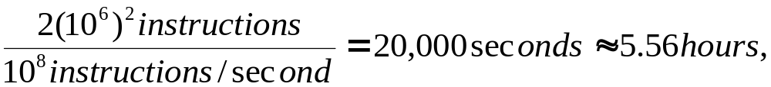

while the personal computer takes

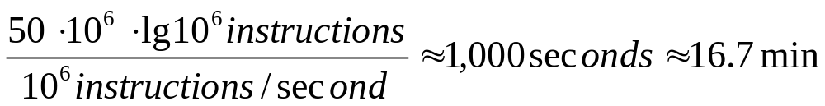

By using an algorithm whose running time has a lower order of growth, even with a poor compiler, the personal computer runs 20 times faster than the supercomputer!

This example shows that algorithms, like computer hardware, are a technology. Total system performance depends on choosing efficient algorithms as much as on choosing fast hardware. Just as rapid advances are being made in other computer technologies, they are being made in algorithms as well.

Problem 2:
The time needed by an algorithm expressed as a function of the size of a problem is called the time complexity of the algorithm. The limiting behavior of the complexity as size increases is called the asymptotic time complexity. Analogous definitions can be made for space complexity and asymptotic space complexity. It is the asymptotic complexity of an algorithm which ultimately determines the size of problems that can be solved by the algorithm.

One might suspect that the tremendous increase in the speed of calculations brought about by the advent of the present generation of digital computers would decrease the importance of efficient algorithms. However, just the opposite is true. As computers become faster and we can handle larger problems, it is the complexity of an algorithm that determines the increase in problem size that can be achieved with an increase in computer speed.

Suppose we have five algorithms A1-A5 with the following time complexities

Algorithm Time Complexity
A1 n
A2 n lg n
A3 n²
A4 n³
A5 2^{n}

The time complexity here is the number of time units required to process an input of size n. Assuming that one unit of time equals one millisecond, algorithm A1 can process in one second an input of size 1000, whereas algorithm A5 can process in one second an input of size at most 9. The table below gives the sizes of problems that can be solved in one second, one minute, and one hour by each of these five algorithms. It represents the limits on problem size as determined by growth rate.

Table 1: Limits on Problem Size as Determined by Growth Rate.
Algorithm | Time  Complexity | Maximum Problem Size
Algorithm | Time  Complexity | 1 sec | 1 min | 1 hour
A1 | n | 1000 | 60,000 | 3,600,000
A2 | n lg n | 140 | 4893 | 200,000
A3 | n² | 31 | 244 | 1897
A4 | n³ | 10 | 39 | 153
A5 | 2^{n} | 9 | 15 | 21

The general equation used to solve this problem is to find n from f(n) = ⎣t⎦ where t is time in the specified unit, that is if t = 1 second, then we write t = 1000 milliseconds. The solution will be

n = ⎣f⁻¹(1000)⎦

For example, if f(n) = n² then n = ⎣sqrt(1000)⎦ = ⎣31.82⎦ = 31.

Suppose now that the next generation of computers is ten times faster than the current generation. Table 2 shows the increase in the size of the problem we can solve due to this increase in speed. Note that with algorithm A5, a tenfold increase in speed only increases by three the size of problem that can be solved, whereas with algorithm A3 the size more than triples.

Algorithm | Time  Complexity | Maximum  problem size  before speed up | Maximum  problem size  after speed up
A1 | n | s₁ | 10 s₁
A2 | n lg n | s₂ | ~10 s₂ for large s₂
A3 | n² | s₃ | 3.16 s₃
A4 | n³ | s₄ | 2.15 s₄
A5 | 2^{n} | s₅ | s₅ + 3.3

(Note that Sqrt(10) = 3.16, CubicRoot(10) = 2.15, lg(10) = 3.3, etc.)

Instead of an increase in speed, consider the effect of using a more efficient algorithm. Refer again to Table 1. Using one minute as a basis for comparison, by replacing algorithm A4 with A3 we can solve a problem six times larger (244/39 = 6.26); by replacing A4 withA2 we can solve a problem 125 times larger (4893/39 = 125.46). These results are far more impressive than the twofold improvement obtained by a tenfold increase in speed. If an hour is used as the basis of comparison, the differences are even more significant. We conclude that the asymptotic complexity of an algorithm is an important measure of the goodness of an algorithm, one that promises to become even more important with future increases in computing speed.

Despite our concentration on order-of-magnitude performance, we should realize that an algorithm with a rapid growth rate might have a smaller constant of proportionality than one with a lower growth rate. In that case, the rapidly growing algorithm might be superior for small problems, possibly even for all problems of a size that would interest us. For example, suppose the time complexities of algorithms A1, A2, A3, A4, and A5 were really 1000n, l00n log n, 10n², n³, and 2^{n}. Then A5 would be best for problems of size 2 ≤ n ≤ 9, A3 would be best for 10 ≤ n ≤ 58, A2 would be best for 59 ≤ n ≤ 1024, and A1 best for problems of size greater than 1024.

SET OF TYPICAL ALGORITHMIC PROBLEMS

1. Use the INSERTION-SORT algorithm on the array A = {31, 41, 59, 26, 41, 58}

2. Use the MERGE-SORT algorithm on the array A = {3, 41, 52, 26, 38, 57, 9, 49}

3. Suppose we are comparing implementations of insertion sort and merge sort on the same machine. For inputs of size n, insertion sort runs in 8n² steps, while merge sort runs in 64n lg n steps. For which values of n does insertion sort beat merge sort? How might one rewrite the merge sort pseudocode to make it even faster on small inputs?

4. What is the smallest value of n such that an algorithm whose running time is 100n² runs faster than an algorithm whose running time is 2^{n} on the same machine?

5. Comparison of running times: For each function f(n) and time t in the following table, determine the largest size n of a problem that can be solved in time t, assuming that the algorithm to solve the problem takes f(n) microseconds.

 | 1  sec | 1  min | 1  hour | 1  day | 1  day | 1  month | 1  year
lg n
sqrt(n)
n
n lg n
n²
n³
2^{n}
n!

6. Find a simple formula for 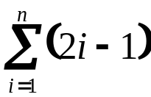

7. Evaluate the sum 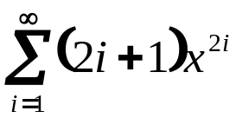

8. Evaluate the product 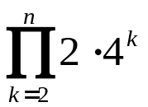

9 Evaluate the product 