RECURSION

1. Linear Recurrence Equations with Constant Coefficients

1.1 Equations of the First Order

1.1.1 Simple recursive equations

1. Solve the following recursive equation a_{n} = a_{n-1} + b for n ≥ 1, where a₀ = c. Constants b and c are real numbers.

Replace n by 1 and obtain: a₁ = a₀ + b
Replace n by 2 and obtain: a₂ = a₁ + b
Replace n by 3 and obtain: a₃ = a₂ + b

and so on .....................................................................

Replace n by n-2 and obtain: a_{n-2} = a_{n-3} + b
Replace n by n-1 and obtain: a_{n-1} = a_{n-2} + b
Replace n by n and obtain: a_{n} = a_{n-1} + b

Add all LHSs (left hand sides) equal to the sum of all RHSs (right hand sides) and then cancel equal terms on the RHS with equal terms on the LHS.

a₁ + a₂ + a₃ + ... + a_{n-2} + a_{n-1} + a_{n} = a₀ + b + a₁ + b + a₂ + b ... +
+ a_{n-3} + b + a_{n-2} + b + a_{n-1} + b.

After simplifying we are left with the following: a_{n} = a₀ + n*b. Lastly, replacing a₀ by its constant value c yields the solution:

a_{n} = c + n*b, for all n ≥ 1.

2. Solve the following recursive equation a_{n} = k*a_{n-1} for n ≥ 1, where a₀ = c. Constant c is real number.

Replace n by 1 and obtain: a₁ = k*a₀
Replace n by 2 and obtain: a₂ = k*a₁
Replace n by 3 and obtain: a₃ = k*a₂

and so on ...................................................................

Replace n by n-2 and obtain: a_{n-2} = k*a_{n-3}
Replace n by n-1 and obtain: a_{n-1} = k*a_{n-2}
Replace n by n and obtain: a_{n} = k*a_{n-1}

Multiply all LHSs which equals the product of all RHSs as follows:

a₁ * a₂ * a₃ * ... * a_{n-2} * a_{n-1} * a_{n} = k*a₀ * k*a₁ * k*a₂ ... *
* k*a_{n-3} * k*a_{n-2} * k*a_{n-1}.

Next cancel all equal terms on the RHS with its equal term on the LHS. We are left with the following: a_{n} = k^{n} a₀. Lastly, replacing the value of a₀ yields the solution:

a_{n} = ck^{n} , for all n ≥ 1. (Replace a0 by c hence proved.)

3. Solve the following recursive equation 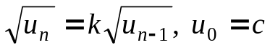, for n ≥ 1. Constants k and c are real numbers.

In this case we simply square the equation to obtain: 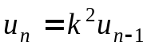 and the equation reduces to example 2 with constant k² instead of k.

4. Solve the following recursive equation a_{n} = a_{n-1} + k*n, for n ≥ 1, with a₀ = c. Constants k and c are real numbers.

Replace n by 1 and obtain: a₁ = a₀ + k*1
Replace n by 2 and obtain: a₂ = a₁ + k*2
Replace n by 3 and obtain: a₃ = a₂ + k*3
and so on and so forth .........................................................

Replace n by n-2 and obtain: a_{n-2} = a_{n-3} + k(n – 2)
Replace n by n-1 and obtain: a_{n-1} = a_{n-2} + k(n – 1)
Replace n by n and obtain: a_{n} = a_{n-1} + kn

In this case adding all terms as done in the first case will also work. However, as a practice, we will proceed by using substitution instead.

We start with the expression for a₂ where we substitute the value of a₁ to get the expression:

a₂ = a₁ + k*2 = a₀ + k*1 + k*2 = a₀ + k*(1 + 2)

Now we introduce this value for a₂ into the expression for a₃ to get:

a₃ = a₂ + k*3 = a₀ + k*(1 + 2) + k*3 = a₀ + k*(1 + 2 + 3)

It is easy to “induce” that the general expression for a_{n} is given by the following:

a_{n} = a₀ + k*[1 + 2 + 3 + ... + (n-2) + (n-1) + n] =
= a₀ + k*[n(n+1)/2], for all n ≥ 1

Replacing the value of a₀ yields:

a_{n} = c + k*[n(n+1)/2], for all n ≥ 1.

5. Solve the following recursive equation a_{n} = k*a_{n-1} + b, for n ≥ 1, with a₀ = c. Constants k, b and c are real numbers.

Replace n by 1 and obtain: a₁ = k*a₀ + b
Replace n by 2 and obtain: a₂ = k*a₁ + b
Replace n by 3 and obtain: a₃ = k*a₂ + b

and so on ...................................................................

Replace n by n-2 and obtain: a_{n-2} = k*a_{n-3} + b
Replace n by n-1 and obtain: a_{n-1} = k*a_{n-2} + b
Replace n by n and obtain: a_{n} = k*a_{n-1} + b

We will proceed by using substitution. We start with the expression for a₂ where we substitute the value of a₁ to get the expression:

a₂ = k*a₁ + b = k²*a₀ + k*b + b = k²*a₀ + b*(1 + k)

Introducing this value for a₂ into the expression for a₃ yields:

a₃ = a₂ + k*3 = k³*a₀ + b*(k + k²) + b = k³*a₀ + b*(1 + k + k²)

It is easy to “induce” that the general expression for a_{n} is as follows:

a_{n} = k^{n}*a₀ + b*[1 + k + k² + ... + k^{(n-2)} + k^{(n-1)}] =
= k^{n}*a₀ + b*(k^{n} – 1)/(k-1), for all n ≥ 1

Replacing the value of a₀ yields:

a_{n} = k^{n}*c + b*(k^{n} – 1)/(k-1), for all n ≥ 1.

6. Solve the recursive equation 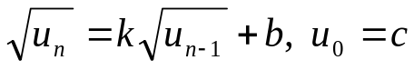, for n ≥ 1. Constants k, b, and c are real numbers.

The “trick” to solve this type of non-linear recurrence equation is to put: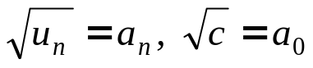 and with this substitution the equation reduces to: a_{n} = k*a_{n-1} + b whose solution is given in example 5 above. Once a_{n} is found you must evaluate u_{n} using u_{n} = (a_{n})².

7. Solve the following recursive equation a_{n} = h*a_{n-1} + k*n, for n ≥ 1, with a₀ = c. Constants h, k and c are real numbers.

Replace n by 1 and obtain: a₁ = h*a₀ + k*1
Replace n by 2 and obtain: a₂ = h*a₁ + k*2
Replace n by 3 and obtain: a₃ = h*a₂ + k*3

and so on ...................................................................

Replace n by n-2 and obtain: a_{n-2} = h*a_{n-3} + k*(n-2)
Replace n by n-1 and obtain: a_{n-1} = h*a_{n-2} + k*(n-1)
Replace n by n and obtain: a_{n} = h*a_{n-1} + k*n

We will proceed by using substitution. We start with the expression for a₂ where we substitute the value of a₁ to get the expression:

a₂ = h*a₁ + k*2 = h²*a₀ + hk + 2k

Introducing this value for a₂ into the expression for a₃ yields:

a₃ = h*a₂ + k*3 = h³*a₀ + h²k + 2hk +3k

It is not yet too easy to “induce” the general expression for a_{n} so we do one more term a₄:

a₄ = h*a₃ + k*4 = h⁴*a₀ + h³k + 2h²k +3hk + 4k =
a₄ = h⁴*a₀ + k(h³ + 2h² +3h +4)

Now it may be possible to “induce” the general term:

a_{n} = h^{n}a₀ + k[h^{(n-1)} + 2h^{(n-2)} + 3h^{(n-3)} + ... + (n-2)h² + (n-1)h + n]

Replacing the value of a₀ yields:

a_{n} = ch^{n} + k[h^{(n-1)} + 2h^{(n-2)} + 3h^{(n-3)} + ... + (n-2)h² + (n-1)h + n]

We need to find out the sum in square parenthesis. Let’s write S for the sum and let’s multiply S by h. Lining up the terms we have:

S = h^{(n-1)} + 2h^{(n-2)} + 3h^{(n-3)} + ... + (n-2)h² + (n-1)h + n
hS = h^{n} + 2h^{(n-1)} + 3h^{(n-2)} + ... + (n-1)h² + nh

therefore:

(h – 1) S = h^{n} + h^{(n-1)} + h^{(n-2)} + ... + h² + h – n,

that is:

(h – 1) S = h[h^{(n-1)} + h^{(n-2)} + ... + h + 1] – n,

and this reduces to:

(h – 1) S = h[(h^{n} – 1)/(h-1)] – n, hence:

S = h(h^{n} – 1) /(h – 1)² – n/(h – 1)

Lastly, replacing S into the expression of a_{n} yields:

a_{n} = ch^{n} + kh(h^{n} – 1) /(h – 1)² – kn/(h – 1)

If you cannot deduce the value of S you can use the formulas given in class as a guide. For that take the following sum:

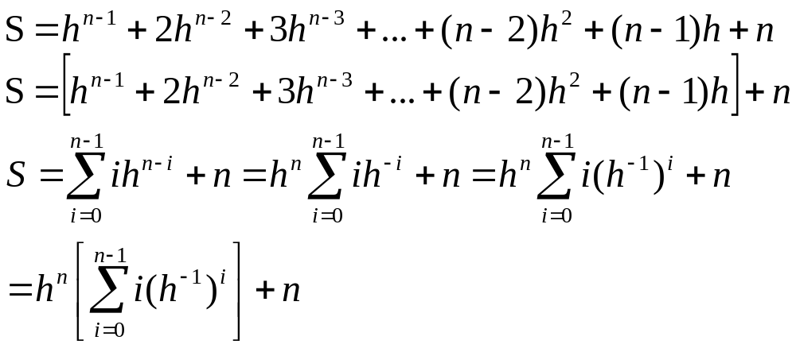
and then for the expression in square parenthesis use the formulas for
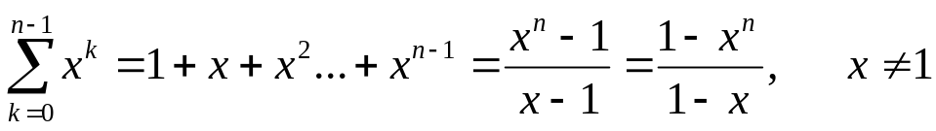
and
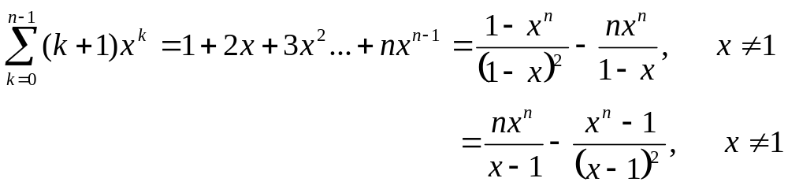
where the last formula has to be worked a little to get:
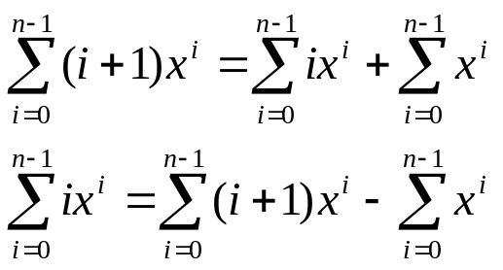

and in this case x = h⁻¹. (Lots of high school algebra as you can see).

8. Solve the recursive equation 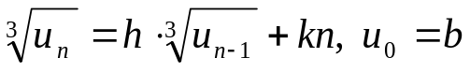.

Use the substitutions: 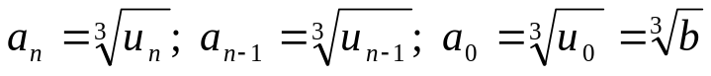 and use the results obtained in example 7 to solve for a_{n}. After that go back to the initial variable u_{n} from the relationship that gives u_{n} as a function of a_{n}.

1.1.2 A different type of simple recursive equations (Substitution Method)

1. T(n)=2T(n/2)
n ≥ 1 with T(1) = c

We start with n = n: T(n) = 2T(n/2)
Replace n by n/2: T(n/2) = 2T(n/2²)
Replace n by n/2²: T(n/2²) = 2T(n/2³)

and then keep repeating this substitution until you reach:

Replace n by n/2^{k-1}: T(n/2^{k-1}) = 2T(n/2^{k})

Here we assume that we have reached T(1) = c when we wrote T(n/2^{k}), that is: n/2^{k} = 1 or 2^{k} = n and k = lg n (the log is base 2). Using all the equalities above we can write:

T(n) = 2T(n/2) = 2²T(n/2²) = 2³T(n/2³) = .... = 2^{k-1}T(n/2^{k-1})
= 2^{k}T(n/2^{k}) = n*c

because 2^{k} = n and T(n/2^{k}) = T(1) = c.

The major assumption in this type of solution is: n/2^{k} = 1, that is after k iterations n was finally reduced to 1.

2. Solve T(n) = 4T(n/3) for n > 1 with T(1) = c.

We start with n = n: T(n) = 4T(n/3)
Replace n by n/b²: T(n/3) = 4T(n/3²)
Replace n by n/b³: T(n/3²) = 4T(n/3³)

and then keep repeating this substitution until you reach:

Replace n by n/3^{k-1}: T(n/3^{k-1}) = 4T(n/3^{k})

Again, we assume that we have reached T(1) = c = T(n/3^{k}), that is, the assumption here is: n/3^{k} = 1 or 3^{k} = n.

On this last expression take logs base 3, and then k = log₃ n.

Using all the equalities above, and since T(n/3^{k}) = T(1) = c, we can write:

T(n) = 4T(n/3) = 4²T(n/3²) = 4³T(n/3³) = .... = 4^{k-1}T(n/3^{k-1}) =
= 4^{k}T(n/3^{k}) = 4^{k}*c

We need 4^{k} , which is 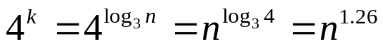since log₃4 = = log4/ log3 = 1.26. Hence:

T(n) = c*n^{1.26}, a polynomial function.

3. Solve the general case: T(n) = aT(n/b) for n ≥ 1 with T(1) = c and a and b positive integers and c a real number.

We start with n = n: T(n) = aT(n/b)
Replace n by n/b: T(n/b) = aT(n/b²)
Replace n by n/b²: T(n/b²) = aT(n/b³)

and then keep repeating this substitution until you reach:

Replace n by n/b^{k} and get: T(n/b^{k-1}) = aT(n/b^{k})

Again, we assume that we have reached T(1) = c = T(n/b^{k}), that is, the assumption here is: n/b^{k} = 1 or b^{k} = n. Taking logs base b yields: k = log_{b} n.

Using all the equalities above, and since T(n/b^{k}) = T(1) = c, we can write:

T(n) = aT(n/b) = a²T(n/b²) = a³T(n/b³) = .... = a^{k-1}T(n/b^{k-1}) =
= a^{k}T(n/b^{k}) = a^{k}*c

Since we need a^{k} and k = log_{b} n, 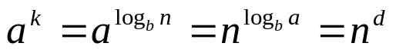 where d = log_{b} a, therefore:

T(n) = c*n^{d}, a polynomial function.

4. Solve T(n) = 2T(n/2) + a*n, for n > 1 with T(1) = c

We start with n = n: T(n) = 2T(n/2) + a*n
Replace n by n/2: T(n/2) = 2T(n/2²) + a*(n/2)
Replace n by n/2²: T(n/2²) = 2T(n/2³) + a*(n/2²)

and then keep repeating this substitution until:

Replace n by n/2^{k-1}: T(n/2^{k-1}) = 2T(n/2^{k}) + a*(n/2^{k-1})

Again, we assume that we have reached T(1) = c = T(n/2^{k}), that is: n/2^{k} = 1 or 2^{k} = n and k = lg n (the log is base 2).

Now, using the previous equalities we can write:
T(n) = 2T(n/2) + a*n = 2[2T(n/2²) + a*(n/2)] + a*n
= 2²T(n/2²) + 2a*n =
= 2²[2T(n/2³) + a*(n/2²)]+ 2a*n = 2³T(n/2³) + 3a*n
................

T(n) = 2^{k-1}[2T(n/2^{k}) + a*(n/2^{k-1})]+ (k-1)a*n
= 2^{k}T(n/2^{k}) + k*a*n
= nT(1) + (lg n)*a*n
lastly:

T(n) = n*c + a*n*lg n.

This is a case where T(n) fastest growing component is the one with the term n*lg n.

5. Solve T(n) = 3T(n/2) + 5n², for n ≥ 1 with T(1) = c

We start with n = n: T(n) = 3T(n/2) + 5n²
Replace n by n/2: T(n/2) = 3T(n/2²) + 5(n/2)²
Replace n by n/2²: T(n/2²) = 3T(n/2³) + 5(n/2²)²

and then keep repeating this substitution until:

Replace n by n/2^{k-1}: T(n/2^{k-1}) = 3T(n/2^{k}) + 5(n/2^{k-1})²

As usual, we assume that we have reached T(1) = c = T(n/2^{k}), that is: n/2^{k} = 1 or 2^{k} = n and k = lg n (the log is base 2).

Now, using the previous equalities we can write:
T(n) = 3T(n/2) + 5n² = 3[3T(n/2²) + 5(n/2)²] + 5n²
= 3²T(n/2²) + 3*5(n/2)² + 5n²
= 3²T(n/2²) + 5n²{3/2² + 1}

= 3²[3T(n/2³) + 5(n/2²)²]+ 5n²{3/(2²) + 1}
= 3³T(n/2³) + 5n²{[3/(2²)]² + [3/(2²)] + 1}
= 3³T(n/2³) + 5n²{[3/4]² + [3/4] + 1}
................
at this point we can visualize the general case by “induction”:

T(n) = 2^{k}T(n/2^{k}) + 5n²{[3/4]^{k-1} + [3/4]^{k-2} + ...+[3/4]² + [3/4] + 1}
= 2^{k}T(n/2^{k}) + 5n²([3/4]^{k} – 1)/(3/4 – 1)
= 2^{k}T(n/2^{k}) + 5n²(1 – [3/4]^{k} )/(1/4)
= 2^{k}T(n/2^{k}) + 20n²(1 – [3/4]^{k} )

now T(n/2^{k}) = c, 2^{k} = n and k = lg n, therefore:

T(n) = n*c + 20n²(1 – [3/4]^{lg n} ) = n*c + 20n²(1 – n^{lg 0.75} )
T(n) = n*c + 20n²(1 – n^{-0.415} ) = 20n² + 20n^{1.585} + n*c.

And T(n) fastest growing component is the term in n².

1.2 Second Order Recursive Equations

The general form of this equation include the real numbers a, b, and c in the general recursive expression:

a*u_{n} + b*u_{n-1} + c*u_{n-2} = 0, n ≥ 2.

The technique to find its solution is to guess that u_{n} = r^{n} and thus u_{n-1} = r^{n-1}, u_{n-2} = r^{n-2}. Replacing these terms in the original equation yields:

a*r^{n} + b*r^{n-1} + c*r^{n-2} = r^{n-2}(a r² + br + c) = 0.

Since r ≠ 0 (otherwise the solution is trivial) then:

a*r² + b*r + c = 0.

This last second degree equation is called the characteristic equation of the recursive equation. Using the formula for the quadratic equation yields:

r₁ = [-b + sqrt(b²-4ac)]/2a
r₂ = [-b - sqrt(b²-4ac)]/2a

Therefore the general solution for the second order recursive equation, assuming that r₁ and r₂ are distinct, is:
(If r1 and r2 are different then this)

u_{n} = c₁*r₁^{n} + c₂*r₂^{n}

where c₁ and c₂ are two arbitrary constants determined from the recursive equation initial conditions u₀ = k₁ and u₁ = k₂.

These two solutions are linearly independent. If the two roots are equal, that is, if r₂ = r₁, then the general solution including two arbitrary constants is given by
(If r1 and r2 are same then this)

u_{n} = (c₁ + c₂*n)r₁^{n}

Note: What defines a second order recurrence equation is that the difference between the highest and lowest index in the variable is 2.

Examples:

1. Solve the Fibonacci equation f_{n} = f_{n-1} + f_{n-2} for n ≥ 2 with initial conditions: f₀ = 0 and f₁ = 1.

Write the equation as: f_{n} - f_{n-1} - f_{n-2} = 0 and then the coefficients are: a = 1, b = c = -1. Therefore the characteristic equation is r² - r – 1 = 0 and its solutions are:
r₁ = [1 + sqrt(5)]/2 r₂ = [1 - sqrt(5)]/2.

Since the roots of the characteristic equation are distinct, the general solution for the Fibonacci equation is:

f_{n} = c₁*( [1 + sqrt(5)]/2)^{n} + c₂*([1 - sqrt(5)]/2)^{n}

To find out the value of the two arbitrary constants we use the initial conditions as follows:

For n = 0, f₀ = 0 and thus: f₀ = c₁ + c₂ = 0 → c₂ = - c₁

For n = 1, f₁ = 1 and thus:

f₁ = c₁*( [1 + sqrt(5)]/2) + c₂* ([1 - sqrt(5)]/2) = 1

replacing c₂ = - c₁ yields:

c₁*{( [1 + sqrt(5)]/2) - ([1 - sqrt(5)]/2)} = 1 that is:

c₁ = 1/[2*sqrt(5)] = - c₂

and thus:

f_{n} = 1/[2*sqrt(5)]*{([1 + sqrt(5)]/2)^{n} – ([1 – sqrt(5)]/2)^{n}}

2. Solve the recursive equation u_{n+1} - 5u_{n} + 6u_{n-1} = 0, for n ≥ 1 with initial conditions: u₁ = 5 and u₂ = 7.

The characteristic equation is r² - 5r + 6 = 0 and its solutions are: r₁ = 2, r₂ = 3.

Since the roots of the characteristic equation are distinct, the general solution for this equation is:

u_{n} = c₁*(2)^{n} + c₂*(3)^{n}

To find out the value of the two arbitrary constants we use the initial conditions as follows:

For n = 1, u₁ = 5 and thus:
u₁ = 2c₁ + 3c₂ = 5 → c₂ = (5/3)- (2/3)c₁

For n = 2, u₂ = 7 and thus:

u₂ = 4c₁ + 9c₂ = 7 → 4c₁ + 9[(5/3)- (2/3)c₁] = 7 → c₁ = 4 and thus → c₂ = -1, therefore:

u_{n} = 4*(2)^{n} + (-1)*(3)^{n} = 2^{n+2} - 3^{n}.

3. Solve the recursive equation u_{n+1} + 6u_{n} + 9u_{n-2} = 0, for n ≥ 1 with initial conditions: u₀ = 1 and u₁ = 3.

The characteristic equation is r² + 6r + 9 = 0 and its solutions are: r₁ = r₂ = -3.

Since the roots of the characteristic equation are distinct, the general solution for this equation is:

u_{n} = (c₁+ c₂*n)(-3)^{n}

To find out the value of the two arbitrary constants we use the initial conditions as follows:

For n = 0, u₀ = 1 and thus: u₀ = c₁ = 1

For n = 1, u₁ = 2 and thus: u₁ = (c₁ + c₂)(-3) = 3 → 1+ c₂ = -1 → c₂ = -2, therefore:

u_{n} = (1 + (-2)n)*(-3)^{n} = (1-2n)(- 3)^{n}.

More examples:

1. Solve u_{n} = u_{n-1} u_{n-2} , non linear with u₀ = c₁, and u₁ = c₁. (Hint: take logs and then use substitution, call a_{n} = log u_{n})

2. √(u_{n}) = c*√(u_{n-1} ) + d*√(u_{n-2} ) , non linear with u₀ = c₁ and u₁ = c₁. (Hint: use substitution, call a_{n} = √u_{n})

3. a_{n} = √(a_{n-2} /a_{n-1} ) , non linear with a₀ = c₁ and a₁ = c₁. (Hint: take logs and use substitution)

