1. I eat only when I am hungry => without hunger, I won’t eat, whatever may be the food.
2. I will eat slowly and ensure that the food is grinded well in my mouth before I swallow.
3. If possible, I will sit in the floor/chair, in the below posture while eating.

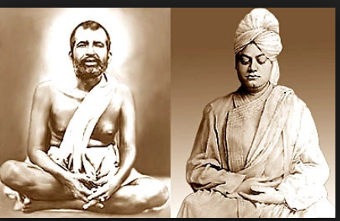

1. I drink only when I am thirsty, only as much water, as I need
2. I sleep only as much as I need
3. I do the physical work required for my body